ECCCO Career Development Curriculum Workbook

September 2021

# Exploring College, Career and Community Options (ECCCO)

ECCCO is a 9th–12th grade curriculum resource designed to help all students, regardless of background, build the necessary skills, knowledge, and networks for a successful transition beyond high school. ECCCO is also a virtual teacher planning resource that provides access to college, career, and community readiness curriculum units, lessons, and performance tasks, which can be mapped out into a 9th–12th grade matrix.

## How should teachers engage with ECCCO?

A **team of pathway teachers**,can use the ECCCO Planwhen they have a cohort of students, a set of pathway outcomes, and a pathway program of study to help identify which courses across the pathway will implement college and career readiness curriculum. The ECCCO Plan and Matrix can be found in ConnectED studios. **Individual teachers**, can use this ECCCO Workbook as a lesson planning resource to help students become more college, career, and community ready within the classroom. Overall, ECCCO helps Pathway Teams or individual teachers:

* review and select college and career readiness themes, units, and lesson plans;
* use materials “as is” or make their own modifications;
* connect Day at Work videos with learning activities to help students explore careers;
* build customized plans indicating which courses will incorporate college, career, or community units; and
* achieve the College and Career Readiness Classroom Framework quality standards.

## ECCCO in ConnectED Studios

Using ConnectED Studios is beneficial when designing an ECCCO Plan ***continuum*of college, career, and community learning experiences for students**, rather than looking for an individual lesson plan or unit. To build a **digital ECCCO Plan**, [log into ConnectED Studios](https://connectedstudios.org/) and explore the ECCCO resources in the instructional design section. If interested in professional development or in need of technical assistance, please [contact us](https://connectednational.org/learn/connect/contact-us/).

# Career Development Curriculum

This workbook contains curriculum resources and lesson plans designed to help students reflect on their values and interests as they consider a career field. Students participate in career exploration and preparation experiences building skill in and applying knowledge of industry best practices; all designed to increase student engagement and give students multiple opportunities to practice and perform. The career development strand maximizes growth and learning from real world experiences. Career development within the industry theme builds students’ capacities to pursue opportunities in other fields and industries after high school. Career development then broadens, rather than narrows, opportunities.

Career Development Curriculum

Theme: Career Interests..........................................................

Explore Career Options Related to My Values................

Skills for Success.............................................................

Career Awareness/Exploration................................................

Researching Careers.......................................................

Academy/Industry Theme..............................................

Career Exploration Visit..................................................

Theme: Career Preparation.....................................................

Professionalism..............................................................

Resume Writing..............................................................

Job Application...............................................................

Theme: Internship:..................................................................

Preparing for the Internship...........................................

During the Internship: Time Management.....................

During the Internship: Stress Management...................

During the Internship: Workplace Diversity...................

During the Internship: Customer Service.......................

During the Internship: Job Satisfaction...........................

During the Internship: Leadership Roles........................

Completing the Internship..............................................

Appendix: Internship Project and Presentation Guides..

2

3

60

89

90

154

158

211

212

276

312

361

362

397

418

444

470

501

545

573

599

# Theme: Career Interests

## Explore Career Options Related to My Values

#### What Matters to Me Survey

|  |
| --- |
| **Purpose** |
| This activity allows students to evaluate their preferences and values as they begin to consider how “who they are” can and should affect their future career paths. |

|  |
| --- |
| **Suggested Grade Level:** |
| 9 |

|  |
| --- |
| **Materials and Handouts** |
| Survey: What Matters to Me |

|  |
| --- |
| **Approximate Time Needed:** |
| 30 minutes |

**Student-Facing Instructions**

By completing this questionnaire, also known as a survey, you will learn more about yourselves and what you value. Of course, you already know a lot about what matters to you right now, based on the experiences you’ve already had, but sometimes it can be difficult for people-- even adults-- to identify all of the specific things they value. Remember that this is not a test. There are no right or wrong answers. This is just a tool to help you think about what matters most to you.

Read each statement in the boxes below. Think about whether or not each statement sounds like you—how you think or feel about things.

* If the statement is true, write “T” on the line next to it.
* If the statement is false, write “F” on the line.
* If the statement is sometimes true and sometimes false, leave the line blank.
* At the bottom of each box, write down how many T’s you have.

**Teacher Notes**

* Tell students that they will learn more about themselves and what they value as they complete the volunteer experience; however, of course students already know a lot about what matters to them right now, based on the experiences they have already had. But it sometimes can be difficult for people—even adults—to identify all of the specific things that they value.
* Explain that students are going to complete a questionnaire, also known as a survey, an assessment tool that will help them identify some of the qualities or experiences that matter to

them. They may not have tried to do this before, and it is different from identifying people or possessions that they value. Let students know that many of the questions may ask them to picture themselves in the future and how they might like their lives to be as adults.

* Reassure students that this is not a test and that there are no right or wrong answers. This is a tool to help them start thinking about this topic.

**Assessment**

Completion of worksheet.

**Instructions**

By completing this questionnaire, also known as a survey, you will learn more about yourselves and what you value. Of course, you already know a lot about what matters to you right now, based on the experiences you’ve already had, but sometimes it can be difficult for people-- even adults-- to identify all of the specific things they value. Remember that this is not a test. There are no right or wrong answers. This is just a tool to help you think about what matters most to you.

Read each statement in the boxes below. Think about whether or not each statement sounds like you—how you think or feel about things.

* If the statement is true, write “T” on the line next to it.
* If the statement is false, write “F” on the line.
* If the statement is sometimes true and sometimes false, leave the line blank.
* At the bottom of each box, write down how many T’s you have.

**Survey: What Matters to Me**

*Student Name: Date:*

**Directions: Read each statement in the boxes below. Think about whether or not each statement sounds like you—how you think or feel about things.**

**If the statement is true, write “T” on the line next to it. If the statement is false, write “F” on the line.**

**If the statement is sometimes true and sometimes false, leave the line blank. At the bottom of each box, write down how many T’s you have.**

**Remember that this is not a test. There are no right or wrong answers. This is just a tool to help you think about what matters most to you.**

|  |  |  |  |
| --- | --- | --- | --- |
| **Group A** | | **Group B** | |
|  | I get bored easily.  I like to try new things.  I adjust well to unexpected events or a |  | I don’t like being told what to do.  I have my own ways of getting stuff done.  I like to have control over my own schedule.  I feel like I’d get more done if people would leave me alone and let me do things my own way. |
|  |  |
|  |  |
| change in plans.  I enjoy being surprised. | |  |
|  |
|  |  |
| How many T’s? out of 4 | | How many T’s? out of 4 | |

I’m comfortable speaking in front of other people.

How many T’s? out of 4

How many T’s? out of 4

people.

**Group D**

**Group C**

I enjoy telling other people what to do.

I feel pleased if someone refers to me as a “leader.”

I would like to be an example for other

I would like to be famous.

I do my best work in front of other people.

I would never do work if I didn’t get the credit for it or get to have my name on it.

I like being the center of attention.

|  |  |  |  |
| --- | --- | --- | --- |
| **Group E** | | **Group F** | |
|  | I get tired or overwhelmed when I have to |  | I like taking care of people or animals.  I like being able to “fix” things, whether that’s putting a bandage on a kid’s scraped knee or giving a friend advice.  I feel good when I take care of others.  I think it’s important to help other people. |
| deal with a lot of people.  I work better alone than with other people. | |  |
|  |
|  | I enjoy spending time alone.  I am comfortable in quiet places. |
|  |
|  |
|  |
|  |
| How many T’s? out of 4 | | How many T’s? out of 4 | |

**Group G Group H**

I like thinking “outside of the box.”

I enjoy the arts: art, drama, dance, or music.

I think it’s more interesting to imagine what “could be” than to talk about what “already is.”

I like coming up with new ways to do something.

I like working with my hands. I don’t like sitting still.

I enjoy sports.

I’d rather work outside all day long than sit in a classroom.

How many T’s?

out of 4

How many T’s?

out of 4

**Group I Group J**

I like to take risks.

I think it’s boring to do “safe” or “predictable” things.

I would rather learn to do a crazy stunt on a bike/rollerblades/skateboard than just ride around.

I am usually interested in trying stuff that other people won’t do.

I don’t mind doing a boring or “not fun” job if it pays a lot of money.

I have more respect for people who earn a lot of money.

When I’m an adult, I don’t want to have to worry about paying my bills.

In the future, I would love to own the “best” of everything—a really nice car, a really great house, etc.

How many T’s?

out of 4

How many T’s?

out of 4

|  |  |  |  |
| --- | --- | --- | --- |
| **Group K** | | **Group L** | |
|  | I am motivated by what others say about |  | I get bored if a task is too easy.  I do my best work when I am “pushed” or |
| me or what they might say about me.  I think it’s important to have other people | |  |
| challenged.  I would hate to have a job where I just did | |
|  | respect you.  I want to impress people.  I like it when people know who I am or have heard about me from others. |
| one thing all day long.  I feel great after I finish a really hard task. | |
|  |
|  |  |  |
| How many T’s? out of 4 | | How many T’s? out of 4 | |

**Group M Group N**

I do my best work if I can talk it through with other people.

I like working together as part of a group or a team.

I get energized by being around other people.

I would hate to work alone in a room all day.

I write or draw in a journal in my spare time.

Listening to music, reading a book, or watching a good movie can have a big impact on my mood.

I am really affected by my surroundings.

I tend to look for beautiful things in my everyday life.

How many T’s?

out of 4

How many T’s?

out of 4

|  |  |  |  |
| --- | --- | --- | --- |
| **Group O** | | **Group P** | |
|  | I want to spend my time working on things that I believe in or for causes that feel important to me.  I spend a lot of time thinking about my |  | I enjoy learning new things from books or |
|  | classes.  I like to analyze problems and work through | |
|  | them logically.  I enjoy subjects like math and science.  I enjoy subjects like history and literature. |
| place in the world.  I want to make the world a better place. | |
|  |
|  | I have strong opinions about what is “right” |
|  |
| or “fair.” | |
| How many T’s? out of 4 | | How many T’s? out of 4 | |

#### What Matters to Me Guide

|  |
| --- |
| **Purpose** |
| This activity allows students to interpret the question- naires they’ve completed and introduces them to new vocabulary that describes values. |

|  |
| --- |
| **Suggested Grade Level:** |
| 9 |

|  |
| --- |
| **Materials and Handouts** |
| Guide: What Matters to Me 5x7 index cards (6 per student) |

|  |
| --- |
| **Approximate Time Needed:** |
| 35 minutes |

**Student-Facing Instructions**

After completing the What Matters to Me questionnaire (Survey: What Matters to Me), use this guide to help you interpret your results. Copy your results—how many T’s you scored for each group—onto this sheet to make it easier to find your answers.

In general, the higher your score, the more important this value is to you. In other words, if you got a 3 or a 4 out of 4 in a particular group, this value is probably something that is pretty important to you. If you got a 1 or a 2 out of 4, this value is something that is less important to you.

Read about the groups for which you received a 3 or a 4. REMEMBER: There are no right or wrong answers!

**Teacher Notes**

* Distribute six 5x7 index cards to each student
* Ask students to call out which words they circled and write them on the board. Conduct a class discus- sion in which students look for the definition of the word from contextual clues or from actual definitions provided in the text. Ask students to provide their own examples of what they think the word means.
* Tell students to read the other categories that they scored a 3 or a 4 in, and circle any unfamiliar words. It is very important that they understand the terminology that describes what they value. Next, tell stu- dents to write each unfamiliar word on an index card.
* Put students in groups of three or four. Have them help each other to come up with what each word means, and write that definition on the other side of the index card. Circulate around the room, offering assistance and checking to make sure students have come up with correct definitions. If they can think of examples, they should write those down as well.
* Have each group share the terms and definitions they wrote down on their index cards. Tell the rest of the class to see if they chose the same term, and if they came up with the same definition. If not, what did they think the word meant? Use this process to ensure that everyone has correct definitions chosen for each term.

**Assessment**

Completion of worksheet.

**Instructions**

After completing the What Matters to Me questionnaire (Survey: What Matters to Me), use this guide to help you interpret your results. Copy your results—how many T’s you scored for each group—onto this sheet to make it easier to find your answers.

In general, the higher your score, the more important this value is to you. In other words, if you got a 3 or a 4 out of 4 in a particular group, this value is probably something that is pretty important to you. If you got a 1 or a 2 out of 4, this value is something that is less important to you.

Read about the groups for which you received a 3 or a 4. REMEMBER: There are no right or wrong answers!

**Guide: What Matters to Me**

*Student Name: Date:*

**Directions: After completing the What Matters to Me questionnaire (Student Resource 4.1), use this guide to help you interpret your results. Copy your results—how many T’s you scored for each group—onto this sheet to make it easier to find your answers.**

**In general, the higher your score, the more important this value is to you. In other words, if you got a 3 or a 4 out of 4 in a particular group, this value is probably something that is pretty important to you. If you got a 1 or a 2 out of 4, this value is something that is less important to you.**

**Read about the groups for which you received a 3 or a 4. REMEMBER: There are no right or wrong answers!**

|  |  |
| --- | --- |
| **Group A: How many T’s?** | out of 4 |
| If you got a high score in this category, you value NOVELTY. That means that you are interested in new things. You probably enjoy change or surprises. You may do very well in unexpected circumstances. It may be hard for you to concentrate on routine or predictable things. That can be boring for you. You may be very adaptable and flexible.  If novelty is important for you, you may want to look for a career or a field of study that is constantly changing or requires you to “think on your feet.” However, you will probably need to find ways to handle some repetitive or “boring” tasks, since almost every job involves a certain amount of routine. | |

|  |  |
| --- | --- |
| **Group B: How many T’s?** | out of 4 |
| If you got a high score in this category, you value CONTROL. You like to do things your own way. You may enjoy being in charge of other people, or you might prefer to work by yourself. In either situation, you want to be able to choose when and how you get things done. You may get frustrated when you have to follow somebody else’s directions. You may value self control in particular; you may also be someone who pays great attention to detail.  People who value control can try many different career fields. Many of these people are organized and efficient workers who can succeed in a number of different jobs. However, people who value control may have a harder time early in their career, because most entry-level jobs require you to take orders from a lot of different people. Generally, you will earn more control as you rise higher in your chosen profession. So it’s important to start thinking about how to respond appropriately to someone else’s requests, even if it’s more difficult for you. | |

|  |  |
| --- | --- |
| **Group C: How many T’s?** | out of 4 |
| If you got a high score in this category, you value LEADERSHIP. You may be the kind of person who serves on Student Council, organizes a dance or a party, or is a team captain in sports. Maybe you have been told you are a “natural leader.” People who value leadership are often more comfortable speaking in front of other people or telling other people what to do. If you are given a group assignment, you may be the one who jumps in first and starts figuring out how to do things. You are not afraid to take the initiative, which means get things going. You can think for yourself.  People who value leadership generally look for careers where they can guide and direct others. That could mean leading a company or running for public office. Many leaders also enjoy jobs like teaching or serving in the military. However, people who value leadership also need to learn to listen. A natural leader has an easy time talking and telling people what to do; that person also needs to listen to other people’s ideas and opinions. | |

|  |  |
| --- | --- |
| **Group D: How many T’s?** | out of 4 |
| If you got a high score in this category, you value ATTENTION. People may call you the “life of the party” or the “class clown.” You enjoy doing things that get other people to notice you. You may be someone who performs in school plays or plays sports, but you do your best when other people are watching. You might be what psychologists call an “extrovert,” which means that you draw your energy from being around a lot of other people.  You would probably love a career that let you be famous, but not everybody can achieve that. Since you know you do your best work when others are watching, use that to your advantage. Choose a field of study and a career that requires you to present your work to other people on a regular basis. That way you will always do your best. You might enjoy working in a field like public relations, where you are constantly dealing with media people as you promote your clients.  Keep in mind, though, that most people need to practice their work, even if nobody sees it. So it’s important to find ways to keep yourself motivated during the times when you aren’t getting a lot of attention for your work. | |

|  |  |
| --- | --- |
| **Group E: How many T’s?** | out of 4 |
| If you got a high score in this category, you value PERSONAL SPACE. People may call you “quiet,” “shy,” or “a loner.” It doesn’t mean that you don’t have friends, but you like to have time alone, too. If you spend too much time in a loud, noisy, crowded place, you probably feel tired. In psychology, you might be called an “introvert,” which means that you draw your energy from being alone or with a few people you trust.  People who value personal space may do well in careers that focus on things rather than people—for example, doing research or working with computers. They may also enjoy working for themselves or telecommuting, which means working outside the office and “commuting” by connecting over the Internet. But you can’t go to school all by yourself, and any job requires you to interact with people some of the time, so it’s important to think about how to get more comfortable at talking to or being around a large group and people you don’t know. | |

|  |  |
| --- | --- |
| **Group F: How many T’s?** | out of 4 |
| If you got a high score in this category, you value NURTURING, or concern for others. You may be good with younger children or animals. You might enjoy baby-sitting or pet-sitting. You feel good being able to help or solve others’ problems. You are probably a good brother or sister and a good friend.  There are many jobs that are a good fit for someone who values nurturing and concern for others. You might want to be a doctor, nurse, or other medical worker. You might enjoy working with children as a teacher, or you might enjoy working with elderly people, who also need a lot of care. If you like animals, being a veterinarian, vet tech, or animal trainer might be appealing. Some nurturing people also work as a counselor, a therapist, or a psychologist. Nurturing people are very warm and caring, but sometimes they have a hard time saying “no” to others. If your friend needs help, but you have to study for a test, what do you do? Sometimes nurturing people are better at taking care of other people than they are at taking care of themselves. It’s good to be supportive of other people, but make sure to balance it with your own needs! | |

|  |  |
| --- | --- |
| **Group G: How many T’s?** | out of 4 |
| If you got a high score in this category, you value CREATIVITY. You may be good at art, music, dance or drama, which are all creative activities. Or you might be creative in other ways—maybe you are good at making up stories or poems, or you can come up with creative ways to solve a problem. You might be good at inventing things or writing computer programs. All of these are different ways to be creative, or innovative. Innovation means dreaming up new ideas, products, or methods.  Creativity is a very valuable skill to have in many different career fields. In fact, lots of companies are starting to put more of an emphasis on finding creative employees, because they are better at solving problems and thinking up new products. However, some creative people have a hard time focusing on non-creative tasks. In school, you might do really well in a more creative subject, but really struggle in something that is factual or requires you to memorize things instead of make them up. Since no job is 100% creative all the time, it’s important to find ways to use your creativity to help you do non-creative tasks. Maybe you can write a song or a poem to help you to memorize those terms, or create a computer program to help you to practice your math problems. | |

|  |  |
| --- | --- |
| **Group H: How many T’s?** | out of 4 |
| If you got a high score in this category, you value PHYSICAL ACTIVITY. You probably enjoy sports or doing stuff out-of-doors. It might be hard for you to sit still in a classroom all day. You may be good with your hands—good at fixing or building things. You might enjoy cooking, gardening, or doing crafts. You may prefer practical, hands-on activities. Maybe you are someone who learns by doing. For example, if someone tried to tell you how to change a car tire or cook dinner, you wouldn’t really get it. But if you can get in there and try to change the tire or cook the recipe yourself, you’ll figure it out.  People who value physical activity sometimes struggle in school, because a lot of school is about sitting still and listening. You may find it easier to concentrate if you get enough physical activity during your breaks. When it’s time to get a job, there are many jobs that require people with good physical skills—anything from being a professional athlete to doing construction or working as a beautician or massage therapist. Remember that you will be more successful in all of these jobs if you develop good basic reading, writing, and math skills, so remember to stay focused, even on those days when you’d rather be doing something physical. | |

|  |  |
| --- | --- |
| **Group I: How many T’s?** | out of 4 |
| If you got a high score in this category, you value RISK-TAKING. People may call you an “adrenaline junkie” because you like to take chances and do things that other people won’t do. You might find it boring to do things the usual way. You may be highly innovative, thinking of new ways to do things. You are also probably comfortable taking the initiative, which means you’re not afraid to take a fresh approach or to get something started.  Many risk-takers are very successful in their careers. After all, the first astronauts to fly into space or the people who invented the first home computer were doing things that other people said were “crazy.” People who are on the cutting edge of their field usually have to take a lot of risks. By trying new things, they are taking a chance that they—or their company—might fail. Risk-takers may enjoy starting their own business or working in fields like science or technology. Advertising can also be a good fit for risk- takers, because launching a major advertising campaign can be very risky. Many risk-takers excel in the military.  However, people who value risk-taking have to learn to identify “smart” risks and “stupid” risks. Successful scientists and entrepreneurs take “smart” risks to make new discoveries and launch new products, but some risks are not worth taking. | |

|  |  |
| --- | --- |
| **Group J: How many T’s?** | out of 4 |
| If you got a high score in this category, you value WEALTH. It is important to you to have enough money that you don’t have to worry about how to pay your bills. You may have specific things you want to buy or do—for example, own a certain type of car or be able to take a trip somewhere far away.  These things are important enough to you that you are willing to do a slightly less interesting job as long as it pays well.  Many people who value wealth get jobs in the business or financial sectors. Many of these jobs pay very well and people spend their time dealing with money and how to make more of it. Other people who value wealth may choose jobs in other fields that traditionally pay well, like being a doctor or a lawyer. However, it’s important to realize that an entry-level job in this field may not pay the big salary you’re dreaming of. If your goal is to make a lot of money, you will probably need to work your way up the career ladder. That usually means you need good grades in school and a good work record, so consider your time in school right now an investment in your future! | |

|  |  |
| --- | --- |
| **Group K: How many T’s?** | out of 4 |
| If you got a high score in this category, you value REPUTATION. You care what other people think and say about you. It’s important for you to have a reputation that people respect. You like to impress people. You may want to impress them with material things—wearing the right clothes, jewelry, etc.—or you may want to impress them with what you say and do.  You will probably do well in a career where your work is presented to other people. Your drive to impress people can lead you to great success, because you want to develop a good reputation within your company and your field. However, especially in your adolescent years, it’s possible to be too concerned about what other people think about you. Try to develop a good sense of yourself and keep a few trusted friends close by. That way, if some people don’t understand, like, or respect you, you won’t be too upset by their negativity. | |

|  |  |
| --- | --- |
| **Group L: How many T’s?** | out of 4 |
| If you got a high score in this category, you value CHALLENGE. Whether it’s a challenging teacher or a tough coach, if somebody pushes you to do your best, you will usually succeed. If things are too easy, you might tune out or stop trying. You have a high stress tolerance, meaning that you can withstand stressors that might cause others to give up.  When you think about future careers, you can’t imagine having a job where you did the same exact thing every day. For you, that would be too boring! Fortunately, there are lots of jobs out there that can offer a wide range of experiences and challenges for you. Whether it’s curing a disease, inventing a new product, or solving a problem, you can find a challenge that appeals to you.  Remember, though, that many entry-level jobs are not very challenging. Companies need to figure out which people can handle the challenge and which people can’t. It may be hard for you to stay focused if you’re doing an entry-level job—or taking a “boring” class in school—but remember that you have to prove that you have the knowledge and the dedication to handle big challenges before someone will give you a chance to work on them. | |

|  |  |
| --- | --- |
| **Group M: How many T’s?** | out of 4 |
| If you got a high score in this category, you value COLLABORATION. You like working in a group. In fact, you might feel as if you work better when you talk over your ideas with other people. You may enjoy playing team sports. You might be what psychologists call an “extrovert,” which means that you draw your energy from being around a lot of other people. Some introverts can get a high score in this category too because they like working with a small group of trusted people. Either way, you value cooperation.  People who value collaboration generally make very good coworkers and can be successful in a lot of fields. You may want to look at careers that involve dealing with other people in a group setting like an office. Working together to solve a problem, having a meeting to make a big decision—these are common experiences in an office, and collaborative people usually excel in those situations. However, no job is 100% collaborative. You will always have times when you have to sit alone at your desk and figure things out, so if that’s difficult for you, start thinking now about how to be more successful at those types of tasks. | |

|  |  |
| --- | --- |
| **Group N: How many T’s?** | out of 4 |
| If you got a high score in this category, you value SENSITIVITY. You may be told you are “thin- skinned” or that you “feel things more deeply than other people.” You may be a very emotional person who cries easily. You might be very sympathetic, easily affected by your friends’ moods. You may be sensitive to artistic things like poetry, art, film, or music. You might be the type of person who reacts to beauty in the world around you—a sunset, or a flower growing through a crack in the sidewalk.  Many sensitive people are also artistic, and you may enjoy a career in art, music, dance, drama, film, or creative writing. Sensitive people often are especially good at understanding how other people are feeling. They may excel as nurses or counselors, and they may be good at working with “special needs” populations—for example, people with disabilities or people who have been abused. You probably pay good attention to detail as well, especially if you know the details are important to people or causes you care about.  Things can be difficult for sensitive people. Other people may not understand why something upset you or excited you, and because you are sensitive, you may get hurt or disappointed more often. However, you will also probably get excited or happy more often than another person, and you will probably notice many beautiful and meaningful things that other people are too busy or distracted to pay attention to. | |

|  |  |
| --- | --- |
| **Group O: How many T’s?** | out of 4 |
| If you got a high score in this category, you value IDEALISM. That means that you have strong ideas or beliefs about how the world “should be” and you want to do something to make your beliefs come true. You may get angry or excited about things that you think are not right or not fair. You will happily spend a lot of time working for a cause that you believe in. You want to be someone who makes the world a better place. You have integrity, which means you are honest and have strong moral principles. You might already be involved in student marches or campaigns online to promote specific causes that are close to your heart.  People who value idealism may enjoy working in public service or government. They might work or volunteer for a nonprofit organization that they believe in. They might get a job in the field of medicine or education, since those two fields can have a direct impact on the future of the country and the world. Many large companies also have foundations, which use some of the company’s profits to do charitable work.  If idealism is important to you, it may affect what kind of company you work for, rather than what kind of job you do. For example, you could be an architect or an engineer, but if you value idealism, you might be an architect who builds green buildings or helps design low-cost homes for poor people. If you’re an engineer, maybe you will help design a new technology that helps bring electricity or clean water to people in third world countries.  Idealists can do a lot of good, but they can also get discouraged and disillusioned when the world isn’t as ideal as they hoped. It’s important to try to keep a certain amount of realism in mind. You won’t solve these big problems overnight, and not everyone will feel as strongly about them as you do. But you can still make a difference. | |

|  |  |
| --- | --- |
| **Group P: How many T’s?** | out of 4 |
| If you got a high score in this category, you value LEARNING. You may be a good student. You probably like school (at least some parts of it), and you would probably enjoy going to college and maybe even graduate school. But even when you’re not in a class, you like to learn new things. Maybe you watch educational shows on TV or online about different topics, or you read books and teach yourself. You may be fond of math and science; you may be very analytical. Or you may prefer history and literature, but you can lose yourself in a topic that interests you. You are interested in ideas, thinking, and figuring things out.  Loving to learn is key to most, if not all, careers. Many people who value learning work in the field of education as teachers, administrators, or college professors. People who value learning tend to make good teachers, and every career field needs people who can train the next generation of workers. In today’s ever-changing economy, employers look for people who are lifelong learners—people who can learn new techniques and technologies. However, even people who love to learn may struggle to pay attention to things they aren’t interested in. It’s important to develop your concentration skills so that you can learn the things you have to know, as well as the ones you want to know. | |

**Frequently Asked Questions**

I scored a 3 or a 4 in many different categories. What does that mean?

Most people would probably score a 3 or a 4 in several different categories of this questionnaire. None of us has only one thing we value. And your results will probably change as you get older. As we experience different things in our life, our values often change. For example, this questionnaire is written for teenagers, so it doesn’t ask questions about things like being married or having kids. But if you grow up and get married and have kids that will probably have a big impact on what matters most in your life.

This is just the first of several personal evaluation tools you will use in this course to help you get to know yourself a little better. As you take more of these tools, you will hopefully start to get a clearer picture of what you might want your future life to look like.

I got some results that don’t sound like me at all! What does that mean?

These types of tools are written to work for a wide range of different people. That means that their results may not always be 100% accurate for you. This questionnaire is just for your personal knowledge. No one is going to ask you to make decisions about your course schedule or your future career and school plans based on this one assessment tool.

If you got results that are unexpected or don’t sound like who you think you are, take time to read over the questions associated with those results. Maybe you said something was “True” that isn’t always true for you. Or maybe, if you think your answers were accurate, you have hidden talents and values that you aren’t sharing with other people right now. The goal of this questionnaire is to get you thinking about yourself and what you value—not to tell you who you are.

#### People Who Love What They Do

|  |
| --- |
| **Purpose** |
| This activity introduces students to a range of occupations that are slightly unconventional and allows them to be aware of their own personalities and talents in exploring satisfying work |

|  |
| --- |
| **Suggested Grade Level:** |
| 9 |

|  |
| --- |
| **Materials and Handouts** |
| Analysis: People Who Love What They Do Reading: People Who Love What They Do |

|  |
| --- |
| **Approximate Time Needed:** |
| 50 minutes |

**Student-Facing Instructions**

Discovering what matters to you is one important clue to building a satisfying life and finding work that you enjoy. But becoming aware of your own personalities and talents is also key to this pursuit. To understand why, you will read about people who have made an excellent match between their personal characteristics, talents, and values and their careers.

For practice, read the first profile about Jeanne Trufant in the reading, People Who Love What They Do. Go back to the reading and underline the sentences that provide clues to the answers. This will help you see how to find the answers in the other profiles. You can also refer to the guide, What Matters to Me.

For the worksheet, you will choose three profiles (not including the practice reading) to read from and then answer the questions.

**Teacher Notes**

* As a class, work through the practice profile (the video game reviewer) and the practice questions. Guide students to recognize where the answers can be found in the reading. Emphasize that the first question is directly answered in the reading, while the second and third questions will require them to think about what they’ve read and the values they’ve learned about and make a judgment based on that information.
* Go over the assessment criteria as a class and answer any questions. Then give students time to begin reading and answering the questions on their three profiles. Make it clear that the practice profile does

not count as one of their three choices.

* When about 15 minutes are left in class, ask for a show of hands for each profile to see which ones students chose. Tell students to pair with someone who worked on one of the same profiles as they did and compare notes. If their partner’s work gives them new ideas, they may revise their own assignments. Follow this procedure with a couple more of the profiles, as time allows.

**Assessment**

Completion of worksheet.

**Instructions**

Discovering what matters to you is one important clue to building a satisfying life and finding work that you enjoy. But becoming aware of your own personalities and talents is also key to this pursuit. To understand why, you will read about people who have made an excellent match between their personal characteristics, talents, and values and their careers.

For practice, read the first profile about Jeanne Trufant in the reading, People Who Love What They Do. Go back to the reading and underline the sentences that provide clues to the answers. This will help you see how to find the answers in the other profiles. You can also refer to the guide, What Matters to Me.

For the worksheet, you will choose three profiles (not including the practice reading) to read from and then answer the questions.

**Reading: People Who Love What They Do**

**Directions: Choose three profiles and answer the questions on Student Resource 4.3. The first profile is for practice.**

**Practice Profile: Jeanne Trufant, Video Game Reviewer**

Jeanne Trufant grew up in New Orleans, Louisiana. Jeanne was a point guard on the basketball team. She also acted in school plays. Being physically active was important to her. She was also very social. She has always been outgoing, confident, and good at talking to people. But her favorite thing to do was to play video games and play around with computers. She’d lose track of time and her mom would tell her to get off the computer! Today, nobody tells Jeanne to stop playing video games, because she reviews them for a living.

Jeanne works for one of the world’s best-known gaming websites. She gets copies of games before they are released to the public. She plays them and then writes a review so that gamers know what to expect before they buy a game.

Jeanne didn’t study to become a game reviewer. In college, she majored in her favorite subject, history. But Jeanne’s job requires many skills that she developed while she was in college. She has to write very well and quickly, because the writers have daily deadlines for producing new articles. She also needs good computer skills. Since she writes for a website, she needs to understand how to publish articles, pictures, and videos to the Internet. Since Jeanne has always enjoyed learning new things as well as working with her hands, she enjoyed developing these skills.

Jeanne has to meet lots of people and do interviews. Sometimes she travels to other countries to research a story about a video game that is being developed. She loves traveling! She needs to be comfortable talking to just about anybody. She has talked to famous athletes as well as game designers that nobody has heard of. She needs good listening skills to conduct her interviews. Jeanne also has to be comfortable talking about her job. She regularly records podcasts or video clips, which are posted on her website. She has to know a lot about games and how they are developed. Sometimes companies ask her advice before they finish putting a game together. Finally, Jeanne is really, really good at playing the games.

Jeanne works long hours, and she could make a lot more money in another line of work. But she gets to try all different kinds of games, meet lots of interesting people, and travel all over the world. She wouldn’t trade her job for anything!

**Alex Brownstein, Dog Trainer, Guide Dogs for the Blind**

If you drive around San Rafael, California, you might see a man with a Seeing Eye dog. But the man isn’t blind, and the dog isn’t leading him down the street. Instead they are walking and stopping, turning around, and walking some more. The man, Alex Brownstein, is talking to the dog and watching him carefully. He gives the dog lots of treats out of a bag attached to his belt. Alex is a special kind of trainer who teaches dogs how to be guide dogs for blind people.

When a potential guide dog is about a year old, he comes to live at the training center. He is paired with a trainer who works with him every day. At first the dog doesn’t know how to do anything. But by the time he graduates, the trainer has taught him how to do a whole lot of different things. Guide dogs even learn to think for themselves! For example, if the dog is leading a blind person and notices a low tree branch up ahead, he steers the blind person around it. Maybe the blind person thinks it’s okay to cross the street, but the dog can see a bicyclist coming. If they step into the street, the blind person will get hit by the bicycle. In that case, the dog will disobey a command and keep the blind person out of the street so she doesn’t get hit.

Alex is one of those people who is very good with animals. He is patient and calm, observant and thoughtful. Growing up, he loved spending time with animals (sometimes even more than people!). He thought about being a veterinarian one day. During college, he started working as a volunteer at an animal shelter. He taught the dogs basic obedience—to sit, stay, and follow other commands. He worked with the dogs to make them adoptable. Alex realized that he had a talent for training dogs. Alex knows each dog is different, and he has to work with each dog in a slightly different way. He is also comfortable being on his own, without talking to many people in a day. The hardest part of Alex’s job is saying goodbye to the dog he has spent so much time with. But Alex can keep his goal in mind: giving a blind person the gift of an amazing companion who can keep her safe and take her anywhere.

**Tamara Lampitoc, Political Consultant**

If you watch the news, you’ve probably seen people that Tamara Lampitoc has worked for. Tamara is a political consultant. That means that she helps people get elected to public office. Tamara has worked on local campaigns for mayor and city council, and on state campaigns for governor, senator, and representative.

Tamara’s grandfather was a city councilman. She used to go to some of his campaign events and victory parties. As she grew up, she had summer jobs answering phones in his office or going door-to-door to promote his campaign. Tamara’s sister and brother hated it. They thought the council meetings were boring. They were embarrassed when their grandfather had fundraisers and asked people for money. But Tamara loved it.

Tamara got very involved with political causes when she went to college. She volunteered on a presidential campaign and helped organize some student demonstrations. She also studied political science in college and started reading up on current events.

Today, Tamara is what people call a “news junkie.” She subscribes to three newspapers and several news magazines, and she’s always reading the news on her smartphone. She knows about current events all over the world. She can answer questions about the latest bill in Congress or the president’s most recent approval ratings.

Tamara is good with people, although sometimes she can be a little bossy. She is confident and speaks well in front of a crowd. She has no problem asking people for money if it’s for a cause or a candidate she believes in. Tamara is extremely organized, which is important. One of her responsibilities is to keep track of her candidates’ schedules so they don’t miss an important meeting or public appearance.

Tamara is also a big fan of social networking sites. She’s on Facebook, Twitter—you name it, and Tamara has a profile. She uses these sites to keep in touch with people. She also encourages them to participate in events or causes that she believes in. Tamara is passionate about making the world a better place.

**Reading: People Who Love What They Do**

**Directions: Choose three profiles and answer the questions on Student Resource 4.3. The first profile is for practice.**

**Practice Profile: Jeanne Trufant, Video Game Reviewer**

Jeanne Trufant grew up in New Orleans, Louisiana. Jeanne was a point guard on the basketball team. She also acted in school plays. Being physically active was important to her. She was also very social. She has always been outgoing, confident, and good at talking to people. But her favorite thing to do was to play video games and play around with computers. She’d lose track of time and her mom would tell her to get off the computer! Today, nobody tells Jeanne to stop playing video games, because she reviews them for a living.

Jeanne works for one of the world’s best-known gaming websites. She gets copies of games before they are released to the public. She plays them and then writes a review so that gamers know what to expect before they buy a game.

Jeanne didn’t study to become a game reviewer. In college, she majored in her favorite subject, history. But Jeanne’s job requires many skills that she developed while she was in college. She has to write very well and quickly, because the writers have daily deadlines for producing new articles. She also needs good computer skills. Since she writes for a website, she needs to understand how to publish articles, pictures, and videos to the Internet. Since Jeanne has always enjoyed learning new things as well as working with her hands, she enjoyed developing these skills.

Jeanne has to meet lots of people and do interviews. Sometimes she travels to other countries to research a story about a video game that is being developed. She loves traveling! She needs to be comfortable talking to just about anybody. She has talked to famous athletes as well as game designers that nobody has heard of. She needs good listening skills to conduct her interviews. Jeanne also has to be comfortable talking about her job. She regularly records podcasts or video clips, which are posted on her website. She has to know a lot about games and how they are developed. Sometimes companies ask her advice before they finish putting a game together. Finally, Jeanne is really, really good at playing the games.

Jeanne works long hours, and she could make a lot more money in another line of work. But she gets to try all different kinds of games, meet lots of interesting people, and travel all over the world. She wouldn’t trade her job for anything!

**Giovanna Volpi, Wind Farm Technician**

Ever since she was a little girl, Giovanna Volpi knew she wanted to be her own boss. She loved the idea of starting up a business and maybe doing something mechanical. In high school, she took welding and automotive repair classes at the local community college. Giovanna said she never wanted to have to rely on anybody else to do work that she could do herself.

Today, Giovanna runs a wind farm—a collection of windmills that generate power. Giovanna went to school to learn how to operate the machinery. Then she started out working as an assistant on a wind farm. She had to climb inside the windmill and maintain the machinery or fix it if it broke down. It’s a good thing that Giovanna is athletic and not afraid of heights, because the windmills can be 100 feet tall!

After several years, Giovanna was able to get some investors to help her start her own wind farm. She manages it, and the investors get a share of the profits. Giovanna recently signed a big deal for her wind farm. Her farm will provide electricity to the utility company that provides power to San Francisco! At first, Giovanna had to maintain all the equipment on her own. But now that the wind farm is making money, she has hired a few employees. She still climbs into the windmills every now and then, just to make sure she remembers how to fix them.

In addition to her mechanical skills, Giovanna has learned through experience how to run a business. In fact, she’s thinking about going back to school and getting an MBA, or a master’s degree in business administration. With investors and budgets and payroll and insurance, there’s a lot to think about!

Giovanna works hard, and she’s invested a lot of her own money in the business. So if something goes wrong, she’ll have to start all over from scratch. But she loves the fact that she’s her own boss, and she’s definitely doing something unique, just as she always said she would.

**Alex Brownstein, Dog Trainer, Guide Dogs for the Blind**

If you drive around San Rafael, California, you might see a man with a Seeing Eye dog. But the man isn’t blind, and the dog isn’t leading him down the street. Instead they are walking and stopping, turning around, and walking some more. The man, Alex Brownstein, is talking to the dog and watching him carefully. He gives the dog lots of treats out of a bag attached to his belt. Alex is a special kind of trainer who teaches dogs how to be guide dogs for blind people.

When a potential guide dog is about a year old, he comes to live at the training center. He is paired with a trainer who works with him every day. At first the dog doesn’t know how to do anything. But by the time he graduates, the trainer has taught him how to do a whole lot of different things. Guide dogs even learn to think for themselves! For example, if the dog is leading a blind person and notices a low tree branch up ahead, he steers the blind person around it. Maybe the blind person thinks it’s okay to cross the street, but the dog can see a bicyclist coming. If they step into the street, the blind person will get hit by the bicycle. In that case, the dog will disobey a command and keep the blind person out of the street so she doesn’t get hit.

Alex is one of those people who is very good with animals. He is patient and calm, observant and thoughtful. Growing up, he loved spending time with animals (sometimes even more than people!). He thought about being a veterinarian one day. During college, he started working as a volunteer at an animal shelter. He taught the dogs basic obedience—to sit, stay, and follow other commands. He worked with the dogs to make them adoptable. Alex realized that he had a talent for training dogs. Alex knows each dog is different, and he has to work with each dog in a slightly different way. He is also comfortable being on his own, without talking to many people in a day. The hardest part of Alex’s job is saying goodbye to the dog he has spent so much time with. But Alex can keep his goal in mind: giving a blind person the gift of an amazing companion who can keep her safe and take her anywhere.

**Josh Worthington, Elder Care Specialist**

Josh Worthington has always had what his grandmother called “a healing touch.” Josh is the oldest of nine brothers and sisters. His parents both worked two jobs just to pay the bills, so Josh was left in charge a lot of the time. His grandmother was the first one to notice how good he was at taking care of people. When a younger brother or sister skinned a knee, Josh could fix it up and get the crying to stop in no time.

Josh loved to visit his grandparents even though they lived in an “old people’s home.” But he noticed that many of his grandparents’ friends never got any visitors at all. He started to visit other people living in the retirement community, and he found that he was good at cheering people up. More than that, he really enjoyed listening to the stories older people told about their lives.

When Josh was getting ready to graduate from high school, his parents didn’t have enough money to send Josh to a four-year college. That was okay with Josh, who wasn’t that interested in college anyway. But he asked his parents if they could help him pay for some classes at the community college.

“What will you study?” his mom asked. Josh showed them a brochure he had picked up. The community college was offering a Medical Assistant training program that specialized in working with the elderly.

“The number of older people in the country is increasing as the Baby Boomers get older,” Josh said. “They need people to look after them—not full-time nurses or doctors, but people to help them in other ways. I could help them get to appointments and do chores for them. I could handle minor medical tasks like taking their blood pressure or giving them medications. The home where Grandma and Grandpa live is always looking for trained workers—I bet I could get a job there. Then I could see Grandma and Grandpa every day!”

Josh’s parents looked the brochure over. The training program was very thorough. Josh would be able to get additional training for things like how to deal with people who have Alzheimer’s. His parents felt relieved. This was something Josh was really excited about, and they knew he’d be good at it. Best of all, he’d be able to really help the older people he took care of—and make them feel special.

**Analysis: People Who Love What They Do**

*Student Name: Date:*

**Directions: After reading each profile, respond to the questions below. An example is provided.**

**Practice Profile**

**Read the first profile about Jeanne Trufant in Student Resource 4.4. Then, read each question and each answer below.**

**Go back to the reading and underline the sentences that provide clues to the answers. This will help you see how to find the answers in the other profiles. You can also refer to Student Resource 4.2, Guide: What Matters to Me.**

1. What did this person enjoy doing as he/she was growing up?

*Jeanne liked to play basketball. She performed in school plays. But her favorite thing was playing video games and playing around with computers.*

1. What does this person value now—what matters to him/her?

*Jeanne values learning and being active. She is social and an extrovert. She likes novelty: traveling to new places, meeting new people, and playing new games.*

1. Why is this person’s work a good match for what this person values?

*She is really excited about video games and computers, and that’s what she works with all day. She also likes meeting new people, and that’s part of this job. And she enjoys traveling, which this job requires. She does not put as much of a value on making money or having a lot of free time, which is good, because this job doesn’t pay a lot of money, and she is expected to work long hours.*

Before handing in your assignment, check to make sure it meets or exceeds the following assessment criteria:

* + The responses are based on a careful reading of each profile.
  + The responses indicate a good understanding of what each character values.
  + The responses clearly describe the connection between the character’s values and choice of work.
  + All responses are neat and use proper spelling and grammar.

**Profile #1**

**Name of Person in Profile:**

1. What did this person enjoy doing as he/she was growing up?
2. What does this person value now—what matters to him/her?
3. Why is this person’s work a good match for what this person values?

**Name of Person in Profile**

1. What did this person enjoy doing as he/she was growing up?
2. What does this person value now—what matters to him/her?
3. Why is this person’s work a good match for what this person values?

**Name of Person in Profile:**

1. What did this person enjoy doing as he/she was growing up?
2. What does this person value now—what matters to him/her?
3. Why is this person’s work a good match for what this person values?

_

#### How Am I Smart Survey

|  |
| --- |
| **Purpose** |
| This activity allows students to consider how their own strengths and interests can influence their future career choices. |

|  |
| --- |
| **Suggested Grade Level:** |
| 9 |

|  |
| --- |
| **Materials and Handouts** |
| How Am I Smart Survey and Guide Multiple Intelligences |

|  |
| --- |
| **Approximate Time Needed:** |
| 50 minutes |

**Student-Facing Instructions**

First, read about the Theory of Multiple Intelligences. Then read each statement in the boxes (refer to the survey). Think about whether or not each statement sounds like you—how you think or feel about things or what things come easily to you. If the statement is true, write “T” on the line next to it. If the statement is false, write “F” on the line. If the statement is sometimes true and sometimes false, leave the line blank. At the bottom of each box, write down how many T’s you have.

Remember that this is not a test. There are no right or wrong answers. This is just a tool to help you think about your innate skills and “smarts.” After you have completed the questionnaire, your teacher will give you a sheet to help you interpret your results.

After completing the How Am I Smart? survey, use the guide to help you interpret your results.

Remember that everybody has every type of intelligence. For right now, just focus on the one or two types of intelligence that you scored highest on. You can read about the other types of intelligence later on.

Use this reading to help you think of ways to use your strengths to help you in school.

**Teacher Notes**

* Begin class by asking: how do you know if a person is smart? Take a few suggestions. Students are likely to say “because somebody does well in school” or “by what kind of job they have.” Acknowledge that doing well in school or having a specific type of job can be one way to tell if a person is intelligent. But there are lots of very smart people who didn’t do well in school.
* Ask students: could you build a computer from scratch? Could you fix your mom’s car if it broke down? Could you play basketball in the NBA? Could you play in the band for Beyonce or be a back-up dancer on Lady Gaga’s latest tour? It takes a certain kind of intelligence to do those things well, too—not necessarily “school” intelligence, but intelligence all the same.
* Explain that the psychologist Dr. Howard Gardner came up with the Theory of Multiple Intelligences because he felt that the common ways we assess how smart someone is, like an IQ test, are not always very accurate. He felt that there were other types of intelligence that those tests didn’t capture or pay attention to.
* Ask students to complete the assessment to evaluate the ways in which they are smart. Reassure them that everyone is smart in some way.

**Assessment**

Completion of worksheet.

**Instructions**

First, read about the Theory of Multiple Intelligences. Then read each statement in the boxes (refer to the survey). Think about whether or not each statement sounds like you—how you think or feel about things or what things come easily to you. If the statement is true, write “T” on the line next to it. If the statement is false, write “F” on the line. If the statement is sometimes true and sometimes false, leave the line blank. At the bottom of each box, write down how many T’s you have.

Remember that this is not a test. There are no right or wrong answers. This is just a tool to help you think about your innate skills and “smarts.” After you have completed the questionnaire, your teacher will give you a sheet to help you interpret your results.

After completing the How Am I Smart? survey, use the guide to help you interpret your results.

Remember that everybody has every type of intelligence. For right now, just focus on the one or two types of intelligence that you scored highest on. You can read about the other types of intelligence later on.

Use this reading to help you think of ways to use your strengths to help you in school.

**Guide: How Am I Smart?**

**Directions: After completing the How Am I Smart? survey (Student Resource 5.4), use this guide to help you interpret your results. Remember that everybody has every type of intelligence. For right now, just focus on the one or two types of intelligence that you scored highest on. You can read about the other types of intelligence later on.**

People with strong verbal-linguistic intelligence are good with words. They may be good with words on paper—good writers and effective readers. Or they may be good with the spoken word—good at speaking in public, at sharing their thoughts in a conversation, or at learning from a lecture or speech.

You may enjoy reading, writing poetry and stories, or doing word puzzles like crosswords. You may also like discussing or debating ideas with people and you may be good at telling jokes. You may be very successful in English or Language Arts classes.

People with strong verbal-linguistic intelligence may be successful writers. They could be journalists, advertising writers, screenwriters, or novelists. They may also be editors or proofreaders. People who speak in public like lawyers, comedians, TV and radio newscasters, and sports announcers also need good verbal intelligence. Finally, some people with strong verbal- linguistic intelligence go into research or education that is connected to words by being a speech pathologist, an English professor, or an archivist for a museum.

**Group A: VERBAL-LINGUISTIC INTELLIGENCE**

If you have strong logical-mathematical intelligence, you are probably very good with reasoning things out and solving puzzles. You may be able to recognize patterns, especially patterns within numbers, better than other people. You may be good at solving math problems in your head. You might enjoy doing scientific experiments or analyzing things more than other people.

You may be systematic and organized, and it may be difficult for you to start working on an assignment if you don’t understand the “big picture” or if you don’t have all your questions answered. You may be successful in math or science classes.

People with strong logical-mathematical intelligence may be good at working with computers as a programmer or technician. They may enjoy jobs that require analyzing mathematical data, like working as a statistician, actuary, or a poll taker. People who work in the financial industries, such as bankers, accountants, and stock brokers, also need good mathematical intelligence. Finally, some people with strong logical-mathematical intelligence go into scientific research or medical fields where they can use their strong logic and reasoning skills to solve medical or scientific problems.

**Group B: LOGICAL-MATHEMATICAL INTELLIGENCE**

People with strong musical-rhythmic intelligence are very sensitive to music. You probably are more aware of sounds around you, whether that’s a song on the radio or the tapping of rain on the roof. You can get a song “stuck in your head” very easily and may frequently have a song in your head throughout the day. You may associate a particular song with a specific event that happened in your life—for example, you may remember what song was playing the first time you saw your boyfriend or girlfriend.

You are probably talented with music. You may be able to play an instrument or sing or rap. You have a good “ear” and may be able to imitate people after listening to them. You may be good at dancing because it’s easy for you to hear the beat.

People with strong musical-rhythmic intelligence might choose music for a career. You may be a performer or a technician who helps to record music. You might work for TV or movies, writing the soundtrack or designing the sound effects. You might work as a music therapist, using music to help people, or as a teacher of music. Also, people with a strong musical-rhythmic intelligence may be successful in advertising, because advertising frequently uses music and rhythm in commercials.

**Group C: MUSICAL-RHYTHMIC INTELLIGENCE**

People with strong visual-spatial intelligence think in pictures and images rather than words. You may be good with understanding diagrams or maps, and you may have a strong ability to picture things in your head. You may be good at jigsaw puzzles or games like chess that require you to picture how moving one piece will affect other pieces. You are probably very aware of shapes, colors, and textures around you. If you are a more “artistic” person, your visual-spatial intelligence may come out through painting, drawing, or sculpting. If you are interested in science or history, you may find yourself more successful at subjects like anatomy, which requires spatial understanding of the human body, or geography, which relies heavily on the use of maps.

People with strong visual-spatial intelligence can pursue many different careers. “Artistic” careers that utilize this intelligence include being an architect, interior designer, photographer, or jewelry or clothing designer. Being a cinematographer and working in the movies is also a good fit, as is working as a graphic designer. For people who are more interested in the sciences, a cartographer (or map maker) and a surgeon both require good visual-spatial intelligence. People who have to navigate, such as professional drivers, tour guides, and airline pilots, also benefit from strong visual-spatial intelligence.

**Group D: VISUAL-SPATIAL INTELLIGENCE**

People with strong bodily-kinesthetic intelligence are good at using their body to accomplish tasks. Very talented athletes and dancers usually have this type of intelligence. You may be someone who learns by doing—if your mom wants to teach you how to make a favorite family recipe, you’ll probably learn better by just getting in the kitchen and doing it yourself, rather than by reading the recipe out of a cookbook.

You are probably someone who is very physically active; in fact, it may be uncomfortable for you to sit still for long periods of time. You may be someone who uses body language a lot, or “talks with your hands.” If you watch someone doing a task, you can probably repeat the task fairly well. It may have been easy for you to learn how to ride a bike or skateboard or to learn how to rollerblade. You may also be good at tasks that require you to use your hands, like building things.

People with strong bodily-kinesthetic intelligence frequently work in the field of sports. They may be athletes, coaches, or trainers. They may excel at jobs that require the use of their hands, such as mechanics or builders. They may be gifted at medical careers, working as a physical therapist, doctor, or nurse. Dancers, gymnasts, and circus performers are also very strong in this area, as are models and actors, who have to be able to use their bodies effectively when they are on stage.

Finally, many law enforcement people have strong bodily-kinesthetic intelligence. This can help them stay in shape, which is an important part of their job, and can also help them when they have to physically interact with a potential suspect.

**Group E: BODILY-KINESTHETIC INTELLIGENCE**

People with strong intrapersonal intelligence are good at knowing themselves. You may spend time thinking about your life, who you are, and how you react to things. You probably have a good sense of your strengths and weaknesses, and you are probably aware of your inner thoughts and feelings more than other people. Because you know yourself pretty well, you may “screw up” less than other people, because you may be more aware of your own limitations.

You may be a quiet person who is less inclined to talk about some of these things in a group setting. People with strong intrapersonal intelligence are often self-confident and may be “wise beyond their years.” You probably have definite, well-thought-out opinions on almost any issue. You may draw your motivation from within—from your own dreams and goals—rather than looking for outside sources of motivation.

People with strong intrapersonal intelligence seem like they “have it all together,” and other people may frequently turn to them for advice. Because of that, it’s not surprising that many people who are strong in this area become therapists, counselors, or social workers. People with a strong religious faith may combine their faith with this type of intelligence to become a minister or spiritual leader. People with strong intrapersonal intelligence can also be very successful working with the mentally ill or working in some branches of scientific research.

**Group F: INTRAPERSONAL (UNDERSTANDING YOURSELF) INTELLIGENCE**

If you have strong interpersonal intelligence, you excel at understanding and dealing with other people. You probably enjoy working as part of a team. You may be sensitive to other people’s feelings and eager to help. You probably have a lot of friends. You may be good at talking to people and “drawing out” quiet people by asking them questions.

It may be easier for you to learn through group interaction. If you find that your work on group projects is usually better than your individual work, that can be a sign of strong interpersonal intelligence.

People with strong interpersonal intelligence do very well in careers that require them to interact with a lot of other people. Teachers, politicians, and leaders of companies all need this trait. People who work in sales and customer service also are more successful if they have strong interpersonal intelligence. These types of people may also do well in careers that require bringing people together, such as a social director, activities coordinator, or travel agent. Anthropologists and sociologists benefit from strong interpersonal intelligence, as do arbitrators, consultants, and public relations officers.

**Group G: INTERPERSONAL (UNDERSTANDING OTHER PEOPLE) INTELLIGENCE**

If you have strong naturalistic intelligence, you are in tune with the outside world. You probably love being outdoors and enjoy dealing with plants and animals. You may enjoy studying or observing them and you may be good at classifying or analyzing things you see in nature. You may pay attention to weather patterns or animal behavior more than other people. Taking care of the planet is probably important to you.

People with strong naturalistic intelligence do well in careers that involve plants or animals. This may involve being a veterinarian, farmer, forest ranger, zookeeper, or animal trainer. They might enjoy serving as a conservationists, landscape designer, or florist. They may be successful at careers that involve outdoor activities, such as hiking or camping. If they like science, people with strong naturalistic intelligence may succeed as botanists, horticulturalists, meteorologists, or biologists investigating the world around us. They may also enjoy working for a nonprofit organization that takes care of the planet by replanting trees or protecting animals from pollution.

**Group H: NATURALISTIC INTELLIGENCE**

**Survey: How Am I Smart?**

*Student Name: Date:*

**Directions: First, read about the Theory of Multiple Intelligences. Then read each statement in the boxes below. Think about whether or not each statement sounds like you—how you think or feel about things or what things come easily to you. If the statement is true, write “T” on the line next to it. If the statement is false, write “F” on the line. If the statement is sometimes true and sometimes false, leave the line blank. At the bottom of each box, write down how many T’s you have.**

**Remember that this is not a test. There are no right or wrong answers. This is just a tool to help you think about your innate skills and “smarts.” After you have completed the questionnaire, your teacher will give you a sheet to help you interpret your results.**

**What Is the Theory of Multiple Intelligences?**

Dr. Howard Gardner proposed the Theory of Multiple Intelligences. He suggested that there are different ways to be smart. Some types of intelligence show up in a traditional classroom, but other types of intelligence may show up in afterschool activities, when you’re playing sports, or when you’re hanging out with your friends.

This tool will help you evaluate which types of intelligence are your strengths. There are eight different types of intelligence. After you answer the questions, you will be able to learn more about your strongest types of intelligence. This can help you in school, because you’ll understand better what your strengths and weaknesses are, or when choosing a career.

|  |  |  |  |
| --- | --- | --- | --- |
| **Group A** | | **Group B** | |
|  | I enjoy reading all kinds of materials.  It is easy for me to explain my ideas to others.  Word puzzles like crosswords and jumbles are fun.  I keep a journal or write because I enjoy it. I like public speaking and debates.  I like listening to speeches and lectures.  I would rather follow written directions than a map or diagram. |  | I can add or multiply in my head. |
|  | I like to work with calculators and computers.  I like to work with numbers and figures.  I keep my things neat and orderly. | |
|  |
|  |
|  | Solving problems comes easily to me. Puzzles requiring logic or reasoning are fun.  I can’t begin an assignment until all my questions are answered. |
|  |
|  |
|  |
|  |
|  |
|  |
|  |
| How many T’s? | | How many T’s? | |

Based on the **Plan A**head educational materials made available by Gap Inc. at [www.whatsyourplana.com](http://www.whatsyourplana.com/) and developed in partnership with the Pearson Foundation. Such materials are copyright © 2010–2013 Gap Inc. and all rights are reserved. The **Plan A**head educational materials are

|  |  |  |  |
| --- | --- | --- | --- |
| **Group C** | | **Group D** | |
|  | I can’t concentrate while listening to music or watching TV.  Life seems empty without music. |  | I’d rather draw a map than give someone |
|  | verbal directions.  I always know north from south no matter where I am.  I always understand the directions that come with new gadgets or appliances.  I can look at an object one way and see it sideways or backwards just as easily.  I enjoy creating art. | |
| I often connect a piece of music with some event in my life.  I like to hum, whistle, and sing in the shower or when I'm alone.  I easily pick up on patterns or rhythms. | |
|  | Moving to a beat is easy for me. I enjoy many kinds of music.  Remembering song lyrics (words) is easy for me. |
|  | I remember well by using graphic organizers. I can remember things using mental pictures. I am good at reading maps. |
|  |
|  |
|  |
|  |
|  |
|  |
| How many T’s? | | How many T’s? | |

|  |  |  |  |
| --- | --- | --- | --- |
| **Group E** | | **Group F** | |
|  | I pick up new dance steps fast. |  | I’m usually aware of the expression on my |
| Learning how to ride a bike or skateboard, or learning how to rollerblade, was easy.  My sense of balance and coordination is good.  I enjoy making things with my hands. | | face.  I stay “in touch” with my moods. I have no trouble identifying them.  I am extremely aware of my moral beliefs, my | |
|  | ideas about “right” and “wrong.” My attitude affects how I learn.  Working alone can be just as productive as working in a group.  I need to know why I should do something before I agree to do it.  When I believe in something I will give 100% effort to it.  I like to be involved in causes that help others. |
|  | Sitting still for long periods of time is difficult for me.  I enjoy outdoor games and sports. I like working with tools.  I learn by doing. |
|  |
|  |
|  |
|  |
|  |
|  |
|  |
|  |
|  |
| How many T’s? | | How many T’s? | |

|  |  |  |  |
| --- | --- | --- | --- |
| **Group G** | | **Group H** | |
|  | I’m sensitive to the expressions on other |  | I enjoy categorizing things by common traits. Environmental issues are important to me.  Hiking and camping are enjoyable activities. I enjoy working in a garden.  Animals are important in my life. I think it’s important to recycle.  I spend a great deal of time outdoors. |
| people’s faces.  I have a good sense of what others think of me.  I learn best by interacting with others. | |  |
|  |
|  |
|  |
|  | The more people around me, the better. Study groups are very productive for me. I enjoy chatting with people online.  I am a team player.  Clubs and extracurricular activities are fun. |
|  |
|  |
|  |
|  |
|  |
|  |
|  |
|  |
| How many T’s? | | How many T’s? | |

**Your Results**

**In each space below, write down how many T’s you had for that group. Then circle or highlight your highest scoring group or groups.**

|  |  |  |  |
| --- | --- | --- | --- |
| **Group A** |  | **Group E** |  |
| **Group B** |  | **Group F** |  |
| **Group C** |  | **Group G** |  |
| **Group D** |  | **Group H** |  |

**Reading: Using Multiple Intelligences**

**Directions: Use this reading to help you think of ways to use your strengths to help you in school.**

|  |  |  |
| --- | --- | --- |
| **Intelligence Type** | **What to Ask Yourself** | **How to Use It to Succeed in School** |
| Verbal-Linguistic | How can I use words (spoken or written) to help me? | Write down directions.  Use reading to learn or help you review material.  If you learn better from lecture, consider recording your classes (with the teacher’s permission) or make a “book on tape” of your textbook by reading it into a microphone and then listening to it. |
| Logical-Mathematical | How can I use numbers, calculations, logic, classifications, or critical thinking? | Take time to get your questions answered and get the “big picture,” so it makes sense to you.  Use a note-taking frame or strategy (like Cornell notes) to help you organize material in a logical way.  Pay attention to timelines, charts, and diagrams in your textbook. |
| Musical-Rhythmic | How can I bring in music or sound or set key points to a rhythm or melody? | If you need to memorize things, set them to a rhythm or a melody.  Find music that connects to what you are studying (for example, create a “soundtrack” to help you remember the sequence of events in a story).  Pay attention to how sound/music affects your ability to study. If you need quiet, plan to study in a library or use earplugs. If a particular sound or type of music helps you concentrate, take advantage of that—maybe make a “studying” playlist on an MP3 player. |

|  |  |  |
| --- | --- | --- |
| **Intelligence Type** | **What to Ask Yourself** | **How to Use It to Succeed in School** |
| Visual-Spatial | How can I use visual aids, color, art, or drawing? | Use graphic organizers to help you take notes or color code your notes to help you make sense of lots of information.  Look for ways to review or present information using drawings or images (for example, diagrams, posters, or PowerPoint presentations).  Pay attention to illustrations in your textbook or try to create your own illustrations to help you remember key details. |
| Bodily-Kinesthetic | How can I use my body or hands-on experience? | Create something (like a shadow box or a diorama) to help you review the content.  Use physical movement to help you memorize (for example, counting on your fingers, or tossing a ball in the air while you study).  Look for ways to review or present information in physical ways (for example, by acting out something you learned). |
| Intrapersonal | How can I connect this to personal feelings or emotions? | Use a journal or similar method to try to relate your personal experiences and ideas to what you are studying.  Take advantage of assignments that allow you to make personal choices (for example, by choosing the topic of your research).  Use your “self-knowledge” to evaluate your work and identify ways you can do better. |
| Interpersonal | How can I use talking to other people to help me learn? | Think about studying with a partner (but make sure you really study).  Try to “teach” the content to somebody else—a friend, a |

|  |  |  |
| --- | --- | --- |
| **Intelligence Type** | **What to Ask Yourself** | **How to Use It to Succeed in School** |
|  |  | parent, a sibling. It will help you recognize what you do and don’t understand.  Choose group projects, or try to find ways to discuss what you’re working on with a friend. Maybe you can trade ideas with a classmate, or talk it through with a parent or teacher before you start on a big assignment. |
| Naturalistic | How can I use nature or natural ideas and images? | Make connections between nature and what you’re studying. For example, how did a country’s weather or geography affect its history? It may help you remember facts about the history more easily.  Study outdoors (if possible). If not, bring nature into your study space—put a nature scene on your computer or have a vase of flowers nearby. It can calm you and help you concentrate better.  If possible, choose assignments or topics that allow you to integrate your love of nature, plants, and animals into your work. For example, if you need to do “service hours,” consider participating in a beach clean-up or volunteering at an animal shelter. |

**Examples**

* Marcus knows that he has strong musical intelligence, but he is weak in linguistic intelligence. That means it may be difficult for him to read and memorize all those dates and places he needs to know for his history test. But once Marcus knows that he has strong musical intelligence, he could set those dates to a rhythm or sing them along with a song—even a simple song, like the ABC song or “Row, Row, Row Your Boat.” By setting those dates and places to music or rhythm, it could make it easier for him to memorize them, which could help him do better on his history test.
* Sofia has strong visual-spatial intelligence, but she has always had a hard time learning vocabulary words in school. Now that she knows she has strong visual-spatial intelligence, she has changed how

she studies. She uses a highlighter to color code her notes, making it easier to spot new terms. When she has a lot of new words to learn, she makes special flash cards. In addition to the word and the definition, Alicia also draws a little picture to illustrate what the term means. When she has to remember the word for a test, she tries to remember what picture is connected with the word, and it helps her think of the definition.

– Jada has always been scolded by teachers for being “too chatty” or talking too much in class. She feels like she understands what she’s being taught in school, but her grades don’t always show that. Then Jada learns that she has strong interpersonal intelligence. She realizes that she can use her talkative nature to help her do better in school. Now Jada tries to study with her older brother. He doesn’t like chatting about her boyfriend or her favorite TV shows, but he will talk with her about her science homework or brainstorm ideas before she writes an essay for English class. Discussing things with him helps Jada recognize what she does and does not know, so she can go back and ask the teachers for help. And by talking things over with him before doing her homework, Jada gets her ideas more organized, so the quality of her work improves.

#### Working Slobs Activity

|  |
| --- |
| **Purpose** |
| Explore the connection between pride and one’s job. |

|  |
| --- |
| **Suggested Grade Level:** |
| 9 |

|  |
| --- |
| **Materials and Handouts** |
| Working Slobs |

|  |
| --- |
| **Approximate Time Needed:** |
| 45 minutes |

**Student-Facing Instructions**

Read the story, “Working Slobs” and as you do, circle words or phrases that give a picture of Tom’s pride in his job.

Examples:

* “not afraid of high places”
* “admiring grin”
* “he’s a good worker”
* “the highest honor”
* “I miss the company”
* “I remember the pride”

**Teacher Notes**

Tell students that they’re going to read an article by a construction worker who is dealing with issues that many of them might one day face, regardless of the job or career they choose. A major theme of the story is pride-- pride in oneself and pride in one’s work. Refer to the vocabulary definition.

Ask a few of these quick questions:

* Do any of you have family members -- or know anyone -- who works in construction?
* If so, what have they said about their job?
* What kind of skills do construction workers have?
* What kind of education or training is required?
* What are the benefits and challenges of working construction?

After students read, go around the room and ask each student to name one word or phrase that (s)he circled, without repeating anything that has already been said.

Focus the discussion on the word pride by asking these questions:

* How was pride important to Tom?
* How important do you feel it is to have pride in your work?
* Can you be successful if you don’t have pride in your work?

Ask students to think about Tom and identify which of the jobs on The ENDLESS JOB LIST he might like and which he might be unhappy doing? Have the class imagine the perfect job for Tom, one he would be proud of. Remember that he no longer wants to jump around on icy beams, but that he does ache to work hard.

**Endless Job List Strategies:**

Large sheets of paper which can be taped together, rolled up, transported, and unfurled will work well for the Endless Job List. Some other suggestions are:

1. Hold a competition between small teams. Assign each team marking pens of a different color to add to the Endless Job List for a given period of time. The group adding the most jobs to the list wins a prize.
2. During the activity, give one student a whistle and have him or her blow it each time a new job is mentioned. Have someone add the job to the Endless Job List at the sound of the whistle.
3. As the students refine their own career interests, have them record on the Endless Job List the jobs they are interested in.

**Assessment**

Class activity.

**Instructions**

Read the story, “Working Slobs” and as you do, circle words or phrases that give a picture of Tom’s pride in his job.

Examples:

* + “not afraid of high places”
  + “admiring grin”
  + “he’s a good worker”
  + “the highest honor”
  + “I miss the company”
  + “I remember the pride”



Not everybody can put his finger on the single dumbest thing he ever did, but I can. I barely got away with my life. I was twenty-one, and I'd just been hired on by a cannery to help build a new four-story steel building. It was winter, all the iron was covered with snow and ice, and the foreman needed another squirrely little guy to work the high beams and bolt the roof members together.

"You afraid of heights?" was all the foreman wanted to know. "No," was all I had to answer. Needless to say that was not entirely true, but at the moment I was more scared of not getting the job than I was of high places. He strapped a leather tool bag to me that held about ten pounds of wrenches and another ten pounds of nuts and bolts. "Have at it," he said, and pointed to an overextended aluminum ladder that reached almost to the top of the framework. The fact that it only *almost* reached the top is significant because that's what prompted me to attempt a stunt that I've yet to match in the way of bonehead maneuvers.

When I climbed to the end of this ladder - a broken-down old thing that would have made any OSHA inspector gag on his citation book - I realized I couldn't reach the top of the beam I was supposed to go to work on. Fully stretched out on the last rung, I was still a good six inches short of my objective and, undoubtedly, my job. *So,* wielding all the common sense a young man in dire need of work could muster, I jumped.

Like I say, I got away with it. My mittened hands made the edge of the iron to the first knuckle and I was able to monkey my way onto it. It was a lucky break. If the fall hadn't killed me, a rusty re-bar sticking up out of the snow on a twelve-inch center would have. What people throughout history have laid on the line for God and country, I'd risked for six- fifty an hour.

I can never recall that incident without a wave of anxiety overtaking me. I see my own young face frozen in astonishment. A broken body impaled on nine dollars' worth of steel reinforcement. Four dollars' worth of nuts and bolts and a few worn wrenches scattered around me. We've all done things in our life we'd handle differently if given another chance, and this might be one of mine.

If was on that same ladder today I wouldn't jump. I'd climb down and tell the foreman he needed a longer ladder. Or more likely, I'd complain about the safety of the whole operation and demand a job on the ground. That would be the smart thing to do, but sometimes there are greater rewards than being just another smart guy. Like hugging a piece of frosted steel with your eyes closed until your heart calms down enough to sit up. Like having the veteran ironworker on the next beam shake his head with an admiring grin and say, "So they sent a wild man to help me, eh?" Being invited into the old-timers' circle on the first day of the job and listening to your veteran partner recount your deed to an appreciative coffee shack audience. Overhearing your foreman explaining to the contractor that the new guy is shaping up fine. "He's a good worker": the highest honor that can be bestowed on a working slob. Yeah, I wouldn't have the guts to try it again, but I think I'd

want to.

I'm not sure why all of this has come to mind just now. Maybe it's because I'm not working this year. Oh, I'm working, I guess, if you can call poking at letters on a plastic keyboard "work." I'm not convinced that it is yet. After spending all of my adult life trying to be a "good worker," I feel like I'm sloughing off.

All my friends are workers. They come by the house sometimes with concrete on their pants and Band-Aids on their fingers. I offer them beers, and their first three gulps are big and thirsty. I don't get very thirsty anymore, and my hands are healed and pink. For the first time in ten years the cuticles have actually attached themselves to my fingernails. I can't remember them ever being that way, and they look strange. I can open my hands up all the way and it doesn't hurt. You wouldn't think a person could miss a thing like pain, but I remember that ache with some fondness. That feeling when you lie down in bed after eight hours of finishing concrete. Your knees untie themselves and your shoulders melt into the pillow. I miss the morning shower bringing to life the cuts and scratches from the day before. I don't know, I guess it was such a *worthy* feeling.

And I miss the company. I work alone now, and the few people I need to talk to for my writing are smart, careful people. They think about what they're saying and try not to offend. They are not the kind of people who would lunge for slippery beams from an overextended ladder, or appreciate anyone else who pulls stunts like that. I don't talk about that stuff much anymore, but I think about it.

I think about it when I pass a construction site. I hear the *patunk-patunk* of an air nailer and remember what it was like when a good crew got on a head of steam to finish a job. Skilled people plying their trade, taking a chance, making a buck. The crude jokes as thick and annoying as the rattle of the air compressor. Leaning on pickup trucks at the end of the day with a few atta-boys. Maybe piling into a tavern for a quick and spirited beer that would shame anything Miller ever put in a TV commercial.

And I think about it when I hear about a guy blown away when the steel beam he was guiding touched a high power line. Or a friend who stepped into the blind spot of a dump truck and got his legs broken. I remember how dangerous it is and what working people put up with to make a living. Mostly I remember the pride that came with being that way.

It might all be looking better to me in hindsight, or these pretty pink hands of mine could finally be getting on my nerves. Whatever it is, I feel this ache sometimes. It's not the ache that comes of hard work, though. I think it's the ache to work hard again.

From: Small Comforts: More Comments And Comic Pieces by Tom Bodett, Da *Cap*o Press, January 22, 1988.

#### Personal Beliefs

|  |
| --- |
| **Purpose** |
| This activity allows students to reflect on how their beliefs can influence career choice and where they choose to work. |

|  |
| --- |
| **Suggested Grade Level:** |
| 9 |

|  |
| --- |
| **Materials and Handouts** |
| Personal Beliefs |

|  |
| --- |
| **Approximate Time Needed:** |
| 30 minutes |

**Student-Facing Instructions**

You are going to begin to examine your beliefs by taking a stand about statements related to the world of work. For this activity you will hear a series of statements and after each is read you will move to the posted sign “Agree” or “Disagree” that reflects your belief. If you are unsure, you may stand somewhere near the middle.

There is no right or wrong answer. Be honest and don’t worry about how others are voting.

**Teacher Notes**

For each statement, after everyone has taken their place, allow time for a few students to explain why they are taking that particular stand. You want students to express their positions freely, but there are two rules:

1. no put downs and 2) anyone has the right to “pass” or remain silent—but you encourage everyone to feel comfortable sharing with the group. It is most important that they:
   * Reflect on the statement to evaluate and express their own feelings about it
   * Listen carefully to each other to share and discuss their beliefs
   * Accept the right of others to hold beliefs that may be different from their own

If all (or the vast majority of students) take one position, you should play ‘devil’s advocate’ to be sure that the other side is heard and considered. As students explain their positions, make it clear that you support their courageous behavior in standing up for their beliefs.

Encourage students to modify their “vote” and move to another part of the room if they hear something

from others that causes them to change the way they feel about a statement. Make it clear that it is okay to change one’s mind based on new information or a new way of seeing an issue. Throughout life, as we gain new knowledge and experiences, we may shift our beliefs.

On some topics, it may be appropriate to share your own beliefs. But, it is important to make it clear that your beliefs are “right” for you but are not necessarily” right” for others.

**Assessment**

Completion of worksheet.

**Instructions**

You are going to begin to examine your beliefs by taking a stand about statements related to the world of work. For this activity you will hear a series of statements and after each is read you will move to the posted sign “Agree” or “Disagree” that reflects your belief. If you are unsure, you may stand somewhere near the middle.

There is no right or wrong answer. Be honest and don’t worry about how others are voting.

**Personal Beliefs about Work Self-Assessment**

Rate yourself on the following beliefs about work. Put a check mark in the appropriate column. Keep this in your portfolio to revisit. People change. Change is good.

|  |  |  |  |
| --- | --- | --- | --- |
|  | I **value very much** | I **value** | I **don’t value - not important to me** |
| **Compensation**  *receiving a good salary with benefits* |  |  |  |
| **Recognition and prestige**  *people pay attention to me and publicly appreciate my work* |  |  |  |
| **Collaborating**  *working with and learning from other people who have different ideas and backgrounds* |  |  |  |
| **Helping others**  *contributing to the betterment of society as a main goal of my work* |  |  |  |
| **Artistic expression**  *create new programs, materials, processes* |  |  |  |
| **Adventure and excitement**  *taking risks, new challenges daily* |  |  |  |
| **Public contact**  *frequent interactions with customers (and colleagues outside the office)* |  |  |  |
| **Independence**  *working on my own - not a lot of supervision* |  |  |  |
| **Change and variety**  *work activities change often with a lot of different projects to work on* |  |  |  |
| **Stability**  *work routine and duties that are predictable and will last over time* |  |  |  |

The one thing I **most value** is:



10th grade Career Development Workshops: Taking a Stand on Beliefs about Work Copyright © 2012 MDRC. All Rights Reserved.

Student Workshop #2, Page 2

August, 2012

Teacher Resource

**Unit Culminating Task:**

#### My Values and My Career Reflection

|  |
| --- |
| **Purpose** |
| This activity asks students to reflect upon their values and to draft a written reflection describing how understanding those values can help them consider possible career options. |

|  |
| --- |
| **Suggested Grade Level:** |
| 9 |

|  |
| --- |
| **Materials and Handouts** |
| None |

|  |
| --- |
| **Approximate Time Needed:** |
| 50-90 minutes |

**Student-Facing Instructions**

**Part 1:**

Review your worksheets and notes from the following lessons about your values:

* + What Matters to Me Survey
  + What Matters to Me Guide
  + Personal Beliefs

As you look over your worksheets and notes, consider which values and beliefs feel most important to you when you think about what future careers you might be interested in.

**Part 2:**

Write a one-page reflection in which you describe your values and beliefs and how these values might impact career paths you choose to follow. Consider the questions below to guide your reflection - you do not have to answer all the questions, and this should be written as a narrative and not simply a response to questions:

* + Refer to your “Personal Beliefs about Work Self Assessment.” What were the beliefs that you “value very much?” Why are these beliefs important to you?
  + What other values are important to you? How might these values influence a career you choose to pursue?
  + What are your strengths; what are you good at? How might those strengths influence a career you choose to pursue?
  + What are some reasons that people may choose a particular career that ARE NOT true for you? Why?
  + After considering your values, what are some careers you are interested in learning more about?
  + Have you learned anything about yourself that you hadn’t previously considered?

**Teacher Notes**

Unit Culminating Task Prerequisites: Completion of the following lessons “What Matters to Me Survey;” “What Matters to Me Guide;” and “Personal Beliefs.” Completing the other lessons in this unit (“People Who Love What They Do:” “How Smart Am I Survey;” and “Working Slobs”) as well will help add depth to student reflections.

**Assessment**

Culminating Assessment: Experience/Understanding reflection assessed against aligned rubric:

Student Learning Outcomes assessed in task:

* + Review prior learning for a broader perspective about educational or life events
  + Sets relevant, realistic, and challenging goals and develops a comprehensive plan for achieving those goals

Optional Student Learning Outcomes for written reflection:

* + Skillfully uses written language to convey ideas and understanding
  + Demonstrates command of standard English conventions

**Instructions**

**Part 1:**

Review your worksheets and notes from the following lessons about your values:

* + What Matters to Me Survey
  + What Matters to Me Guide
  + Personal Beliefs

As you look over your worksheets and notes, consider which values and beliefs feel most important to you when you think about what future careers you might be interested in.

**Part 2:**

Write a one-page reflection in which you describe your values and beliefs and how these values might impact career paths you choose to follow. Consider the questions below to guide your reflection - you do not have to answer all the questions, and this should be written as a narrative and not simply a response to questions:

* + Refer to your “Personal Beliefs about Work Self Assessment.” What were the beliefs that you “value very much?” Why are these beliefs important to you?
  + What other values are important to you? How might these values influence a career you choose to pursue?
  + What are your strengths; what are you good at? How might those strengths influence a career you choose to pursue?
  + What are some reasons that people may choose a particular career that ARE NOT true for you? Why?
  + After considering your values, what are some careers you are interested in learning more about?
  + Have you learned anything about yourself that you hadn’t previously considered?

## Skills for Success

#### How I Spend My Time

|  |
| --- |
| **Purpose** |
| This activity will support students in identifying the differ- ence between intrinsic and extrinsic motivators. |

|  |
| --- |
| **Suggested Grade Level:** |
| 10 |

|  |
| --- |
| **Materials and Handouts** |
| Time Tracker Worksheet Scissors  Post-Its  Pens |

|  |
| --- |
| **Approximate Time Needed:** |
| 45 minutes |

**Student-Facing Instructions**

Think about how you spend your time and fill out the Time Tracker Worksheet. The worksheet should be filled out in 30-minute increments. So, if you spend 60 minutes at the gym from 1:00-2:00, you should write “Working out at the gym” in boxes 1:00-1:30 and 1:30-2:00.

Once you completed the worksheet, cut the worksheet into time blocks. On your post-its, create the following labels:

* + I Really Care about This and Love Doing It
  + My Parents Make Me
  + Everyone Expects Me To
  + My Friends Influence Me
  + Other

Place each activity within your time blocks under one of the above labels.

Work with a partner to share what comes up for you when you see your activities organized under your motivations.

**Teacher Notes**

Debrief:

* + What are your strongest motivators?
  + What is the difference between intrinsic and extrinsic motivators?
  + How is your type of motivation connected to how much you enjoy something you are doing?
  + Do you believe there is a connection between one’s motivation level and their success in life?
  + What is one thing you care about, but don’t feel motivated to do (for example, I feel motivated to earn a lot of money but I don’t feel motivated to work hard at my school work)
  + What are some things you can do to cultivate intrinsic motivations for the things that are important to you?

**Assessment**

Completion of worksheet.

**Instructions**

Think about how you spend your time and fill out the Time Tracker Worksheet. The worksheet should be filled out in 30-minute increments. So, if you spend 60 minutes at the gym from 1:00-2:00, you should write “Working out at the gym” in boxes 1:00-1:30 and 1:30-2:00.

Once you completed the worksheet, cut the worksheet into time blocks. On your post-its, create the following labels:

* + I Really Care about This and Love Doing It
  + My Parents Make Me
  + Everyone Expects Me To
  + My Friends Influence Me
  + Other

Place each activity within your time blocks under one of the above labels.

Work with a partner to share what comes up for you when you see your activities organized under your motivations.

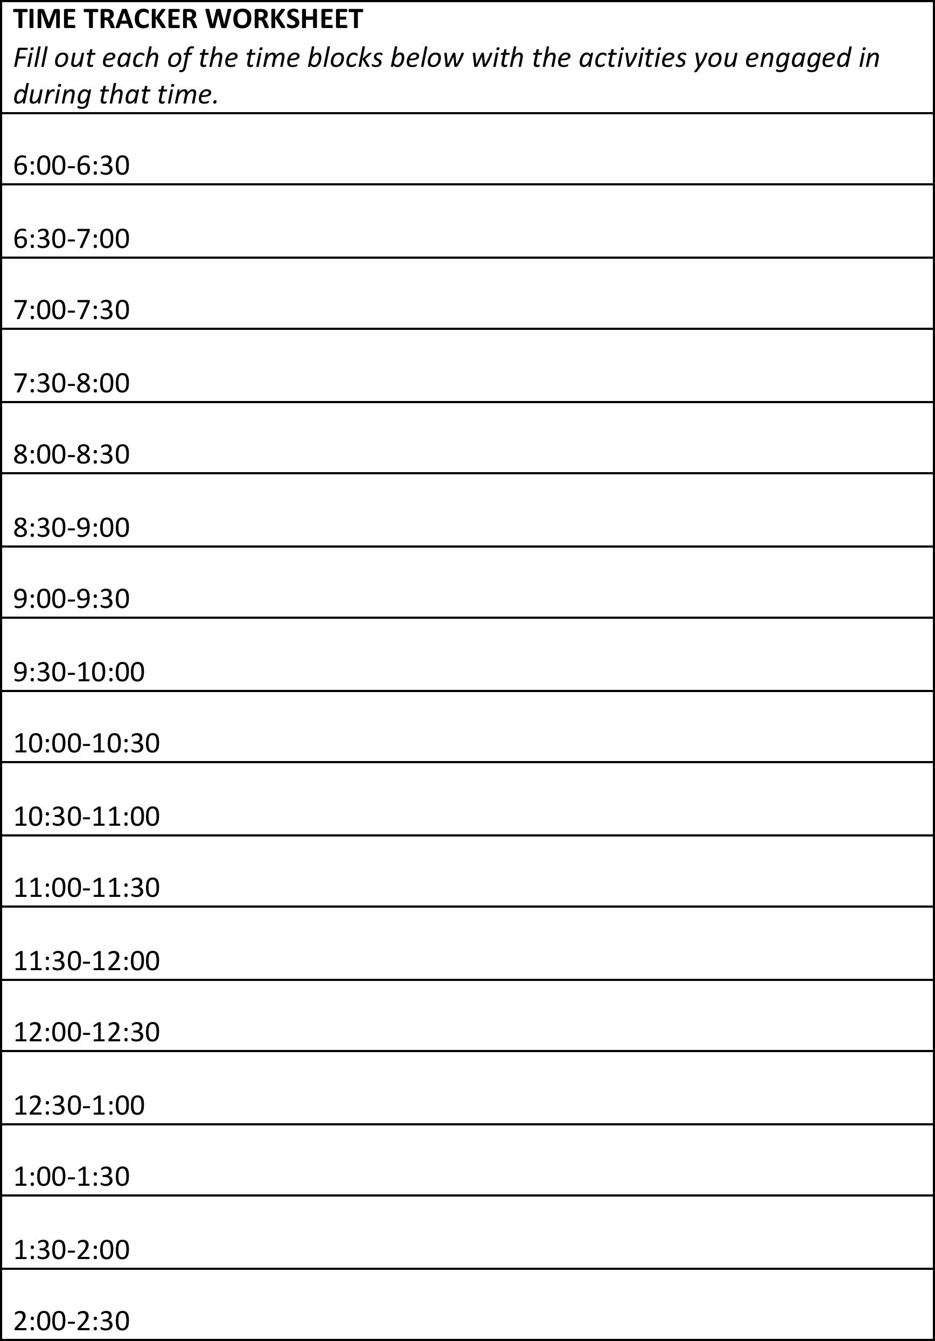

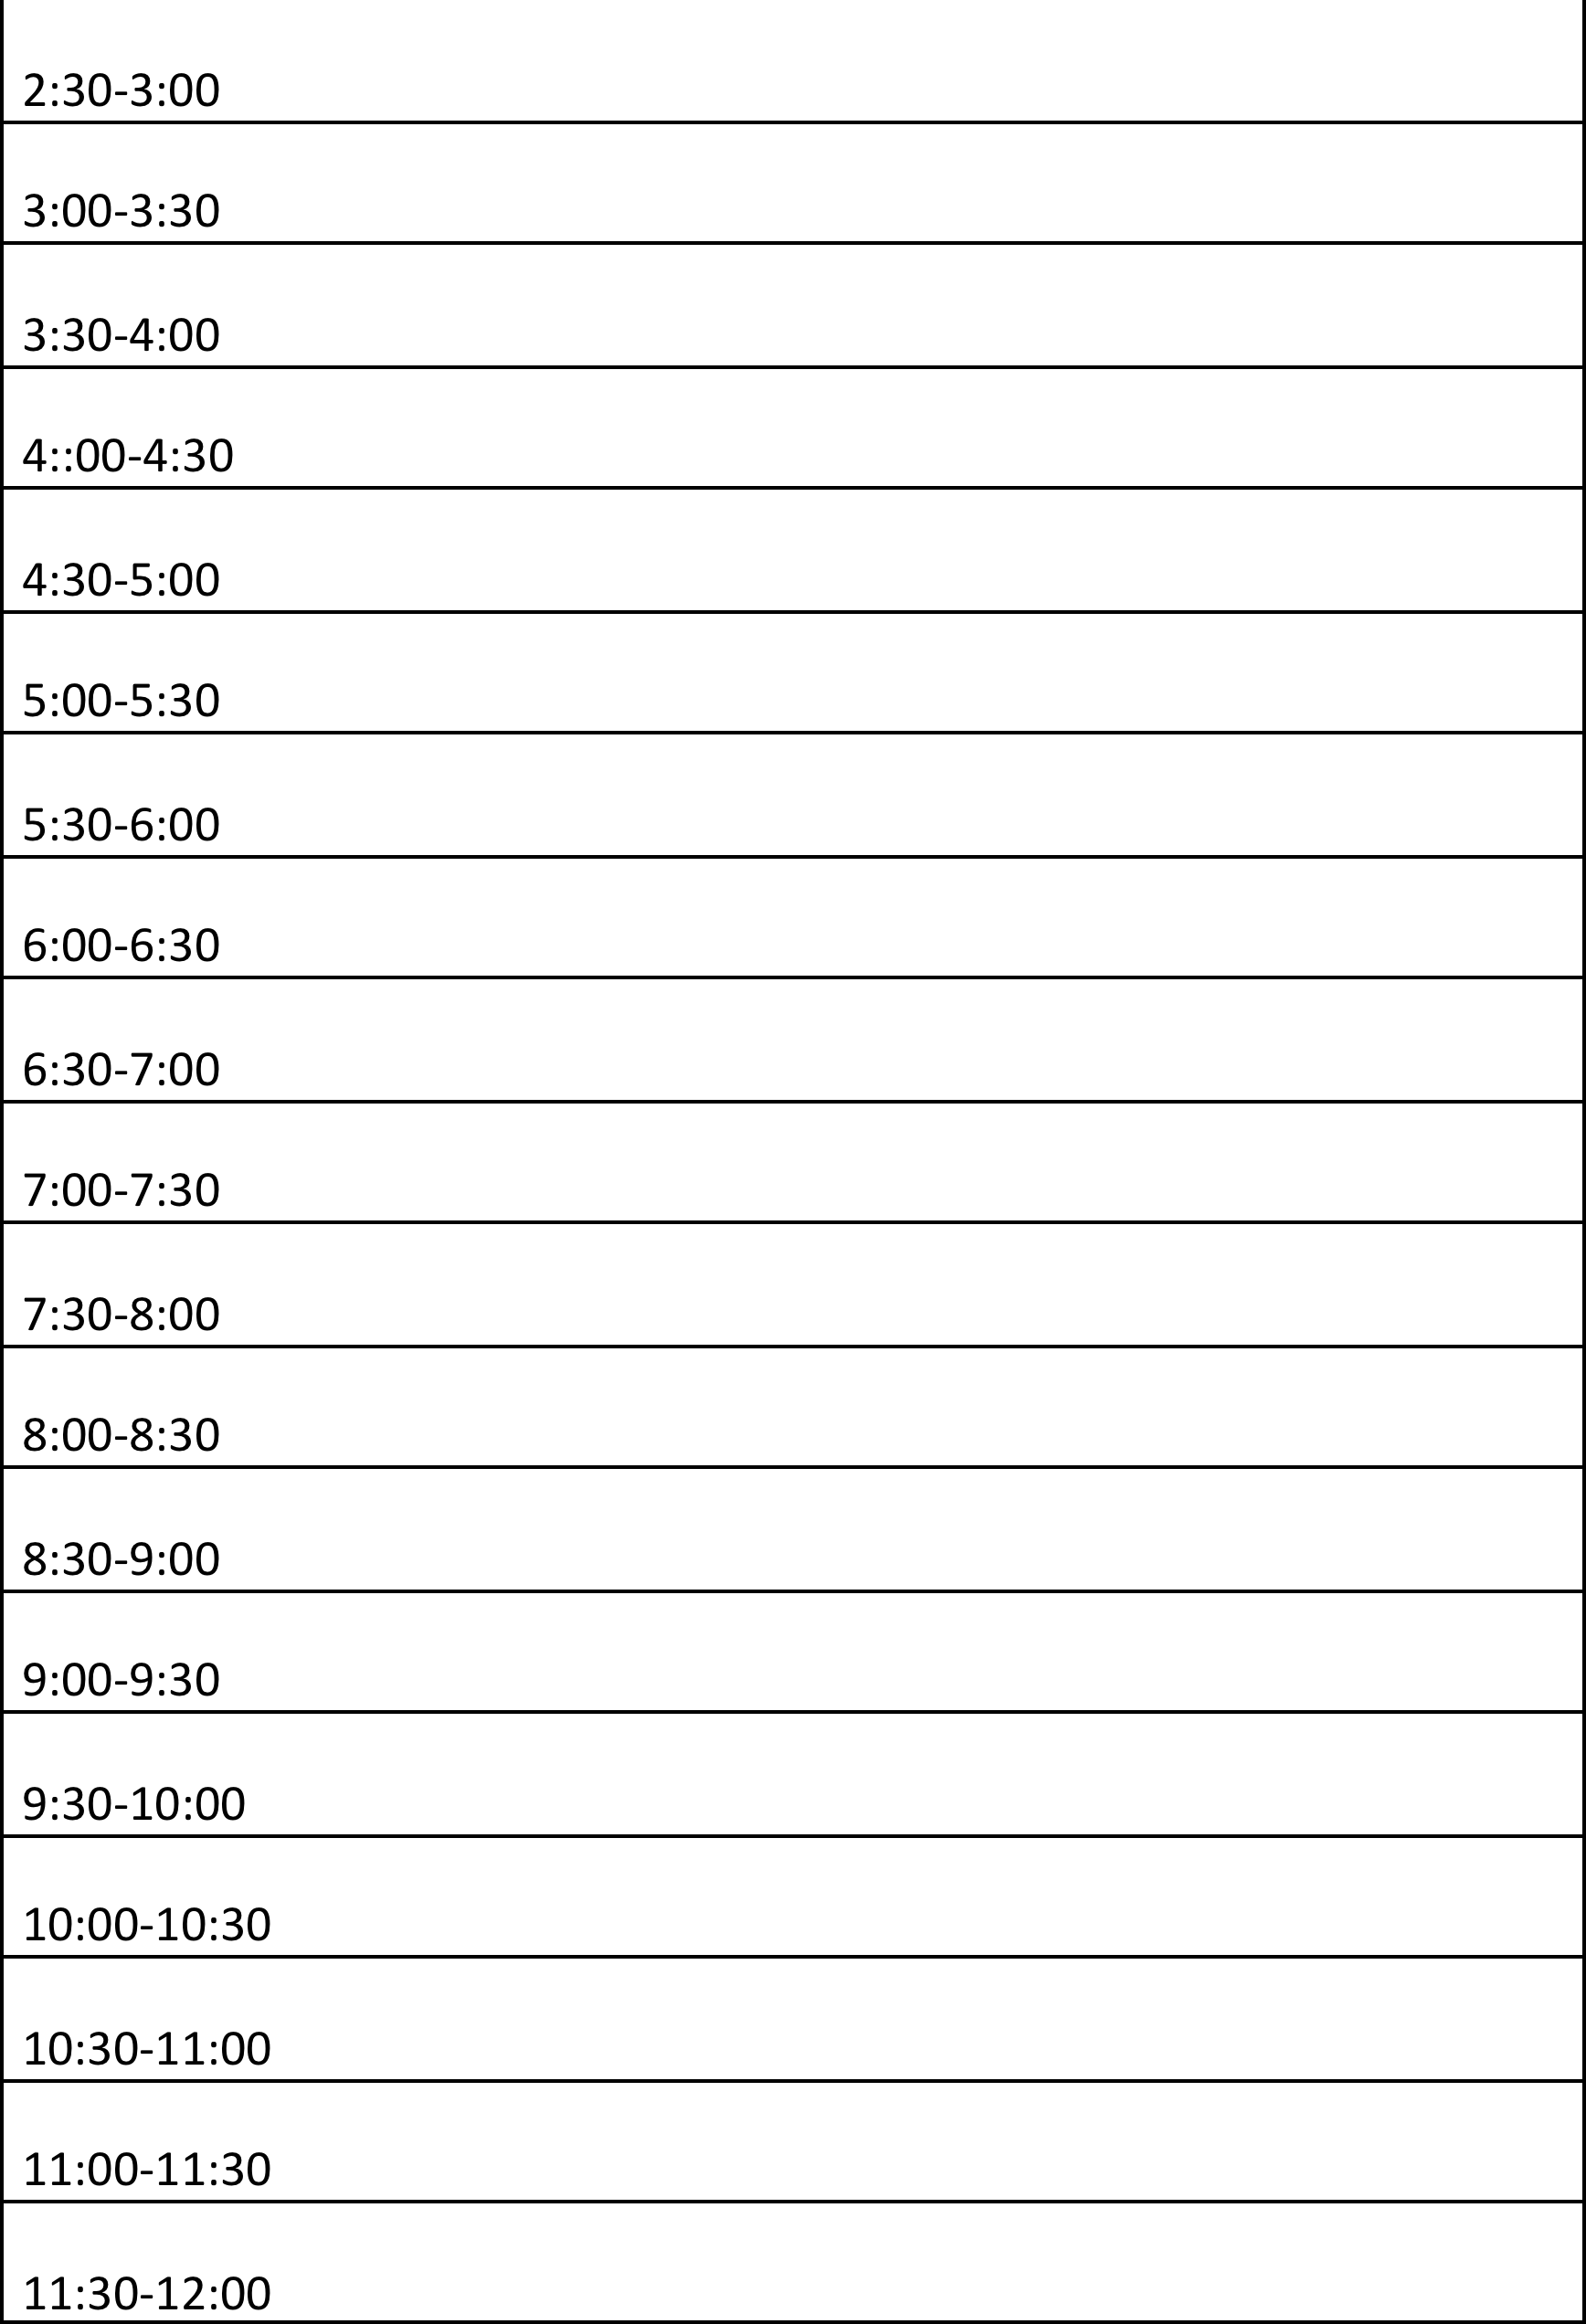

#### Skills for Success

|  |
| --- |
| **Purpose** |
| This activity will support students in identifying their skills and how they apply to job readiness. |

|  |
| --- |
| **Suggested Grade Level:** |
| 10 |

|  |
| --- |
| **Materials and Handouts** |
| Skills for Success Cards Development Plan Handout Chart Paper  Markers |

|  |
| --- |
| **Approximate Time Needed:** |
| 60 minutes |

**Student-Facing Instructions**

**Part 1: Make a List**

1. What are some of the skills you will need to get your dream job?
2. What are some of the skills you will need to keep your jobs, and earn promotions and pay raises?

**Part 2: Reflect**

In this activity, you will reflect on what you are good at and what skills you may need to develop.

Using the Skills for Success cards, make 3 piles with the cards: What I do well, What I need to develop, What I haven’t learned to do yet. After you are finished creating your piles, partner up and share your lists.

**Part 3:**

Using your “What I need to develop” pile, you will create plans for how they can develop the skills that they need to get a job and keep a job by filling out the Development Plan worksheet.

**Teacher Notes**

Debrief:

* Why is it important to know what you are good at and what you are not good at?
* What skills do you already have that you could use to get and keep a job now? Why are those skills important?
* Based on the skills you feel you have developed, what types of jobs are you likely to get?
* How does this compare with the job you want?
* What is the difference between the skills we need to get a job, and the skills we need to keep a job?
* What will you do to continuously improve your skills?

**Assessment**

Completion of worksheet.

**Instructions**

**Part 1: Make a List**

1. What are some of the skills you will need to get your dream job?
2. What are some of the skills you will need to keep your jobs, and earn promotions and pay raises?

**Part 2: Reflect**

In this activity, you will reflect on what you are good at and what skills you may need to develop.

Using the Skills for Success cards, make 3 piles with the cards: What I do well, What I need to develop, What I haven’t learned to do yet. After you are finished creating your piles, partner up and share your lists.

**Part 3:**

Using your “What I need to develop” pile, you will create plans for how they can develop the skills that they need to get a job and keep a job by filling out the Development Plan worksheet.

**Career Academy Skills for Success**

|  |  |  |
| --- | --- | --- |
| **CREATIVE AND CRITICAL THINKING** | | |
| v **Solve problems and make decisions**   * Understand the issue or problem * Get accurate information * Consider many solutions * Consult with others * Make an informed decision * Evaluate decision and reflect on the process | v **Think creatively**   * Explore many alternative ways of looking at something * Use brainstorming to generate innovative ideas * Ask “what if” questions to explore options * Be open to new and diverse ideas * Solve old problems in new ways * Think “out-of-the-box” | |
| v **Learn through research**   * Gather and organize information * Use many methods: web searches, library, data bases, print materials, interviews, etc. * Collect and interpret information to answer a question or confirm a prediction * Use variety to communicate information: verbal presentations, power point, video, YouTube, written reports, etc. * Retain information for future use | v **Reflect and evaluate**   * Examine your thoughts, feelings and reactions * Think about what you have learned from an experience * Determine what else you need to know * Plan next steps | |
| **COMMUNICATION** | | |
| v **Write clearly**   * Know your audience * Organize your ideas * Stick to the point; make it interesting * Use correct grammar, spelling and sentence structure * Proofread! Proofread! Proofread! | | v **Speak distinctly**   * Use language and tone appropriate for the audience * Know what you want to say * Speak slowly and pronounce words carefully * Keep it simple; don’t say too much * Check to make sure you are being understood |
| v **Listen carefully and ask good questions**   * Pay close attention to the speaker(s) * Maintain eye contact * Ask questions or repeat back to check for understanding * Confirm understanding verbally or otherwise * Retain information for further use | | v **Observe effectively**   * Watch for visual information * Ask questions if you aren’t sure about * what you are seeing or hearing * Reflect to determine the meaning of what you are seeing or hearing * Confirm understanding verbally or otherwise |

|  |  |
| --- | --- |
| **COLLABORATION AND TEAMWORK** | |
| v **Cooperate with others**   * Understand the goals of the team * Make courteous and friendly contributions * Respect opinions different from your own * Respect racial and cultural diversity * Be flexible; make compromises as needed * Know everybody’s roles and responsibilities | v **Give and receive feedback**  When you **give** feedback, remember to:   * Begin with positive comments; then negative * Be specific and ask for response * Choose the right time * Don’t blame * Be honest & don’t always expect acceptance   When you **receive** feedback, remember to:   * Listen without judgment * Think carefully before responding * Thank the giver |
| v **Negotiate challenges and resolve**  **conflicts**   * Approach problems positively * Try to get to the root of the problem without blaming * Evaluate multiple paths to resolve a conflict before taking action * Cooperate courteously with others involved in the conflict * Be constructive, not destructive, in a conflict | v **Plan and prioritize to reach a goal**   * Set short and long term goals * Assess how realistic your goals are * Prioritize in order of importance * Create realistic timelines * Reflect on your success and plan for next time |
| **MEDIA and TECHNOLOGY** | |
| v **Use new and emerging technology**   * Know what technology to use for a given purpose * Continually update your skills * Use digital technology for learning purposes (research, organizing and communicating information) * Use multi-media to communicate * Evaluate how technology assists you, and adapt in the future, if necessary | v **Use responsible behavior regarding technology (“digital citizenship”)**   * Know appropriate uses of cell phone, email, tweets, Face Book, chat rooms, etc. * Recognize legal, ethical and safety issues (on-line purchases; downloading music) * Learn to evaluate digital information for accuracy |



|  |  |
| --- | --- |
| **PERSONAL QUALITIES** | |
| v **Manage time effectively**   * Know what needs to be accomplished * Prioritize tasks * Break big tasks into small chunks * Keep a daily or weekly “to do” list | v **Demonstrate appropriate behavior and attire**   * Meet workplace standards on attendance, punctuality and dress code * Maintain confidentiality * Exhibit maturity, confidence, flexibility and self -control |
| v **Show initiative and work independently**   * Set your own goals * Take on tasks without being asked * Be ready to work on your own without supervision * Be motivated and demonstrate “get up and go” |
| v **Recognize and respond appropriately to workplace challenges**   * Know potential challenges (discrimination,   o harassment)   * Understand what’s legal and what’s not * Know the “chain of command” to follow if you have a complaint * Know how to advocate for yourself and others |
| v **Be reliable and dependable**   * Be where you need to be, on time (or early!) * Ask if you are not certain what is expected * Be honest and true to your word * Make sure that others know they can count on you |

|  |  |  |
| --- | --- | --- |
| Skill | **Questions Activities to Support Development** | |
|  | **What is the first step to deepen this skill?** |  |
|  | **Relational: What do I need to do in my personal and professional relationships?** |  |
|  | **School: What do I need to do at school to deepen this skill** |  |
|  | **Tools I can use to practice this skill** |  |
|  | **Personal: Individual practices or meditations I can do to deepen this skill** |  |
|  | **Work, project, community action I can do to practice this Skill** |  |

|  |  |  |
| --- | --- | --- |
|  |  |  |

#### Rolling for Jobs

|  |
| --- |
| **Purpose** |
| This activity introduces students to how transferable skills are used by different workers in different career fields. |

|  |
| --- |
| **Suggested Grade Level:** |
| 10, 11 |

|  |
| --- |
| **Materials and Handouts** |
| Rolling for Jobs- Teen, Dreams, Theme Rolling for Jobs- Theme  Skills for Success Cards  Skills for Success- one page |

|  |
| --- |
| **Approximate Time Needed:** |
| 25 minutes |

**Student-Facing Instructions**

**Rolling for Jobs-Teen, Dream and Theme:**

In your group, take turns rolling 2 dice. Look at the handout, “Rolling for Jobs-Teen, Dream and Theme” and find the “Teen, Dream, and Theme Job” for the number you just rolled. Pick a card from the Skills for Success deck, announce the skill and read the description aloud. Tell how a person with the teen job would use the skill you picked. If you are stuck, ask someone else in your group to help out. Now look at the “dream job” for the same number and tell how a person holding that job would use the skill. Everyone in the group should get a turn. (Everyone should hold on to their card for later.)

After you will be asked to write down 3 theme-related jobs on the handout. Think about how the skill you have chosen (on the card you are holding) applies to these three different theme-related jobs. Share your answers with your group.

**Rolling for Jobs- Theme:**

You are going to make two lists of jobs: one list of “typical jobs” and one list of “dream jobs.” For example, in the culinary world, a typical job could be a line cook and a dream job could be a chef/owner of a 4-star

restaurant. In the digital media world, a typical job could be a web designer and a dream job could be the head of Pixar.

In your group, take turns rolling 2 dice. Look at the handout, “Rolling for Jobs- Theme” and find the “Typical Job” for the number you just rolled. Pick a card from the Skills for Success deck, announce the skill and read the description aloud. Tell how a person with the typical job would use the skill you picked. If you are stuck, ask someone else in your group to help out. Now look at the “dream job” for the same number and tell how a person holding that job would use the skill. Everyone in the group should get a turn. (Everyone should hold on

to their card for later.)

After you will be asked to write down 3 theme-related jobs on the handout. Think about how the skill you have chosen (on the card you are holding) applies to these three different theme-related jobs. Share your answers with your group.

**Teacher Notes**

**Rolling for Jobs-Teen, Dream and Theme:**

Divide the class into groups of 4-5 students. Student with the longest hair rolls the 2 dice and throws a number between 2 and 12. 10th Grade: Student looks at the Teen job list on the Teen, Dream and Theme Job Lists

and chooses the job that corresponds to the number he/she just rolled. Student picks a card randomly out of the deck of Skills for Success cards, announces the skill, and reads the description aloud. Student describes an example of how a person holding the job they rolled would use the skill they picked. If student is stuck, let

others chime in so the activity moves along with energy. The same student now looks at the Dream job list and chooses the job that corresponds to the number he/she rolled and gives an example of how a person holding that job would use the skill they picked.

When the student has finished analyzing how 1 skill is used at 2 different jobs, he/she keeps the skill card and the next student takes a turn.

**Rolling for Jobs- Theme:**

Same rules apply except students must first fill out the Theme Job List.

After about 15 minutes, call the class together and apply the same transferable skills to theme jobs.

**Assessment**

Completion of worksheet.

**Instructions**

**Rolling for Jobs-Teen, Dream and Theme:**

In your group, take turns rolling 2 dice. Look at the handout, “Rolling for Jobs-Teen, Dream and Theme” and find the “Teen, Dream, and Theme Job” for the number you just rolled. Pick a card from the Skills for Success deck, announce the skill and read the description aloud. Tell how a person with the teen job would use the skill you picked. If you are stuck, ask someone else in your group to help out. Now look at the “dream job” for the same number and tell how a person holding that job would use the skill. Everyone in the group should get a turn. (Everyone should hold on to their card for later.)

After you will be asked to write down 3 theme-related jobs on the handout. Think about how the skill you have chosen (on the card you are holding) applies to these three different theme-related jobs. Share your answers with your group.

**Rolling for Jobs- Theme:**

You are going to make two lists of jobs: one list of “typical jobs” and one list of “dream jobs.” For example, in the culinary world, a typical job could be a line cook and a dream job could be a chef/owner of a 4-star

restaurant. In the digital media world, a typical job could be a web designer and a dream job could be the head of Pixar.

In your group, take turns rolling 2 dice. Look at the handout, “Rolling for Jobs- Theme” and find the “Typical Job” for the number you just rolled. Pick a card from the Skills for Success deck, announce the skill and read the description aloud. Tell how a person with the typical job would use the skill you picked. If you are stuck, ask someone else in your group to help out. Now look at the “dream job” for the same number and tell how a person holding that job would use the skill. Everyone in the group should get a turn. (Everyone should hold on to their card for later.)

After you will be asked to write down 3 theme-related jobs on the handout. Think about how the skill you have chosen (on the card you are holding) applies to these three different theme-related jobs. Share your answers with your group.

**Teen, Dream & Theme Job List**

|  |  |  |  |  |
| --- | --- | --- | --- | --- |
|  |  |  |  |  |
|  | **TEEN JOBS** | **DREAM JOBS** | **THEME JOBS** |  |
| **2.** | baby sitter | actor/actress |  |  |
| **3.** | grocery bagger | super model |  |  |
| **4.** | camp counselor | TV talk show host |  |  |
| **5.** | cashier | photographer |  |  |
| **6.** | tutor | professional athlete |  |  |
| **7.** | restaurant host/hostess | computer mogul |  |  |
| **8.** | lawn mower | detective |  |  |
| **9.** | pet sitter | doctor |  |  |
| **10.** | store sales clerk | movie director |  |  |
| **11.** | waitperson | song writer/recording artist |  |  |
| **12.** | pizza delivery | CEO of your own company |  |  |

Career Exploration Visit: Career Academy Skills for Success Student Workshop #2, Page 2 Copyright © 2012 MDRC. All Rights Reserved. July, 2012

**Theme Job List**



12th Grade Career Development Workshops: Career Academy Skills for Success Copyright © 2012 MDRC. All Rights Reserved.

Student Workshop #2, Page 2

August, 2012

|  |  |  |  |  |
| --- | --- | --- | --- | --- |
|  |  | **TYPICAL JOBS** |  | **DREAM JOBS** |

|  |
| --- |
| **2.**  **3.**  **4.**  **5.**  **6.**  **7.**  **8.**  **9.**  **10.**  **11.**  **12.** |

**Career Academy Skills for Success**

|  |  |  |
| --- | --- | --- |
| **CREATIVE AND CRITICAL THINKING** | | |
| v **Solve problems and make decisions**   * Understand the issue or problem * Get accurate information * Consider many solutions * Consult with others * Make an informed decision * Evaluate decision and reflect on the process | v **Think creatively**   * Explore many alternative ways of looking at something * Use brainstorming to generate innovative ideas * Ask “what if” questions to explore options * Be open to new and diverse ideas * Solve old problems in new ways * Think “out-of-the-box” | |
| v **Learn through research**   * Gather and organize information * Use many methods: web searches, library, data bases, print materials, interviews, etc. * Collect and interpret information to answer a question or confirm a prediction * Use variety to communicate information: verbal presentations, power point, video, YouTube, written reports, etc. * Retain information for future use | v **Reflect and evaluate**   * Examine your thoughts, feelings and reactions * Think about what you have learned from an experience * Determine what else you need to know * Plan next steps | |
| **COMMUNICATION** | | |
| v **Write clearly**   * Know your audience * Organize your ideas * Stick to the point; make it interesting * Use correct grammar, spelling and sentence structure * Proofread! Proofread! Proofread! | | v **Speak distinctly**   * Use language and tone appropriate for the audience * Know what you want to say * Speak slowly and pronounce words carefully * Keep it simple; don’t say too much * Check to make sure you are being understood |
| v **Listen carefully and ask good questions**   * Pay close attention to the speaker(s) * Maintain eye contact * Ask questions or repeat back to check for understanding * Confirm understanding verbally or otherwise * Retain information for further use | | v **Observe effectively**   * Watch for visual information * Ask questions if you aren’t sure about * what you are seeing or hearing * Reflect to determine the meaning of what you are seeing or hearing * Confirm understanding verbally or otherwise |

|  |  |
| --- | --- |
| **COLLABORATION AND TEAMWORK** | |
| v **Cooperate with others**   * Understand the goals of the team * Make courteous and friendly contributions * Respect opinions different from your own * Respect racial and cultural diversity * Be flexible; make compromises as needed * Know everybody’s roles and responsibilities | v **Give and receive feedback**  When you **give** feedback, remember to:   * Begin with positive comments; then negative * Be specific and ask for response * Choose the right time * Don’t blame * Be honest & don’t always expect acceptance   When you **receive** feedback, remember to:   * Listen without judgment * Think carefully before responding * Thank the giver |
| v **Negotiate challenges and resolve**  **conflicts**   * Approach problems positively * Try to get to the root of the problem without blaming * Evaluate multiple paths to resolve a conflict before taking action * Cooperate courteously with others involved in the conflict * Be constructive, not destructive, in a conflict | v **Plan and prioritize to reach a goal**   * Set short and long term goals * Assess how realistic your goals are * Prioritize in order of importance * Create realistic timelines * Reflect on your success and plan for next time |
| **MEDIA and TECHNOLOGY** | |
| v **Use new and emerging technology**   * Know what technology to use for a given purpose * Continually update your skills * Use digital technology for learning purposes (research, organizing and communicating information) * Use multi-media to communicate * Evaluate how technology assists you, and adapt in the future, if necessary | v **Use responsible behavior regarding technology (“digital citizenship”)**   * Know appropriate uses of cell phone, email, tweets, Face Book, chat rooms, etc. * Recognize legal, ethical and safety issues (on-line purchases; downloading music) * Learn to evaluate digital information for accuracy |

|  |  |
| --- | --- |
| **PERSONAL QUALITIES** | |
| v **Manage time effectively**   * Know what needs to be accomplished * Prioritize tasks * Break big tasks into small chunks * Keep a daily or weekly “to do” list | v **Demonstrate appropriate behavior and attire**   * Meet workplace standards on attendance, punctuality and dress code * Maintain confidentiality * Exhibit maturity, confidence, flexibility and self -control |
| v **Show initiative and work independently**   * Set your own goals * Take on tasks without being asked * Be ready to work on your own without supervision * Be motivated and demonstrate “get up and go” |
| v **Recognize and respond appropriately to workplace challenges**   * Know potential challenges (discrimination,   o harassment)   * Understand what’s legal and what’s not * Know the “chain of command” to follow if you have a complaint * Know how to advocate for yourself and others |
| v **Be reliable and dependable**   * Be where you need to be, on time (or early!) * Ask if you are not certain what is expected * Be honest and true to your word * Make sure that others know they can count on you |

**Career Academy Skills for Success**

One Page Summary

|  |
| --- |
| **CREATIVE AND CRITICAL THINKING** |
| v Solve problems and make decisions  v Think creatively  v Learn through research  v Reflect and evaluate |
| **COMMUNICATION** |
| v Write clearly  v Speak distinctly  v Listen carefully and ask good questions  v Observe effectively |
| **COLLABORATION AND TEAMWORK** |
| v Cooperate with others  v Give and receive feedback  v Negotiate challenges and resolve conflicts  v Plan and prioritize to reach a goal |
| **MEDIA and TECHNOLOGY** |
| v Use new and emerging technology  v Use responsible behavior regarding technology (“digital citizenship”) |
| **PERSONAL QUALITIES** |
| v Manage time effectively  v Demonstrate appropriate behavior and attire  v Recognize and respond appropriately to workplace challenges  v Show initiative and work independently  v Be reliable and dependable |

Adapted from 21st Century Skills for Success, [www.21stcenturyskills.org](http://www.21stcenturyskills.org/)

Career Exploration Visit: Career Academy Skills for Success Student Workshop #2, Page 1 Copyright © 2012 MDRC. All Rights Reserved. July, 2012

#### Transferable Skills

|  |
| --- |
| **Purpose** |
| This activity introduces students to the importance of transferable skills in the world of work. |

|  |
| --- |
| **Suggested Grade Level:** |
| 10 |

|  |
| --- |
| **Materials and Handouts** |
| Skills for Success Expanded Skills for Success Summary |

|  |
| --- |
| **Approximate Time Needed:** |
| 10 minutes |

**Student-Facing Instructions**

In your group, take one minute to write down as many transferable skills as you can.

After one minute, look at the “Career Academy Skills for Success Summary” and count how many of those skills you identified.

Turn to the “Career Academy Skills for Success Expanded” handout and participate in a class read-aloud. Pick the two that are least critical for success in college. In your groups, report out by explaining why you chose the skills you did as least important.

How about for career, why are transferable skills an important key to success?

Lastly, write down one transferable skill you think you need to improve on the most to succeed in your first semester in college or on your first job after high school. Name the one thing you can do to try to make this improvement.

**Teacher Notes**

By now students clearly understand the importance of transferable skills in the world of work. The next step is to apply these same skills to college. After groups report out, have students ask other students if they agree—or if they feel that the skills named ARE important in college. If they conclude that there are NO least important skills, then you know that they really understand the importance of the Skills for Success.

Possible answers for question prompt about important of transferable skills in career:

* The more transferable skills you have, the more jobs you’ll qualify for
* Transferable skills enable you to move up in a company
* Transferable skills in one career area can enable you to enter a whole new field
* When an interviewer asks you to “tell us about yourself”, describing your transferable skills will be an impressive beginning.
* Most people will have many jobs, and skills that transfer will give you a leg up on other applicants
* Listing transferable skills strengthens your resume and cover letter
* Potential employers are impressed if you can list skills you’ve already mastered

**Assessment**

Write-up of transferable skills

**Instructions**

In your group, take one minute to write down as many transferable skills as you can.

After one minute, look at the “Career Academy Skills for Success Summary” and count how many of those skills you identified.

Turn to the “Career Academy Skills for Success Expanded” handout and participate in a class read-aloud. Pick the two that are least critical for success in college. In your groups, report out by explaining why you chose the skills you did as least important.

How about for career, why are transferable skills an important key to success?

Lastly, write down one transferable skill you think you need to improve on the most to succeed in your first semester in college or on your first job after high school. Name the one thing you can do to try to make this improvement.

**Career Academy Skills for Success**

Expanded Version

|  |  |  |
| --- | --- | --- |
| **CREATIVE AND CRITICAL THINKING** | | |
| v **Solve problems and make decisions**   * Understand the issue or problem * Get accurate information * Consider many solutions * Consult with others * Make an informed decision * Evaluate decision and reflect on the process | v **Think creatively**   * Explore many alternative ways of looking at something * Use brainstorming to generate innovative ideas * Ask “what if” questions to explore options * Be open to new and diverse ideas * Solve old problems in new ways * Think “out-of-the-box” | |
| v **Learn through research**   * Gather and organize information * Use many methods: web searches, library, data bases, print materials, interviews, etc. * Collect and interpret information to answer a question or confirm a prediction * Use variety to communicate information: verbal presentations, power point, video, You Tube, written reports, etc. * Retain information for future use | v **Reflect and evaluate**   * Examine your thoughts, feelings and reactions * Think about what you have learned from an experience * Determine what else you need to know * Plan next steps | |
| **COMMUNICATION** | | |
| v **Write clearly**   * Know your audience * Organize your ideas * Stick to the point; make it interesting * Use correct grammar, spelling and sentence structure * Proofread! Proofread! Proofread! | | v **Speak distinctly**   * Use language and tone appropriate for the audience * Know what you want to say * Speak slowly and pronounce words carefully * Keep it simple; don’t say too much * Check to make sure you are being understood |
| v **Listen carefully and ask good questions**   * Pay close attention to the speaker(s) * Maintain eye contact * Ask questions or repeat back to check for understanding * Confirm understanding verbally or otherwise * Retain information for further use | | v **Observe effectively**   * Watch for visual information * Ask questions if you aren’t sure about * what you are seeing or hearing * Reflect to determine the meaning of what you are seeing or hearing   o Confirm understanding verbally or otherwise |



12th Grade Career Development Workshops: Career Academy Skills for Success Copyright © 2012 MDRC. All Rights Reserved.

Student Workshop #2, Page 3

August, 2012

**Career Academy Skills for Success** page 2

|  |  |
| --- | --- |
| **COLLABORATION AND TEAMWORK** | |
| v **Cooperate with others**   * Understand the goals of the team * Make courteous and friendly contributions * Respect opinions different from your own * Respect racial and cultural diversity * Be flexible; make compromises as needed * Know everybody’s roles and responsibilities | v **Give and receive feedback**  When you **give** feedback, remember to:   * Begin with positive comments; then negative * Be specific and ask for response * Choose the right time * Don’t blame * Be honest & don’t always expect acceptance   When you **receive** feedback, remember to:   * Listen without judgment * Think carefully before responding * Thank the giver |
| v **Negotiate challenges and resolve conflicts**   * Approach problems positively * Try to get to the root of the problem without blaming * Evaluate multiple paths to resolve a conflict before taking action * Cooperate courteously with others involved in the conflict * Be constructive, not destructive, in a conflict | v **Plan and prioritize to reach a goal**   * Set short and long term goals * Assess how realistic your goals are * Prioritize in order of importance * Create realistic timelines * Reflect on your success and plan for next time |
| **MEDIA AND TECHNOLOGY** | |
| v **Use new and emerging technology**   * Know what technology to use for a given purpose * Continually update your skills * Use digital technology for learning purposes (research, organizing and communicating information) * Use multi-media to communicate * Evaluate how technology assists you, and adapt in the future, if necessary | v **Use responsible behavior regarding technology (“digital citizenship”)**   * Know appropriate uses of cell phone, email, tweets, Face Book, chat rooms, etc. * Recognize legal, ethical and safety issues (on-line purchases; downloading music) * Learn to evaluate digital information for accuracy |

**Career Academy Skills for Success** page 3

|  |  |
| --- | --- |
| **PERSONAL QUALITIES** | |
| v **Manage time effectively**   * Know what needs to be accomplished * Prioritize tasks * Break big tasks into small chunks * Keep a daily or weekly “to do” list | v **Demonstrate appropriate behavior and attire**   * Meet workplace standards on attendance,   o punctuality and dress code   * Maintain confidentiality * Exhibit maturity, confidence, flexibility and self control |
| v **Show initiative and work independently**   * Set your own goals * Take on tasks without being asked * Be ready to work on your own without supervision * Be motivated and demonstrate “get up and go” | v **Recognize and respond appropriately to workplace challenges**   * Know potential challenges (discrimination,   o harassment)   * Understand what’s legal and what’s not * Know the “chain of command” to follow if you have a complaint * Know how to advocate for yourself and others |
| v **Be reliable and dependable**   * Be where you need to be, on time (or early!) * Ask if you are not certain what is expected * Be honest and true to your word * Make sure that others know they can count on you |

###### Career Academy Skills for Success

One Page Summary

|  |
| --- |
| **CREATIVE AND CRITICAL THINKING** |
| v Solve problems and make decisions  v Think creatively  v Learn through research  v Reflect and evaluate |
| **COMMUNICATION** |
| v Write clearly  v Speak distinctly  v Listen carefully and ask good questions  v Observe effectively |
| **COLLABORATION AND TEAMWORK** |
| v Cooperate with others  v Give and receive feedback  v Negotiate challenges and resolve conflicts  v Plan and prioritize to reach a goal |
| **MEDIA and TECHNOLOGY** |
| v Use new and emerging technology  v Use responsible behavior regarding technology (“digital citizenship”) |
| **PERSONAL QUALITIES** |
| v Manage time effectively  v Demonstrate appropriate behavior and attire  v Recognize and respond appropriately to workplace challenges  v Show initiative and work independently  v Be reliable and dependable |

Adapted from 21st Century Skills for Success, [www.21stcenturyskills.org](http://www.21stcenturyskills.org/)

Career Exploration Visit: Career Academy Skills for Success Student Workshop #2, Page 1 Copyright © 2012 MDRC. All Rights Reserved. July, 2012

# Theme: Career Awareness/ Exploration

## Researching Careers

#### The Career for Me

|  |
| --- |
| **Purpose** |
| This activity allows students to explore careers that they are interested in pursuing and to understand their skill set in the context of the careers that they want to pursue. |

|  |
| --- |
| **Suggested Grade Level:** |
| 9 |

|  |
| --- |
| **Materials and Handouts** |
| Career Exploration Visit Index cards |

|  |
| --- |
| **Approximate Time Needed:** |
| Varies |

**Student-Facing Instructions**

Think of 3 careers that you are interested in and write them on 3 separate index cards. On the back of each card write what you think you would enjoy about that career.

Conduct internet research about the 3 jobs that you are interested in.

**Teacher Notes**

Begin with a check-in question:

1. What is the difference between a job and a career?
2. What do you want to do as a career? Why?

Have participants share what they wrote on their index cards and get into groups based on common themes. (Some themes may be: Food industry, design, Computers, etc.)

Have students with similar career interests work together as a group for the next activity.

Give participants the Career Exploration handout and explain they will be doing some research to find out more about the careers they are interested in.

Give students 30-45 minutes to do some internet research about the 3 jobs that they are interested in. Have each group report back about one of the careers.

Debrief Questions:

* Based on what you learned in your research, of the three careers, which one would be the best for you?
* Did any of the information surprise you? Why?
* Did you change your mind about any of the careers? Why?
* Did you learn anything about the career that you did not know before the interview?
* What skills do you already have that would help you to be successful in one of those careers?
* What skills would you need to build to be successful in one of these careers?

**Assessment**

Completion of career cards.

**Instructions**

Think of 3 careers that you are interested in and write them on 3 separate index cards. On the back of each card write what you think you would enjoy about that career.

Conduct internet research about the 3 jobs that you are interested in.

Career Exploration

**Title of Occupation:**

* 1. Description of the occupation including main duties and responsibilities
  2. What are the education and training requirements for the occupation?
  3. List other required qualifications such as licensing, certifications, etc.
  4. What is the average wage or salary for this occupation?
  5. What is the employment outlook for this occupation?
  6. List the places and work environments where people in this occupation might work.
  7. What are the opportunities for advancement?
  8. List other occupations that are similar or related.

#### Taxonomy of Careers

|  |
| --- |
| **Purpose** |
| This activity introduces students to researching careers by having students aggregate all their current career-related vocabulary. |

|  |
| --- |
| **Suggested Grade Level:** |
| 9 |

|  |
| --- |
| **Materials and Handouts** |
| Alphabetical Taxonomy  Career and Occupational Taxonomy Worksheet |

|  |
| --- |
| **Approximate Time Needed:** |
| 20 minutes |

**Student-Facing Instructions**

This activity will allow pull together all the different words you can think of that relate to careers by completing a career taxonomy.

The terms job, or occupation, and career are sometimes used interchangeably, but they have different mean- ings. A job is a period of employment in your life—it is an activity you do for money or income. An occupation is the same thing as a job. A career is something you build throughout your lifetime. A series of jobs can lead to a long-term career if you decide to focus on a particular field in your employment choices. Some people change careers over the course of their lives (e.g., an investment banker who becomes a teacher), but they usually start with a certain work goal in mind. Career planning, which you will be doing in this lesson, is when you look ahead and think about where you want to go and how you can get there.

Look at the example taxonomy, it is a place to collect words describing different colors; and the words are orga- nized according to what letter they begin with. If you were to continue working with this taxonomy, you would think of colors not on the list and write them in the row that corresponds with the first letter of that color. For example, if you thought of the word purple, you would write it in the row for words beginning with P, where “pink” and “periwinkle” are already listed.

For this activity, you will develop taxonomies to build vocabulary and to see the relationships among important words. Your taxonomies will also be helpful tools for the writing and reading assignments you receive in the future.

**Teacher Notes**

* + Have students begin independently by thinking of words that might belong under the general heading of “careers.” For example, if the word teaching comes to mind, the student would write the word teaching in the row labeled with the letter T.
  + Have students work independently for about five minutes, writing as many words as they can think of that relate directly to what they know about or associate with careers. They may write more than one word for each letter, and they should not worry about finding a word for every letter.
  + Now organize students in pairs. Ask them to collaborate by sharing words in order to build their taxono- mies. For example, if one student has written farming and the other has not, the second student would add farming to his or her taxonomy.
  + If time allows, after five minutes, have students leave their taxonomies on their desks and walk around the room to view each other’s lists. They should note new words from their peers’ lists to add to their own taxonomies.
  + Give students a couple of minutes to add the words they collected to their taxonomies. Then, have them put an asterisk next to those words that name one or two careers they think sound like fun or that they might like to explore.
  + Invite students to share some of the words that were easy to come up with, as well as words from peers’ lists that they hadn’t thought of themselves. Also call on several volunteers to share the careers they starred.
  + Finally, explain that researchers have come up with ways to categorize careers based on what different careers have in common. Organizing careers in this way can be helpful in deciding which ones to investi- gate. Specifically, some researchers have developed a system to organize careers into six general career fields and 16 different career clusters. Tell students that they will be learning more about the 16 career clusters and the six general career fields the clusters belong to in the next activity.

**Assessment**

Completion of career cards.

**Instructions**

This activity will allow pull together all the different words you can think of that relate to careers by completing a career taxonomy.

The terms job, or occupation, and career are sometimes used interchangeably, but they have different mean- ings. A job is a period of employment in your life—it is an activity you do for money or income. An occupation is the same thing as a job. A career is something you build throughout your lifetime. A series of jobs can lead to a long-term career if you decide to focus on a particular field in your employment choices. Some people change careers over the course of their lives (e.g., an investment banker who becomes a teacher), but they usually start with a certain work goal in mind. Career planning, which you will be doing in this lesson, is when you look ahead and think about where you want to go and how you can get there.

Look at the example taxonomy, it is a place to collect words describing different colors; and the words are orga- nized according to what letter they begin with. If you were to continue working with this taxonomy, you would think of colors not on the list and write them in the row that corresponds with the first letter of that color. For example, if you thought of the word purple, you would write it in the row for words beginning with P, where “pink” and “periwinkle” are already listed.

For this activity, you will develop taxonomies to build vocabulary and to see the relationships among important words. Your taxonomies will also be helpful tools for the writing and reading assignments you receive in the future.

Example: Alphabetical Taxonomy

Student Name: Date:

Directions: A taxonomy is a list of related words grouped into categories. You will develop taxonomies in this course to build vocabulary and to see the relationships among important words. Your taxonomies will also be helpful tools for the writing and reading assignments you receive. Below is a taxonomy for the topic of colors, in which the words have been categorized alphabetically.

Can you think of any others? Go ahead and add them into the correct category.

|  |  |
| --- | --- |
| A | aquamarine, amber, azure |
| B | beige, bronze, burgundy |
| C | cobalt, chartreuse, cream, crimson |
| D |  |
| E | ecru, emerald |
| F | fuchsia |
| G |  |
| H |  |
| I | indigo, ivory |
| J | jade |
| K |  |
| L | lavender, lilac |
| M | magenta, mauve |
| N | navy blue |
| O | ochre, olive |
| P | pink, periwinkle |
| Q |  |
| R |  |
| S | scarlet, silver |
| T | teal, tan, terra-cotta |
| U | ultramarine |
| V | violet, vermilion |
| W |  |
| X |  |
| Y | yellow |
| Z |  |

Worksheet: Career and Occupation Taxonomy

Student Name: Date:

|  |  |
| --- | --- |
| A |  |
| B |  |
| C |  |
| D |  |
| E |  |
| F |  |
| G |  |
| H |  |
| I |  |
| J |  |
| K |  |
| L |  |
| M |  |
| N |  |
| O |  |
| P |  |
| Q |  |
| R |  |
| S |  |
| T |  |
| U |  |
| V |  |
| W |  |
| X |  |
| Y |  |
| Z |  |

#### Career Clusters

|  |
| --- |
| **Purpose** |
| This activity introduces students to 16 career clusters and their related career fields. |

|  |
| --- |
| **Suggested Grade Level:** |
| 9 |

|  |
| --- |
| **Materials and Handouts** |
| Reading: 16 Career Clusters |

|  |
| --- |
| **Approximate Time Needed:** |
| 30 minutes |

**Student-Facing Instructions**

The career clusters are a helpful tool to start thinking about what kinds of careers might interest you. A career cluster is a group of similar careers based on common factors such as interests and job requirements. The

US Department of Education developed 16 career clusters under six career fields as a way for counselors, teachers, and students to organize career planning. Complete the Career and Occupational Taxonomy using what you learned about creating taxonomies in the Alphabetical Taxonomy example.

**Teacher Notes**

This lesson requires students to complete the reading and should follow the Taxonomy of Careers lesson.

* Tell students to listen (or look when reading) for words that they’d like to add to their taxonomies. In par- ticular, they can add words related to the career clusters that they find appealing.
* Give students a chance to add to their taxonomies throughout the presentation/reading by stopping fre- quently and asking students which words they added.
* Once the new words have been exhausted, tell students to put this taxonomy in their notebooks and enter it into their table of contents.
* After the reading/presentation, ask for student volunteers to share a couple of new words they added to their taxonomies. Invite the rest of the class to make sure they have those terms written down as well.
* Conclude by explaining that, in this lesson, students will be using different assessment tools to add to their understanding of their interests, skills, and values.

**Assessment**

Completion of worksheet.

**Instructions**

The career clusters are a helpful tool to start thinking about what kinds of careers might interest you. A career cluster is a group of similar careers based on common factors such as interests and job requirements. The

US Department of Education developed 16 career clusters under six career fields as a way for counselors, teachers, and students to organize career planning. Complete the Career and Occupational Taxonomy using what you learned about creating taxonomies in the Alphabetical Taxonomy example.

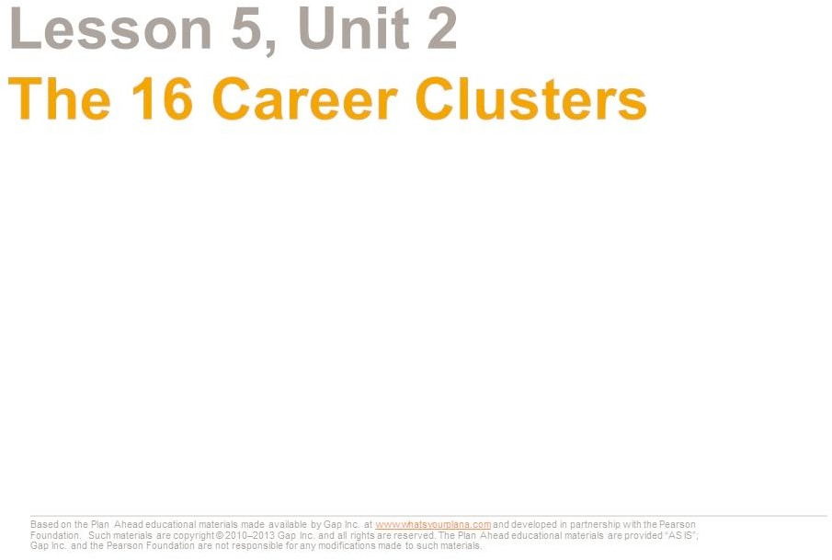

Remember when you were little and you would say, “I want to be a doctor or a firefighter (or a wizard!) when I grow up”? Now that you are older, thinking about which career to pursue may seem overwhelming. There are literally thousands of possible jobs out there.

The career clusters are a helpful tool to start thinking about what kinds of careers might interest you. A career cluster is a group of similar careers based on common factors such as interests and job requirements. The US Department of Education developed 16 career clusters under six career fields as a way for counselors, teachers, and students to organize career planning.

First, get to know a little about each career field.

Based on the Plan Ahead educational materials made available by Gap Inc. at [www.whatsyourplana.com](http://www.whatsyourplana.com/) and developed in partnership with the Pearson Foundation. Such materials are copyright © 2010–2013 Gap Inc. and all rights are reserved. The Plan Ahead educational materials are provided “AS IS”; Gap Inc. and the Pearson Foundation are not responsible for any modifications made to such materials.

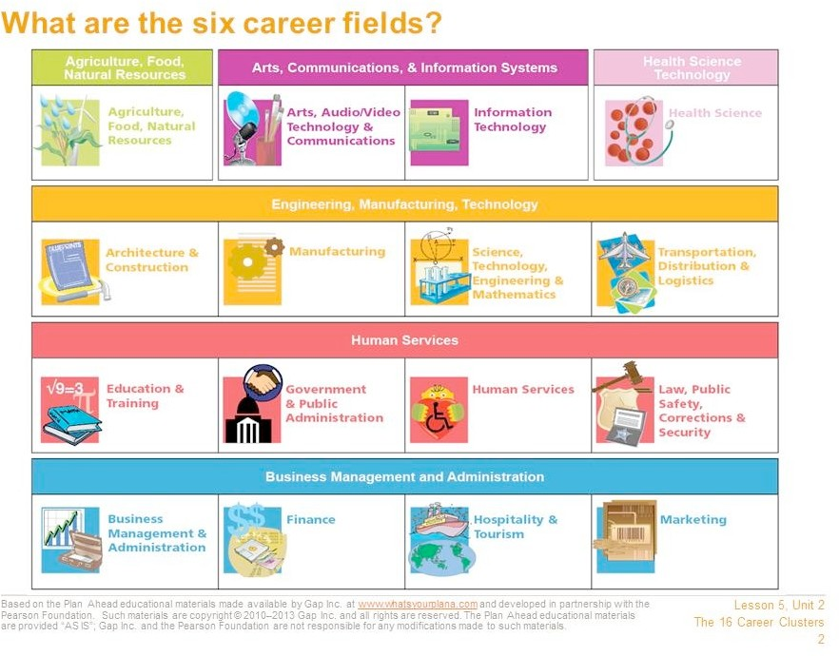

The six career fields are very broad and general. They include:

* Agriculture, Food, Natural Resources
* Arts, Communications, & Information Systems
* Health Science Technology
* Engineering, Manufacturing, Technology
* Human Services
* Business Management and Administration

These fields each include many different kinds of jobs. These are organized into 16 career clusters. Two of the fields—Agriculture, Food, Natural Resources and Health Science Technology—only contain

one career cluster each. Another field, Arts, Communications, & Information Systems, has two clusters. The rest of the fields have four clusters each.

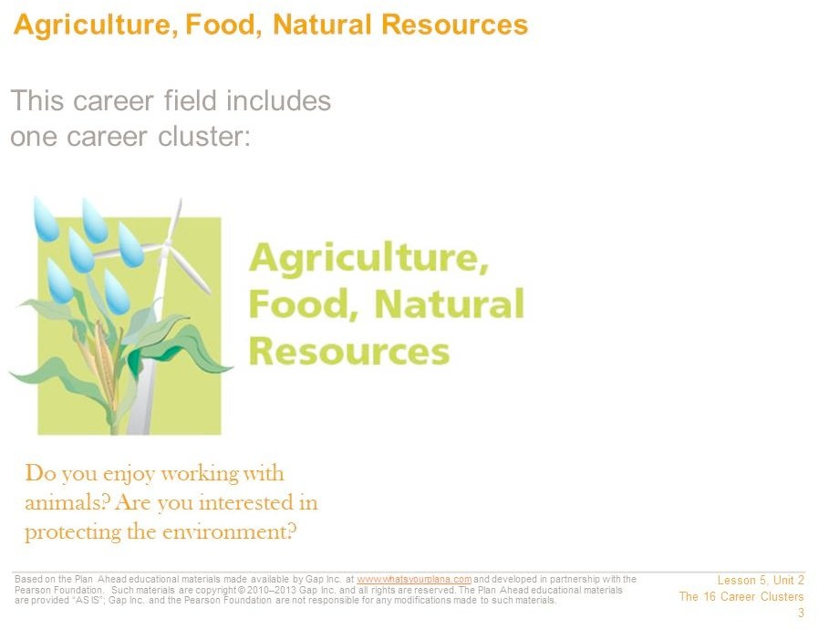

In this career cluster, nature, plants, and animals are the focus. You might produce agricultural goods, such as food, fabrics, or wood. Or, you might work on a farm, a ranch, or a dairy, or at an orchard, a greenhouse, or a plant nursery. You could work in a clinic or a laboratory as a scientist or an engineer doing research related to agriculture or food. Finally, you could also work to conserve natural resources or protect the environment. Jobs that focus on protecting the environment, or “green jobs,” are becoming more and more popular as we look for ways to take better care of the planet. Some of these jobs are about creating renewable energy through solar, wind, and other natural sources of power.

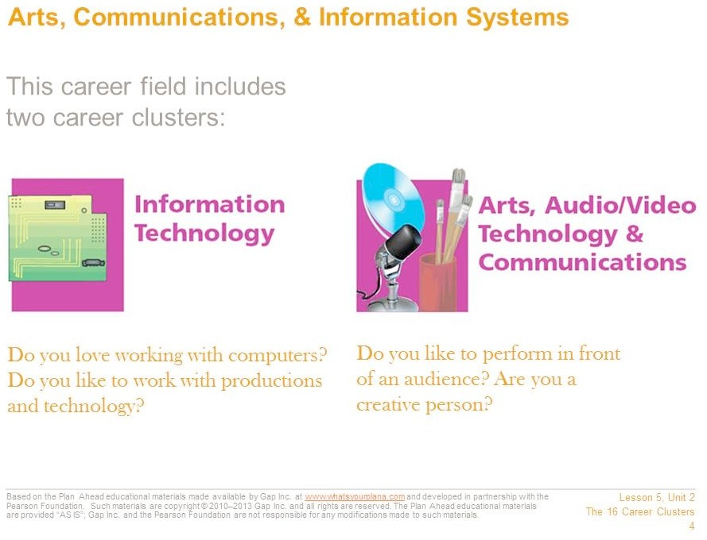

This career field includes these two career clusters: Information Technology and Arts, A/V Technology & Communications.

In Information Technology you would work with computers and software. You might design computer hardware, create software programs, or find ways to make computers run more efficiently. Or you might link workers in several parts of the world using technology, or support others and answer questions about specific software or hardware.

Another area of focus is Arts, Audio/Video Technology & Communications. In this area you might be a performer or an artist. You would be on the stage, acting in a play or performing music in a concert. You might be in front of the camera as an actor in a movie or a television show, or maybe you would work behind the scenes. With this cluster, you might create a painting or write a book. You might also work on film production or magazine, book, or newspaper publishing. Another option might be to use your creative talents with technology and work as an animator, a graphic designer, or a film editor.

Based on the Plan Ahead educational materials made available by Gap Inc. at [www.whatsyourplana.com](http://www.whatsyourplana.com/) and developed in partnership with the Pearson Foundation. Such materials are copyright © 2010–2013 Gap Inc. and all rights are reserved. The Plan Ahead educational materials are provided “AS IS”; Gap Inc. and the Pearson Foundation are not responsible for any modifications made to such materials.

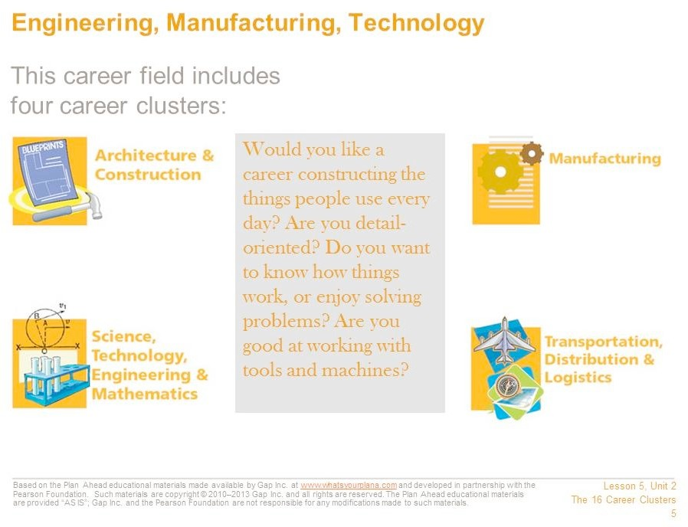

This career field includes these four career clusters:

* Architecture & Construction
* Manufacturing
* Science, Technology, Engineering & Mathematics
* Transportation, Distribution & Logistics

In these career clusters you might construct buildings or make products—anything from household appliances to medical devices, from furniture to tools and systems for businesses and industries. Or you might design new structures or products. Another option would be to install or repair these manufactured products. You might do research to develop new products or systems. Or you could operate the vehicles, the trains, or the planes that deliver the products.

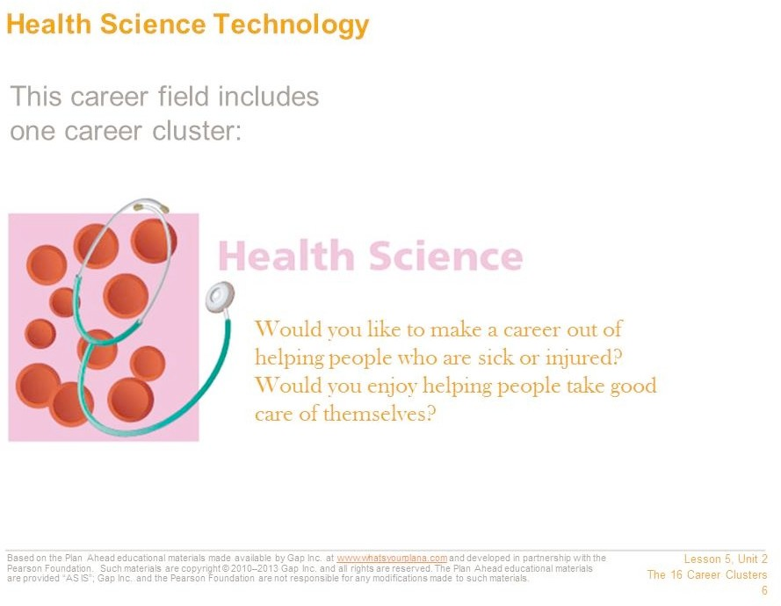

This career field includes the Health Science career cluster. In this career cluster you would identify and treat injuries or diseases, or you might work to keep people healthy. You could work at many different sites. Work may be done in offices, hospitals, or labs, or you might even work on a cruise ship or in a hotel. Doctors, nurses, therapists, and X-ray technicians are examples of jobs in this career field.

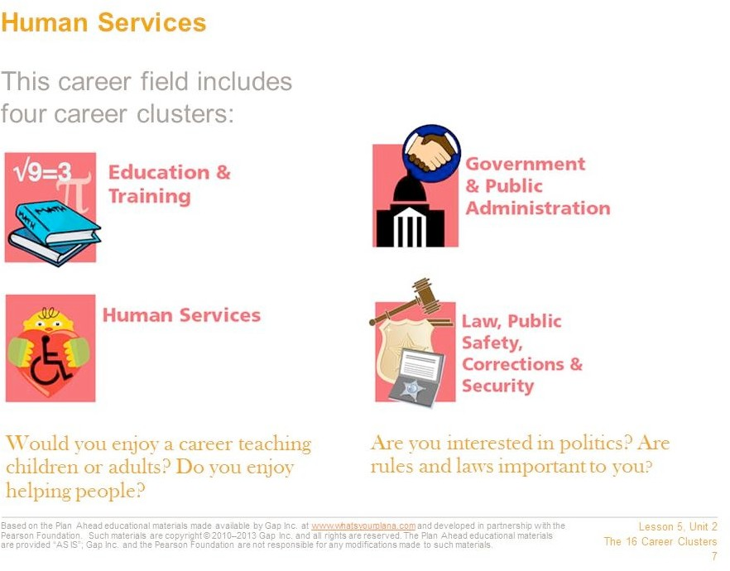

This career field includes four career clusters.

In Education & Training you help young people and adults learn. You may teach in a classroom. You could provide training to employees in a business. In addition, you might support teachers in schools. You could be a counselor, a librarian, or a principal.

In Government & Public Administration you might work in many different places. You might work in your hometown for the city government. Or you might work for your state or federal government. Or you might live in another country and work at an embassy.

You will find many chances to help people in Human Services. You could care for children or the elderly, or take care of disabled people. You might arrange a funeral or help people with money problems.

In Law, Public Safety, Corrections & Security you keep people safe. You might guard people who are in jail or in prison. Or you might defend homes and businesses during fires. Another option is to enforce the law and investigate crimes. You might protect buildings, people, and products. Or you might help people deal with laws.

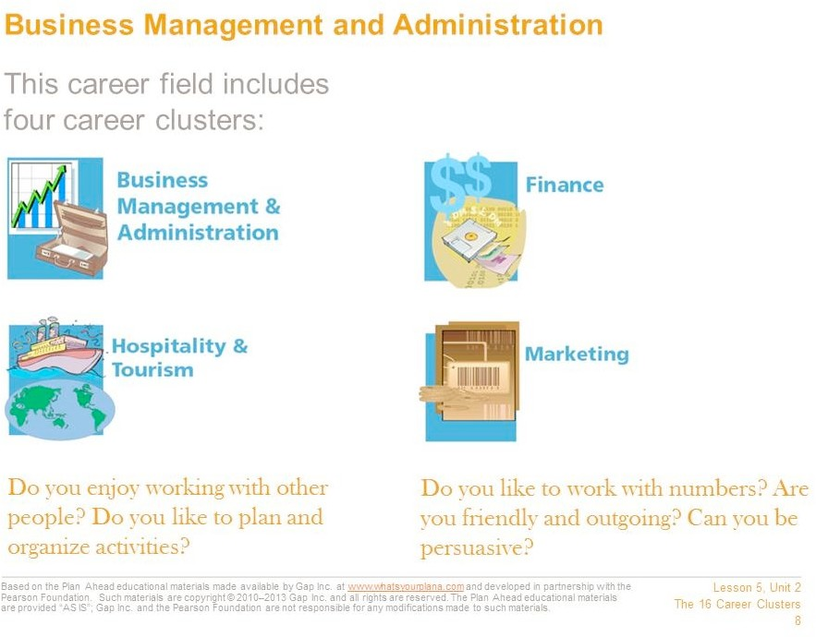

This career field breaks out into four main areas.

In Business Management & Administration you may own, manage, or direct a business. Another option is to keep track of expenses and income. Or you might hire and train the workers.

In Finance you keep track of money. You could keep records. Or you could help people get loans and save money. Another option is to help people buy insurance. You could also run a bank.

In Hospitality & Tourism you help people have fun. You could work in a restaurant, manage one, or own one. Another option is to take care of guests at a hotel. Or you could help people plan trips.

In Marketing you sell products. You might create ads to get customers to buy products through magazines, newspapers, the media, or the Internet. Or you might sell directly to customers.



Do some of these career fields and clusters sound more interesting to you than others? To find out which career clusters match your interests, skills, and values, you will take a series of career assessments.

Based on the Plan Ahead educational materials made available by Gap Inc. at [www.whatsyourplana.com](http://www.whatsyourplana.com/) and developed in partnership with the Pearson Foundation. Such materials are copyright © 2010–2013 Gap Inc. and all rights are reserved. The Plan Ahead educational materials are provided “AS IS”; Gap Inc. and the Pearson Foundation are not responsible for any modifications made to such materials.

#### Using the Internet for Research

|  |
| --- |
| **Purpose** |
| This activity introduces students to basic internet research skills and focuses on the importance of seeking legitimate and reliable online resources. |

|  |
| --- |
| **Suggested Grade Level:** |
| 9 |

|  |
| --- |
| **Materials and Handouts** |
| Worksheet: Using the Internet for Research Reading: Using the Internet for Research |

|  |
| --- |
| **Approximate Time Needed:** |
| 30 minutes |

**Student-Facing Instructions**

Complete the worksheet to take notes on how to do effective research after reading the Using Internet for Research document.

**Teacher Notes**

Before this class period begins, review Interactive Presentation Notes and Instructions: Using the Internet for Research. It may be helpful to print the resource out; it contains suggestions for activities to accompany particular slides. Determine the citation format you want students to use. If you do not have a preference, consult with the English/Language Arts department about their preferred format.

* + Have students read through Worksheet: Using the Internet for Research, so that they will know what information to look for in the presentation. Also remind them to keep their true/false responses in mind as they watch (or read).
  + Show the presentation (or have students refer to the reading). Use the suggestions in Teacher Resource, to stop at key points and conduct brief activities with the students. This will help students understand the content and help to keep them engaged with the material.
  + Once the presentation is complete, revisit the true/false questions. For each one, ask for a show of hands to see who thinks the statement is true and who thinks it’s false now that they have seen the presentation. Share the answers from the “Answer Key” section of Teacher Resource. Use this time to clarify any misconceptions.

**Assessment**

Completion of worksheet.

**Instructions**

Complete the worksheet to take notes on how to do effective research after reading the Using Internet for Research document.

Worksheet: Using the Internet for Research

Student Name: Date: Directions: Use this sheet to take notes on how to do effective research on the Internet.

How to Search Effectively

Step One:

Step Three:

Step Two:

How to Choose the Right Sources

Step One:

Step Two:

Step Three:

Step Four:

Based on the Plan Ahead educational materials made available by Gap Inc. at [www.whatsyourplana.com](http://www.whatsyourplana.com/) and developed in partnership with the Pearson Foundation. Such materials are copyright © 2010–2013 Gap Inc. and all rights are reserved. The Plan Ahead educational materials are provided “AS IS”; Gap Inc. and the Pearson Foundation are not responsible for any modifications made to such materials.

* + 1. What should you do if a website asks for personal information like your name, email address, or phone number? What might happen if you submit these things?
    2. What should you look for in a web address? Why?
    3. What should you do if a website redirects you to a different site?
    4. What do you need to know about the author and/or publisher? Why?
    5. Why does it matter what a site’s goal is?
    6. Why should you check the site’s date?
    7. Why is it important to cite your sources?
    8. What are two websites that help you cite your sources properly?

Reading: Using the Internet for Research

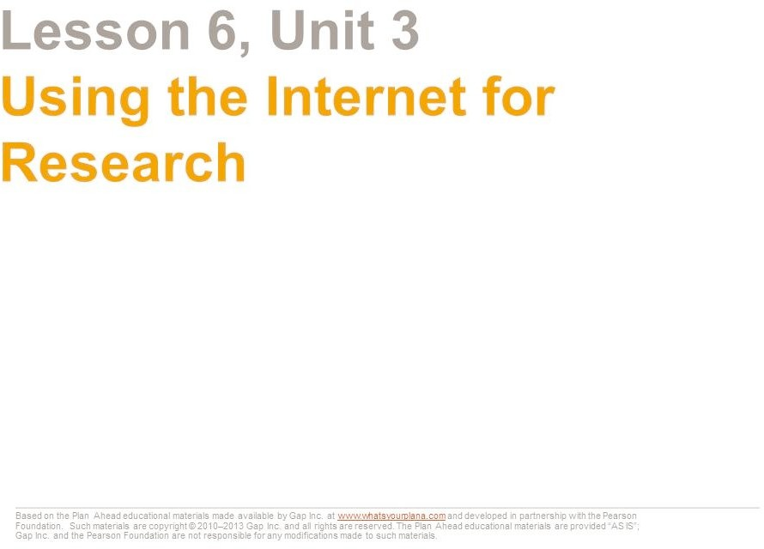

The Internet is a great tool for doing research. But just like any research tool, you need to know how to use it.

Today we’re going to look at:

* + - * How to do an effective Internet search
      * How to know if the information you find is trustworthy
      * How to keep track of your sources

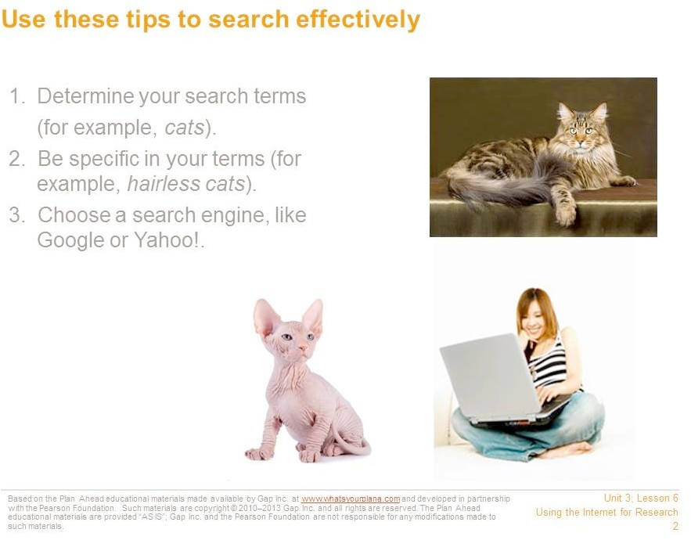

First, decide on your search terms. If you are going to write a report on cats, you will use that word as your main search term. But if you want to write a report on a specific type of cat, you would use that term—for example, hairless cats.

Next, choose a search engine. A search engine is a tool that helps you to find information on the Internet. You can use a regular search engine like Google or Yahoo!.

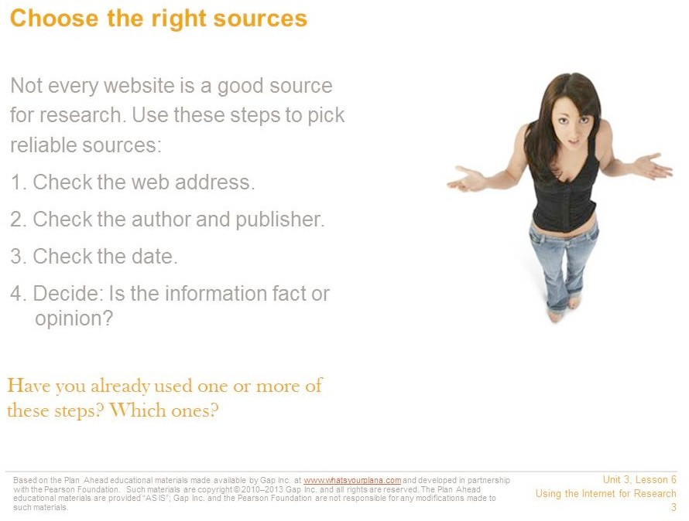

Your search may turn up hundreds or even thousands of results. You have to decide which ones to look at.

You shouldn’t just start with the first result that shows up. There are many sites on the Internet that contain false information. Sometimes the only reason sites show up at the top of the list is that they’ve paid to appear there.

Even worse, there are sites that people use to steal your identity. That means they get information about you so they can pretend to be you. They could get credit cards in your name or even commit crimes, and then people would think you had spent that money or committed those crimes! Be very careful with websites that ask for your name, your email address, or your phone number. You don’t know who can see that information once you plug it in!

There are four steps to make sure that you’re using a reliable source. We will go through each one in detail, so you can feel confident that you’re choosing good sites.

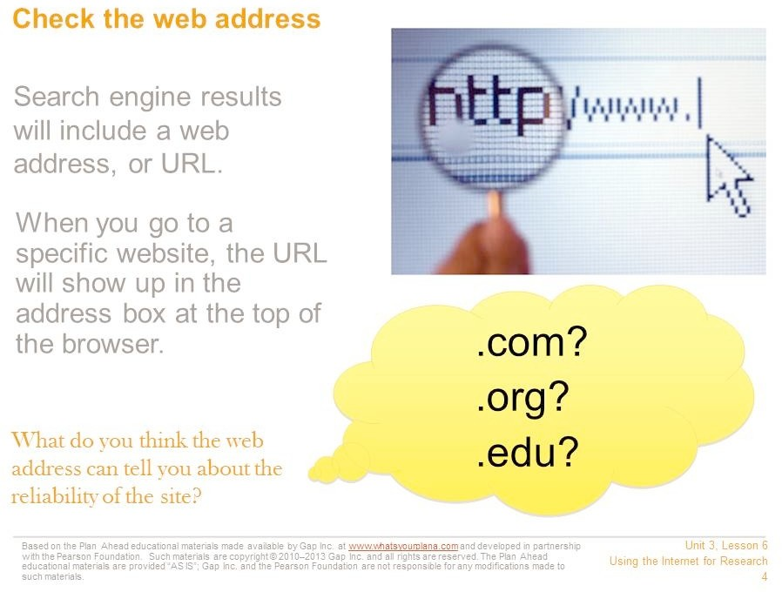

When you use a search engine, the results will include a web address. When you go to a specific site, the address will show up at the top, in the browser.

Web addresses can be long and confusing. They can include lots of numbers, letters, or symbols that mean something to your computer, but don’t mean much to you. That’s okay. The web address can still give you important information.

The web domain can help you recognize where the information comes from. The domain shows up as the last few letters after the period. Here are some of the common ones you see and what they mean:

* + - * .com = company (many newspapers and news magazines are also .com)
      * .org = organization (many museums are .org)
      * .edu = educational institution (usually a college or a university)

If the address says it comes from a national newspaper, news magazine, museum, a college, or a university, that’s a good first sign.

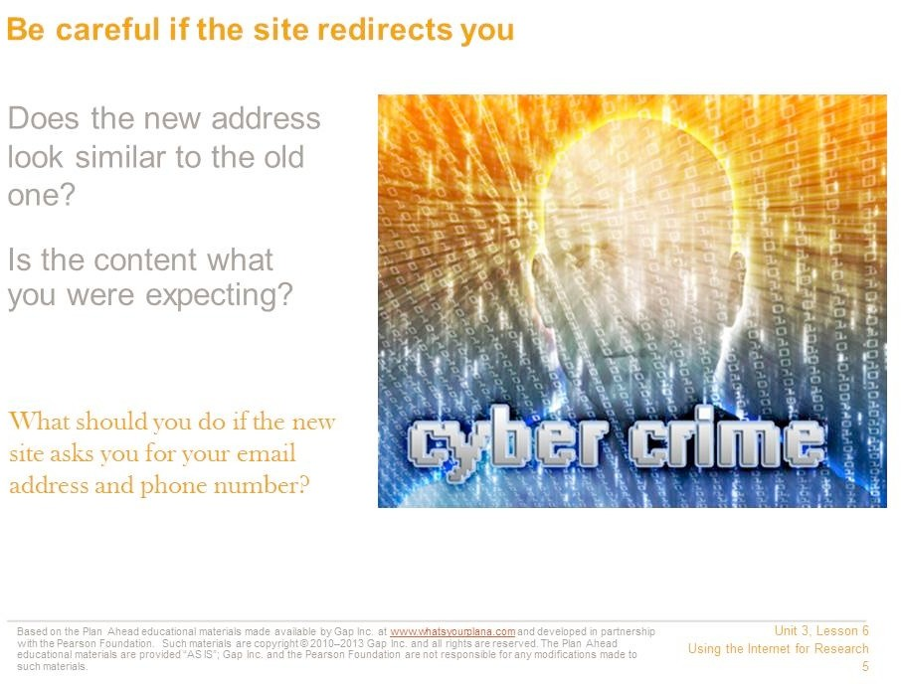

What happens if the site “redirects” you? Sometimes organizations need to move their websites to a new address. If you go to the old link, you may see a message explaining that you will be redirected to a new site.

When the new site loads, check the web address immediately.

* + - * Does it look similar to the old address? Is it still a .com, .org, or .edu?
      * Does the content look appropriate? If you were expecting the home page for a museum, is that what you see at the new address? If you expected to see something from a museum and now you see someone’s personal page, or some other page that has nothing to do with museums, don’t use that link! It is no longer reliable.
      * You can also check the “About Us” or “About the Company” section to learn more about the site and its sponsor.

Sometimes people make their websites look as though they’re for museums, schools, or other good sources, but they aren’t. Anybody can start up a website claiming to represent a museum, and there are plenty of college professors who run websites that promote their own personal opinions. So you need to look at more than just the web address.

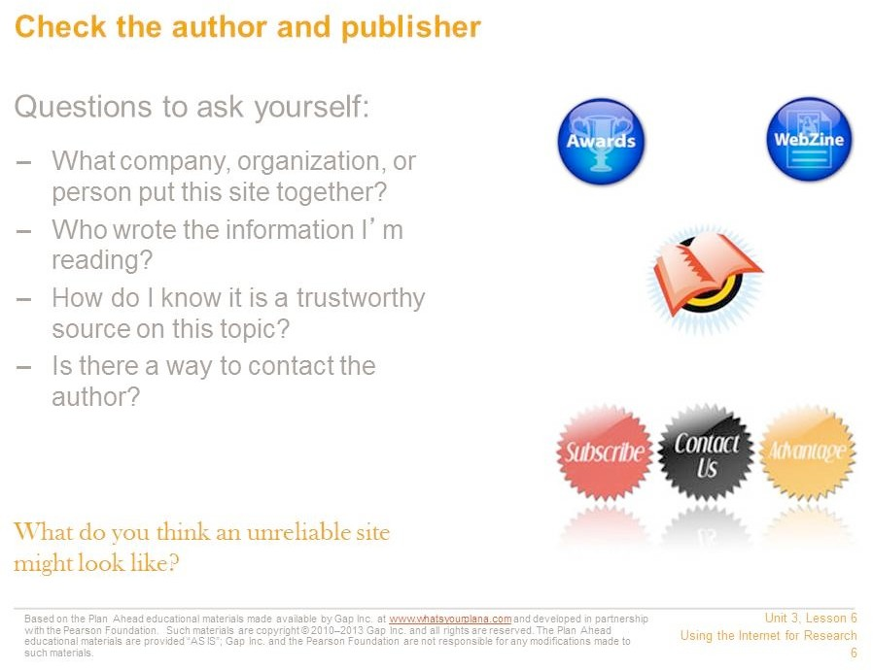

Who is responsible for writing the content on the site? Look for an author’s name. “Webmaster” is not someone’s name; this person puts the information onto the website but doesn’t necessarily write it.

You’re trying to find reputable websites. “Reputable” means that the site has a good reputation; it contains trustworthy information.

Try to identify who created the site—whether it represents a person, a company, or some other kind of organization.

Some websites, like online encyclopedias, may not list their authors. If you have other reasons to trust the website (for example, because it’s one your teacher recommended), you can still use it, but it’s always better to use a site that tells you who its authors are.

One thing you should always do is compare the information you find from different resources. For example, if you are doing research for your history class, compare what each website says with what is in your textbook. A site might have more detailed information than your textbook, which is okay. But if the site says World War II didn’t happen, it’s clearly not a reliable site for you to use.

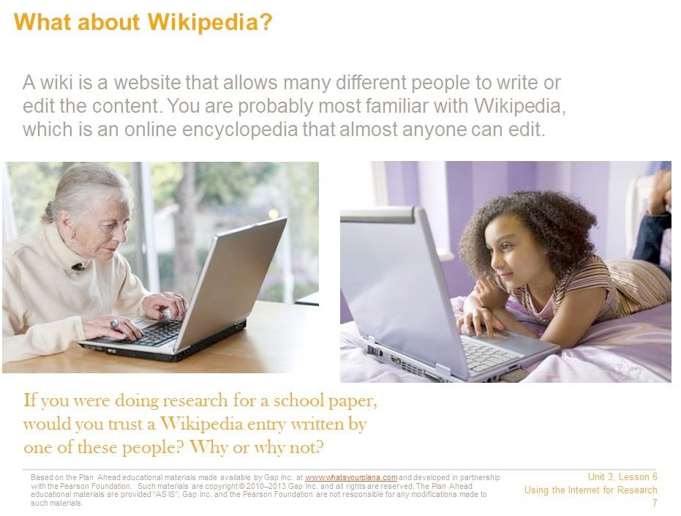

A wiki allows many different people to add content or edit it, so either of the people pictured above could edit the content of a Wikipedia entry. There are advantages and disadvantages to wikis. The advantage is that many different people can contribute. It’s interactive and it benefits from the wisdom and expertise of a wide range of contributors.

However, that can also be a disadvantage. Look at the photographs above. One of these people is younger than you are. She might not know enough about a topic to provide good information. The woman is much older than you are, and she probably does have knowledge and expertise on some topics. But you certainly wouldn’t expect her to know a lot about the latest techno band or the most popular TV show with high schoolers. So when you use a site like Wikipedia, you always need to remember that you might be reading something that a non-expert wrote. It could be incorrect. That’s why some teachers prefer that you not use Wikipedia as a source for assignments.

If you are allowed to use Wikipedia, make sure to double check the information against other sources. Some articles on the site are more accurate than others.

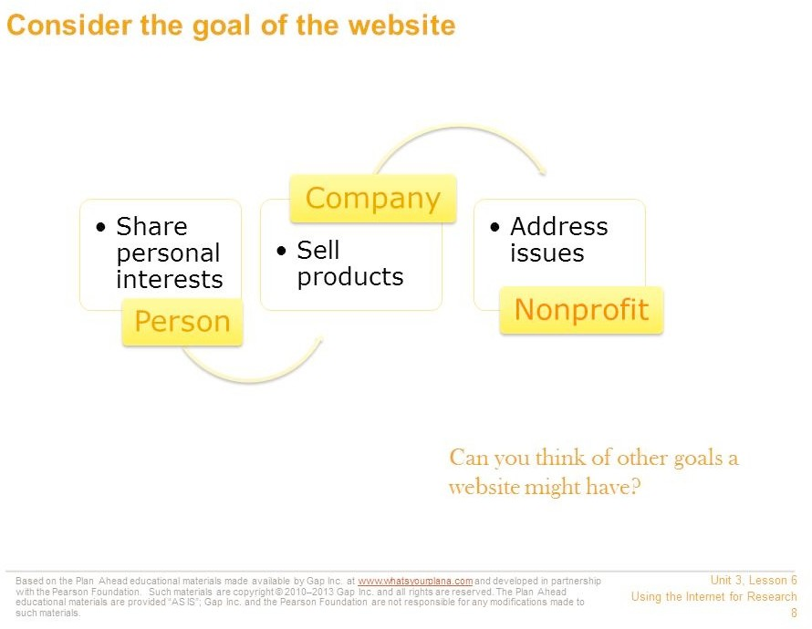

The site’s creators have a goal, a reason they built the site. See if you can identify what the goal is. Usually, a site is built to share information with the general public.

A person might make a site to share her personal interests.

A company usually makes a site to promote its business or products.

An organization, like a nonprofit group, might have a site to talk about the issue or cause the organization addresses.

If people or companies are selling something or just sharing their own opinions, their information may not be trustworthy. A school or a museum might be more reliable. But also keep in mind that there are some schools and museums that have very specific beliefs that most people don’t follow. So it’s important to continue to double check your information against sources you know are reliable, like your textbook.

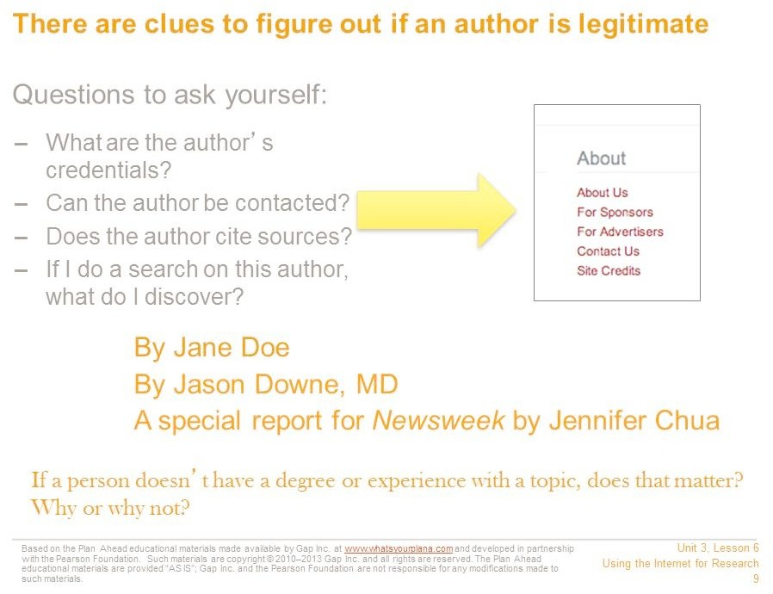

How do you know the author is a trustworthy source on this topic?

* + - * A good source will include the author’s credentials. Is this person an expert on this subject—a college professor in this subject or someone with an important job in this field?
      * If the author is a journalist, who is she writing for? If she writes for a reputable magazine or newspaper, then she had to prove that her facts were accurate.
      * You can also do a separate search on the author to learn more about him or her.
      * Is there a way to contact the author? Journalists and experts frequently include this information, so if people have questions about the article, they know whom to ask.

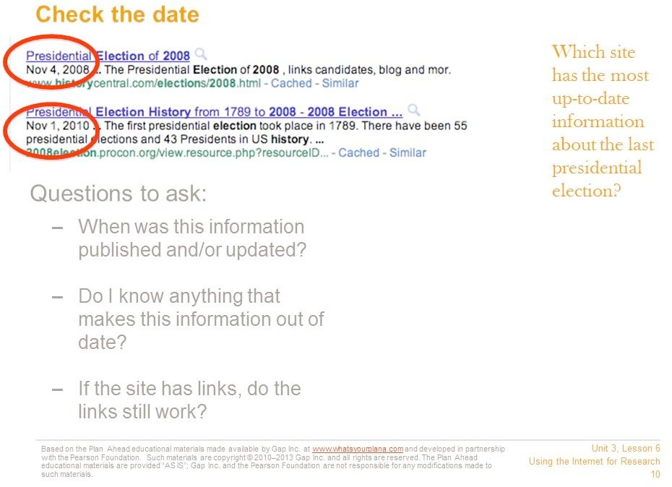

Look for the date when the information was published or updated. It may be at the very top of the page, or down at the bottom by a copyright statement.

Sometimes you will see “Published on” and “Updated on”—that means the information was published on one date and then added to or revised on another date. This often happens with news stories.

What is an acceptable date? In general, look for the newest information available.

If you are researching something that hasn’t changed very much, like a historical event, you can use older information and still feel confident that it’s reliable. For example, what we know about the Roman Empire hasn’t changed much in the last year or two.

But say you’re researching US politics using a website from 2007. That site would say that our country has never had an African American president. If no one has updated this website to include President Obama, then it’s probably not a reliable website.

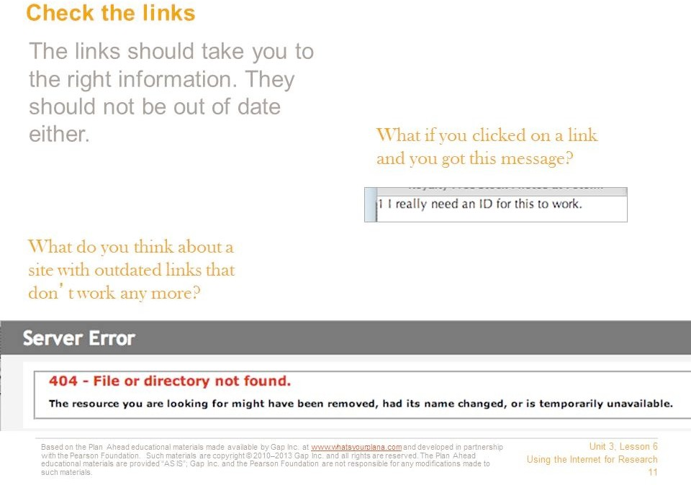

Many sites link to other websites that offer similar information. Try out the links—do they still connect you to the right information? If they don’t work, that is a warning sign. If the people who run the site don’t keep their links up to date, they probably aren’t making sure the rest of their information is up to date either.

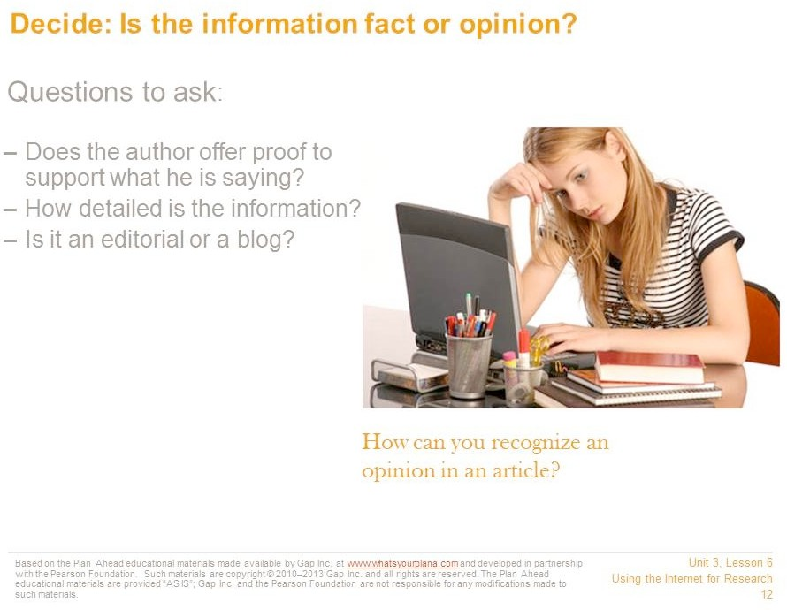

Is the information fact or opinion? If the article includes links to other reputable sites or quotes reputable sources, that’s a good sign. Even if the article you’re reading is an opinion, you can look up the facts being provided and use them for your research.

One sign that the website contains opinions and not facts is if it says things like, “Everyone knows….”

If the article says, “I think…” or “I believe…,” that’s a hint that you’re reading an opinion piece. Also, if the piece is labeled as an “editorial,” that’s another word for an opinion piece. Many blog entries are also opinion pieces, so be careful if you find something on a blog. If you can’t find supporting evidence, don’t use a blog as part of your research.



Does the website have ads? If the ads aren’t related to the topic, it just means that this is how the website is getting paid for. But if the ads are for the thing you’re researching, then it makes the whole site suspicious. For example, if you are researching why Vitamin B is a good thing, and the ads are for a company that sells Vitamin B, then you can’t be sure you’re getting the whole story.

If the website is selling something, that might influence what the article says. For example, a veterinarian’s office might have good information on cats. But if the site claims you should only feed your cat a specific type of cat food—which it sells—that’s a warning sign.

|  |
| --- |
|  |

Citing your sources means telling people where you got your information. When you do research, you need to list the books, encyclopedias, and Internet sources you used.

It’s important to cite your sources. It lets your teacher know that you have used good information for your report. When experts do research, they cite their sources so that other people can do the same research if they want to. Any time you use someone else’s words or information, you must cite who and where you got it from.

It’s also illegal not to! You need to give credit to the people who wrote the information. Otherwise it seems as though you wrote it, and that’s called plagiarism.

For each Internet source you use, write down the following information:

* The name of the site and the author (Who made the website? A company? An organization? An individual?)
* The name of the article, if there was a specific article you used
* What day you found the information
* The web address or URL
* The date on which the information was published

Citation generators, such as EasyBib and Son of Citation Machine, can help you put the information in the right format. Different teachers use different formats, so ask your teacher which one is right for your class.

#### Road Trip Nation Stories

|  |
| --- |
| **Purpose** |
| This activity introduces students personal stories they can use to learn about preparation for college and the world of work. |

|  |
| --- |
| **Suggested Grade Level:** |
| 12 |

|  |
| --- |
| **Materials and Handouts** |
| Reading- Road Trip Nation Hollywood Superstars |

|  |
| --- |
| **Approximate Time Needed:** |
| 40 minutes |

**Student-Facing Instructions**

Read the handout, “Hollywood Superstars”, and think about what the message is. Participate in a class discussion.

Turn to the handout, “Readings from Road Trip Nation” and while the story, “Last-Second Shot” is read aloud, follow along and underline 5 keywords or phrases that communicate the essence of the story.

Think about the stories and people you learned about today. Write down one meaningful lesson that you learned that will help you after high school.

**Teacher Notes**

Lead a group discussion around following two questions:

1. What advice would this person give you for success in college? For example, appropriate responses might be:
   * “Nothing just happens”…you have to take responsibility for yourself, show up every day, and know you can do it.
   * “Each of us has a wonderful talent inside us”, so think creatively about what you want to major in… don’t limit yourself to what others think you should do or what you did in the past.
   * “Sure, there is going to be struggle”, but stick with it, and maybe look in new directions for assistance,

e.g., find a professor who can advise you or seek direction from a club or study group.

1. What advice would this person give you for success in the world of work? For example, appropriate responses might be:
   * “You always have to help your teammates”. How you treat people can make a huge difference in how far you go in a career.
   * “Go for the gold” (which is what Phil Knight meant when he said, “you could go all the way here, if that’s what you wanted.”)

Read the Remaining Stories

For the rest of the stories, divide the class into pairs or groups of 3-4 and assign one story to each group. Ask them to:

* + Individually, read the story and underline 5 key phrases
  + With their partner(s), compare the 5 key phrases and pick the two most important to report to the class
  + Ask groups to answer the two questions in step #2 above and pick one to report to the class

Point out to students that the text in the box at the beginning of each story provides an introduction to that story’s author and should be read first.

Give each small group time to read and then report-out on their story to the whole class.

Conclude the discussion by summarizing some of the advice that you feel is most important for your students to remember.

**Assessment**

Completion of career cards.

**Instructions**

Read the handout, “Hollywood Superstars”, and think about what the message is. Participate in a class discussion.

Turn to the handout, “Readings from Road Trip Nation” and while the story, “Last-Second Shot” is read aloud, follow along and underline 5 keywords or phrases that communicate the essence of the story.

Think about the stories and people you learned about today.

Write down one meaningful lesson that you learned that will help you after high school.

Readings from ROADTRIP NATION a book about finding your path in life

**THE LAST-SECOND SHOT**

*Who you are should be defined every day of your life*

**INTRODUCTION**: Howard White is tall, confident, and speaks in such a deep, mesmerizing voice that you’d swear he was a preacher and not a corporate vice president. What struck us most about Howard’s story was how – after he quit pro basketball and went into business – he continued to live by simple lessons that he learned from playing college basketball. The kid who grew up in a poor city neighborhood is now a major player at a $9 billion company and counseling athletes like Michael Jordan. As Howard walked across Nike’s campus with his signature stride, there wasn’t a person who didn’t shout out, “Yo, Hi!” Back at his office, flanked by sports paraphernalia like Lance Armstrong’s yellow jersey, he leaned back in his chair and looked back on his life.

**HOWARD WHITE**

Beaverton, Oregon

Vice President and Manager of the Michael Jordan Brand, Nike University of Maryland

My life has been fun, a lot of fun. And I’m not the smartest guy in the world. Hell, I flunked the second grade. What I’ve learned is not rocket science. It’s available to everybody.

Back in college I was playing basketball at the University of Maryland and things just kind of happened. [Pause.] But nothing just happens. You have a huge part in it. How you carry yourself every day. How you represent yourself every day. The passion you show up with every day.

Most people have a gift but don’t know what it is. You have to decide what makes you a little different from person X, Y, or Z. I felt that people followed me. That was my gift. When I spoke to people they listened. They paid attention. They wanted more. So you just start building on that.

People will see greatness in you and you can choose to see it or not. I met a guy in Hawaii who had chiseled a beautiful figure out of a tree. I said, “Man, how did you do that?” He said, “Well, actually the figure was always in the tree. I just let it out. It’s not anything special I’ve done. The figure was there. I only released it from the tree.”

In essence, each of us has a wonderful talent inside us but we need others to help chisel it out, to help fine-tune it, to give us wings. Every step along my way there has been someone who said, “You can do this.”

My coach in high school saw me play and he pulled me aside. He said, “Have you ever heard of the Big O – Oscar Robinson?” Who hadn’t? Today that’s like asking someone if they’ve ever heard of Michael Jordan. Coach said, “If you listen to everything I tell you, you can be just like the Big O.”

I couldn’t even play ball. He taught me how to dribble. He taught me how to shoot. He taught me the game of basketball. When I went to college, I was the Big H. I had a big “H” on my uniform.

I accepted that getting knocked down was a way of life. I had a major knee operation in high school and that was before doctors really knew what they were doing. But I played college ball on it. People said, **“How do you play with the knees of a ninety-year old man?”** I just saw myself playing beyond the rim.



12th Grade Career Development Workshops: Choosing a Path That’s Right for YOU Copyright © 2012 MDRC. All Rights Reserved.

Student Workshop #1, Page 3

August, 2012

There is going to be pain and there is going to be struggle and there will be times you have to shift your direction. You’ll have to take a lot of bullets, but if you stay on that path you can pretty much do what you want to do. Most people just aren’t willing to stay on the path. They aren’t willing to take the heartache. They aren’t willing to get beat on. They aren’t willing to get stepped on.

In basketball you are in a world where everyone looks at you. But they see more than just how you play ball. They see how you interact with people, how you help your teammates win.

If you are going to win, it takes a lot more than the effort you give at one particular time.

You might hit the last shot that wins the game, yet you’ve made that shot hundreds of tines in private. It’s just the first time others have seen it. That’s what the cameras focus on and what everyone jumps up and down about. Most people are seeing it for the first time, but you’ve done it a million times. **One shot preceded by two million, but that’s the one that gets noticed.** While it was luck that you had the last shot to win the game, it was not luck that you shot two million times, every day of your life, waiting for just that opportunity. All of your steps led up to that.

If you’re good at ball and you want to be good at life, you have to show up in life with the same passion that you showed up with to play ball. Not every day will be the most fantastic day of your life. Some days you are going to shoot poorly, some days you’re gonna get scored on. Some days you get dunked on, but it is how you rebound from that. All the things that hold people back are learning experiences.

I had another operation my senior year, and I got drafted into the pros. Basketball just wasn’t that much fun anymore. My college coach asked me to come on board and help coach. He saw something in me going way back – how I helped, deal with, and handled people – and that made him say I want this person to be a part of this team.

I went forward, but one day I said this coaching stuff is fun but I’m not sure how far it will take me. I talked to Coach about it, and he said if I left I should get into the insurance business, said I could make a lot of money, deal with people. So I went into the insurance business doing estate planning, people’s wills, because I didn’t know what else to do.

It was all right. Was it fun? No, but it was okay.

While I was in the insurance business, a guy came to me who happened to be an old teammate. He said there was a great job I would love at Nike.

Here’s the interesting part about that. This was the same guy who had been seeing my girlfriend behind my back years ago. He had starting messing with drugs and doing the wrong things and I said to myself, “This young man needs help. I need to be around him. I want to help him in his life,” and I did. We started getting together, going to dinner, playing tennis. This person was the one who said, “Here is this wonderful job.”

Why do I tell you that story? Most people feel that if a guy had been seeing his girlfriend, they really would not want much to do with him. My approach was to help him. So out of that situation I get this Nike job. Twenty years later I’m a vice president. If I didn’t have the fortitude to help him in his dilemma, I would not be here today. No one looks at me and says, “Wow, he helped that guy.” All they see now is a vice president of Nike. Simple lesson: How you treat people is important. I could not have gotten here by myself.

One day I said to Phil Knight, chief of Nike, how far could someone like me – a guy who flunked the second grade – go in a company like this? Phil looked at his chair and said, “You could go all the way here, if that’s what you wanted.”

I said, “Well, maybe not, but I like the way your think.” That’s it. Simple story, but it’s mine.



12th Grade Career Development Workshops: Choosing a Path That’s Right for YOU Copyright © 2012 MDRC. All Rights Reserved.

Student Workshop #1, Page 4

August, 2012

**MAY THE FORCE BE WITH YOU**

*Go into something that no one else is going into*

|  |
| --- |
| **INTRODUCTION**: Sitting before us in a black-and-white Hawaiian shirt was Dennis Muren, the man behind the visual effects for movies like E.T., The Extra-Terrestrial, Terminator 2: Judgment Day, and the Star Wars flicks. He has won eight academy awards for best achievement in visual effects throughout his career, which is ironic when you consider that when he started out in the 1960s, Visual Effects wasn’t even a career! Dennis had no road to follow and very few mentors, yet he clung to his fascination with visual effects. We had lunch with him just outside the set of the latest Star Wars film, Episode II: Attack Of The Clones. They wouldn’t let us on the set, but we snuck a few peeks. Anyway. |

**DENNIS MUREN**

San Rafael, California

Senior Visual Effects Supervisor, Industrial Light & Magic California State University, Los Angeles

Pasadena City College

I grew up thirty minutes from Hollywood, but it might as well have been further because I didn’t know anyone in the business.

When I was six or seven, I liked visual effects—I don’t even know why. There were no video cameras in those days, and I used an eight-millimeter camera in high school and college. I used my allowance to buy film, but back then you shot only two minutes of film, sent it to Kodak to be developed, and couldn’t get it back for two weeks! That made everything I shot really important. It made me focus on every little thing. But **it was just a hobby. I never thought it would be a career**.

When I went to college, my folks told me to major in business so I had something to fall back on. I minored in advertising so at least I could do special effects for commercials. **I crammed my classes into Tuesdays and Thursdays so I could make movies Mondays, Wednesdays, and Fridays**.

Between classes some friends and I spent two years making a low-budget film for $3,500. I sold it to a distributor for $6,000 or $7,000. He put another $40,000 into it, redid the sound, added some more shots, released it in L.A., and showed it all over the country. I think I learned more doing that film than I would have during four years at film school. So I am really self-taught. I just followed what I liked to do.

**My friends and I also went to films that we thought were really neat. Afterward, I’d call up all the people who did the movies’ special effects and ask them about their work before, so they were thrilled to talk about it.**

I sort of goofed off in my early twenties and had, like, four different jobs a year and earned maybe $1,000 for a commercial. I’m an independent person and didn’t like the idea of working nine-to-five every day. Besides, if I had been pushed into a job that took fifty hours a week, I wouldn’t have been able to learn what I did. People need time to find what they’re good at.

Still, I lived at home and knew that I couldn’t go on much longer, so one day I went through the Los Angeles Times classified section and found a job for inhalation therapy, something about teaching people to breathe. I’d probably work in a hospital, and I could do it while I continued my hobbies.



12th Grade Career Development Workshops: Choosing a Path That’s Right for YOU Copyright © 2012 MDRC. All Rights Reserved.

Student Workshop #1, Page 5

August, 2012

**Then, Star Wars came along.**

Most of the movies being made with special effects back then were union movies, and I didn’t care to work on them because they were too structured. But at some point I thought I should at least work on one and see what it was like. I picked Star Wars because I figured that if I was going to do a Hollywood movie, I might as well do it with a director I liked, and I really liked George Lucas. I didn’t know him, but I knew John Dykstra, so I contacted him. I pushed for an interview, got it, and told them how much money I wanted. They said they couldn’t afford to pay me.

So, literally, I was faced with this choice: Did I want to do Star Wars for less money than I made doing commercials or did I want to do inhalation therapy and wait for another commercial to come along?

I contacted John Dykstra and dropped my price. I figured it would be a steppingstone.

From the very beginning I tried to separate myself from everyone else. I didn’t just deliver a shot, I took it further. I would try to shoot something in a way that people would look and say, “I never knew that was possible.” I’m passionate about the end result. I like looking at my work when it’s done and saying “Wow!” All the rest of the process is just a way to get to that end result. That’s what drives me. The process can be hard – fun at first, but tough to do – and it’s really neat when it’s all over.

Over the years, technology has made the work easier, and in some ways harder. Now you can buy software and two dozen books about doing visual effects. There are a lot of people coming into the profession that know how to use the tools, but what they need to learn is how to apply the effects within the movie. They have to know how movies are made, about direction, photography, lighting, composition, and how to tell a story. And they must have interpersonal skills, because on every movie you work with dozens of people.

I’m going through an interesting peri0od now because I’ve done so much stuff for so long that I have to work hard to make it interesting. So I try to find a hook in every project, something I’ve never done before. I imagine that my work is obsolete as soon as it’s done, so I look for the next thing and always try to come up with something new so I don’t repeat myself. The audience can get bored and you have to keep surprising people.

I did luck out. Steven Spielberg and George came along, all the Baby Boomers grew up and wanted to see these movies, and society became very visually oriented. I don’t know if I would do the same thing today. I got into this because special effects were just that: special. They were unique and different. They’re not special any more. You see them everywhere.

Yet because they were so rare, I went through a difficult period before Star Wars. I felt like my passion had no future because there were no jobs. But someone at that time told me, or maybe I overheard it said, that what people should do when they’re young is to go into something that nobody else is going into. And if it ever becomes fashionable, then there you are. And that, in fact, is my story.



12th Grade Career Development Workshops: Choosing a Path That’s Right for YOU Copyright © 2012 MDRC. All Rights Reserved.

Student Workshop #1, Page 6

August, 2012

**PURSE DUTY**

*No Job is Too Small*

**INTRODUCTION**: In April 1996, the U.S. Secretary of commerce, Ron Brown, was on an air force plane that crashed into the mountains a few miles from Dubrovnik, Croatia. Traveling with secretary Brown were thirty-four people, including business executives and colleagues. While there was only one survivor found at the crash, there was someone else close to Brown who was not on the plane that day. That person was the secretary’s personal aide, Morris Reid. Today, Morris is thirty years old and works as a government lobbyist and business consultant. Before the tragedy, Morris had paved his road into politics by being aggressive and hardworking. Since then he has doubled his efforts. After all, he says, he’s living life for thirty-three people who no longer can.

**MORRIS REID**

Washington, D.C., Lobbyist, Westin Rinehart University of Akron

I didn’t come from an affluent background and had no appreciation for school. I was very unfocused. The day I arrived at the University of Akron, I knew I wanted to get out as quickly as possible, because there was a whole world I wanted to see.

My grandmother’s accident led me to politics. She got injured and I had to get her Social Security and things of that nature, which meant I had to call up congressmen. The whole experience led to a career path of walking up to people who I didn’t know, talking to them, seeking advice, and picking their brains.

I didn’t want to be a politician because they really don’t make that much money, so I figured out how to use politics to get to the money. In college I started a little PR company that represented politicians. I made $1,000 a week and was the richest guy on campus. My break came when I was working for a state representative who happened to be from Arkansas. He said a guy named Bill Clinton was going to run for president and he might be able to get me hooked into the campaign.

To make a long story short, I ended up running a portion of the northeast Ohio campaign for Clinton. I got exposed to all the principals, like Bill and Hillary, Al and Tipper Gore. Meanwhile, they saw this young guy who was hungry and aggressive and doing what he needed to do. **Being hungry and aggressive paid off, especially the aggressive part**.

After Clinton was elected, Hillary’s people called me and asked me to come to D.C. and work for them. I packed everything I had into a duffel bag and jumped on a Greyhound bus from Akron to Washington.

The day I arrived I knew I wanted to work with Ron Brown. I asked everyone if they knew him or knew someone who knew him. Eventually, I found three people, and we identified a person named Mike who could get me a job: Mike was the chief of staff for the inaugural committee. I asked people to talk to Mike about me. Then one day I walked into his office and said, “Hi, I’m Morris Reid. I know a lot of people have been bugging you about me.” Mike said he couldn’t use me, so I told him I just wanted to introduce myself and asked him to let me know if anything happened.

A few days later I told a friend of mine who worked for Hillary Clinton that I really appreciated all that she had done for me but that I wanted to work for Ron Brown. Unbeknownst to me, she called Mike and said that I was already on her payroll, but that if I worked for both of them, Mike wouldn’t have to pay me. Two days later Mike called me. I was ecstatic. He said, “Reid, your job is to take care of Ron Brown’s mother and mother-in-law.” [Laughs.]

It was the best thing that had happened to me. Here I was on “purse duty,” a phrase I coined, for a couple of old ladies. My job was to get them from one place to another, carry their purses,



12th Grade Career Development Workshops: Choosing a Path That’s Right for YOU Copyright © 2012 MDRC. All Rights Reserved.

Student Workshop #1, Page 7

August, 2012

help them along. **It was the biggest break of my life** because these two little old black women saw this young black kid who was ecstatic about everything. And these women talked about me nonstop! Nonstop! So Secretary Brown wondered, “Who the hell is this kid Morris Reid?” That’s my point: No job is too small. There I was, on purse duty carrying a Chanel bag—and it didn’t even match my outfit! [Laughs.]

One day I was at an event and something went wrong. Being aggressive, I jumped in and fixed it. Later, Mike told me I’d done a great job and asked me to join him at the Washington Convention Center that night. I went and was made the coat man for the evening. So I’m standing in the corner holding everyone’s coats, and President Clinton comes by and says, “Hey, Morris.” Secretary Brown looks at me like, “Who the hell is this kid?” [Laughs.] That evening Secretary Brown’s son offered me a job to work with his dad.

I went from being Secretary Brown’s gofer to his personal assistant. I drove around with him and his wife, and I was the fly on the wall in every meeting he had. I was the first person he saw in the morning and the last person he saw at night. I was a young aide, but I spent so much time with him that he’d tell me things he couldn’t say to other people. He relied on me. People at the Commerce Department used to call me a “leading indicator,” because they knew what Brown was going to do based on my attitude.

This was a lot of power for a young kid from Akron, Ohio, and I often screwed up. Brown fired me twelve times, but I’d show up the next day. We had such a fantastic relationship. **He was more than a boss—he was my mentor**.

We were on a trip to Croatia and I was supposed to be with Secretary Brown on a plane to Dubrovnik. It was a trip I told him he had to take because it was important. He wanted me to stay behind in another city and focus on a deal we were doing. When he saw me sitting on the plane he said, “I thought I told you I didn’t want you on this trip.” They literally had to roll back the stairs to the plane so I could get off.

Later I flew down separately to meet him. And hour and thirty minutes before the secretary’s plane was supposed to land, it disappeared from the radar. We learned several hours later that the plane had crashed.

I flew home on a C-17 with five other people and thirty-three bodies. The aircraft was gutted and it was just me and thirty-three coffins, including my mentor and all of my friends. This was my world, and they were all dead and I really felt like I was the reason. I was the guy who was directing what he did. I had insisted he go to Dubrovnik. **We flew back home for twelve hours, and it was the most horrific experience of my life**. I was twenty-six.

My friends always ask if I’m over it. No. I never want to be over it because it’s become the driving force of my life. Here was a guy in his fifties and others in their thirties and forties—they all had long lives to live. I never want to forget that pain. It propels me. I feel like I’m living a certain part of my life devoted to making sure I’m a success. Secretary Brown would have been a success, so I want to continue to do things my friends never got to do. I feel every day that I have a new lease on life, a day that I wasn’t supposed to have. It’s hard for me to have a bad day because nothing will ever equal all that pain.

Now I try to focus on running my business. I’ve started one company and am a major player in two others. I leave my house every morning at 7:15 and come home at 11:30 every night. I put in a full day, and at the end of it I look at what I accomplished. **I’m very critical of myself, but it keeps me sharp**. It’s a day-to-day, week-to-week measurement. It’s almost like flying an airplane: You have to watch the instruments and know what’s going on with the plane moment to moment because if anything goes wrong, the plane could crash.

**EXPOSE YOURSELF**

*Do something you have a personal interest in.*

**INTRODUCTION**: The North Face has been making outdoor gear since 1966, and in 2000 it was bought by VF Corp., enormous apparel company that owns other brands. Mike Egeck was hired that year to head the North Face’s product design and development. He had twenty years of experience in the clothing industry, which he sort of stumbled into after college but came to love. With his tan goatee, and black fleece jacket, he looked like he had just come off the slopes. He signed the roof of the RV “never stop exploring,” which is his advice to college grads and, not so coincidentally, is also the North Face’s motto.

**MIKE EGECK**

San Leandro, California President, The North Face University of Washington

I came from a family of firemen but made a conscious decision not to be a firefighter. It’s a great job and after September 11 you can’t help but admire firefighters, but it’s really dangerous and tough. Actually, my father asked me not to do it. He wanted to make sure I was exposed to other things and looked at other opportunities before I chose firefighting.

That’s part of my advice to people graduating college today. **Expose yourself to as many different careers as you can.** You don’t have to pick one and stick with it. You can always change. Sooner or later it will come down to your gut. But remember, it’s easier to take a flier earlier rather than later in life, when you have a family.

I knew I wanted to go to grad school, so I went right after college. Then, after six years of school I was tired of being poor! Money was probably my biggest motivation to get a job when I finally graduated.

I accepted a job in the training program of a bank. The weekend before I started, I was at a party on the boat of Dick Lentz, a guy who had just started Union Bay sportswear. I’d gone to school with his daughters and he asked me what I was doing after graduation. When he heard that I was working at a bank, he said, “You don’t want to do that, come join me.” Monday I called the bank and told them I was sorry but I was going to try something else.

It was just a gut feeling. At the bank everyone had been in suits. When I walked into Union Bay there was so much more energy. Pieces of fabric were everywhere and people were making stuff. The bank job would have been standard modus operandi. **My parents, who are very understanding, thought I had flipped out when I didn’t take the banking job**. But at some point you just have to follow your gut and what feels right.

Networking is important. So many career decisions are based on who you meet and run into. It’s important to know a lot of people. Try to find others whose lifestyle you admire and who seem to enjoy what they do, and investigate why. Learn what people feel so good about. Keep your mind open.

I started working at Union Bay on a Monday, and on Wednesday I was in Hong Kong meeting with fabric buyers and purchasing denim.

A big appeal of Union Bay was the fact that it was a new company run by three guys who had been in the apparel business for years. Those guys were true mentors. They’d sit us down each morning and say, “Okay, this is what you did wrong yesterday and this is what we’re going to do

today.” The majority of the company was just a bunch of kids who didn’t know what we were doing.

They gave us the freedom to make mistakes, but it became a sizable business pretty quickly, so they didn’t let us do anything too wrong**. It was really an ideal situation, like a continuation of school but more fun.**

At The North Face we try to create the same atmosphere. Our average employee is thirty years old. It’s a young, very educated workforce, and most are here because they love doing the stuff we make products for. The passion they have for the business is one of the best things we have going for us. At the same time, you have to teach and mentor as you go along.

The best thing about the apparel and equipment business is that we make stuff you can wear.

I like that idea, that we make things you can touch, feel, and use.

I encourage people to do something they have a personal interest in. Frankly, the higher up you get in an organization, the more time you spend thinking about work. You never really get away from it. You go home at night and thing about it, you go to the gym and think about it. I go skiing and see people wearing North Face clothes, and I ask them what they think about the gear. People are blatantly honest. If they say something like, “You know, this zipper doesn’t work,” it drives me crazy for the rest of the day. I guess that’s an occupational hazard.

I get totally absorbed in the work, and I think people should be. I think people who enjoy their jobs are absorbed by them. If you’re not, maybe it’s the wrong line of work. **If you don’t feel great about your job, it can limit you**. You probably won’t aspire to higher positions.

I had friends who were totally programmed, and I admire that. A lot of them are very successful. Some people have a clear vision of what they want, but I think that’s pretty rare. I was not like that at all. I was open to opportunities that presented themselves and that is why I ended up on this path. I’m very lucky.

**ABSOLUTE INTUITION**

*Just because you’re competent at something doesn’t mean it will fuel your passion.*

**INTRODUCTION**: TBWA/Chiat/Day’s clients include Absolut Vodka, Nissan, and Apple Computer. Its funky office in Playa Del Rey, California, looks more like an art museum than a corporate building. The middle section of its façade is designed to look like a giant pair of binoculars. Inside, it’s open and colorful. There’s a bar, a huge basketball court, and a section with trees and foliage dubbed central park. That’s where we sat down with Laurie and talked. After the interview we were the “guest speakers” at the agency’s weekly keg party, which was held on the hip indoor basketball court.

**LAURIE COOTS**

Los Angeles, California TBWA/Chiat/Day

Chief Marketing Officer Worldwide Colorado State University

As a kid I was going to be a veterinarian because I rode horses competitively and I loved science. I also loved taking things apart and putting them back together. But after a couple of years in veterinary school, I realized it wasn’t for me. I was good at it – I even liked surgery – but it didn’t make me happy.

**So I dropped out.**

Talk about traumatic! For ten years I was going to be a veterinarian! Just admitting to myself that I didn’t want to do it took a year. But once you finally say, “Okay, this is not it,” you have to believe that it’s the right decision. Yes, there was a lot of pressure not to quit. I was one of two women who were accepted to the school and it was an honor to be there. People challenged me on it. They said I had taken someone’s place. And I think my dad was a little freaked that I wasn’t going to have this fabulous degree to hang on my wall; he thought I was destined to live a life of poverty. [Laughs.] But I just wouldn’t have been happy. You have to trust your gut. **Sometimes being clear about what you don’t want is almost as important as being clear about what you do want.**

Leaving vet school was the first “ah-ha” moment in my life because my assumption had always been that if you’re good at something it will automatically make you happy. But just because you’re competent at something doesn’t necessarily mean it will fuel your passion.

I left school and rode horses for a few years. I also spent time in the hotel business, but when you get promoted they want you to move like 3,000 miles away. But by then I’d gotten married and had a baby, and I realized that the hotel industry wasn’t going to work out for me.

Meanwhile, I had met people from Chiat/Day who had talked about the company’s great attitude. I didn’t know anything about advertising, but I inquired about a job. For a while they didn’t have anything but, finally, a secretarial position for the Apple Computer account opened. **So I bit the bullet and started completely over as a secretary**. It was tough, let me tell you. I went from having a pretty good life as a marketing director for Hilton to saving up money for panty hose. [Laughs.] When I interviewed for the Apple account, they asked me if I knew computers. I lied and said yes. So, yes, I kind of bullshitted my way in, but once there I was really committed to making sure that everyone felt that they hadn’t made a mistake by hiring me.

Where did I get the courage? I was looking for a place where I could make a big impact. That was one of the problems I had with medicine. It would have taken me too long to become good enough to be a world-changing surgeon. At Chiat/Day, I thought, “Where can I be a part of a place or a group of people who believe that they can change the world every day?” That’s what I wanted to sign up for. I didn’t know where I was going to go, but I knew that I’d be a better person for having done it.

I never intended to stay for eighteen years. But in that period I’ve reinvented myself six or seven times. I’ve been a secretary, I’ve helped change the way we pitch new business, I’ve run human resources for North America, and in 1994 I was in charge of creating Chiat/Day’s first virtual office environment, where we took away everybody’s desk!

Now I have a son who’s a sophomore in college. He’s so creative, but I worry about his last two years of school. A lot of juniors and seniors don’t read the newspaper every day. They get myopic. They are out of touch with the world, and when you do that you lose touch with your intuition. **A lot of students coming out of school have had the intuition just beaten out of them.** To follow your bliss you must know what your bliss is, and the only way to know that is by trying new things and having different life experiences. If you’re too directed you run the risk of eliminating choices before you ever see them. That’s sad to me

**A PINCH OF TALENT, A DASH OF RISK - MIX WELL**

*There’s no excuse for someone in his early twenties not to pursue a dream.*

**INTRODUCTION**: It costs about $300 – yes, that’s per person – to dine at world-famous Charlie Trotter’s, a four-star restaurant in Chicago. He cooks for celebrities upon request and has prepared meals for many presidents. The restaurant takes reservations months in advance, and most evenings limos line up outside. Not only did we get a free meal with Charlie’s staff, but he treated us to some unexpected insights. A serious scholar, he can quote Ayn Rand, Nietzsche, Russian writer Fyodor Dostoevsky, and singer Bob Dylan – all in the same conversation. Wearing his white chef’s jacket, he sat in the shotgun seat of the RV and dished out his tale.

**CHARLIE TROTTER**

Chicago, Illinois Chef

Charlie Trotter’s Restaurant University of Wisconsin

In college I felt like I didn’t have a single ally. I felt alienated. I really didn’t encounter anybody who I could completely relate to. I wasn’t interested in the rally du jour on campus or the whole fraternity world. I wasn’t better or worse than anyone, I just had a point of view. So I led a fairly reclusive existence. I lived alone, slept in a sleeping bag on the floor, had no TV, no telephone, no nothing. I just read books.

Everyone goes through a point in their late teens and twenties when they question things.

My particular metamorphosis happened as an undergraduate at the University of Wisconsin, where I studied philosophy and political science.

Everyone else wanted to use the undergraduate experience as a steppingstone to get into law or business school. Forget that. Undergraduate life is all about finding yourself, reading great books, talking to people, and learning to think critically.

My older cousin slipped me a copy of The Fountainhead by Ayn Rand. To me the book was a celebration of what man can accomplish. I had found someone who looked at the world the same way I did! I real all of Rand’s work and then all of Dostoevsky and then all of Henry Miller, then Faulkner – and it just started to gel.

**Along the way I began to cook for my roommates**. That was the one thing I really looked forward to and loved. I began working in a restaurant, first as a waiter, then as a bartender. I got the bug for the restaurant life because I liked the manual labor. I also liked the idea that you could really connect to another person. Cooking is very personal. I wanted to study that and understand more about it.

I had no agenda when I graduated from college in 1982. I was appalled by the idea of planning a career, but I liked the idea of filling my head with knowledge. Forget the career. My plan was to cook for four or five years and, if I wasn’t very good or I didn’t like it, I’d have lost nothing. As Bob Dylan said, “When you ain’t got nothing, you got nothing to lose.”

My first day on the job in a kitchen, I got paid $3.10 an hour, minimum wage back then. I thought, “These guys are idiots! They’re giving me $3.10 when I should be paying them.” I felt blessed. Here I am learning how to work with a knife, to filet fish, and just do this stuff.

It doesn’t really matter that you don’t understand everything quickly. Dostoevsky says that sometimes it’s better to be a little bit dumb, a bit slow, because if we understand things too quickly then we don’t know them well enough. Sometimes when we take a little time we gain a more profound knowledge of things.

I gained an understanding of the pleasures of the table. Every great thing in life practically happens around the table. Whether you are proposing marriage, celebrating a birthday, or the extended family gets together on a Sunday afternoon, it all ends up at the table.

I never worried about what my family thought**. The people who are really close to you are the ones who will not judge you.** People who worry about what others think or say about them hesitate. They may hesitate to make a mistake; worse, they might hesitate to achieve greatness.

Just take a chance. There is no excuse for someone in his early or mid-twenties not to pursue a dream. I think it’s about giving yourself over to something blindly. Give yourself in a way that you’re willing to jump over the edge of a cliff while not sure what’s on the other side. That’s how pure your dream has to be.

If it doesn’t work, if you don’t like it, who cares? You’ll have done something that others don’t have the courage or the wherewithal to try. And you’ll be young enough at twenty-five, twenty-six, or twenty-eight to get on the track for a so-called “mainstream” career. That will still be there. So big deal, you start school five years later than somebody else. But twenty, fifteen years later, it doesn’t make any difference.

My career happened as a by-product of my pursuit to learn more about cooking and the philosophy and history of food. **It’s nineteen years later and I don’t even feel like I’ve had a job**. I feel a little guilty at times because I do something that I cannot believe I can make a living at. I would gladly do this for a lot less. On the other hand, I could stop and never bat an eyelash. I am willing to walk away and do something else with the same sort of fanaticism. A year from now, this place could be closed.

Hollywood Superstars…Something to Think About

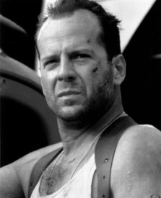

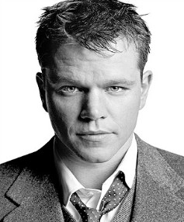**QUESTION: What do the following Hollywood stars have in common?**

Bruce Willis Matt Damon

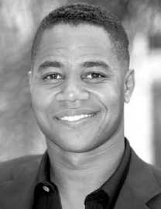Renee Zellweger

Cuba Gooding, Jr.

Heath Ledger

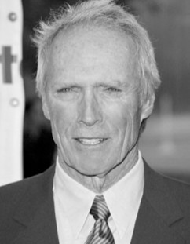Clint Eastwood

Brad Pitt Whoopi Goldberg



*Source:* [*http://movie-­‐*](http://movie-/)*extra.com/famous*



12th Grade Career Development Workshops: Choosing a Path That’s Right for YOU Copyright © 2012 MDRC. All Rights Reserved.

Student Workshop #1, Page 1

August, 2012

Teacher Resource **Day in the Life Videos Exploring Careers in Your Industry Sector**

|  |
| --- |
| **Purpose** |
| The purpose of this activity is expose students to the working lives of professionals within their pathway industry sector. |

|  |
| --- |
| **Suggested Grade Level:** |
| 9 |

|  |
| --- |
| **Materials and Handouts** |
| Know- What to Know- Learned |

|  |
| --- |
| **Approximate Time Needed:** |
| 25 minutes |

**Student-Facing Instructions**

In ConnectEd Studios, go to Toolbox, then select Day in the Life Videos. From the Day in the Life page, select your pathway industry sector. You will then see a list of Day in the Life Videos related to your pathway industry sector.

BEFORE YOU WATCH A VIDEO: Complete the first two rows of the KNOW - WANT TO KNOW - LEARNED handout

AFTER YOU WATCH A VIDEO: Complete the remaining row of the KNOW - WANT TO KNOW - LEARNED handout

Be prepared to share your comments with a partner or the rest of the class.

**Teacher Notes**

This lesson is recommended to be done after What Matters to Me Survey, What Matters to Me Guide, and How Am I Smart Survey.

**Assessment**

Completion of worksheet.

Student Resource

**Instructions**

In ConnectEd Studios, go to Toolbox, then select Day in the Life Videos. From the Day in the Life page, select your pathway industry sector. You will then see a list of Day in the Life Videos related to your pathway industry sector.

BEFORE YOU WATCH A VIDEO: Complete the first two rows of the KNOW - WANT TO KNOW - LEARNED handout

AFTER YOU WATCH A VIDEO: Complete the remaining row of the KNOW - WANT TO KNOW - LEARNED handout

Be prepared to share your comments with a partner or the rest of the class.

**KNOW – WANT TO KNOW – LEARNED**

What did I **LEARN** about this career? (*What was I surprised by? What will I remember about this career from watching this video?)*

**Name: Date:**

Day in the Life Videos – *Exploring Careers* in your Pathway Industry Sector

**Before** watching a Day in the Life Video: complete the first two rows.

**After** watching a Day in the Life Video: complete the third row. Be prepared to share your work with a classmate or the rest of the class.

In ConnectEd Studios, go to Toolbox, then select Day in the Life Videos. From the Day in the Life page, select your pathway industry sector in the CHOOSE A SECTOR drop-­‐down menu on the left. You will then see a list of Day in the Life Videos related to your pathway industry sector.

Name of your Day in the Life Video:

|  |
| --- |
| What do I already **KNOW** about this career? (*Consider skills, knowledge required, and the challenges a professional in this career deals with*) |
| What do I **WANT TO KNOW** about this career? (*What do you want to learn by watching this video?*) |

Now, watch the video. After watching, complete the box below.

Teacher Resource **Day in the Life Videos Exploring Careers You Are Interested In**

|  |
| --- |
| **Purpose** |
| The purpose of this activity is expose students to careers which they may be interested in and have them reflect on how their interests match a career after viewing a Day in the Life Video. |

|  |
| --- |
| **Suggested Grade Level:** |
| 9 |

|  |
| --- |
| **Materials and Handouts** |
| Think- Write- Pair- Share |

|  |
| --- |
| **Approximate Time Needed:** |
| 25 minutes |

**Student-Facing Instructions**

In ConnectEd Studios, go to Toolbox, then select Day in the Life Videos. Browse the pages or select an industry sector you are interested in to find a career video you are curious about.

BEFORE YOU WATCH A VIDEO: Complete the first two rows of the THINK – WRITE – PAIR – SHARE handout AFTER YOU WATCH A VIDEO: Complete the remaining rows of the THINK – WRITE – PAIR – SHARE handout Be prepared to share your work with the rest of the class.

**Teacher Notes**

This activity is recommended to be done after What Matters to Me Survey, What Matters to Me Guide, and How Am I Smart lessons.

**Assessment**

Completion of worksheet.

Student Resource

**Instructions**

In ConnectEd Studios, go to Toolbox, then select Day in the Life Videos. Browse the pages or select an industry sector you are interested in to find a career video you are curious about.

BEFORE YOU WATCH A VIDEO: Complete the first two rows of the THINK – WRITE – PAIR – SHARE handout AFTER YOU WATCH A VIDEO: Complete the remaining rows of the THINK – WRITE – PAIR – SHARE handout Be prepared to share your work with the rest of the class.

**THINK – WRITE – PAIR – SHARE**

**Name: Date:**

Day in the Life Videos – *Exploring Careers* based on your interests

In ConnectEd Studios, go to Toolbox, then select Day in the Life Videos. Browse the pages or select an industry sector you are interested in to find a career video you are curious about.

**THINK** on your own about the career video you are about to watch

**WRITE** your thoughts in the box below

**PAIR** with a classmate, share your thoughts, and record your partner’s thoughts in the box below

**SHARE** your thoughts and your partner’s thoughts with the rest of the class. Listen for new ideas from your classmates.

|  |  |
| --- | --- |
| **My Thoughts Before Watching** | **My Partner’s Thoughts Before Watching** |
| Which video did I select:  Why did I choose this one?  What do I want to know about this career? | Which video did they select:  Why did they choose that one?  What did they want to know about that career? |
| **My Thoughts After Watching** | **My Partner’s Thoughts After Watching** |
| Did you learn what you hoped to by viewing this video? What questions do you still have about this career?  How does this career match my interests? | Did they learn what you hoped to by viewing this video? What questions do they still have about this career?  How does that career match their interests? |

Teacher Resource

**Unit Culminating Task:**

#### Career Research

|  |
| --- |
| **Purpose** |
| The purpose of this task is for students to synthesize and share accurate career research they have conducted, and to reflect upon the personal relevance of that research. |

|  |
| --- |
| **Suggested Grade Level:** |
| Any |

|  |
| --- |
| **Materials and Handouts** |
| None |

|  |
| --- |
| **Approximate Time Needed:** |
| Varies |

**Student-Facing Instructions**

You have researched different potential careers. Using your notes from this research you will choose one of the following options for sharing your career research.

**Option 1:** Choose ONE particular career to analyze and reflect upon the relevance of that career to your personal interests.

**Option 2:** Choose THREE OR MORE careers to analyze and reflect upon the characteristics of those careers that are most desirable to you.

Whichever option you choose, you must use at least 5 sources. Document all sources in a bibliography or a works cited page which you will submit with one of the following products:

* + Written rationale which addresses the questions below
  + Oral presentation which addresses the questions below
  + Poster which addresses the questions below

**Questions for Option 1:**

* + Why did you choose this career to research? What specifically interests you about it?
  + What are the steps a person must take to enter this career field?
    - What/how much education is required for this career?
    - Are there special training or certification programs required?
  + What specific skills/knowledge does one need to be successful in this career?
  + What is most excited/interesting about this career?
  + What seems most challenging or unappealing about this career?
  + Which sources were particularly helpful for learning new information about this career?
  + Reflection: Would this be a career you are interested in pursuing?
    - If yes, what steps would you need to take for this to be a realistic option for you?
    - If no, specifically what about this career makes you want to pursue another career field?

**Questions for Option 2:**

* + Which three (or more) careers did you choose to research?
  + Compare and contrast the following characteristics for the selected careers:
    - Level of education required
    - Income/salary range
    - Work environment (Where/how is time spent daily?)
  + What characteristics of these careers are most interesting or appealing to you (be specific about which career a particular characteristic comes from)?
  + What characteristics of these careers are least appealing (again, specify which career)?
  + What sources were particularly helpful when researching these careers?
  + What questions are important for you to ask when learning about a particular career?
  + Reflection: Are you interested in pursuing any of these careers? Why/why not?

**Teacher Notes**

Unit Culminating Task Prerequisites: Prior to this lesson, students need to complete career research. Completion of the “Using the Internet for Research” lesson will help students navigate the internet for their career research and with citation of sources. Completion of “Day in the Life - Industry Specific;” “Day in the Life

* Careers of Interest;” or “Road Trip Nation Stories” may be useful for student research into particular careers.

**Assessment**

Bibliography/Works Cited AND written rationale ,oral presentation, or poster presentation assessed against aligned rubric:

Student Learning Outcomes assessed in this task:

* + Cite sources and textual evidence consistently and accurately
  + Develop an argument and draw meaningful connections and conclusions
  + Organize and structure argument consistently and logically
  + Review prior learning for a broader perspective about educational or life events

Optional Student Learning Outcomes assessed in written rationale :

* + Demonstrates command of standard English conventions
  + Skillfully uses written language to convey ideas and understanding

Optional Student Learning Outcomes assessed in oral presentation:

* + Demonstrates command of appropriate body language and speaking skills
  + Employs language appropriately and fluidly
  + Responds directly and effectively to audience questions

Optional Student Learning Outcomes assessed in visual presentation:

* + Uses digital media/visual displays to engage and support audience understanding

**Instructions**

You have researched different potential careers. Using your notes from this research you will choose one of the following options for sharing your career research.

**Option 1:** Choose ONE particular career to analyze and reflect upon the relevance of that career to your personal interests.

**Option 2:** Choose THREE OR MORE careers to analyze and reflect upon the characteristics of those careers that are most desirable to you.

Whichever option you choose, you must use at least 5 sources. Document all sources in a bibliography or a works cited page which you will submit with one of the following products:

* + Written rationale which addresses the questions below
  + Oral presentation which addresses the questions below
  + Poster which addresses the questions below

**Questions for Option 1:**

* + Why did you choose this career to research? What specifically interests you about it?
  + What are the steps a person must take to enter this career field?
    - What/how much education is required for this career?
    - Are there special training or certification programs required?
  + What specific skills/knowledge does one need to be successful in this career?
  + What is most excited/interesting about this career?
  + What seems most challenging or unappealing about this career?
  + Which sources were particularly helpful for learning new information about this career?
  + Reflection: Would this be a career you are interested in pursuing?
    - If yes, what steps would you need to take for this to be a realistic option for you?
    - If no, specifically what about this career makes you want to pursue another career field?

**Questions for Option 2:**

* + Which three (or more) careers did you choose to research?
  + Compare and contrast the following characteristics for the selected careers:
    - Level of education required
    - Income/salary range
    - Work environment (Where/how is time spent daily?)
  + What characteristics of these careers are most interesting or appealing to you (be specific about which career a particular characteristic comes from)?
  + What characteristics of these careers are least appealing (again, specify which career)?
  + What sources were particularly helpful when researching these careers?
  + What questions are important for you to ask when learning about a particular career?
  + Reflection: Are you interested in pursuing any of these careers? Why/why not?

## Academy/Industry Theme

#### Lots More Theme Jobs

|  |
| --- |
| **Purpose** |
| This activity allows students to apply what they have learned about the interrelatedness of hidden jobs and the big picture of product. |

|  |
| --- |
| **Suggested Grade Level:** |
| 110 |

|  |
| --- |
| **Materials and Handouts** |
| Lots More Theme Jobs |

|  |
| --- |
| **Approximate Time Needed:** |
| 10 minutes |

**Student-Facing Instructions**

Think about all the “hidden” jobs that fall into your career theme area. Pretend you are making a presentation to middle school students who might be interested in joining your academy. You want to impress these mid- dle-schoolers by telling them about the many “behind the scenes”, “hidden”, or not-so--obvious academy-re- lated careers and jobs they may never have thought of. Start making a list on the handout, “Lots More Theme Jobs”.

Then form pairs and compare your lists. Add any good ideas you get from your partner onto your own list.

**Teacher Notes**

Give students 2 or 3 minutes to think independently and start their list before forming pairs. Ask partners to call out their top job or career that they would use to encourage middle schoolers to join this Academy. Ask students not to repeat anything that has already been said so that you can generate as comprehensive a list as possible.

**Assessment**

Completion of worksheet.

**Instructions**

Think about all the “hidden” jobs that fall into your career theme area. Pretend you are making a presentation to middle school students who might be interested in joining your academy. You want to impress these mid- dle-schoolers by telling them about the many “behind the scenes”, “hidden”, or not-so--obvious academy-re- lated careers and jobs they may never have thought of. Start making a list on the handout, “Lots More Theme Jobs”.

Then form pairs and compare your lists. Add any good ideas you get from your partner onto your own list.

**Lots More Theme Jobs!**

Career Academy

1.

2.

3.

4.

5.

6.

7.

8.

9.

10.

11.

12.

## Career

Exploration Visit

#### Why Do Career Exploration Visits

|  |
| --- |
| **Purpose** |
| This activity introduces to students to career exploration visit plans and the Career Exploration Visit: Guide for Students. |

|  |
| --- |
| **Suggested Grade Level:** |
| 11 |

|  |
| --- |
| **Materials and Handouts** |
| Why Do Career Exploration Visits Just the Facts  CEV Guide for Students |

|  |
| --- |
| **Approximate Time Needed:** |
| 20 minutes |

**Student-Facing Instructions**

Think about as many reasons as you can for “WHY do Career Exploration Visits”? Jot down your answers on the handout, Why do Career Exploration Visits? Take turns sharing your list with a partner; add to your list when you hear your partner’s answers, if you agree. Share your lists with the class and continue to update your list.

If the class is sharing out, continue to add to the list of someone mentions something that you or your partner had not previously included.

**Teacher Notes**

Tell students that they will be going on a Career Exploration Visit which is a ½-day off-campus experience where they will visit an organization to observe and spend time with people who work in our career theme area.

Distribute the CEV Guide for Students or have students refer to the section of their handouts with this material.

Tell students what organization(s) they will be visiting and give a brief overview, indicating whether they are profit, not for profit and/or government agency.

* + Tell students when the CEV will take place. Have them record this on the Just the Facts page in their Guide.
  + Time and date
  + Classes that will be missed
  + Transportation details

Be sure to give a brief description of what happens during the visit:

* + Orientation
  + Tour
  + Hands-on learning (if available)
  + Informal interviews with individual employees
  + Debriefing
  + Possible lunch

Tailor your description to reflect what has been arranged with each site.

Conclude by telling students that this Career Exploration Visit Guide will serve to 1) guide their learning and 2) document their learning.

During the activity, students add ideas for why to go on Career Exploration Visits to their list. Make sure the following are included:

* + Learn about different careers and work environments
  + Make connections between what is learned in both theme and academy classes at school and what is expected in the workplace
  + Observe how employees apply job-specific skills, how transferable skills are used in a variety of jobs, and how technology is used in the workplace
  + Develop the skills to interact comfortably and confidently with working adults
  + Practice communication skills such as professional introductions, interviewing and taking notes
  + Gain awareness of the academic, technical and personal skills required to succeed in the workplace
  + Possibly make contacts for summer jobs and internships

**Assessment**

Completion of worksheet.

**Instructions**

Think about as many reasons as you can for “WHY do Career Exploration Visits”? Jot down your answers on the handout, Why do Career Exploration Visits? Take turns sharing your list with a partner; add to your list when you hear your partner’s answers, if you agree. Share your lists with the class and continue to update your list.

If the class is sharing out, continue to add to the list of someone mentions something that you or your partner had not previously included.

###### Why Do Career Exploration Visits?

**What students say about career exploration visits:**

v “Doing career explorations *gives you an edge* over other students who don’t do them because you get to know what the workforce is like, and *you get experience* dealing with different kinds of people and situations.”

v “Career explorations teach you *what the real world is like,* and they are also *fun* sometimes. It’s nice because you can *meet so many people* who all have *different work styles****.*** They even *gave me advice* about what I should do if I ever wanted to do their jobs.”

v “After my career exploration, I have a lot of respect for *what it takes to run a business.”*

**What is a Career Exploration Visit?**

A ½-day off-campus experience during which a group of high school students visits an organization to observe and spend time with people who work in our career theme area

**Why do Career Exploration Visits?** Write down as many reasons as you can:

###### Just the Facts

Complete this page before going to your Career Exploration Visit.

Student’s name Host organization Host website Date of visit Site address Transportation Time leaving school Time returning to school Classes missed Employee Host’s name

Job title and responsibility Business phone number Business email address

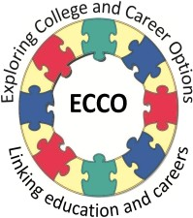***WELCOME***

Your class is getting ready to make a Career Exploration Visit. The purpose of this Guide is to help you plan for the visit so that you will get the most out of the experience.

Your teacher will present three workshops BEFORE the visit—and two workshops AFTER the visit to help you reflect on what you learned. This packet contains the materials that you will use during the workshops, as well as resources you will need DURING the visit.

***WHAT IS A CAREER EXPLORATION VISIT?***

This Guide will help you prepare for one type of work-­‐based learning activity—a group Career Exploration Visit—which is a half-­‐day off-­‐campus experience during which the group visits an organization to observe and spend time with local people who work in a career theme area of interest.

***GOALS OF THE VISIT***

The goals of the Career Explorations Program are to:

* Understand how the skills you are learning in the Academy are used in different jobs and careers
* Increase your awareness of careers in your Academy theme area
* Observe how transferable skills and technology are used in different theme-­‐ related jobs
* Become comfortable and confident when interacting with adults in the business community
* Learn the skills you need to get and keep certain jobs

***YOUR RESPONSIBILITIES***

1. Participate in workshops to prepare in advance of the visit
2. Have a parent or guardian sign the consent form and return it to school
3. Notify teachers whose classes you will miss
4. Participate actively in Career Exploration Visit activities—pay close attention to what is said and demonstrated
5. Ask questions, take notes, and record observations
6. Observe all safety rules
7. Adhere to behavior guidelines established by the school staff or employer host
8. Dress appropriately
9. Participate in reflection workshops to think and talk about the visit
10. Complete writing assignments
11. Write a thank you letter to the host
12. Complete a Student Feedback Form

***GOOD LUCK—AND ENJOY YOUR VISIT!!***

#### Researching the Organization

|  |
| --- |
| **Purpose** |
| This activity allows students to make predictions about what they expect to observe and learn during the Career Exploration Visit. |

|  |
| --- |
| **Suggested Grade Level:** |
| 11 |

|  |
| --- |
| **Materials and Handouts** |
| Researching the Organization |

|  |
| --- |
| **Approximate Time Needed:** |
| 25 minutes |

**Student-Facing Instructions**

Knowing how to do research to find accurate information is a life-long skill particularly critical for getting into and succeeding in college.

Turn to the “Researching the Organization” handout and review the points about research at the top of the page. Conduct online research to find out the answers to as many of these questions as you can. While you are doing your research, make note of other interesting information about the company and list other ques- tions that come up. There may be questions that you can’t find answers to, but you will learn more during the Career Exploration Visit.

**Teacher Notes**

Review the questions:

1. What does the organization do?
2. Who are the customers/clients of this organization?
3. How long has the organization been in business?
4. What are some of the jobs at this organization?
5. How large or small is the organization (# employees, # people served/year, etc).
6. How does the organization incorporate new and emerging technology?
7. Other questions that you choose to add

Demonstrate how to find the answer to one of the questions using print materials that you have collected and/

or the internet.

Tell students they can do this individually or in pairs and record their answers on their worksheet. Tell students that while they’re doing their research and taking notes, they should also:

* + Make notes about other interesting information they learn
  + List some of their own questions that come up
  + Skip questions that they can’t find answers to.

After about 15 minutes, tell the group to stop their research. Review their answers to each question.

**Assessment**

Completion of worksheet.

**Instructions**

Knowing how to do research to find accurate information is a life-long skill particularly critical for getting into and succeeding in college.

Turn to the “Researching the Organization” handout and review the points about research at the top of the page. Conduct online research to find out the answers to as many of these questions as you can. While you are doing your research, make note of other interesting information about the company and list other ques- tions that come up. There may be questions that you can’t find answers to, but you will learn more during the Career Exploration Visit.

###### Researching the Organization



**What is research?**

**Research is...**

v ...what we do when we want information to answer a question or resolve an issue.

v ...the process of collecting information about any subject of interest.

v ...active: reading material and checking web-based sources to gather information, taking notes, interpreting and evaluating the information, documenting what you learned, revising your opinions if necessary.

v ...motivating, challenging and enlightening…and it can be fun. It’s a skill that will lead you to success both in college and in the world of work.

* 1. What does the organization do?
  2. Is it a for-profit company, not-for-profit organization, or a government agency?
  3. Who are the customers/clients of this organization?
  4. How long has the organization been in business?
  5. What are some of the jobs at this organization?
  6. How large or small is the organization (# employees, # people served/year, etc)?



* 1. How does the organization incorporate new and emerging technology?

Other interesting information I learned from my research:

#### Making Predictions

|  |
| --- |
| **Purpose** |
| This activity allows students to make predictions about what they expect to observe and learn during the Career Exploration Visit. |

|  |
| --- |
| **Suggested Grade Level:** |
| 11 |

|  |
| --- |
| **Materials and Handouts** |
| Making Predictions |

|  |
| --- |
| **Approximate Time Needed:** |
| 10 minutes |

**Student-Facing Instructions**

Turn to the handout, “Making Predictions” and answer the questions about what you think you will find on the Career Exploration Visit.

**Teacher Notes**

Definition: Ask students what the word prediction means. Note: the prefix Pre = before. “Dict” is derived from the Latin meaning “to say”. Predicting is saying something before it actually happens.

Types of Predictions: What kinds of predictions do we experience daily? Possible answers: will it be sunny or rainy? Is the stock market going up or down? Who will win the Grammy for Best Male Vocalist? Will the Oak- land Raiders or the Tampa Bay Buccaneers get to the Super Bowl? Who will be elected President?

Jobs Involving Predictions: If there is time, you could list the numerous actual jobs where the main task is to make public predictions, such as weather forecaster, political analyst, (and add to ENDLESS JOB LIST, if you have already started it In the Career Development Workshops).

Making Predictions: Now have each student write his/her predictions in the Guide on the page, Making Pre- dictions. Give one of your own predictions to model the type of responses you expect (For example, “I expect to see the chef using lots of new equipment in the kitchen. “ Or “I expect to see people using state-of-the-art, high-tech video equipment.”)

Sharing Predictions: Call on a few students to share their predictions. Tell students that they’ll revisit these predictions after the visit.

**Assessment**

Completion of worksheet.

**Instructions**

Turn to the handout, “Making Predictions” and answer the questions about what you think you will find on the Career Exploration Visit.

###### Making Predictions

Imagine what your career exploration site will be like by answering the following questions.

What skills do you think employees need to have to do their job well?

What do you predict the atmosphere will be like at the workplace?

What do you think a typical day is like at this workplace?

What do you predict you will learn?



Career Exploration Visits: Career Explorations: What, Where, Why Copyright © 2012 MDRC, All Rights Reserved

Student Workshop #1, Page 5

July, 2012

#### Tips for Professional Introductions

|  |
| --- |
| **Purpose** |
| This activity allows students to prepare for professional introductions using best practices. |

|  |
| --- |
| **Suggested Grade Level:** |
| 11 |

|  |
| --- |
| **Materials and Handouts** |
| Professional Introductions Feedback Form Tips for Professional Introductions |

|  |
| --- |
| **Approximate Time Needed:** |
| 15 minutes |

**Student-Facing Instructions**

Any interview starts with introductions. So what does this mean: “You never get a second chance to make a first impression”?

This activity will provide you with a few skills that will lead to making a good, professional impression the first time around. When you meet someone for the first time in a professional setting it’s important to be able to talk briefly about yourself.

Turn to the handout, “Tips for Professional Introductions” and review it.

Think about and write down on page 2 a few words or phrases that describe your career academy. Brainstorm with the class.

Suggest short summary sentences that describe the academy.

Write your own 2-3 sentence description of your academy and the skills you are learning.

In pairs, use the “Introduction Peer Feedback Form” to take turns practicing your introduction and giving feedback to each other.

**Teacher Notes**

Conduct a group brainstorm session -- have students call out some of their answers which you record.

After you have a good collection of words and phrases, ask students to suggest short summary sentences which you will write down. This is often called an “elevator speech” because it’s something short that you can tell someone about a topic in the time it takes an elevator to go from one floor to another.

Now ask students to spend about 5 minutes to write their own 2-3 sentence description of their career academy and the skills they are learning.

Call on students to read what they have written. If students hear another answer they prefer, they can write that down on their sheet as well. At the end of this activity students should have a concise statement explaining about the academy and themselves.

**Assessment**

Completion of feedback form.

**Instructions**

Any interview starts with introductions. So what does this mean: “You never get a second chance to make a first impression”?

This activity will provide you with a few skills that will lead to making a good, professional impression the first time around. When you meet someone for the first time in a professional setting it’s important to be able to talk briefly about yourself.

Turn to the handout, “Tips for Professional Introductions” and review it.

Think about and write down on page 2 a few words or phrases that describe your career academy. Brainstorm with the class.

Suggest short summary sentences that describe the academy.

Write your own 2-3 sentence description of your academy and the skills you are learning.

In pairs, use the “Introduction Peer Feedback Form” to take turns practicing your introduction and giving feedback to each other.

Introductions - Peer Feedback Form

Observer

Rate how well conducted the introduction.

(Fill in student’s name)

Put one check mark ✓ in the box for your rating of each of the criteria.

|  |  |  |  |  |
| --- | --- | --- | --- | --- |
| **CRITERIA** | **GREAT!**  **FIRST RATE PROFESSIONAL** | **NICE BUT**  **COULD BE**  **BETTER** | **JUST OK** | **NEEDS MORE PRACTICE** |
| **Said name clearly** |  |  |  |  |
| **Physical appearance** |  |  |  |  |
| **Smiled, was friendly** |  |  |  |  |
| **Shook hands firmly** |  |  |  |  |
| **Maintained eye contact** |  |  |  |  |
| **Spoke clearly and slowly** |  |  |  |  |
| **Gave brief, clear description of the career academy** |  |  |  |  |

**TIPS for Professional Introductions**

1. Say your name clearly.

It’s not about being speedy; it’s about being heard and remembered.

***Bottom line: Show confidence with your name.***

1. Physical appearances create first impressions.

It’s not about what you look like; it’s how you present yourself.

***Bottom line: Dress appropriately for the world of work.***

1. Smile, be friendly.

It’s not about hugs; it’s about being positive and warm.

***Bottom line: Smile as if you mean it.***

1. Shake hands firmly

It’s not about physical strength; it’s about personal confidence.

***Bottom line: Shake confidently at the beginning and at the end.***

1. Maintain eye contact

It’s not about staring; it’s about showing that you are interested and listening.

***Bottom line: Focus on who you’re talking with.***

1. Describe your Career Academy

It’s not about telling your life story; it’s about briefly and clearly describing what you’re learning in your Academy.

***Bottom line*: *Speak clearly and be proud of your skills.***





Career Exploration Visit: Making a Professional First Impression Copyright © 2012 MDRC, All Rights Reserved

Student Workshop #3, Page 1

July, 2012

**TIPS for Professional Introductions** page 2

Describe your Career Academy

Think for a minute or two of some words or phrases that describe your career academy and record them below:

After the group brainstorm, write your own 2-3 sentence description of the career academy that you will use on the career exploration visit.



Career Exploration Visit: Making a Professional First Impression Copyright © 2012 MDRC, All Rights Reserved

Student Workshop #3, Page 2

July, 2012

#### Questions for the Career Exploration Visit

|  |
| --- |
| **Purpose** |
| This activity allows students to learn and practice the skills to make a professional and favorable first impression. |

|  |
| --- |
| **Suggested Grade Level:** |
| 11 |

|  |
| --- |
| **Materials and Handouts** |
| Questions, Questions, Questions The Interview  Skills for Success Expanded |

|  |
| --- |
| **Approximate Time Needed:** |
| 15 minutes |

**Student-Facing Instructions**

In your group, turn to the “Questions, Questions, Questions” handout as well as the expanded version of the “Skills for Success” from the last session. Review the questions together. Each group should select 5-8 questions that you want to ask on the visit. You may write them down on the “Interview” handout and bring that with you on the visit.

Based on your practice today, write down one thing you need to work on or improve to be “professional” during the Career Exploration Visit.

**Teacher Notes**

Have students get into their groups for the visit and turn to Questions, Questions, Questions in the Guide and the Career Academy Skills for Success from the previous workshop.

Review the questions as a whole group and check for understanding. Give the groups time to select/write the questions they want to ask.

Tell them that each group should have 5 to 8 questions ready to ask. They can pick questions from this list or dream up their own, based on their research and predictions.

Have students write their questions on the bottom of the page or on a separate sheet of note paper which

they will bring with them on the visit.

**Assessment**

Completion of worksheet, “Questions, Questions, Questions,” with 5-8 questions selected.

**Instructions**

In your group, turn to the “Questions, Questions, Questions” handout as well as the expanded version of the “Skills for Success” from the last session. Review the questions together. Each group should select 5-8 questions that you want to ask on the visit. You may write them down on the “Interview” handout and bring that with you on the visit.

Based on your practice today, write down one thing you need to work on or improve to be “professional” during the Career Exploration Visit.

**Questions, Questions, Questions**

1. What is a typical day like for you?
2. What/s the biggest challenge of your job and how do you meet that challenge?
3. What’s the most amusing thing that’s happened to you at work?
4. What’s the most important job duty you have?
5. What skills do you have you can also use in other jobs/careers (transferable skills)?
6. How did you learn those skills?
7. What about your job makes you want to come to work every day?
8. What experience and education got you where you are today?
9. How do you contribute to the success of the organization?
10. What advice would you give us if we want a job like yours?
11. What are some of the entry level jobs here that someone can get with little or no prior experience?
12. How does a person climb the career ladder from an entry level position to top management?



Career Exploration Visit: Making a Professional First Impression Copyright © 2012 MDRC, All Rights Reserved

Student Workshop #3, Page 4

July, 2012

The Interview

Name of person you are interviewing

Job title: E-mail address:

Question #1

Response:

Question #2

Response:

Question #4

Response:

Question #6

Response:

**Career Academy Skills for Success**



Expanded Version

|  |  |  |
| --- | --- | --- |
| **CREATIVE AND CRITICAL THINKING** | | |
| v **Solve problems and make decisions**   * Understand the issue or problem * Get accurate information * Consider many solutions * Consult with others * Make an informed decision * Evaluate decision and reflect on the process | v **Think creatively**   * Explore many alternative ways of looking at something * Use brainstorming to generate innovative ideas * Ask “what if” questions to explore options * Be open to new and diverse ideas * Solve old problems in new ways * Think “out-of-the-box” | |
| v **Learn through research**   * Gather and organize information * Use many methods: web searches, library, data bases, print materials, interviews, etc. * Collect and interpret information to answer a question or confirm a prediction * Use variety to communicate information: verbal presentations, power point, video, You Tube, written reports, etc. * Retain information for future use | v **Reflect and evaluate**   * Examine your thoughts, feelings and reactions * Think about what you have learned from an experience * Determine what else you need to know * Plan next steps | |
| **COMMUNICATION** | | |
| v **Write clearly**   * Know your audience * Organize your ideas * Stick to the point; make it interesting * Use correct grammar, spelling and sentence structure * Proofread! Proofread! Proofread! | | v **Speak distinctly**   * Use language and tone appropriate for the audience * Know what you want to say * Speak slowly and pronounce words carefully * Keep it simple; don’t say too much * Check to make sure you are being understood |
| v **Listen carefully and ask good questions**   * Pay close attention to the speaker(s) * Maintain eye contact * Ask questions or repeat back to check for understanding * Confirm understanding verbally or otherwise * Retain information for further use | | v **Observe effectively**   * Watch for visual information * Ask questions if you aren’t sure about * what you are seeing or hearing * Reflect to determine the meaning of what you are seeing or hearing   o Confirm understanding verbally or otherwise |

**Career Academy Skills for Success** page 2

|  |  |
| --- | --- |
| **COLLABORATION AND TEAMWORK** | |
| v **Cooperate with others**   * Understand the goals of the team * Make courteous and friendly contributions * Respect opinions different from your own * Respect racial and cultural diversity * Be flexible; make compromises as needed * Know everybody’s roles and responsibilities | v **Give and receive feedback**  When you **give** feedback, remember to:   * Begin with positive comments; then negative * Be specific and ask for response * Choose the right time * Don’t blame * Be honest & don’t always expect acceptance   When you **receive** feedback, remember to:   * Listen without judgment * Think carefully before responding * Thank the giver |
| v **Negotiate challenges and resolve conflicts**   * Approach problems positively * Try to get to the root of the problem without blaming * Evaluate multiple paths to resolve a conflict before taking action * Cooperate courteously with others involved in the conflict * Be constructive, not destructive, in a conflict | v **Plan and prioritize to reach a goal**   * Set short and long term goals * Assess how realistic your goals are * Prioritize in order of importance * Create realistic timelines * Reflect on your success and plan for next time |
| **MEDIA AND TECHNOLOGY** | |
| v **Use new and emerging technology**   * Know what technology to use for a given purpose * Continually update your skills * Use digital technology for learning purposes (research, organizing and communicating information) * Use multi-media to communicate * Evaluate how technology assists you, and adapt in the future, if necessary | v **Use responsible behavior regarding technology (“digital citizenship”)**   * Know appropriate uses of cell phone, email, tweets, Face Book, chat rooms, etc. * Recognize legal, ethical and safety issues (on-line purchases; downloading music) * Learn to evaluate digital information for accuracy |

**Career Academy Skills for Success** page 3

|  |  |
| --- | --- |
| **PERSONAL QUALITIES** | |
| v **Manage time effectively**   * Know what needs to be accomplished * Prioritize tasks * Break big tasks into small chunks * Keep a daily or weekly “to do” list | v **Demonstrate appropriate behavior and attire**   * Meet workplace standards on attendance,   o punctuality and dress code   * Maintain confidentiality * Exhibit maturity, confidence, flexibility and self control |
| v **Show initiative and work independently**   * Set your own goals * Take on tasks without being asked * Be ready to work on your own without supervision * Be motivated and demonstrate “get up and go” | v **Recognize and respond appropriately to workplace challenges**   * Know potential challenges (discrimination,   o harassment)   * Understand what’s legal and what’s not * Know the “chain of command” to follow if you have a complaint * Know how to advocate for yourself and others |
| v **Be reliable and dependable**   * Be where you need to be, on time (or early!) * Ask if you are not certain what is expected * Be honest and true to your word * Make sure that others know they can count on you |

#### Skills for Success Observed

|  |
| --- |
| **Purpose** |
| This activity allows students to identify the Skills for Success they observed at the worksite. |

|  |
| --- |
| **Suggested Grade Level:** |
| 11 |

|  |
| --- |
| **Materials and Handouts** |
| Skills for Success Observed |

|  |
| --- |
| **Approximate Time Needed:** |
| 10 minutes |

**Student-Facing Instructions**

Look at the “Skills for Success” list and think about what skills you observed or heard about on the CEV. List at least 3 skills you heard about or saw in action on the “Skills for Success Observed on the Career Exploration Visit” form. Share your list with a partner. Tell each other where and when you saw or heard about it.

**Teacher Notes**

Ask students to take a few minutes to look at their Career Academy Skills for Success sheet from workshop #2 and think about what skills they observed or heard about on the visit.

Have students jot down at least 3 skills they observed or heard discussed during the visit on the Skills for Success Observed on the Career Exploration Visit form.

Ask students to turn to a partner and share their lists. Make sure they tell each other where and when they saw or heard about it.

Ask for a few pairs to share their observations.

**Assessment**

Completion of worksheet.

**Instructions**

Look at the “Skills for Success” list and think about what skills you observed or heard about on the CEV. List at least 3 skills you heard about or saw in action on the “Skills for Success Observed on the Career Exploration Visit” form.

Share your list with a partner. Tell each other where and when you saw or heard about it.

**Skills for Success Observed on the Career Exploration Visit**



Career Exploration Visit: What does the Career Exploration Visit Mean for ME? Copyright © 2012 MDRC, All Rights Reserved

Student Workshop #4, Page 1

July, 2012

|  |  |
| --- | --- |
| **SKILLS FOR SUCCESS OBSERVED WHERE AND WHEN THEY ON THE VISIT WERE OBSERVED** | |
|  |  |
|  |  |
|  |  |
|  |  |
|  |  |

#### Checking Predictions

|  |
| --- |
| **Purpose** |
| This activity allows students to learn and practice the skills to make a professional and favorable first impression. |

|  |
| --- |
| **Suggested Grade Level:** |
| 11 |

|  |
| --- |
| **Materials and Handouts** |
| Checking Predictions |

|  |
| --- |
| **Approximate Time Needed:** |
| 15 minutes |

**Student-Facing Instructions**

Turn to the “Checking Predictions” handout and fill in the blanks with your answers to the questions.

1. Before the career exploration visit, I thought , but now I think .
2. One of my predictions that turned out to be true was: .
3. One of my predictions that turned out to be false was: .

Pair up with someone you don’t know well and compare your responses to the “Checking Predictions” handout.

**Teacher Notes**

What is Reflection?

Tell students that today’s workshop is “all about you” --reflecting back on the visit and thinking about what it means for YOU. Explain the concept of reflection:

* + Reflection is a way to look back on an experience and learn from it
  + Reflection is carrying on a dialog with yourself to think deeply about what’s important to you
  + Reflection is a way to think about experiences so that you come to a new understanding
  + Reflection isn’t about finding the right answer.

**Assessment**

Completion of worksheet.

**Instructions**

Turn to the “Checking Predictions” handout and fill in the blanks with your answers to the questions.

1. Before the career exploration visit, I thought , but now I think .
2. One of my predictions that turned out to be true was: .
3. One of my predictions that turned out to be false was: .

Pair up with someone you don’t know well and compare your responses to the “Checking Predictions” handout.

**Checking Predictions**



Career Exploration Visit: What does the Career Exploration Visit Mean for ME? Copyright © 2012 MDRC, All Rights Reserved

Student Workshop #4, Page 2

July, 2012

* 1. Before the career exploration visit, I thought _

,

but now I think

.

* 1. One of my predictions that turned out to be true was:
  2. One of my predictions that turned out to be false was:

#### Draft a Thank You Letter

|  |
| --- |
| **Purpose** |
| This activity introduces students to tips and practices for writing thank you letters. |

|  |
| --- |
| **Suggested Grade Level:** |
| 11 |

|  |
| --- |
| **Materials and Handouts** |
| Tips for Writing Thank You Letters Sample Format for Thank You Letters Thank You Letter Checklist  Draft Thank You Letter |

|  |
| --- |
| **Approximate Time Needed:** |
| 40 minutes |

**Student-Facing Instructions**

In this activity, you will write a thank you letter to the company host or to the individual employee hosts with whom you spent time. The recipient of the letter will depend on the structure of the visit or a specific individual at the direction of your teacher.

Begin your draft thank you letter to your visit host or employee. Review the tips, sample format and checklist.

As you draft your thank you letter, refer to the following for ideas: your reflections and the Skills for Success.

**Teacher Notes**

Ask students when they last received or sent a thank you letter. Elicit some responses and conclude with the question: What happens when you send or receive a letter of appreciation?

Possible responses could be:

* The sender will be remembered positively
* The recipient will be proud of what they were being thanked for
* The potential for a continued relationship is established

Do a quick read aloud of the Tips for Writing Thank You Letters and ask for any comments. Conclude the

discussion of tips by asking if these apply to both handwritten and email letters of appreciation.

Quickly review the Sample Thank You Letter Template and instruct students to use it as a guide as they write their own letters. If you have developed the assignment together with the English teacher, give students any additional requirements of the assignment, including the Thank You Letter Checklist.

As students finish their drafts, ask them to swap with a partner and ask for suggestions. They should use the checklist provided to guide their review.

Students will revise their letters based on the peer feedback checklist and type them on the computer as you circulate and review. These final copies are to be turned into you at the end of the workshop.

**Assessment**

Completion of Thank You letter.

**Instructions**

In this activity, you will write a thank you letter to the company host or to the individual employee hosts with whom you spent time. The recipient of the letter will depend on the structure of the visit or a specific individual at the direction of your teacher.

Begin your draft thank you letter to your visit host or employee. Review the tips, sample format and checklist.

As you draft your thank you letter, refer to the following for ideas: your reflections and the Skills for Success.

**TIPS for Writing Thank You Letters**



1. Write it promptly ...

Procrastination detracts from the impact of the letter.

1. Keep it short and simple …

One page is plenty to get your message across.

1. Be personal ...

Show that you were listening and mention something that you learned from your host.

1. Be scholarly …

Show that you understand the importance of high school and college—and use

the skills and vocabulary learned in the workshops.

1. Be accurate …

Correct spelling and grammar are critical.

1. Use correct names, spellings, and titles…

If you are in doubt, ask your teacher (or call the organization to verify).

**Sample Format for Thank You Letters**



Writing a letter of appreciation demonstrates professional courtesy. Telling people how much you appreciate their efforts makes them feel good about what they do, it makes a good impression, and it helps them remember YOU.

Use the format below as a guide to draft a thank you letter to your career exploration visit host.

Date (month, day, year)

Host’s Name, Title Name of Company Street Address

Suite, Floor, or Room Number City, State, Zip Code

Dear Mr. or Ms. (host’s last name),

*Paragraph 1* - Thank your host for the opportunity to do the visit

*Paragraph 2* - Describe some of the things you learned. Be sure to mention at least three of the transferable skills in the Career Academy Skills for Success and use other new vocabulary words.

*Paragraph 3* - Add any additional comments you have Sincerely,

Sign your name

###### Thank You Letter Checklist

û

ü



|  |  |  |
| --- | --- | --- |
|  | **YES** | **NO** |
| **Is it short and simple?** *Is it one page?* |  |  |
| **Is it personal?** *Is something specific that was learned mentioned?* |  |  |
| **Is it scholarly?** *Are skills or vocabulary mentioned?* |  |  |
| **Is it accurate?** *Are correct grammar and spelling used?* |  |  |

**Draft Thank You Letter**

***________***



***________***

***________***

***________***

***________***

***________***

***________***

***________***

***________***

***________***

***________***

***________***

***________***

***________***

***________***

***______***

***______***

***______***

***______***

***______***

***______***

***______***

***______***

***______***

***______***

***______***

***______***

***______***

***______***

***______***

***______***

***______***

***______***

***______***

***______***

***______***

***______***

***______***

***______***

***______***

***______***

***______***

***______***

***______***

***______***

***___***

***___***

***___***

***___***

***___***

***___***

***___***

***___***

***___***

***___***

***___***

***___***

***___***

***___***

***___***

***________***

***________***

***________***

***________***

***________***

***________***

***________***

***________***

***________***

***________***

***________***

***________***

***________***

***________***

***________***

***______***

***______***

***______***

***______***

***______***

***______***

***______***

***______***

***______***

***______***

***______***

***______***

***______***

***______***

***______***

***______***

***______***

***______***

***______***

***______***

***______***

***______***

***______***

***______***

***______***

***______***

***______***

***______***

***______***

***______***

#### Career Exploration Visit Feedback Form

|  |
| --- |
| **Purpose** |
| This activity allows students to evaluate their experience with the career exploration visits and workshops. |

|  |
| --- |
| **Suggested Grade Level:** |
| 11 |

|  |
| --- |
| **Materials and Handouts** |
| Career Exploration Visit Feedback Form |

|  |
| --- |
| **Approximate Time Needed:** |
| 10 minutes |

**Student-Facing Instructions**

Please complete the “Student Feedback Form”. Your opinion is important and will help future career exploration students.

**Teacher Notes**

Distribute the Student Feedback Form and explain the importance of feedback.

**Assessment**

Completion of feedback form.

**Instructions**

Please complete the “Student Feedback Form”. Your opinion is important and will help future career exploration students.

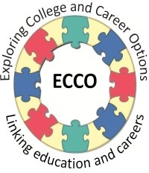**Career Exploration Visit: Student Feedback Form**

*Congratulations on completing your career exploration visit! Please tell us what you thought about it.*

* 1. What was the name of the organization that you visited?
  2. Please rate each of the statements below. *(Circle one response for each item; 1 means that you strongly agree and 4 means that you strongly disagree)*

|  |  |  |  |  |
| --- | --- | --- | --- | --- |
|  | Strongly Agree | Sort of Agree | Sort of Disagree | Strongly Disagree |
| The visit helped me think about career options | 1 | 2 | 3 | 4 |
| I learned what the expectations are for being a good employee | 1 | 2 | 3 | 4 |
| I learned what skills are needed to perform my host’s job  (Your host was the person who showed you around and whom you interviewed) | 1 | 2 | 3 | 4 |
| I enjoyed my career exploration visit | 1 | 2 | 3 | 4 |
| I felt well prepared by my school to get the most out of the visit. | 1 | 2 | 3 | 4 |
| My host was helpful and informative during my career exploration visit | 1 | 2 | 3 | 4 |
| My career exploration visit helped me see how school is important to my future plans | 1 | 2 | 3 | 4 |
| I can see myself working at a place like this in the future | 1 | 2 | 3 | 4 |

* 1. The most important thing I learned on my career exploration visit was:



Career Exploration Visit: Expressing Appreciation Copyright © 2012 MDRC, All Rights Reserved

Student Workshop #5, Page 5

July, 2012

* 1. Prior to the visit, which of these things did you do to prepare? (Check Yes or No for each activity)

|  |  |  |
| --- | --- | --- |
| ACTIVITY | YES | NO |
| Researched information about the organization |  |  |
| Prepared questions to ask |  |  |
| Learned and practiced how to make a professional introduction |  |  |
| Learned about transferable skills (Career Academy Skills for Success) |  |  |
| Anything else? |  |  |

* 1. After the visit, which of these things did you do to reflect? (Check Yes or No for each activity)

|  |  |  |
| --- | --- | --- |
| ACTIVITY | YES | NO |
| Shared what we did and learned with other students in the class |  |  |
| Compared our predictions (what we expected to see) with what actually happened on the visit |  |  |
| Was assigned to write a reflection |  |  |
| Was assigned to write a thank you note to the host |  |  |
| Anything else? |  |  |

* 1. How could future Career Exploration Visits be improved?
  2. What grade are you in? (Check one)

9th Grade 10th Grade 11th Grade 12th Grade

* 1. Have you ever had a paid job? (Check one) Yes No



Career Exploration Visit: Expressing Appreciation Copyright © 2012 MDRC, All Rights Reserved

Student Workshop #5, Page 6

July, 2012

Teacher Resource

**Unit Culminating Task:**

#### Career Exploration Visit Reflective Essay

|  |
| --- |
| **Purpose** |
| The purpose of this task is to do final preparations for a reflective essay in which students describe their impressions and what they learned during the Career Exploration Visit. |

|  |
| --- |
| **Suggested Grade Level:** |
| 11 |

|  |
| --- |
| **Materials and Handouts** |
| None |

|  |
| --- |
| **Approximate Time Needed:** |
| Varies |

**Student-Facing Instructions**

Use your Career Exploration Visit handouts and notes to write a reflective essay about your visit. Your essay should include:

* Why do a Career Exploration Visit?
* What did you learn through your research of the organization?
* What skills did you predict you would see in the workplace?
* What skills did you observe or hear about during the visit?
* How did your perspective about school and/or life change as a result of the visit?
* What new learning goals have you set for yourself as a result of the visit? How will you meet these learning goals?
* What conclusions have you made about workplace based on your visit?

**Teacher Notes**

This task should be given after students have completed the following lessons in the Career Exploration Visits unit and have participated in a Career Exploration Visit to a workplace.

Lessons: Why Do Career Exploration Visits, Researching the Organization, Making Predictions, Skills for Success Observed, Checking Predictions

**Assessment**

Written reflection assessed against aligned rubric:

Student Learning Outcomes assessed in this task:

* Review prior learning for a broader perspective about educational or life events
* Sets relevant, realistic, and challenging goals and develops a comprehensive plan for achieving those goals

**Instructions**

Use your Career Exploration Visit handouts and notes to write a reflective essay about your visit. Your essay should include:

* Why do a Career Exploration Visit?
* What did you learn through your research of the organization?
* What skills did you predict you would see in the workplace?
* What skills did you observe or hear about during the visit?
* How did your perspective about school and/or life change as a result of the visit?
* What new learning goals have you set for yourself as a result of the visit? How will you meet these learning goals?
* What conclusions have you made about workplace based on your visit?

# Theme: Career Preparation

## Professionalism

#### From the Horse’s Mouth

|  |
| --- |
| **Purpose** |
| This activity allows students to explore careers that they are interested in pursuing and to understand their skill set in the context of the careers that they want to pursue. |

|  |
| --- |
| **Suggested Grade Level:** |
| 10 |

|  |
| --- |
| **Materials and Handouts** |
| Career Interview Template |

|  |
| --- |
| **Approximate Time Needed:** |
| Varies |

**Student-Facing Instructions**

Take out your career cards from the lesson “The Career for Me.”

In groups, think of questions to ask of the following:

* Parents
* Relatives
* Friends of the family
* Neighbors
* Community members at a church or community organization
* Career Exploration Visits
* Presenters

You will select 1-3 people that are in careers you are interested in and conduct career interviews using the Career Interview Template.

**Teacher Notes**

Requires the career cards from the lesson The Career for Me (Researching Careers unit)

1. Explain that sometimes we think that we want certain careers based on what we may have seen on TV or heard from other people, but the only way to know whether you want to do something is to actually do it or talk to someone who does.
2. Give each participant 3 copies of the career interview template and explain that they are going to do

career interviews.

1. Explain that each participant should find 1-3 people that are in the careers they are interested in and interview them.
2. Have participants get into groups of 4-5
3. Within each group, have participants take turns sharing what career(s) they are interested in, and brain- storm as a group various people they could reach out to for

Interviews:

Have groups think of the careers in their network of and come up with questions for the individuals they will interview. At the next session, have students share the information that they got out of their interviews.

**Assessment**

What was learned from the interviews.

**Instructions**

Take out your career cards from the lesson “The Career for Me.”

In groups, think of questions to ask of the following:

* Parents
* Relatives
* Friends of the family
* Neighbors
* Community members at a church or community organization
* Career Exploration Visits
* Presenters

You will select 1-3 people that are in careers you are interested in and conduct career interviews using the Career Interview Template.

Career Interview Template

* 1. Why did you choose to work in the field you are in?
  2. What do you like most about your work?
  3. What do you like least about your work?
  4. What are the key skills needed to be successful in your work place?
  5. How did you prepare for this line of work? (College, Internship, Certifications?)
  6. Is it difficult to work with/ collaborate with others? What are the challenges? What are the benefits?
  7. What advice do you have for someone like me just beginning to think about my future career?

#### 20 Questions Activity

|  |
| --- |
| **Purpose** |
| This activity allows students to practice asking and an- swering difficult interview questions and practice offering succinct yet insightful responses to questions. |

|  |
| --- |
| **Suggested Grade Level:** |
| 11 |

|  |
| --- |
| **Materials and Handouts** |
| 50 Interview Questions |

|  |
| --- |
| **Approximate Time Needed:** |
| 30-45 minutes |

**Student-Facing Instructions**

How do you talk to adults? This activity will allow you to practice interviewing in a game-show format. As you do the activity, think about the following questions:

• What did you notice about how responded to these questions?

• What made it hard?

• What was easy for you?

• What are some qualities you feel interviewers are looking for in your responses?

• What did you notice appealed to the “judges” in this activity?

**Teacher Notes**

This is a game show activity that builds from the internship lessons (ie. First Week on the Job lesson). The lesson is designed to demonstrate how to talk to adults at the workplace? Practice for the break room.

1. Explain to participants that in this activity participants will take turns playing a contestant and a host on an Interview Game Show.
2. In each round, there will be 1 host, 3 judges, and 3 contestants.
3. The judge will select a question from the 50 Interview Questions Handout.
4. Each of the contestants will have 3 minutes to answer the question as best they can.
5. The judges will listen to the responses and select the response that they feel would best impress an interviewer, and share why.
6. This activity can go a few rounds, until everyone has had a turn to “interview” or you can play one round each day over a few weeks.

**Assessment**

Completion of activity.

**Instructions**

How do you talk to adults? This activity will allow you to practice interviewing in a game-show format. As you do the activity, think about the following questions:

• What did you notice about how responded to these questions?

• What made it hard?

• What was easy for you?

• What are some qualities you feel interviewers are looking for in your responses?

• What did you notice appealed to the “judges” in this activity?

* 1. How would you describe yourself?
  2. Describe yourself in one word.
  3. Name 3 of your strengths and weaknesses.
  4. What type of books, magazines and newspapers do you read? Which were the latest ones you read?
  5. Why did you choose your specific university?
  6. How was your transition from high school to university?
  7. Tell me more about your academic performances.
  8. How will your university education benefit your future career?
  9. Do you have any plans to continue studying, for an advanced degree for example?
  10. If given the chance, would you have done anything differently in your university career?
  11. What would you have done anything differently in your life until now?
  12. Where do you see yourself 5 years from now?
  13. What makes you angry?
  14. Describe your ideal job following graduation.
  15. What career goals have you set yourself?
  16. What influenced you to choose this career path?
  17. What traits and qualifications do you have which will make you successful in this career path?
  18. Why do you want to work at our company?
  19. What do you know about our company?
  20. Why should I hire you?
  21. I can also hire someone internally in the firm. Why should I hire an external person such as you?
  22. What changes would you make in our company if I hired you?
  23. You`re standing in an elevator with your potential future boss -­‐ how would you sell yourself in 10 seconds?
  24. You are allowed to ask someone in history a single question. Who would you choose and what is your question?
  25. How many airplanes are there in the world?
  26. How would you gain the confidence of a client who has over 30 years experience?
  27. Do you prefer working alone or in a team?
  28. What is the role you adopt whilst working in a team?
  29. Tell me about a problem you faced whilst working in a team. How did you resolve the problem?
  30. How good are you at solving conflicts?
  31. What would you do if a colleague is underperforming, which is hurting you and your division as well?
  32. Are you good at dealing with stress? Give me several examples which demonstrate this.
  33. Are you willing to travel for the job?
  34. Are you willing to relocate for the job?
  35. What was the biggest challenge you ever faced?
  36. Describe a situation where you successfully convinced others of your ideas.
  37. Describe a situation where you arrived at a compromise with a colleague.
  38. Please give me some examples which show that you can adapt to a variety of people, cultures, and environments.
  39. Which areas of the world would you like to explore and why?
  40. Are you good at handling several tasks and responsibilities simultaneously?
  41. How do you determine priorities in your planning?
  42. How would your friends describe you?
  43. Have you ever considered starting your own business?
  44. Tell me more about your prior internship/job experience. How would your previous colleagues describe you?
  45. What is the most significant contribution you made in your previous company?
  46. Could you have done better in your previous job?
  47. What would you like to improve professionally about yourself?
  48. Your boss tells you in confidence that he is considering firing a colleague, who happens to be your best friend at work. How would you handle this situation?
  49. Tell me a joke.
  50. What would you do with 1 million ping-­‐pong balls?

#### Speed Dating Networking Activity

|  |
| --- |
| **Purpose** |
| This activity provides students with an understanding of the concept of networking and allows them to practice networking in small groups. |

|  |
| --- |
| **Suggested Grade Level:** |
| 11 |

|  |
| --- |
| **Materials and Handouts** |
| Networking Questions Index Cards (3 per student) |

|  |
| --- |
| **Approximate Time Needed:** |
| 15-25 minutes |

**Student-Facing Instructions**

People Network in order to build and make connections so that they will have future opportunities, or can help each other. In this group activity each person will be asking the other person a list of questions.

Throughout this activity, you may find a MATCH in either their skills or interests that would make you want to exchange information and connect later. If you feel you’ve made a MATCH in either skill or interest, exchange index cards.

• After the activity, reflect on the following questions:

• What did you like about this activity?

• Did any of you find any connections? Did any of you exchange cards?

• What was easy about this activity? What was hard?

• Why is it important to share information about yourself?

• How is asking interesting questions connected to Networking?

• Why is it important to know what skills you have and be able to talk about them?

**Teacher Notes**

Need index cards (3 per person) with information on it (Like Business Cards)

1. Divide the group in half. Assign an A group and a B group. Distribute 3 Index Cards. Have each student

write their names on each card.

1. Have the A group sit in the inner circle, and the B group sit in the outer circle. Make sure they are in pairs with a student directly across from them.
2. Explain that in this activity to help them think about the concept of Networking. Explain that people Network in order to build and make connections so that they will have future opportunities, or can help each other. Share that you never know when a personal connection might come in handy for employ- ment later.
3. Explain that in this activity each person will be asking the other person a list of questions. Each round begins when you ring the bell.
4. .In each round Person A and Person B in will have two minutes to ask their partner a list of questions.
5. Explain that the idea, is that they can find a MATCH in either their skills or interests that would make them want to exchange information and connect later. If they feel they made a MATCH in either skill or interest, have them exchange index cards.
6. Let them know that when you give the signal by ringing the bell, they should begin interviewing , and when you ring it again, they should stop. The B group should then rotate partners
7. After a few rounds ask people to share out about their experience.

**Assessment**

Completion of activity.

**Instructions**

People Network in order to build and make connections so that they will have future opportunities, or can help each other. In this group activity each person will be asking the other person a list of questions.

Throughout this activity, you may find a MATCH in either their skills or interests that would make you want to exchange information and connect later. If you feel you’ve made a MATCH in either skill or interest, exchange index cards.

• After the activity, reflect on the following questions:

• What did you like about this activity?

• Did any of you find any connections? Did any of you exchange cards?

• What was easy about this activity? What was hard?

• Why is it important to share information about yourself?

• How is asking interesting questions connected to Networking?

• Why is it important to know what skills you have and be able to talk about them?

**Networking Questions**

* 1. What are your hobbies? What do you like to do when you’re not at school?
  2. What are you good at?
  3. Where did you grow up? What was your experience like?
  4. Do you have any talents or skills not obvious just by looking at you?
  5. What kind of career do you envision for your self in the future? What do you want to do?
  6. What skills do you think you might need to do in a future career?

#### Exchanging Business Cards

|  |
| --- |
| **Purpose** |
| This activity introduces students to the purpose of business cards. |

|  |
| --- |
| **Suggested Grade Level:** |
| 11 |

|  |
| --- |
| **Materials and Handouts** |
| Tips for Exchanging Business Cards Creating Your Business Card |

|  |
| --- |
| **Approximate Time Needed:** |
| 25 minutes |

**Student-Facing Instructions**

Many businesses and companies provide business cards for their employees, but also many people create their own because new and emerging technology make it so easy.

Think about what type of information would be optional and what would be optional or not appropriate. Consider the following:

• Name

• Name of your school and Career Academy

• Home or school address/city/zip

• Telephone contact (cell or home)

• E-mail address

• Facebook page

• Twitter account Digital Dirt

Why would it be professional suicide to have inappropriate information on your Facebook or other social media accounts/sites? It is a commonly accepted fact that potential employers WILL search the internet for information about you. Some people have one email account for friends and family and a different account (with a presentable name) for professional interactions. Having a business card is also a good practice for those looking for work.

Look at the handout, “Creating Your Business Card” and participate in a read-aloud as directed. Read the handout, “Tips for Exchanging Business Cards”, and answer the “why” questions.

**Teacher Notes**

Tips for Creating Business Cards

Tell students that many businesses and companies provide business cards for their employees, but also many people create their own because new and emerging technology makes it so easy. Refer to the handout, Creat- ing Your Business Card, and use a quick round-robin read aloud. Take a few moments to discuss the two ques- tions.

Tips for Exchanging Business Cards

Pick a student and model introducing yourself to the student and giving your business card. Ask the class for feedback on your giving and the student receiving the business card. Direct students to Tips for Exchanging Business Cards. Give them a chance to read it and answer the “why” questions. Do a quick round robin to share their answers.

**Assessment**

Completion of worksheet.

**Instructions**

Many businesses and companies provide business cards for their employees, but also many people create their own because new and emerging technology make it so easy.

Think about what type of information would be optional and what would be optional or not appropriate. Consider the following:

• Name

• Name of your school and Career Academy

• Home or school address/city/zip

• Telephone contact (cell or home)

• E-mail address

• Facebook page

• Twitter account Digital Dirt

Why would it be professional suicide to have inappropriate information on your Facebook or other social media accounts/sites? It is a commonly accepted fact that potential employers WILL search the internet for information about you. Some people have one email account for friends and family and a different account (with a presentable name) for professional interactions. Having a business card is also a good practice for those looking for work.

Look at the handout, “Creating Your Business Card” and participate in a read-aloud as directed. Read the handout, “Tips for Exchanging Business Cards”, and answer the “why” questions.

##### Creating Your Business Card

**Remember…**

• Your card represents YOU. A well-designed and skillfully presented card makes an excellent first impression.

• A business card will help someone remember you, which is SO important in today’s competitive labor market.

• When someone has your business card, they can enter your contact information into their mobile phone contact list or address book.

• High school and college students with business cards are on the cutting edge…you will impress people!

**While designing your card, think about these two questions:**

* + 1. What will make someone look twice at your card?
    2. What will make someone say, “thank you, tell me more about yourself?”



11th Grade Career Development Workshops: Creating and Using Business Cards Copyright © 2012 MDRC. All Rights Reserved.

Student Workshop #4, Page 1

August, 2012

**Tips for Exchanging Business Cards**

|  |  |
| --- | --- |
| **TIPS FOR GIVING CARDS** | **WHY?** |
| 1. Never leave home without them. Keep them in a handy place, such as a small case, your purse, or wallet. |  |
| 2. Your card represents you when you’re not there. Don’t let them get rumpled or “dog-eared.” |  |
| 3. Keep your information up to date. |  |
| 4. Whenever you introduce yourself in a professional setting, offer your card as you introduce yourself, smile and establish eye contact. |  |
| 5. Present your card with the text facing the person to whom you’re giving it. |  |
| 6. When you write a thank you note after an interview, include your business card. |  |
| 7. If someone asks you for your phone or email, you can say, “Here, I happen to have a card with that information on it.” |  |
| 8. When you meet someone you might want to talk with again, you can say, “It was a pleasure to meet you. Here’s my card and I hope we can talk again  sometime.” |  |
|  |  |

|  |  |
| --- | --- |
| **TIPS FOR RECIEVING CARDS** | **WHY?** |
| 1. When someone presents their card to you, look at it with genuine interest and say, “Thank you; and I’d like to give you my card, too.” |  |
| 2. Put their card somewhere that indicates you care, such as your wallet or planner. |  |
| 3. Don’t bend or fold their card (at least not in their presence!). |  |
| **MORE TIPS** | |
| Enter the information into your address book or contact list. Or keep all the cards you acquire in a binder, rolodex or special place where you can find them easily. | |
| * If you collect lots of business cards, think of all the contacts you have for:   + Looking for a summer job   + Asking for career advice   + Calling people to ask for informational interviews | |
| * You might want to make a few notes on the back of the card before filing it somewhere, so you’ll remember why you have the card and how you might want to use it later. | |
| **DEATH SENTENCES FOR BUSINESS CARDS** | |
| * Typos or mistakes of any kind * Inappropriate personal information * Being used aggressively instead of sensitively with purpose * Having so much information on it that it’s unreadable * Having so little information on it that it’s not useful * Having them but not using them | |

#### Design Your Business Cards

|  |
| --- |
| **Purpose** |
| This activity introduces students to ways to design and produce a business card. |

|  |
| --- |
| **Suggested Grade Level:** |
| 11 |

|  |
| --- |
| **Materials and Handouts** |
| Criteria for Business Cards |

|  |
| --- |
| **Approximate Time Needed:** |
| 20 minutes |

**Student-Facing Instructions**

In this activity, you will look at “Criteria for Business Cards” and think about these items as you begin to design your business card.

**Teacher Notes**

Students will start drafting the text for their card. If they have access to a computer, they can search the web for examples of design and layout and begin their draft electronically. Some possible websites:

Vistaprint.com Creativebits.org Tempestdesign.com

Let students know the procedure and your timetable for completing the cards as homework or in class:

• Students will finish a mock up of the card - on paper or on a computer

• Teacher will review and approve content and provide feedback

• Students will make any necessary revisions based on teacher input

• Students will then print their cards according to paper or on computer provide feedback the method chosen by each teacher

**Assessment**

Completion of business card.

**Instructions**

In this activity, you will look at “Criteria for Business Cards” and think about these items as you begin to design your business card.

### Criteria for Business Cards

|  |  |  |
| --- | --- | --- |
|  | **Yes** | **No** |
| Information is accurate and appropriate |  |  |
| All spelling is correct |  |  |
| Design is pleasing to the eye |  |  |
| Just enough but not too much information |  |  |
| Accepted size |  |  |

#### Academy Card Group Design

|  |
| --- |
| **Purpose** |
| This activity allows students to create a design for a business card that represents their academy. |

|  |
| --- |
| **Suggested Grade Level:** |
| 11 |

|  |
| --- |
| **Materials and Handouts** |
| Business Card Design- Academy Card |

|  |
| --- |
| **Approximate Time Needed:** |
| 20 minutes |

**Student-Facing Instructions**

You will work in groups to design a business card for our academy. The design should include symbols that reflect our theme or show what is special about our academy.

You can use the blank “Business Card Design Sketch” and put down your group number.

**Teacher Notes**

Arrange students into groups of 4 and assign a number to each group. Give each group about 15 minutes to sketch a design that might become a standardized card for all the students (and faculty?) in the Academy. Tell them to include all the elements they’ve just been discussing. There is a Business Card Design Sketch form they can use and a place to put down their group number.

If students have access to a computer, they can search the web for examples of designs and layouts (and do their draft on the computer).

When groups are done with their design, have them pass them around for other groups to look at. Ask stu- dents to jot down the number of the card they like the best. When everyone has had a chance to look at all the designs, take a vote to decide which will be the Academy Internship Card.

Decide how the card should be finalized and printed.

**Assessment**

Completion of academy business card.

**Instructions**

You will work in groups to design a business card for our academy. The design should include symbols that reflect our theme or show what is special about our academy.

You can use the blank “Business Card Design Sketch” and put down your group number.

**Business Card Design**

Group #

|  |
| --- |
|  |



11th Grade Career Development Workshops: Creating and Using Business Cards Copyright © 2012 MDRC. All Rights Reserved.

Student Workshop #3, Page 1

July, 2012

#### Questions for the Mock Interview

|  |
| --- |
| **Purpose** |
| This activity allows students to learn and practice the skills to make a professional and favorable first impression. |

|  |
| --- |
| **Suggested Grade Level:** |
| 11 |

|  |
| --- |
| **Materials and Handouts** |
| Questions, Questions, Questions The Interview  Skills for Success Expanded |

|  |
| --- |
| **Approximate Time Needed:** |
| 20 minutes |

**Student-Facing Instructions**

In your group, turn to the “Questions, Questions, Questions” handout as well as the expanded version of the “Skills for Success”. Review the questions together. Each group should select 5-8 questions that you want to ask during the mock interview.

You may write them down on the “Interview” handout and bring that with you to your scheduled mock interview.

Based on your practice today, write down one thing you need to work on or improve to be “professional.”

**Teacher Notes**

Have students get into their groups for the visit and turn to Questions, Questions, Questions in the Guide and the Career Academy Skills for Success from the previous workshop.

Review the questions as a whole group and check for understanding. Give the groups time to select/write the questions they want to ask.

Tell them that each group should have 5 to 8 questions ready to ask. They can pick questions from this list or dream up their own, based on their research or experience. You may want to have students refer to the

handout from the “20 Questions Activity.”

Have students write their questions on the bottom of the page or on a separate sheet of note paper which they will bring with them on the visit.

**Assessment**

Completion of worksheet, Questions, Questions, Questions, with 5-8 questions selected or created.

**Instructions**

In your group, turn to the “Questions, Questions, Questions” handout as well as the expanded version of the “Skills for Success”. Review the questions together. Each group should select 5-8 questions that you want to ask during the mock interview.

You may write them down on the “Interview” handout and bring that with you to your scheduled mock interview.

Based on your practice today, write down one thing you need to work on or improve to be “professional.”

**Questions, Questions, Questions**

1. What is a typical day like for you?
2. What/s the biggest challenge of your job and how do you meet that challenge?
3. What’s the most amusing thing that’s happened to you at work?
4. What’s the most important job duty you have?
5. What skills do you have you can also use in other jobs/careers (transferable skills)?
6. How did you learn those skills?
7. What about your job makes you want to come to work every day?
8. What experience and education got you where you are today?
9. How do you contribute to the success of the organization?
10. What advice would you give us if we want a job like yours?
11. What are some of the entry level jobs here that someone can get with little or no prior experience?
12. How does a person climb the career ladder from an entry level position to top management?



Career Exploration Visit: Making a Professional First Impression Copyright © 2012 MDRC, All Rights Reserved

Student Workshop #3, Page 4

July, 2012

The Interview

Name of person you are interviewing

Job title: E-mail address:

Question #1

Response:

Question #2

Response:

Question #4

Response:

Question #6

Response:

**Career Academy Skills for Success**

Expanded Version

|  |  |  |
| --- | --- | --- |
| **CREATIVE AND CRITICAL THINKING** | | |
| v **Solve problems and make decisions**   * Understand the issue or problem * Get accurate information * Consider many solutions * Consult with others * Make an informed decision * Evaluate decision and reflect on the process | v **Think creatively**   * Explore many alternative ways of looking at something * Use brainstorming to generate innovative ideas * Ask “what if” questions to explore options * Be open to new and diverse ideas * Solve old problems in new ways * Think “out-of-the-box” | |
| v **Learn through research**   * Gather and organize information * Use many methods: web searches, library, data bases, print materials, interviews, etc. * Collect and interpret information to answer a question or confirm a prediction * Use variety to communicate information: verbal presentations, power point, video, You Tube, written reports, etc. * Retain information for future use | v **Reflect and evaluate**   * Examine your thoughts, feelings and reactions * Think about what you have learned from an experience * Determine what else you need to know * Plan next steps | |
| **COMMUNICATION** | | |
| v **Write clearly**   * Know your audience * Organize your ideas * Stick to the point; make it interesting * Use correct grammar, spelling and sentence structure * Proofread! Proofread! Proofread! | | v **Speak distinctly**   * Use language and tone appropriate for the audience * Know what you want to say * Speak slowly and pronounce words carefully * Keep it simple; don’t say too much * Check to make sure you are being understood |
| v **Listen carefully and ask good questions**   * Pay close attention to the speaker(s) * Maintain eye contact * Ask questions or repeat back to check for understanding * Confirm understanding verbally or otherwise * Retain information for further use | | v **Observe effectively**   * Watch for visual information * Ask questions if you aren’t sure about * what you are seeing or hearing * Reflect to determine the meaning of what you are seeing or hearing   o Confirm understanding verbally or otherwise |



12th Grade Career Development Workshops: Career Academy Skills for Success Copyright © 2012 MDRC. All Rights Reserved.

Student Workshop #2, Page 3

August, 2012

**Career Academy Skills for Success** page 2

|  |  |
| --- | --- |
| **COLLABORATION AND TEAMWORK** | |
| v **Cooperate with others**   * Understand the goals of the team * Make courteous and friendly contributions * Respect opinions different from your own * Respect racial and cultural diversity * Be flexible; make compromises as needed * Know everybody’s roles and responsibilities | v **Give and receive feedback**  When you **give** feedback, remember to:   * Begin with positive comments; then negative * Be specific and ask for response * Choose the right time * Don’t blame * Be honest & don’t always expect acceptance   When you **receive** feedback, remember to:   * Listen without judgment * Think carefully before responding * Thank the giver |
| v **Negotiate challenges and resolve conflicts**   * Approach problems positively * Try to get to the root of the problem without blaming * Evaluate multiple paths to resolve a conflict before taking action * Cooperate courteously with others involved in the conflict * Be constructive, not destructive, in a conflict | v **Plan and prioritize to reach a goal**   * Set short and long term goals * Assess how realistic your goals are * Prioritize in order of importance * Create realistic timelines * Reflect on your success and plan for next time |
| **MEDIA AND TECHNOLOGY** | |
| v **Use new and emerging technology**   * Know what technology to use for a given purpose * Continually update your skills * Use digital technology for learning purposes (research, organizing and communicating information) * Use multi-media to communicate * Evaluate how technology assists you, and adapt in the future, if necessary | v **Use responsible behavior regarding technology (“digital citizenship”)**   * Know appropriate uses of cell phone, email, tweets, Face Book, chat rooms, etc. * Recognize legal, ethical and safety issues (on-line purchases; downloading music) * Learn to evaluate digital information for accuracy |

**Career Academy Skills for Success** page 3

|  |  |
| --- | --- |
| **PERSONAL QUALITIES** | |
| v **Manage time effectively**   * Know what needs to be accomplished * Prioritize tasks * Break big tasks into small chunks * Keep a daily or weekly “to do” list | v **Demonstrate appropriate behavior and attire**   * Meet workplace standards on attendance,   o punctuality and dress code   * Maintain confidentiality * Exhibit maturity, confidence, flexibility and self control |
| v **Show initiative and work independently**   * Set your own goals * Take on tasks without being asked * Be ready to work on your own without supervision * Be motivated and demonstrate “get up and go” | v **Recognize and respond appropriately to workplace challenges**   * Know potential challenges (discrimination,   o harassment)   * Understand what’s legal and what’s not * Know the “chain of command” to follow if you have a complaint * Know how to advocate for yourself and others |
| v **Be reliable and dependable**   * Be where you need to be, on time (or early!) * Ask if you are not certain what is expected * Be honest and true to your word * Make sure that others know they can count on you |

#### Interview Know-How Activity

|  |
| --- |
| **Purpose** |
| This activity allows students to discuss and practice important elements of a good first impression. |

|  |
| --- |
| **Suggested Grade Level:** |
| 11 |

|  |
| --- |
| **Materials and Handouts** |
| Is Your Handshake a Winner or a Killer Tips for Presenting Your Resume Typical Interview Elements |

|  |
| --- |
| **Approximate Time Needed:** |
| 25 minutes |

**Student-Facing Instructions**

Read the handout, “Is your Handshake a Winner or a Killer?”, and practice some handshakes with your classmates.

Take turns reading the handout, “Typical Interview Elements” aloud as directed. Read the “Tips for Presenting Your Resume” handout.

**Teacher Notes**

**First Impressions**

Ask students how long they think it takes to create a first impression of someone who walks in the room. (It’s about 5 – 7 seconds.)

Now ask what they think will influence the employer’s first impression of them when they walk in for their interview. After a very short brainstorm, tell them that professional interviewers say that these are the things that make or break the first impression:

• Were you on time?

• Were you dressed well?

• Did you look them in the eye with a good handshake?

**Being on Time**

Explain these two easy ways to always being on time:

1. Do a practice run and time the trip from door to door.
2. Plan to get there 10-15 minutes early, taking into account that your bus could be running late, you could get stuck in traffic, or something totally unexpected could happen.

Tell students that when they get their internship assignments, they will need to do this practice run BEFORE their interview appointment.

**Dress for Success**

Have a discussion on what makes an outfit appropriate or inappropriate for an interview. You may want to assign students to come to the next class wearing appropriate interview clothes—and check to see if you agree with their choices!

**The Handshake**

Demonstrate with a student or two a professional handshake and a not-so-good handshake. Ask them to identify what’s good and what’s not good in each of the handshakes. Refer to Is your Handshake a Winner or a Killer? handout. Provide time for students to practice.

Explain that the basic technique is this: Keep your fingers together with the thumb up and open. Slide your hand into the other person’s so that each person’s web of skin between the thumb and forefingers touches the other’s.

**Good 2nd Impressions**

Now that students know how to make a good 1st impression, it’s time to think about making a good 2nd impression. Ask students to offer suggestions of what makes for a good 2nd impression -- which can start as soon as 10 seconds after you walk into the room!

Two excellent ways to make a good second impression are to:

1. Ask questions that show you’ve researched the company
2. Respond to questions honestly and with confidence

**Typical Interview Elements**

Tell students that it will be helpful for them to have an idea of what takes place in a typical interview. Ask them to turn to the Typical Interview Elements handout and take turns reading aloud.

Take some time to discuss the concept of an “elevator speech” – a brief, concise statement about something (in this case about themselves and the academy) that can be delivered in the time it would take an elevator to go from one floor to another.

Ask students to call out some good ways they would explain about the academy to a potential employer.

**Tips for Presenting Your Resume In An Interview**

Read aloud this short handout and check for understanding.

**Assessment**

Complete the activity.

**Instructions**

Read the handout, “Is your Handshake a Winner or a Killer?”, and practice some handshakes with your classmates.

Take turns reading the handout, “Typical Interview Elements” aloud as directed. Read the “Tips for Presenting Your Resume” handout.

**Is Your Handshake a Winner or a Killer?**

|  |
| --- |
| When you shake someone’s hand, they make a snap judgment about you. It’s an immediate impression!!  Some interviewers say that the people with the best handshake are seen as the  most hirable candidates. Just think, you are judged by the quality of your handshake before they even see your resume or ask you any questions!! |
| **Tips for a Good Handshake in an interview** |
| * Use your right hand. *(Unless you have a very good reason not to)* * Use a firm but not a bone crusher grip. *(It’s not a wrestling match)* * Don’t use a limp or four finger grip. *(Some people call this a “dead fish” handshake and nobody likes it)* * Lasts no longer than 3 seconds. *(You’re not bonding for life)* * Pump once or twice, from the elbow, not the wrist, and then release. *(You don’t want to start a hand-pumping war)* * Face the person square on and make eye contact. *(That shows confidence)* * Include a simultaneous smile. *(Be friendly, but not like you’re laughing at a joke)* * If your hand is sweaty, just discretely wipe it on your pants or skirt before shaking. *(Better to wipe than offer a soggy palm.)* |
| **Final advice: practice, practice, practice!!** |

Important note: *These tips are accurate for most of the US. population. Different cultures and different countries have other norms for proper greeting etiquette*.



11th Grade Career Development Workshops: The Winning Interview Copyright © 2012 MDRC. All Rights Reserved.

Student Workshop #6, Page 3

August, 2012



##### Tips for Presenting Your Resume During an Interview

* 1. Arrive with your resume in a folder so that it’s neat and not crumpled or dirty. An envelope is not used unless you are mailing it.
  2. Hand it to the person with the text facing them, ready for them to read it.
  3. As you hand them your resume, say something like, “I’d like to give you my resume so you’ll know a little more about me and my experiences.”
  4. Don’t expect them to read it on the spot, but if they do ask you questions about your resume, you should have a copy that you can to refer to.

**Typical Interview Elements**



|  |
| --- |
| **MEET AND GREET**  When you arrive, someone will come and escort you to the place where your interview will take place...this may be your interviewer or someone else. |
| **INTRODUCTIONS**  The interviewer will introduce himself. You should extend your hand, smile, and shake hands. Give your business card to the interviewer. |
| **ABOUT YOU**  You will be asked to tell a little bit about yourself. Be prepared to say the “elevator speech” that you have practiced about yourself and the academy. Give your resume to the interviewer at this time. |
| **ABOUT THE COMPANY**  The interviewer will explain things about the company. You should have a few questions to ask based on research that you have done. |
| **ABOUT THE JOB**  The interviewer will explain about the job. You should be prepared to ask some questions based on what you know about the company. |
| **POSSIBLE TOUR**  You may be shown around the office and introduced to other employees. Be sure to smile and show interest as you meet new people.. |
| **WRAP-UP**  You will be escorted back to the door. As you say good bye and thank the interviewer for taking the time to meet with you, maintain good eye contact and offer a firm handshake. |

#### Interview Bloopers Activity

|  |
| --- |
| **Purpose** |
| This activity allows students to anticipate some commonly-asked interview questions and practice responses. |

|  |
| --- |
| **Suggested Grade Level:** |
| 11 |

|  |
| --- |
| **Materials and Handouts** |
| You Said WHAT? Interview Bloopers |

|  |
| --- |
| **Approximate Time Needed:** |
| 10 minutes |

**Student-Facing Instructions**

When participating in this activity, refer to the handouts, “You Said WHAT?!” and “Interview Bloopers”. Look at your assigned interview question or interview blooper and individually add at least one more “do” or “don’t” in the space provided.

**Teacher Notes**

In the event that students don’t know yet where their internships are, have them become familiar with some commonly-asked interview questions and practice responses. Additionally, you’ll address some potentially embarrassing things that can happen during an interview.

Ask students to turn to the handouts You said WHAT?! and Interview Bloopers. Divide the class into six small groups. Groups 1 – 3 will each take one of the three typical interview questions on You said WHAT?! and groups 4 – 6 will each take one of the three interview bloopers. Give the groups four or five minutes to read their question or blooper and individually add at least one more “Do” and one more “Don’t” in the space provided.

Give each group about one minute to read their blooper or question to the class and then facilitate their sharing additional Do’s and Don’ts with the rest of the class. Move quickly from group to group. Have students take notes on the handout as other groups present their suggestions.

**Assessment**

Complete the activity.

**Instructions**

When participating in this activity, refer to the handouts, “You Said WHAT?!” and “Interview Bloopers”. Look at your assigned interview question or interview blooper and individually add at least one more “do” or “don’t” in the space provided.

**You Said WHAT?!**



During an interview, you will be asked a variety of questions. Some you can prepare for in advance, but some will make you think quickly on the spot. Here are some hints for responding to a few typical questions:

**Question #1: What can you tell me about yourself?**

**DON’T:**

* Tell your whole life story
* Tell about things irrelevant to the job/internship, like how many brothers and sisters you have, or where you live, or what your favorite music is

**DO:**

* Tell what you’re learning in your Career Academy
* Talk about how the Career Academy is helping you plan for college
* Describe some of the skills you’re learning and why you think they are important

**Question #2: Why do you want this internship?**

**DON’T SAY:**

* I’m here because my teacher (parent) told me to
* I’m not sure if I do



11th Grade Career Development Workshops: The Winning Interview Copyright © 2012 MDRC. All Rights Reserved.

Student Workshop #4, Page 5

August, 2012

**DO SAY:**



* + I think it will help me decide if this is a career area I want to pursue in college
  + This internship will help me improve and practice the skills I’m learning at school
  + I love learning new things and I think I could learn a lot here
  + I really want to use my skills to help this company and I want this company to teach me new skills

**Question #3: What do you know about this company?**

**DON’T SAY:**

* + I haven’t had time to look at your website so I don’t know much yet
  + I thought I’d learn about it while I’m here

**DO SAY:**

* + I’ve looked at your website (or materials) and the work here looks interesting and exciting
  + I think there are some jobs here that I might want to think about for a career, such as ...
  + Tell one or two specific things you know about the company, such as “I know this company offers training programs, I know this company likes to hire interns, I know this company is a leader in the industry”



11th Grade Career Development Workshops: The Winning Interview Copyright © 2012 MDRC. All Rights Reserved.

Student Workshop #4, Page 6

August, 2012

**Interview BLOOPERS!**

**Blooper #1 - Your cell phone goes off during the interview**

Do:

* + - Apologize and turn it off

Don’t:

* + - Pause to look at who’s calling
    - Say “Do you mind if I take this call?”

**Blooper #2 - You are offered coffee or soda and you spill it**

Do:

* + - Realize that it can happen to anyone and it often does
    - Take a moment to wipe it up and then proceed with confidence

Don’t :

* + - Say “Oh, s**t!”

**Blooper #3 - You are asked a question that you have NO idea how to answer**

Don’t say:

* + - Gee, I have no idea
    - How the heck should I know?!

Do say:

* + - That’s a good question and I need some time to think about it
    - I think I know the answer, but I’m a little nervous right now, so could we come back to that question?



11th Grade Career Development Workshops: The Winning Interview Copyright © 2012 MDRC. All Rights Reserved.

Student Workshop #4, Page 7

August, 2012

#### Interview Practice Activity

|  |
| --- |
| **Purpose** |
| This activity allows students to practice interview techniques in small groups. |

|  |
| --- |
| **Suggested Grade Level:** |
| 11 |

|  |
| --- |
| **Materials and Handouts** |
| Interview Observation Rubric with Mock Interview Rubric Interview Practice |

|  |
| --- |
| **Approximate Time Needed:** |
| 10 minutes |

**Student-Facing Instructions**

Turn to the handout, “Interview Practice”. In your group of 3, each person will assume the role of either the interviewer (adult), the interviewee (student), or the observer. The interviewer and interviewee will play out the scene in the handout while the observer fills out the rubric. As time allows, switch roles and play out the scene again until you have a chance to play each role.

**Teacher Notes**

Divide class into groups of 3. Ask them to turn to the Interview Practice handout. They will rotate between these three roles for as long as time allows: interviewer (adult), interviewee (student), and observer. Observers will use the Mock Interview Rubric.

**Assessment**

Complete the activity.

**Instructions**

Turn to the handout, “Interview Practice”. In your group of 3, each person will assume the role of either the interviewer (adult), the interviewee (student), or the observer. The interviewer and interviewee will play out the scene in the handout while the observer fills out the rubric. As time allows, switch roles and play out the scene again until you have a chance to play each role.

Intervi



ew

Observati

n Rubric

As an observer, you will be watching the student who is being interviewed and rate him/her on this sheet. After the interview, you will share your ratings.



o



Observer

Student Interviewee

|  |  |  |  |
| --- | --- | --- | --- |
|  | **Excellent** | **OK** | **Needs Improvement** |
| Introduces self by saying name slowly and clearly |  |  |  |
| Handshake is firm and short |  |  |  |
| Eye contact is made with a smile |  |  |  |
| Resume and business card are offered with print facing the recipient |  |  |  |
| Responds to questions with honesty and confidence |  |  |  |
| Appreciation is expressed |  |  |  |

**Mock Interview Rubric**

**_8.27.15**

|  |  |  |  |  |
| --- | --- | --- | --- | --- |
| **Interview Content Rubric** | | | | |
| **SCORING DOMAIN** | **1 EMERGING** | **2 DEVELOPING** | **3 PROFICIENT** | **4 ADVANCED** |
| **ORAL INTERACTION** | * Does not listen to questions and/or response is completely off-topic * Provides one word, or incomplete answers | * Listens to questions but responses may be slightly off-topic * Answers to questions short or vague | * Listen actively to questions and responds with an appropriate answer * Answers questions with detail and specific examples | * Listens actively to questions and asks clarifying questions during interview where appropriate * Feels like a natural conversation more than Q & A |
| **SELF- AWARENESS** | * Expresses difficulty in describing skills and strengths * Either does not identify previous mistakes, or blames previous challenges on others * Unable to demonstrate awareness of personal resiliency, responsibility, or independence | * Able to refer to some skills and strengths during interview * Identifies previous mistakes, though unclear if he/she takes ownership of those mistakes * Demonstrates some ability to describe personal resiliency, responsibility, and/or independence | * Talks adeptly about skills and strengths * Takes ownership of previous mistakes and areas of growth * Answers to questions demonstrate his/her resiliency, responsibility, and independence | * Consistently relates how skills/strengths contribute to an internship/job * Takes ownership of previous mistakes/growth to reflect upon future improvement * Uses stories and examples adeptly when answering questions to show resiliency, responsibility and independence, as opposed to telling |

|  |  |  |  |  |
| --- | --- | --- | --- | --- |
| **Professionalism Rubric** | | | | |
| **SCORING DOMAIN** | **1 EMERGING** | **2 DEVELOPING** | **3 PROFICIENT** | **4 ADVANCED** |
| **FIRST IMPRESSION** | * Introduction does not occur * No handshake * Does not smile during introduction * Posture/body language communicates lack of interest | * Introduction is unclear, hard to understand * Weak handshake * Smile is forced * Posture/body language communicates lack of confidence | * Begins interview with introduction * Handshake occurs * Smiles during introduction * Attempts good posture | * Begins the interview with a clear introduction by name * Firm handshake * Genuine smile * Confident body language |
| **EYE CONTACT/ ATTITUDE** | * Does not make eye contact * Passive/indifferent * Extremely shy/nervous * Fidgeting is distracting | * Makes minimal eye contact, lack of eye contact distracts from interview * Some interest, but underprepared or reticent * Clearly shy/nervous * Some fidgeting distracts | * Consistent eye contact throughout interview * Engaged and present during interview * Posture/body language do not distract from interview | * Engages interviewer with eye contact * Interested and enthusiastic throughout interview * Mannerisms and posture convey confidence |
| **COMMUNICATION SKILLS** | * Speaks too quietly, or too loudly * Speaks inappropriately for a professional setting * Filler words and/or awkward breaks greatly distract from interview | * Mumbles occasionally or otherwise hard to understand at times * Some informal speech/grammar * Filler words and/or awkward breaks minimally distract from interview | * Speech is clear and generally understood * Speaks in a formal manner * Filler words and/or awkward breaks do not distract from interview * Thanks interviewer at the end | * Speaks clearly at all times * Uses grammatically correct language * Conversation flows smoothly * Asks questions and asks for a business card |
| **APPEARANCE** | * Poor hygiene/appearance * Clothing inappropriate for a professional setting | * Presentable, but could clearly improve hygiene/appearance * Wrinkled clothing * Clothing overly casual (i.e. jeans, flip-flops, etc.) | * Professional hygiene and appearance * Either under, or over-dressed (i.e. lacking a tie/stockings vs. tux or club attire) | * Impeccable hygiene and overall appearance * Clean, pressed clothing * Appropriate business attire |

*Adapted by* ***ConnectEd: The California Center for College and Career*** *from rubrics created by Oakland Unified School District, Stanford’s Center for Assessment, Learning, and Equity (SCALE), Los Angeles Unified School District, and the National Academy Foundation (NAF)*

*Adapted by* ***ConnectEd: The California Center for College and Career*** *from rubrics created by Oakland Unified School District, Stanford’s Center for Assessment, Learning, and Equity (SCALE), Los Angeles Unified School District, and the National Academy Foundation (NAF)*

##### Interview Practice



11th Grade Career Development Workshops: The Winning Interview Copyright © 2012 MDRC. All Rights Reserved.

Student Workshop #4, Page 9

August, 2012

In your groups, each person will assume the role of either the interviewer (adult), the interviewee (student), or the observer. The interviewer and interviewee will play out the scene below while the observer fills out the *Interview Observation Rubric****.*** Then, as time allows, switch roles and play out the scene again until you have a chance to play each role.

**Act #1**. Interviewer greets student; says “Hello, my name is , and you must be . Welcome.”

**Act #2.** Now the ball is in the student’s court to:

o Introduce self

o Shake hands

o Offer business card

o Thank host for taking time for this interview

o Offer resume

**Act #3**. Interviewer then asks one of the three questions on ***“You Said What?!”*** Student responds.

**Act #4**. Observer shares rating on the Rubric.

Teacher Resource

**Unit Culminating Task:**

#### Mock Interview

|  |
| --- |
| **Purpose** |
| The purpose of this task is for students to demonstrate proficiency in a professional interview. This should  be seen as an opportunity to practice demonstrate professionalism and interviewing. The purpose of a “mock” interview is to provide students with clear expectations for success and provide him/her with feedback prior to a “real” interview for a job, internship,  etc. |

|  |
| --- |
| **Suggested Grade Level:** |
| 10, 11 |

|  |
| --- |
| **Materials and Handouts** |
| Tips for Professional Introductions Tips for Presenting Your Resume Typical Interview Elements Resume Rubric |

|  |
| --- |
| **Approximate Time Needed:** |
| Varies |

**Student-Facing Instructions**

Your task is to complete a mock-interview in a way that demonstrates both your professionalism and your employability. During this interview, you will be assessed using the attached rubric - this rubric will give you a sense of how to prepare for a successful interview.

Before you complete this task, you should have opportunities to learn about the characteristics of a successful professional internship, as well as have practiced your professional interview skills. Notes or feedback from any of the lessons below may help you prepare for your mock-interview:

• “Tips for Professional Introduction”

• “Questions, Questions, Questions”

• “Interview Know-How”

• “Interview Bloopers”

• “Interview Practice”

If you have not completed any of the lessons above, review the attached handouts for tips and reminders about successful professional interviews.

Step 1: Preparation

If you have not already done so in previous lessons, review the attached rubric and become familiar with the characteristics of a successful professional interview that may help your secure employment in the future. Read over the “Proficient” and “Advanced” columns for each of the following areas:

Interview Content:

• Oral Interaction

• Self-Awareness

Professionalism:

• First Impression

• Eye Contact/Attitude

• Communication Skills

• Appearance

With a partner discuss the following questions:

• What are some of the major differences between an interview that is emerging/developing and one that is proficient/advanced?

• Why do you think there is a distinction between “Interview Content” and “Professionalism?”

Can you answer the following questions about your mock-interview? If not, find out!:

• When and where will my interview take place?

• Who will I interview with? Do I need to know anything about a particular company/organization before the interview?

• Do I need to do anything to document my interview (submit a picture, video, completed rubric, etc.)?

• How should I dress? Do I have access to clothes that are professionally appropriate for this interview? How will I know if what I plan to wear is appropriate?

• Should I bring a resume with me to the interview?

• Should I have questions prepared to ask the interviewer?

Step 2: Complete and document your mock-interview

On the day of your interview remember to present your best professional self, but don’t forget to be yourself! Employers want to hire someone professional, but it’s also important that you are authentic to you, you don’t want to have to pretend to be someone you’re not.

Remember, this is an opportunity to learn and practice the skill of interviewing. Good luck!

**Teacher Notes**

Unit Culminating Task Prerequisites: The following lessons will help introduce understand how to successfully navigate a professional interview and/or give them an opportunity to practice prior to the assessed task below: “Tips for Professional Introduction;” “Questions, Questions, Questions (when revised);” “Interview Know- How;” “Interview Bloopers;” and “Interview Practice.” “Draft a Thank You Letter” is a good extension lesson for this task.

**Logistics:** One of the biggest challenges for this task is determining what the assessable artifact will be for each student’s mock interview. Here are a few options to consider:

* **Technologically-heavy options:**
  + If you have good audio recording capability (quiet space, mics, etc.), you could record an audio file of the mock-interview for the student to upload. However, you would also need a way to assess student dress and professionalism.
  + If the space is quiet enough to record clear audio, the interviewer, the student, or a peer of the student could video record the mock-interview using a smartphone or other handheld video camera.
  + If you have organized an event for many students to interview on the same day, you could set up a quiet, isolated space with a video team that could serve as a recording studio where each student could be scheduled for an individually filmed interview
* **Technologically-light options:**
  + Have students upload a picture of themselves on the day of the mock-interview as evidence for the “Appearance” scoring domain of the mock-interview rubric. The interviewer will assess the other scoring domains of the rubric on-line or by hand (which could be transferred to a digital format after the mock-interview)
  + Have the interviewer score a student by hand using the mock-interview rubric, and provide hand- written notes that explain/justify the student’s score. The rubric assessment and notes can later be transferred on-line as a digital record of the student’s performance during the mock-interview

**Best Practices:** Many Linked Learning districts and pathways have created experiences for students to engage in mock-interviews. Here are some best practices we’ve observed:

* Utilize industry or community partners as the interviewers and scorers. Having an external adult will raise the stakes of this “mock” interview for students, provide authentic feedback from actual employers, and provide an opportunity to engage partners in the fabric of teaching and learning at your schools.
* Practice, feedback, practice, feedback. This is a learned skill for anyone to do well, especially to perform at the proficient and advanced levels of the attached rubric. Students need lots of opportunities to practice, and lots of opportunities to receive feedback about his/her performance. Students at Health Professions High School (Sacramento) demonstrated peer feedback by working in triads to filming one another’s mock-interviews and provide one another with feedback aligned to the rubric.
* Celebrate student strengths - Educators from Oakland Unified host an “Internship Readiness Fair” each spring for 11th grade students from across the district. Mock-interviews with industry partners are

a central component of the readiness fair experience for students. However, the Oakland educators are clear to emphasize the importance of building student self-esteem during this experience, and underscore that this is a formative opportunity for students to learn and improve. Industry partners debrief the rubric assessment with students immediately after the mock interview and are asked to begin the conversation with what the student did well before moving on to how the student could improve in interviews in the future.

* Utilize the mock-interview badge as a professional right of passage - Some districts are requiring students to successfully demonstrate proficiency on the mock-interview rubric to secure a paid summer internship. Motivation is high for students driven to secure an internship placement, and a proficient mock-interview demonstration reflects elements of the student’s readiness for a professional setting.

**Assessment**

Student interview assessed against aligned rubric:

Student Learning Outcomes assessed in this task:

* [New, need to add] Listens actively and speaks with substance about oneself during a professional inter- view
* [New, need to add] Make a positive and professional first impression
* [New, need to add] Maintain eye contact and engaged demeanor
* [New, need to add] Speak clearly and appropriately for a professional setting
* [New, need to add] Presents a clean, well-kept appearance appropriate to a professional setting

**Instructions**

Your task is to complete a mock-interview in a way that demonstrates both your professionalism and your employability. During this interview, you will be assessed using the attached rubric - this rubric will give you a sense of how to prepare for a successful interview.

Before you complete this task, you should have opportunities to learn about the characteristics of a successful professional internship, as well as have practiced your professional interview skills. Notes or feedback from any of the lessons below may help you prepare for your mock-interview:

* “Tips for Professional Introduction”
* “Questions, Questions, Questions”
* “Interview Know-How”
* “Interview Bloopers”
* “Interview Practice”

If you have not completed any of the lessons above, review the attached handouts for tips and reminders about successful professional interviews.

Step 1: Preparation

If you have not already done so in previous lessons, review the attached rubric and become familiar with the characteristics of a successful professional interview that may help your secure employment in the future.

Read over the “Proficient” and “Advanced” columns for each of the following areas:

Interview Content:

* Oral Interaction
* Self-Awareness

Professionalism:

* First Impression
* Eye Contact/Attitude
* Communication Skills
* Appearance

With a partner discuss the following questions:

* What are some of the major differences between an interview that is emerging/developing and one that is proficient/advanced?
* Why do you think there is a distinction between “Interview Content” and “Professionalism?”

Can you answer the following questions about your mock-interview? If not, find out!:

* When and where will my interview take place?
* Who will I interview with? Do I need to know anything about a particular company/organization before the interview?
* Do I need to do anything to document my interview (submit a picture, video, completed rubric, etc.)?

• How should I dress? Do I have access to clothes that are professionally appropriate for this interview?

How will I know if what I plan to wear is appropriate?

* Should I bring a resume with me to the interview?
* Should I have questions prepared to ask the interviewer?

Step 2: Complete and document your mock-interview

On the day of your interview remember to present your best professional self, but don’t forget to be yourself! Employers want to hire someone professional, but it’s also important that you are authentic to you, you don’t want to have to pretend to be someone you’re not.

Remember, this is an opportunity to learn and practice the skill of interviewing. Good luck!

**TIPS for Professional Introductions**

1. Say your name clearly.

It’s not about being speedy; it’s about being heard and remembered.

***Bottom line: Show confidence with your name.***

1. Physical appearances create first impressions.

It’s not about what you look like; it’s how you present yourself.

***Bottom line: Dress appropriately for the world of work.***

1. Smile, be friendly.

It’s not about hugs; it’s about being positive and warm.

***Bottom line: Smile as if you mean it.***

1. Shake hands firmly

It’s not about physical strength; it’s about personal confidence.

***Bottom line: Shake confidently at the beginning and at the end.***

1. Maintain eye contact

It’s not about staring; it’s about showing that you are interested and listening.

***Bottom line: Focus on who you’re talking with.***

1. Describe your Career Academy

It’s not about telling your life story; it’s about briefly and clearly describing what you’re learning in your Academy.

***Bottom line*: *Speak clearly and be proud of your skills.***





Career Exploration Visit: Making a Professional First Impression Copyright © 2012 MDRC, All Rights Reserved

Student Workshop #3, Page 1

July, 2012

**TIPS for Professional Introductions** page 2

Describe your Career Academy

Think for a minute or two of some words or phrases that describe your career academy and record them below:

After the group brainstorm, write your own 2-3 sentence description of the career academy that you will use on the career exploration visit.



Career Exploration Visit: Making a Professional First Impression Copyright © 2012 MDRC, All Rights Reserved

Student Workshop #3, Page 2

July, 2012



##### Tips for Presenting Your Resume During an Interview

* 1. Arrive with your resume in a folder so that it’s neat and not crumpled or dirty. An envelope is not used unless you are mailing it.
  2. Hand it to the person with the text facing them, ready for them to read it.
  3. As you hand them your resume, say something like, “I’d like to give you my resume so you’ll know a little more about me and my experiences.”
  4. Don’t expect them to read it on the spot, but if they do ask you questions about your resume, you should have a copy that you can to refer to.

**Typical Interview Elements**



|  |
| --- |
| **MEET AND GREET**  When you arrive, someone will come and escort you to the place where your interview will take place...this may be your interviewer or someone else. |
| **INTRODUCTIONS**  The interviewer will introduce himself. You should extend your hand, smile, and shake hands. Give your business card to the interviewer. |
| **ABOUT YOU**  You will be asked to tell a little bit about yourself. Be prepared to say the “elevator speech” that you have practiced about yourself and the academy. Give your resume to the interviewer at this time. |
| **ABOUT THE COMPANY**  The interviewer will explain things about the company. You should have a few questions to ask based on research that you have done. |
| **ABOUT THE JOB**  The interviewer will explain about the job. You should be prepared to ask some questions based on what you know about the company. |
| **POSSIBLE TOUR**  You may be shown around the office and introduced to other employees. Be sure to smile and show interest as you meet new people.. |
| **WRAP-UP**  You will be escorted back to the door. As you say good bye and thank the interviewer for taking the time to meet with you, maintain good eye contact and offer a firm handshake. |

**Resume Rubric**

**_8.24.15**

|  |  |  |  |  |
| --- | --- | --- | --- | --- |
| **SCORING DOMAIN** | **1 EMERGING** | **2 DEVELOPING** | **3 PROFICIENT** | **4 ADVANCED** |
| **FORMAT** | * Font is too big, or otherwise difficult to read * Resume is either too long, or too short * Multiple spelling errors and/or grammar mistakes * Cannot be easily scanned | * The font and spacing of the resume are not appealing * Resume may be too long, or too short * Multiple spelling errors and/ or grammar mistakes * Cannot be easily scanned | * Font and spacing is appropriate * Resume may be longer than one page or shorter than one page, but has overall appealing format * There may a single spelling or grammar error * It can be easily scanned | * Font and spacing is appropriate * The resume fills one page and is not overcrowded * There are no grammar or spelling errors * It can be easily scanned – all information is clear and brief |
| **CONTACT INFORMATION & REFERENCES** | * Contact information missing or incomplete * Email address provided clearly not appropriate for professional environment * If included, reference contact information is incomplete * References are clearly irrelevant and/or have not given permission | * Incomplete contact information * Email address provided raises questions about professional appropriateness * If included, reference contact information is incomplete * References may not be relevant representatives for student | * Full contact information provided (Name; Email; Phone; Address) * Email address provided is appropriate to a professional setting * If included, reference contact information is included * References are relevant and have given permission before being listed | * Full contact information provided (Name; Email; Phone; Address) * Email address provided is appropriate to a professional setting * Voicemail to phone # provided is appropriate to a professional setting * Includes accurate contact information for references for three references * References are relevant and have given permission before being listed |
| **CONTENT (GENERAL)** | * Clearly contains dishonest or inaccurate information * Little to no accomplishments or strengths included * Information is mainly off-topic or irrelevant * Information too general | * Raises questions about truth and accuracy of information * Contains an accomplishment or strength, but may be hard to find * Some off-topic or irrelevant information shared * Descriptions are general, not specific | * Information is truthful and accurate * Clearly contains accomplishments and strengths * Focus on most relevant information shared * Includes action words and description of activities/experiences | * Information is truthful and accurate * Accomplishments and strengths clearly stand out * Only relevant information is shared * Action words and description of activities/experiences provided |
| **CONTENT (EDUCATION)** | * No reference to education | * Lists school attended and dates of attendance * Educational accomplishments and experiences missing, or do not strengthen resume | * Accurately lists schools attended and dates of attendance * Lists educational accomplishments and experiences (possibly GPA; professional training; special courses;   language study, etc.) | * Accurately lists school/s attended and dates of attendance * Describes educational accomplishments and experiences (possibly GPA; professional training;   special courses; language study, etc.) |
| **CONTENT (WORK- EXPERIENCE)** | * No reference to work/volunteer experience | * Employers and contact info listed inaccurately or incompletely * Work/volunteer experiences is not described in a way that demonstrates skills or employability | * Lists employers with contact info with dates of employment and titles held * Adds some detail to any work/volunteer experience to demonstrate employability | * Lists employers with contact info with dates of employment and titles held * Descriptions of work/volunteer experiences demonstrate skills gained |
| **CONTENT (ACTIVITIES & HONORS)** | * No activities or honors are listed | * Activities and honors are listed, though possibly unclear why * Activities and honors not described in a way that demonstrates skills gained | * Activities and honors are listed with descriptions, and titles held * Adds some detail to activities and honors to demonstrate skills gained | * Extracurricular activities and honors listed with dates of participation * Descriptions of activities and honors demonstrate skills gained |

*Adapted from a rubric created by Amy Diepenbrock (courtesy of the National Association of Colleges and Employers – NACE) by* ***ConnectEd: The California Center for College and Career***

*Adapted from a rubric created by Amy Diepenbrock (courtesy of the National Association of Colleges and Employers – NACE) by* ***ConnectEd: The California Center for College and Career***

275

## Resume Writing

#### Analyzing Resumes

|  |
| --- |
| **Purpose** |
| This activity introduces students to the characteristics of an effective resume and allows students to evaluate sample resumes. |

|  |
| --- |
| **Suggested Grade Level:** |
| 10 |

|  |
| --- |
| **Materials and Handouts** |
| Sample Resume- Hannah Ishibashi Sample Resume- Luda Benster Resume Criteria Checklist  Criteria for Evaluating Resumes |

|  |
| --- |
| **Approximate Time Needed:** |
| 20 minutes |

**Student-Facing Instructions**

In this activity, you will be looking at a resume sample and becoming familiar with its organization and information. You’ll be looking at:

* Section headers
* Format
* Order
* Content

**Teacher Notes**

Distribute copies of Sample Resume- Hannah Ishibashi. Point out that the resume is divided into labeled sections (Education, Awards, etc.). Instruct students to work in their groups to describe each section of the resume—in other words, to write a short description of what goes in each section. You may wish to do the first section with them by having them label the Contact Information at the top of the resume. Point out that this section includes the applicant’s name, mailing address, phone number, and email address.

Give students time to describe each of the labeled sections. Then call on each group to share how they described one of the sections of the resume (Education, Awards, Work Experience, Extracurricular Activities, Skills, and References). Take time to clear up any misunderstandings about what information goes in each section.

Next, ask students to look at how the resume is formatted. Point out that the contact information is centered at the top of the page. The rest of the information is organized into sections and each section has a heading which is underlined.

Make sure students also recognize that some information, such as when Hannah won an award or when Hannah held a job or volunteer position, includes the approximate date. Ask students: why does the date matter? Help them to recognize that if you have a lot of details on your resume, the employer wants to see things in chronological order—that is, list the most recent stuff first. That’s how Hannah has listed her work experience. Also point out that when you took a class, won an award, or graduated from a school can be important. If Hannah got an award for perfect attendance when she was in fifth grade, that doesn’t say anything about how reliable she is now. If she won the award in ninth grade and she’s now in tenth grade means that the award is pretty recent, so she’s probably still very reliable.

Distribute Sample Resume 2- Luda Benster to offer another opportunity to look at a resume and see how it compares. Have students complete the Resume Criteria Checklist.

**Assessment**

Completed Resume Criteria Checklist.

**Instructions**

In this activity, you will be looking at a resume sample and becoming familiar with its organization and information. You’ll be looking at:

* Section headers
* Format
* Order
* Content

HANNAH ISHIBASHI

1300 19th Avenue San Francisco, CA 94122

(415) 555-1234

[hannahishibashi@gmail.com](mailto:hannahishibashi@gmail.com)

Education 10th Grade

Thurgood Marshall High School, San Francisco GPA: 3.5

Awards

Perfect Attendance Award (9th Grade) Most Improved, Algebra (9th Grade)

Work Experience

Babysitter, Private Employers, San Francisco (2010–2012)

 Took care of children ages 5–10, including preparing meals and getting ready for bedtime.

Volunteer, Kimochi, Inc., San Francisco (2011)

 Helped deliver meals to seniors and sell burgers at the Annual Cherry Blossom Festival.

Extracurricular Activities Band (2011–2012)

Spanish Club (2010–2012)

Theater (2010–2011)

Skills

Languages: basic Japanese and Spanish Computer: can use both PCs and Macs Reliable, hardworking, and a good team player

Experienced pet owner: cats (10 years), hamster (1 year), goldfish (3 years)

References

Mr. Prashant Desai, History Teacher (415) 222-3456 Ms. Artemis Bliss, babysitting client (415) 333-1234

Mrs. Kyoko Nishimura, volunteer supervisor (415) 444-5678

**Luda Benster**



111 Foster Street

Sacramento, CA 88888

(916) 111-1111 (Home) (916) 999-9999 (cell)

Email: [ludab27@heythere.com](mailto:ludab27@heythere.com)

**Education**

Johnson High School Business Career Academy

High School Diploma will be awarded in June 2010

**Relevant Skills and Interests**

* + Team worker
  + Customer service experience, including listening and dealing with complaints
  + Good time management skills
  + Computer technology skills
  + Interested in fashion (I write a fashion blog), graphic design, art
  + Reliable and dependent

**Work Experience**

**Customer Service Assistant,** May 2008 to Present

Jorge’s Market, work full time in summer and 10 hour/week during school year Responsibilities include:

* + Serving customers at cash register
  + Managing my own till, including daily balancing
  + Taking phone calls and giving clear responses
  + Cleaning and general maintenance, when needed

**Volunteer**, 5 hours/week

Dress for Success Clothes Closet Responsibilities include:

* + Help sort clothes for women needing interview outfits
  + Help decide which clothes are not appropriate for interviews
  + Helped start database of customers

**Achievements**

* + Maintaining a 3.8 GPA
  + Participating in the after-school drama club for two years
  + 100% school attendance award two years in a row
  + 'Customer Service Champion' Award 2009 at work

**References**

Mr. J. Timmons, Principal Mrs. Sally Hedges, Supervisor

Johnson High School Jorge’s Market

3262 Wallace Lane 999 Baker Street

Sacramento, CA 88888 Sacramento, CA 88888

Tel: (916) 222-2222 Tel: (916) 333-3333

##### Resume Criteria Checklist

Put check mark in each column to rate the candidate on the listed resume criteria.

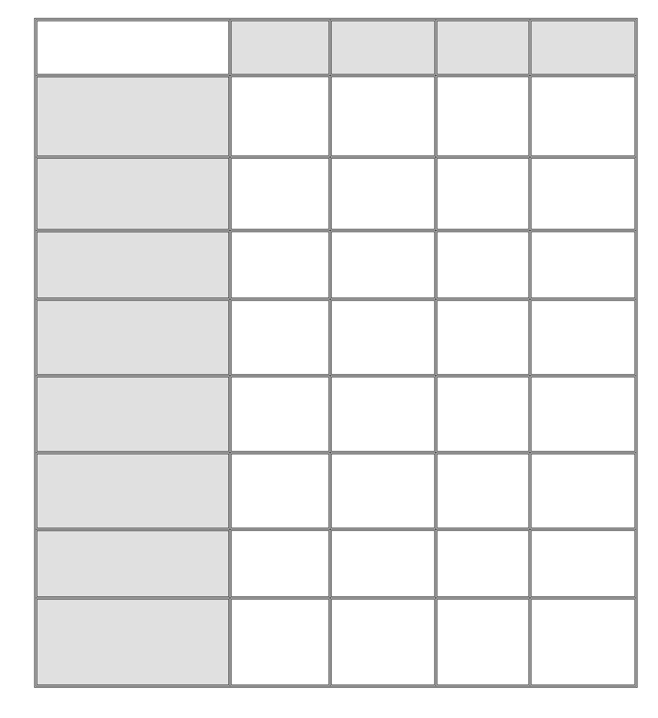 **LUDA BENSTER**



**Resume Criteria**

**Contact information complete**

**Information clear and brief**

**Skills for Success reflected in the resume**

**Volunteer + paid work included with responsibilities listed**

**Accomplishments and awards included**

**Spelling and grammar correct**

**Format easy to read and pleasing to look at**

**References including contact information provided**

**GREAT GOOD JUST OK NOT**

**INCLUDED**

##### Criteria for Evaluating a Resume

v Contact information is complete

v Format is easy to read

v All Information is clear and brief (not too much and not too little information)

v No spelling or grammar mistakes

v Resume highlights Career Academy Skills for Success

v Resume includes both paid work and volunteer experiences, with specific tasks and responsibilities, as well as the name of the company and dates worked

v Awards and accomplishments are listed

v If references are listed, all necessary contact information is included



10th Grade Career Development Workshops: Planning a Resume Copyright © 2012 MDRC. All Rights Reserved.

Student Workshop #5, Page 1

August, 2012

#### Previous Jobs

|  |
| --- |
| **Purpose** |
| This activity allows students to write about their own work history, paid or not paid, and reflect on personal pride. |

|  |
| --- |
| **Suggested Grade Level:** |
| 10 |

|  |
| --- |
| **Materials and Handouts** |
| Previous Jobs |

|  |
| --- |
| **Approximate Time Needed:** |
| 15 minutes |

**Student-Facing Instructions**

Think about previous jobs you have held -- both paid and volunteer. Which job are you most proud of? On the handout, “Previous Jobs”, answer the following questions:

* What did you do on the job?
* How did you and/or others benefit from the work?
* What made you feel proud about the work?

**Teacher Notes**

Ask students to think about jobs they’ve held- both paid and volunteer work. Ask them to pick the job that they are most proud of and do a short quick write on the form in their handouts to answer the questions:

* What did you do on the job?
* How did you and/or others benefit from the work?
* What made you feel proud about the work?

**Assessment**

Answer the questions regarding Previous Jobs.

**Instructions**

Think about previous jobs you have held -- both paid and volunteer. Which job are you most proud of? On the handout, “Previous Jobs”, answer the following questions:

* What did you do on the job?
* How did you and/or others benefit from the work?
* What made you feel proud about the work?

**PREVIOUS JOBS**

**Quick Write**

Think about jobs you’ve held—both paid and volunteer work. Pick the job you are most proud of and answer the following questions:

**What did you do on the job?**

**How did you and/or others benefit from the work?**

**What made you feel proud about the work?**



10th Grade Career Development Workshops: The ENDLESS JOB LIST Copyright © 2012 MDRC. All Rights Reserved.

Student Workshop #1, Page 3

August, 2012

#### Preparing to Write a Resume

|  |
| --- |
| **Purpose** |
| This activity helps students organize their thoughts before they begin writing their resumes. |

|  |
| --- |
| **Suggested Grade Level:** |
| 10 |

|  |
| --- |
| **Materials and Handouts** |
| Preparing to Write a Resume Resume Action Words Resume Tips  Skills for Success Resume Planner  Resume Planner Worksheet |

|  |
| --- |
| **Approximate Time Needed:** |
| 50 minutes |

**Student-Facing Instructions**

Look at the handout, “Resume Planner” and review each category.

Complete your “Resume Planner Worksheet” and/or the “Preparing to Write a Resume” worksheet based on your teacher’s instructions.. Use the “Career Academy Skills for Success Summary” handout to remind you of transferable skills you might want to mention in the skills and interests section.

The worksheets will help you gather and organize the information you will need as you draft your resume.

**Teacher Notes**

Distribute copies of Preparing to Write a Resume and/or the Resume Planner (the Resume Planner has additional fields for volunteer experience and Career Academy specific skills learned in courses). Explain that students should use worksheets to help them think about things that would be appropriate to include on a resume, as well as a place for them to write down the phone numbers, email addresses, or other information that they might need to look up. The worksheet will be used as they draft their resumes.

Refer to the Resume Tips, Resume Action Words, Resume Planner, and Skills for Success Summary for reference materials.

**Assessment**

Completion of worksheet(s).

**Instructions**

Look at the handout, “Resume Planner” and review each category.

Complete your “Resume Planner Worksheet” and/or the “Preparing to Write a Resume” worksheet based on your teacher’s instructions.. Use the “Career Academy Skills for Success Summary” handout to remind you of transferable skills you might want to mention in the skills and interests section.

The worksheets will help you gather and organize the information you will need as you draft your resume.

Worksheet: Preparing to Write a Resume

Student Name: Date:

Directions: Use this worksheet to help you gather and organize the information you will need to create your resume. Before you begin, read through all of the instructions on this worksheet, and read the assessment criteria at the end of the worksheet to make sure you understand how your final resume will be assessed.

Contact Information

Things to Think About:

* What phone number will you put on your resume? If you give them a cell phone number, make sure your outgoing message is something appropriate, not loud blaring music or you screaming into the phone while your friends are laughing in the background.
* What email address will you put on your resume? Make sure it is an appropriate email address, and make sure that it is one you will check regularly. You don’t want to have someone email you to set up an interview and you don’t respond for days because you don’t bother to look at the email account.

|  |  |
| --- | --- |
| Name |  |
| Mailing Address |  |
| Phone Number |  |
| Email Address |  |

Education

Things to Think About:

* Do you have a good GPA? If so, that can be a good thing to put on your resume. It shows that you are hardworking.
* Do you have any other training that might be helpful for a job? For example, have you taken any classes outside of school or during the summer? Have you taken any classes in school that might help you be a better employee? (HINT: This course!) Any classes you have taken in other languages, any musical

instruments or sports you play, or any training you have received, like babysitter training or CPR classes, could be good things to list on your resume, depending on the job you’re applying for.

|  |  |
| --- | --- |
| School Name |  |
| School Location |  |
| Current Grade Level |  |
| Current GPA |  |
| Other Education/Training |  |

Awards/Honors/Achievements

Things to Think About:

* Have you gotten any awards? Been on honor roll? Joined an honor society? Earned a “Most Improved” certificate? An award for sportsmanship? Earned your letter in sports? Set a record in a sporting event? Been on a championship team? Write down the details below. Use an extra sheet of paper if necessary.

|  |  |
| --- | --- |
| Award/Honor/Achievement Name | Year Received |
|  |  |
|  |  |
|  |  |

Work Experience

Things to Think About:

* + What jobs have you held? If you’ve never held a “real” job, have you done any babysitting? Taken care of a neighbor’s pet, watered their plants, or picked up their mail when they were out of town? Ran errands, mowed lawns, tutored another kid in your class, or did some other short-term thing to help someone out and/or earn some money?
  + What volunteer work have you done? Was it a one-time thing, like a beach clean-up day? Or an ongoing activity?
  + Fill out the chart(s) below. If you run out of space, use an extra sheet of paper.

|  |  |
| --- | --- |
| Job Title |  |
| Employer Name and Location |  |
| Dates of Employment |  |
| Brief Description of Duties |  |

|  |  |
| --- | --- |
| Job Title |  |
| Employer Name and Location |  |
| Dates of Employment |  |
| Brief Description of Duties |  |

|  |  |
| --- | --- |
|  |  |

Extracurricular Activities

Things to Think About:

* Do you play any sports? When? What level (intramural, frosh/soph, JV, varsity)? Any special achievements?
* Do you do any performing arts activities (band, drama, dance)? When? Any special achievements?
* Have you been on Student Council? In any clubs? When? Any special achievements?
* Have you organized any fundraisers or big events (like a school dance)? When?

Fill out the chart below. Use the comments section to write down special achievements or specific details. If you run out of space, use a separate sheet of paper.

|  |  |  |
| --- | --- | --- |
| Activity | Year Participated In | Comments |
|  |  |  |
|  |  |  |
|  |  |  |

Skills

Things to Think About:

* Do you speak any other languages? How fluently? How do you know the language—because it’s spoken at home? Because you took it in school?
* How good are you at using a computer? How much time do you spend on a computer? Do you use a Mac or a PC? How comfortable are you with email? Doing research on the Internet? Using Word? Excel? PowerPoint? Do you know any other programs? Do you know anything about how to maintain a computer or fix it if it breaks?
* Do you have any other special skills that might be interesting to an employer? For example, if you are

trying to get a job in a store that sells musical instruments, the employer would want to know if you play

an instrument, sing, or can read music. If you are trying to get a job in a craft store, the employer might like to know if you sew, crochet, or make scrapbooks.

Complete the chart below. Use the comments section to make specific notes about information you might want to include. If you run out of space, use a separate sheet of paper.

|  |  |
| --- | --- |
| Skill | Comments |
| Example: Good with computers | I use PCs and Macs. I helped my brother rebuild an old PC and I’m teaching myself how to design a web page. I can use Word, Excel, and PowerPoint. I’ve also played around with Photoshop and GarageBand in classes at school. |
|  |  |
|  |  |
|  |  |

References

Things to Think About:

* Which adults could you ask to be a reference for you? Former employers? Teachers? Coaches? Volunteer Supervisors? Neighbors? Remember, a relative cannot be a reference.
* You need to get their permission before you list them as a reference. Are these people you can get in touch with easily? If you don’t see them often and don’t have a phone number or email address for them, they’re probably not a good reference option.
* If possible, you should choose people who know you now—getting your third grade teacher to be a reference doesn’t help, unless you still see her in your neighborhood or you babysit her kids or something.
* For each reference, you will need to list his or her contact information. Make sure you can get that information from them—some people may want to give you a specific phone number or email address where it’s easier to reach them.

Remember, you should provide at least three references.

|  |  |
| --- | --- |
| Reference Name |  |
| Relationship (How You Know The Person) |  |
| Contact Information |  |

|  |  |
| --- | --- |
| Reference Name |  |
| Relationship (How You Know The Person) |  |
| Contact Information |  |

|  |  |
| --- | --- |
| Reference Name |  |
| Relationship (How You Know The Person) |  |
| Contact Information |  |

Putting the Resume Together

Once you complete this worksheet, you will have all the information you need to create a resume. But this worksheet isn’t a resume by itself—you have to type it up in the proper format, using the example resume in Student Resource 12.4 to guide you.

Before handing in your final resume, check to make sure it meets or exceeds the following assessment criteria:

* The resume includes full contact information for the job applicant (full name, mailing address, phone number, email address).
* The resume includes accurate information about the job applicant’s education and work experience.
* The resume includes useful information about awards, extracurricular activities, or special skills that an employer might want to know.
* The resume includes contact information for three references.
  + The resume is organized and formatted in a way that makes it easy to read and find information.
  + The resume is neat and uses proper spelling and grammar.

**Resume Action Words**



The following words can help your resume come alive

|  |  |  |
| --- | --- | --- |
| arranged | evaluated | recorded |
| assembled | filed | repaired |
| assisted | gathered | responded |
| attended | handled | responsible for |
| built | helped | scheduled |
| carried out | improved | served |
| collected | instructed | set up |
| communicated | introduced | sold |
| completed | maintained | solved |
| contacted | operated | started |
| coordinated | ordered | succeeded |
| created | organized | supported |
| delivered | participated | trained |
| designed | performed | translated |
| developed | planned | typed |
| distributed | presented | volunteered |
| established | produced | wrote |

**Resume TIPS**



Your resume can determine whether or not you get a job you really want. Whether it’s on paper or on-line, your resume is a critical document. Remember these tips!!

1. **Make it easy to read**

A good resume includes all relevant information, but should be short and to the point. Write clear, short phrases, and limit it to one page.

1. **Leave out unnecessary information**

Employers want to know about your qualifications for the job. They don’t need to know your age, race, height, weight, color of your eyes, religion, marital status or how many children you have.

1. **Emphasize your accomplishments**

List your successes, awards and leadership roles.

1. **Use action words to describe what you have done**

Don’t just list the titles of jobs you have held. If you have worked as a clerk in an office, for example, you might say: “Filed letters and reports, maintained records, operated office machines.”

1. **Tell the truth**

Employers DO check on the accuracy of resumes. If they find that you have not been truthful, they won’t hire you.

1. **Make your resume look good**

Have clear headings and plenty of white space. Readability is key. Use your finest graphic design skills or get a friend with those skills to help you.

1. **Check for errors**

Make sure your grammar and spelling are correct. Ask two other people to check your grammar and spelling for you.

1. **Have someone whose opinion you respect read your resume**

Ask them if it draws a positive picture of you. Ask for suggestions and another reading.

1. **Keep working on your resume until it is perfect**

It is worth the effort.

**Career Academy Skills for Success**



Expanded Version

|  |  |  |
| --- | --- | --- |
| **CREATIVE AND CRITICAL THINKING** | | |
| v **Solve problems and make decisions**   * Understand the issue or problem * Get accurate information * Consider many solutions * Consult with others * Make an informed decision * Evaluate decision and reflect on the process | v **Think creatively**   * Explore many alternative ways of looking at something * Use brainstorming to generate innovative ideas * Ask “what if” questions to explore options * Be open to new and diverse ideas * Solve old problems in new ways * Think “out-of-the-box” | |
| v **Learn through research**   * Gather and organize information * Use many methods: web searches, library, data bases, print materials, interviews, etc. * Collect and interpret information to answer a question or confirm a prediction * Use variety to communicate information: verbal presentations, power point, video, You Tube, written reports, etc. * Retain information for future use | v **Reflect and evaluate**   * Examine your thoughts, feelings and reactions * Think about what you have learned from an experience * Determine what else you need to know * Plan next steps | |
| **COMMUNICATION** | | |
| v **Write clearly**   * Know your audience * Organize your ideas * Stick to the point; make it interesting * Use correct grammar, spelling and sentence structure * Proofread! Proofread! Proofread! | | v **Speak distinctly**   * Use language and tone appropriate for the audience * Know what you want to say * Speak slowly and pronounce words carefully * Keep it simple; don’t say too much * Check to make sure you are being understood |
| v **Listen carefully and ask good questions**   * Pay close attention to the speaker(s) * Maintain eye contact * Ask questions or repeat back to check for understanding * Confirm understanding verbally or otherwise * Retain information for further use | | v **Observe effectively**   * Watch for visual information * Ask questions if you aren’t sure about * what you are seeing or hearing * Reflect to determine the meaning of what you are seeing or hearing   o Confirm understanding verbally or otherwise |

**Career Academy Skills for Success** page 2



|  |  |
| --- | --- |
| **COLLABORATION AND TEAMWORK** | |
| v **Cooperate with others**   * Understand the goals of the team * Make courteous and friendly contributions * Respect opinions different from your own * Respect racial and cultural diversity * Be flexible; make compromises as needed * Know everybody’s roles and responsibilities | v **Give and receive feedback**  When you **give** feedback, remember to:   * Begin with positive comments; then negative * Be specific and ask for response * Choose the right time * Don’t blame * Be honest & don’t always expect acceptance   When you **receive** feedback, remember to:   * Listen without judgment * Think carefully before responding * Thank the giver |
| v **Negotiate challenges and resolve conflicts**   * Approach problems positively * Try to get to the root of the problem without blaming * Evaluate multiple paths to resolve a conflict before taking action * Cooperate courteously with others involved in the conflict * Be constructive, not destructive, in a conflict | v **Plan and prioritize to reach a goal**   * Set short and long term goals * Assess how realistic your goals are * Prioritize in order of importance * Create realistic timelines * Reflect on your success and plan for next time |
| **MEDIA AND TECHNOLOGY** | |
| v **Use new and emerging technology**   * Know what technology to use for a given purpose * Continually update your skills * Use digital technology for learning purposes (research, organizing and communicating information) * Use multi-media to communicate * Evaluate how technology assists you, and adapt in the future, if necessary | v **Use responsible behavior regarding technology (“digital citizenship”)**   * Know appropriate uses of cell phone, email, tweets, Face Book, chat rooms, etc. * Recognize legal, ethical and safety issues (on-line purchases; downloading music) * Learn to evaluate digital information for accuracy |

**Career Academy Skills for Success** page 3



|  |  |
| --- | --- |
| **PERSONAL QUALITIES** | |
| v **Manage time effectively**   * Know what needs to be accomplished * Prioritize tasks * Break big tasks into small chunks * Keep a daily or weekly “to do” list | v **Demonstrate appropriate behavior and attire**   * Meet workplace standards on attendance,   o punctuality and dress code   * Maintain confidentiality * Exhibit maturity, confidence, flexibility and self control |
| v **Show initiative and work independently**   * Set your own goals * Take on tasks without being asked * Be ready to work on your own without supervision * Be motivated and demonstrate “get up and go” | v **Recognize and respond appropriately to workplace challenges**   * Know potential challenges (discrimination,   o harassment)   * Understand what’s legal and what’s not * Know the “chain of command” to follow if you have a complaint * Know how to advocate for yourself and others |
| v **Be reliable and dependable**   * Be where you need to be, on time (or early!) * Ask if you are not certain what is expected * Be honest and true to your word * Make sure that others know they can count on you |

**Resume Planner**



**Contact Information**

The first section of your resume should include information on how to contact you.

First & Last Name Street Address City, State, Zip

Phone (Landline and Cell) Email Address

**Education**

List the names and addresses of schools you have attended since and including the ninth grade. List the name of your Career Academy and your expected date of graduation.

**Courses and/or Skills Learned in the Career Academy**

Include your most important courses and the skills you have learned or are learning.

**Work Experience**

Starting with your present or most recent job, list any part-time or full-time jobs you have held. For each job, list the name of the company, address, your job title, the period of time you were employed (*ex: June-August 2009*) and the number of hours you worked per week. Briefly describe your responsibilities and accomplishments.

**Volunteer Experience**

List any volunteer experience you have had. Describe who you did it for, when and what your “duties” were.

**Skills and Interests**

In order to show that you are a well-rounded person with many interests, list hobbies or activities in which you regularly participate, such as sports teams (team work), chess club (critical thinking, patience), literature or movie club (analytical reader/viewer) or restaurant reviewer for the school newspaper (initiative, think critically, gourmand).

**References**

Many people do not list references on the resume, but instead have a separate list of references to give to employers upon request. However, it is good to start gathering names, titles, addresses, and phone numbers. List three people who will speak positively about you (teacher, coach, or former employer). Don’t list relatives. You should always ask permission before listing a person as a reference.

**Resume Planner Worksheet**



**Your Contact Information**

**Education**

**Courses and/or Skills Learned in the Career Academy**

**Work Experience**

**Volunteer Experience**

**Interests**

**References**

#### Resume Peer Review

|  |
| --- |
| **Purpose** |
| This activity allows students to draft their resume and exchange them with peers for feedback. |

|  |
| --- |
| **Suggested Grade Level:** |
| 10 |

|  |
| --- |
| **Materials and Handouts** |
| Criteria for Evaluating a Resume Resume Peer Review |

|  |
| --- |
| **Approximate Time Needed:** |
| 35 minutes |

**Student-Facing Instructions**

Work on your resume and produce a good first draft.

Read the “Resume Peer Review” and “Criteria for Evaluating a Resume” handouts. Exchange your resume with a partner and complete the assessment for each other.

Revise your resume based on your partner’s feedback.

**Teacher Notes**

Have pairs of students exchange their resumes, take the role of potential employers, and complete the checklist. Then each pair should discuss their review.

**Assessment**

Complete peer review.

**Instructions**

Work on your resume and produce a good first draft.

Read the “Resume Peer Review” and “Criteria for Evaluating a Resume” handouts. Exchange your resume with a partner and complete the assessment for each other.

Revise your resume based on your partner’s feedback.



10th Grade Career Development Workshops: Planning a Resume

Student Workshop #5, Page 1

##### Criteria for Evaluating a Resume

v Contact information is complete

v Format is easy to read

v All Information is clear and brief (not too much and not too little information)

v No spelling or grammar mistakes

v Resume highlights Career Academy Skills for Success

v Resume includes both paid work and volunteer experiences, with specific tasks and responsibilities, as well as the name of the company and dates worked

v Awards and accomplishments are listed

v If references are listed, all necessary contact information is included

**Resume Peer Review**

Assume the role of an employer. You just received your partner’s resume and you are ready to do an assessment of it.

How did

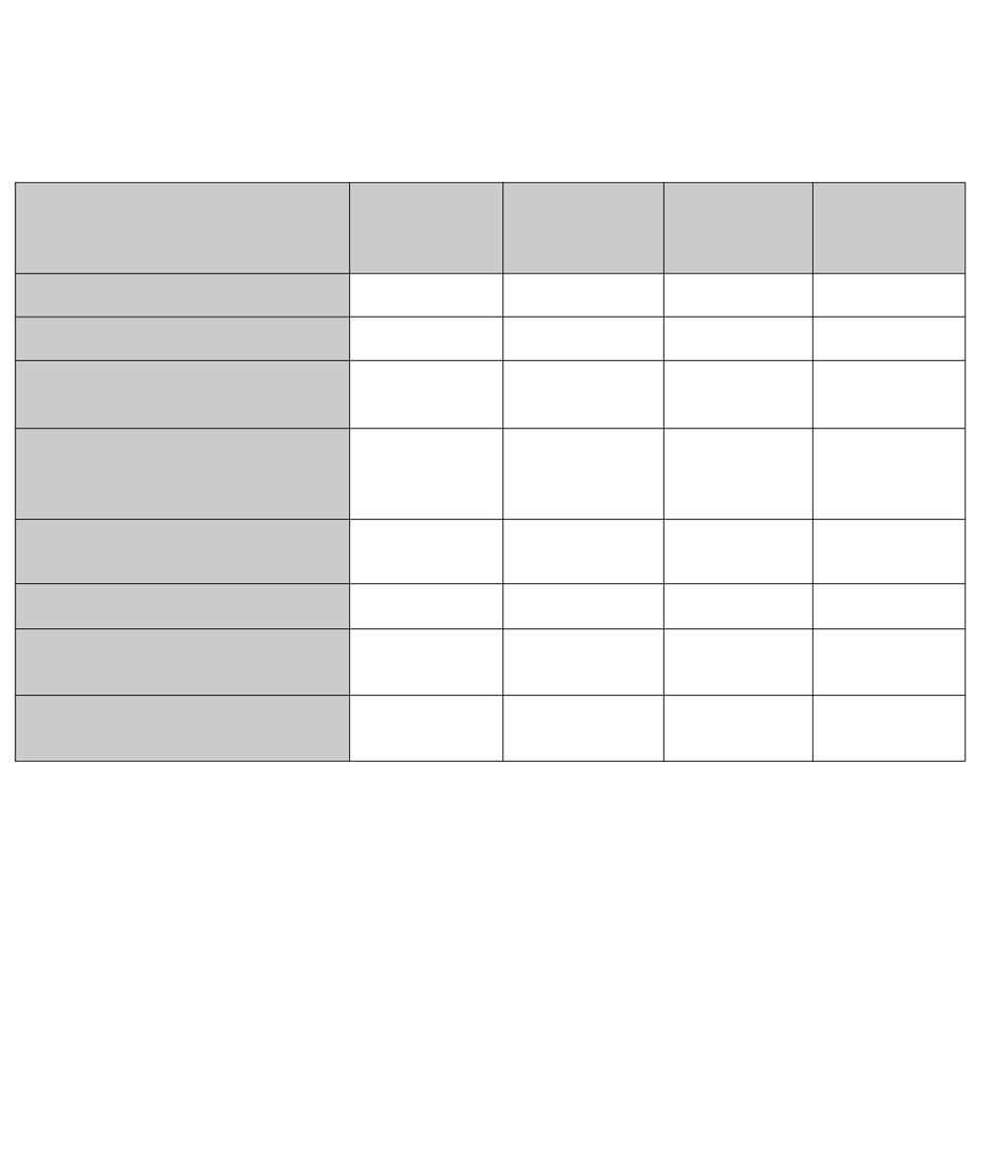

(Fill in student’s name)

do on their resume?

Employer (reviewer)

Put a check mark ü in the box that best describes each resume component.

**RESUME CRITERIA GREAT!**

**FIRST RATE**

**GOOD JUST OK**

**NEEDS MORE WORK**

Contact information complete

Information clear and brief

Skills for Success reflected in the resume

Volunteer + paid work included with responsibilities listed

Accomplishments and awards included

Spelling and grammar correct

Format easy to read and pleasing to look at

References including contact information provided

*Answer the following questions and discuss your review with your partner*

Does the resume seem complete? Does any information seem to be missing?

When a potential employer looks at this resume, what will look strongest and what will look weakest?

What is the single most important suggestion you can make to help your partner strengthen their resume?



10th Grade Career Development Workshops: Writing a Resume

Student Workshop #6, Page 3

Teacher Resource

**Unit Culminating Task:**

#### Create a Resume

|  |
| --- |
| **Purpose** |
| The purpose of this task is for students to publish a polished version of his/her resume. While the student’s resume development will always be iterative (one’s re- sume is never “done”), this task reflects an opportunity to approve a student resume for his/her digital portfolio. |

|  |
| --- |
| **Suggested Grade Level:** |
| 10, 11 |

|  |
| --- |
| **Materials and Handouts** |
| Resume Rubric |

|  |
| --- |
| **Approximate Time Needed:** |
| 50-90 minutes |

**Student-Facing Instructions**

Your task is to submit the most professional resume possible. This resume should reflect your strengths, experiences, and interests, as well as provide some contact and reference information about you. An approved resume reflects a resume that is ready to represent you at a job interview or other engagement with a potential employer.

Before you complete this task, you should be aware of resume formatting, and you should have done some pre-thinking or brainstorming about the contents of your resume. If you have notes from any of the lessons below, these will help you complete this task:

* “Preparing to Write a Resume”
* “Previous Jobs”
* “Analyze a Resume”
* “Planning Your Resume”
* “Resume Peer Review”

**Step 1:**

Review the attached rubric and become familiar with the characteristics of a professional resume that will help you stand out to potential employers. Read over the “Proficient” and “Advanced” columns for each of the following areas:

* Format

~~• Contact Information & References~~

* Content (General)
* Content (Education)
* Content (Work-Experience)
* Content (Activities & Honors)

With a partner discuss the following questions:

What are some of the major differences between a resume that is emerging/developing and one that is proficient/advanced?

What is the difference between the sections related to “content” (for example general vs. education, work- experience, and/or activities & honors)?

**Step 2:**

Using a word processing program on a computer type your resume. If helpful, ask your teacher for a template that you can fill in, so that you don’t have to spend too much time with formatting for your first draft. Refer to your notes (listed above) and input the information relevant to you.

When you have finished typing your resume, review it for errors, and compare it to the rubric. Do you feel that you’ve done your best job of aligning it to the rubric criteria? If so, you’re ready to submit your resume!

**Teacher Notes**

Unit Culminating Task Prerequisites: The following lessons will help students brainstorm both characteristics and experiences that will be useful when writing a resume: “Preparing to Write a Resume;” and “Previous Jobs.” Other lessons will help students learn about and draft a resume: “Analyze a Resume;” “Planning Your Resume;” “Resume Peer Review.”

**Assessment**

Student resume assessed against aligned rubric:

Student Learning Outcomes assessed in this task:

* Organize and describe personal information accurately in a properly formatted resume

Optional Student Learning Outcomes assessed in the resume :

* Demonstrates command of standard English conventions
* Skillfully uses written language to convey ideas and understanding

**Instructions**

Your task is to submit the most professional resume possible. This resume should reflect your strengths, experiences, and interests, as well as provide some contact and reference information about you. An approved resume reflects a resume that is ready to represent you at a job interview or other engagement with a potential employer.

Before you complete this task, you should be aware of resume formatting, and you should have done some pre-thinking or brainstorming about the contents of your resume. If you have notes from any of the lessons below, these will help you complete this task:

* “Preparing to Write a Resume”
* “Previous Jobs”
* “Analyze a Resume”
* “Planning Your Resume”
* “Resume Peer Review”

**Step 1:**

Review the attached rubric and become familiar with the characteristics of a professional resume that will help you stand out to potential employers. Read over the “Proficient” and “Advanced” columns for each of the following areas:

* Format
* Contact Information & References
* Content (General)
* Content (Education)
* Content (Work-Experience)
* Content (Activities & Honors)

With a partner discuss the following questions:

What are some of the major differences between a resume that is emerging/developing and one that is proficient/advanced?

What is the difference between the sections related to “content” (for example general vs. education, work- experience, and/or activities & honors)?

**Step 2:**

Using a word processing program on a computer type your resume. If helpful, ask your teacher for a template that you can fill in, so that you don’t have to spend too much time with formatting for your first draft. Refer to your notes (listed above) and input the information relevant to you.

When you have finished typing your resume, review it for errors, and compare it to the rubric. Do you feel that you’ve done your best job of aligning it to the rubric criteria? If so, you’re ready to submit your resume!

**Resume Rubric**

**_8.24.15**

*Adapted from a rubric created by Amy Diepenbrock (courtesy of the National Association of Colleges and Employers – NACE) by* ***ConnectEd: The California Center for College and Career***

311

|  |  |  |  |  |
| --- | --- | --- | --- | --- |
| **SCORING DOMAIN** | **1 EMERGING** | **2 DEVELOPING** | **3 PROFICIENT** | **4 ADVANCED** |
| **FORMAT** | * Font is too big, or otherwise difficult to read * Resume is either too long, or too short * Multiple spelling errors and/or grammar mistakes * Cannot be easily scanned | * The font and spacing of the resume are not appealing * Resume may be too long, or too short * Multiple spelling errors and/ or grammar mistakes * Cannot be easily scanned | * Font and spacing is appropriate * Resume may be longer than one page or shorter than one page, but has overall appealing format * There may a single spelling or grammar error * It can be easily scanned | * Font and spacing is appropriate * The resume fills one page and is not overcrowded * There are no grammar or spelling errors * It can be easily scanned – all information is clear and brief |
| **CONTACT INFORMATION & REFERENCES** | * Contact information missing or incomplete * Email address provided clearly not appropriate for professional environment * If included, reference contact information is incomplete * References are clearly irrelevant and/or have not given permission | * Incomplete contact information * Email address provided raises questions about professional appropriateness * If included, reference contact information is incomplete * References may not be relevant representatives for student | * Full contact information provided (Name; Email; Phone; Address) * Email address provided is appropriate to a professional setting * If included, reference contact information is included * References are relevant and have given permission before being listed | * Full contact information provided (Name; Email; Phone; Address) * Email address provided is appropriate to a professional setting * Voicemail to phone # provided is appropriate to a professional setting * Includes accurate contact information for references for three references * References are relevant and have given permission before being listed |
| **CONTENT (GENERAL)** | * Clearly contains dishonest or inaccurate information * Little to no accomplishments or strengths included * Information is mainly off-topic or irrelevant * Information too general | * Raises questions about truth and accuracy of information * Contains an accomplishment or strength, but may be hard to find * Some off-topic or irrelevant information shared * Descriptions are general, not specific | * Information is truthful and accurate * Clearly contains accomplishments and strengths * Focus on most relevant information shared * Includes action words and description of activities/experiences | * Information is truthful and accurate * Accomplishments and strengths clearly stand out * Only relevant information is shared * Action words and description of activities/experiences provided |
| **CONTENT (EDUCATION)** | * No reference to education | * Lists school attended and dates of attendance * Educational accomplishments and experiences missing, or do not strengthen resume | * Accurately lists schools attended and dates of attendance * Lists educational accomplishments and experiences (possibly GPA; professional training; special courses;   language study, etc.) | * Accurately lists school/s attended and dates of attendance * Describes educational accomplishments and experiences (possibly GPA; professional training;   special courses; language study, etc.) |
| **CONTENT (WORK- EXPERIENCE)** | * No reference to work/volunteer experience | * Employers and contact info listed inaccurately or incompletely * Work/volunteer experiences is not described in a way that demonstrates skills or employability | * Lists employers with contact info with dates of employment and titles held * Adds some detail to any work/volunteer experience to demonstrate employability | * Lists employers with contact info with dates of employment and titles held * Descriptions of work/volunteer experiences demonstrate skills gained |
| **CONTENT (ACTIVITIES & HONORS)** | * No activities or honors are listed | * Activities and honors are listed, though possibly unclear why * Activities and honors not described in a way that demonstrates skills gained | * Activities and honors are listed with descriptions, and titles held * Adds some detail to activities and honors to demonstrate skills gained | * Extracurricular activities and honors listed with dates of participation * Descriptions of activities and honors demonstrate skills gained |

## Job Application

#### Job Advertisement Terminology

|  |
| --- |
| **Purpose** |
| This activity helps students make connections between a want ad and the information provided in a job application. |

|  |
| --- |
| **Suggested Grade Level:** |
| 10 |

|  |
| --- |
| **Materials and Handouts** |
| Job Ad Terminology Reading: Job Applications |

|  |
| --- |
| **Approximate Time Needed:** |
| 50 minutes |

**Student-Facing Instructions**

You already know about the power of excellent communication skills to make a good impression on others. Now, as you make plans for college and a future job, it’s also important to know how to present yourself on applications and in interviews. Much of the information and advice in this reading will apply to college admissions. But our main focus is on the job application process.

Read over the job ad in the worksheet and write down any terms you don’t recognize. Then work together with your teacher and classmates to define the terms in your own words. An example will be provided.

**Teacher Notes**

Explain that one of the most common ways to find a job nowadays is to search on the Internet. Explain a little bit about the website you are going to use for job hunting practice. For example: “Craigslist is an excellent site for local and part-time work in the San Francisco Bay Area. During this class period, we are going to look at what it’s like to hunt for a job on Craigslist.”

Have students turn to the Job Terminology worksheet. Explain that job ads frequently use terms that students may not have heard before. When they see a new term during this exercise, they should write it down on their list.

Project the Craigslist Bay Area homepage (http://www.sfbay.craigslist.org). Ask students: if you’re looking for

a job, where would you click on this page? Obviously, students will identify the “jobs” section, but push them for more specifics. Point out that there are two ways students could job hunt on Craigslist. They could select a specific type of job—for example, “food/bev/hosp” if they want to be a waiter/waitress—or they could simply go to the “part-time” listing at the bottom of the jobs section. Click on the part-time listing.

Now the screen should display all part-time jobs. Point out the tabs along the top of the page and explain that students can use these tabs to narrow down which part of the Bay Area they are searching. If necessary,

explain what each location (East Bay, South Bay, etc.) refers to. Then click on the “San Francisco” tab to restrict your search to the City.

Next, guide students through the process of reading the job listings as they show up. Ask students to identify the date the ad was posted, the job title, the neighborhood, and the job category. For example: Sept 19—Sales Associate—(downtown/civic/van ness)—retail/wholesale. This is a good time to ask students to look over the information they can see and identify any new/unfamiliar terms. Many job titles may be unfamiliar to students and can be added to their lists—for example, barista, busser, administrative assistant, data entry person. Re- mind students to write down a definition for each term.

Then ask students: what jobs can you rule out just by looking at this information? Guide students to recognize that they should be able to rule out some jobs based on the job title. For example, if the job specifies driving or delivery and they can’t drive yet, that rules out that job. If the job specifies a skill set they do not have or

haven’t done on a professional level (such as cooking or doing people’s hair or nails), they can rule out that job. They should also be able to rule out some jobs based on the neighborhood, since they should look for neigh- borhoods that they can easily reach.

Ask students to identify a potential job they might be able to apply for and click on it. Read through the ad as a class. Point out common elements of a job posting, such as responsibilities, requirements, schedule/number of hours, how to apply, etc. Guide students to where Craigslist commonly lists compensation (at the bottom of the page in the bullet points).

Have students scan the ad for any new terms and add the terms to their lists. Then review these terms as a class and have students complete the definition part of their worksheet.

**Assessment**

Complete the worksheet.

**Instructions**

You already know about the power of excellent communication skills to make a good impression on others. Now, as you make plans for college and a future job, it’s also important to know how to present yourself on applications and in interviews. Much of the information and advice in this reading will apply to college admissions. But our main focus is on the job application process.

Read over the job ad in the worksheet and write down any terms you don’t recognize. Then work together with your teacher and classmates to define the terms in your own words. An example will be provided.

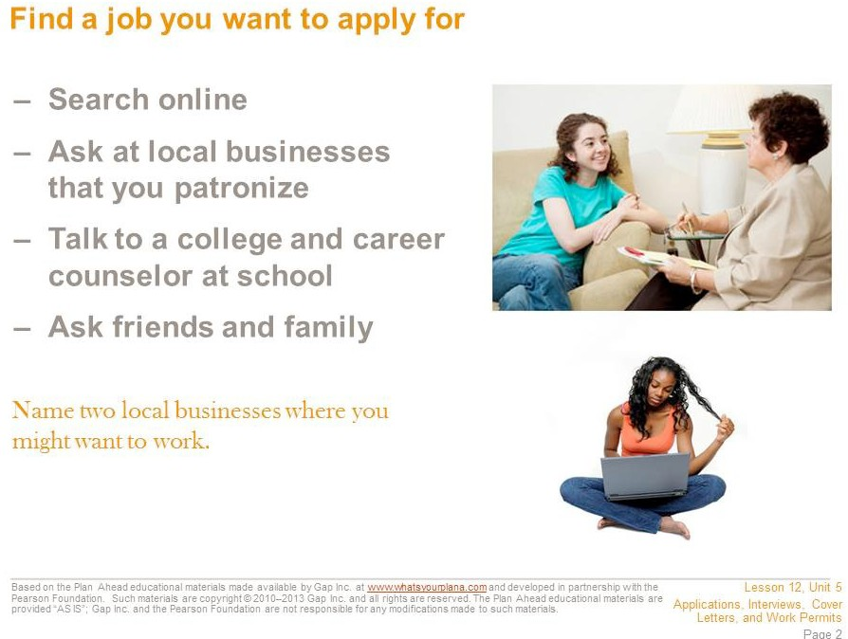

These days, most available jobs are posted online at websites. On a job search website, you can narrow your search geographically—for example, you can search for jobs specifically within a major city or even within a certain neighborhood. Craigslist also has a special section for part-time jobs.

Maybe you already have a potential employer in mind. Some big chains may have local stores in your area, such as coffee bars, grocery stores, or fast-food restaurants. Many of these employers may have applications online that you can fill out.

Many people find jobs by word of mouth. Ask your friends, family members, and neighbors if they know of any job openings. In the business world, this is called networking.

If you’re not sure how to get an application, go to the business and ask in person. Many businesses have applications available; you can take one home to complete and come back another day to return it.

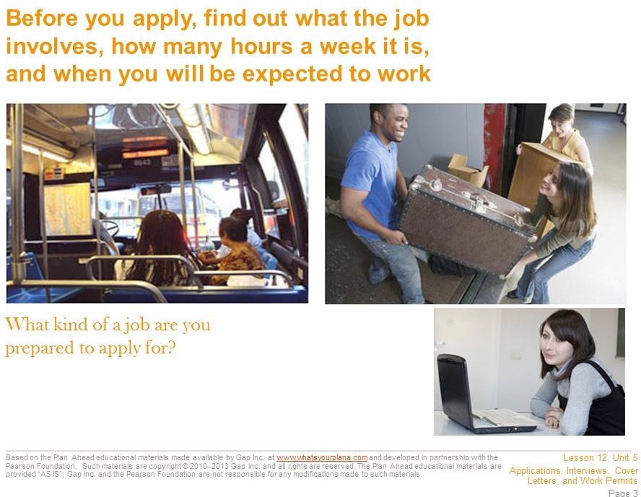

You need to find out some information about a job before you apply for it. Research the company on its website or talk to people who might know something about it. Try to find a job that suits your interests and make sure that you can handle the job requirements.

Do you need to be physically strong? Do you need to be able to use a computer? Will you be serving customers? Also think about scheduling. Can you work around your school schedule? You might want to work at a coffee bar, but if they need people to work the morning shift on weekdays, that job probably won’t work for you except in the summers. Also think about how you will get to work. It might be really fun to get a job at that cool store on the other side of town, but how long will it take you to get there?

As you look for a job, keep these practical considerations in mind.

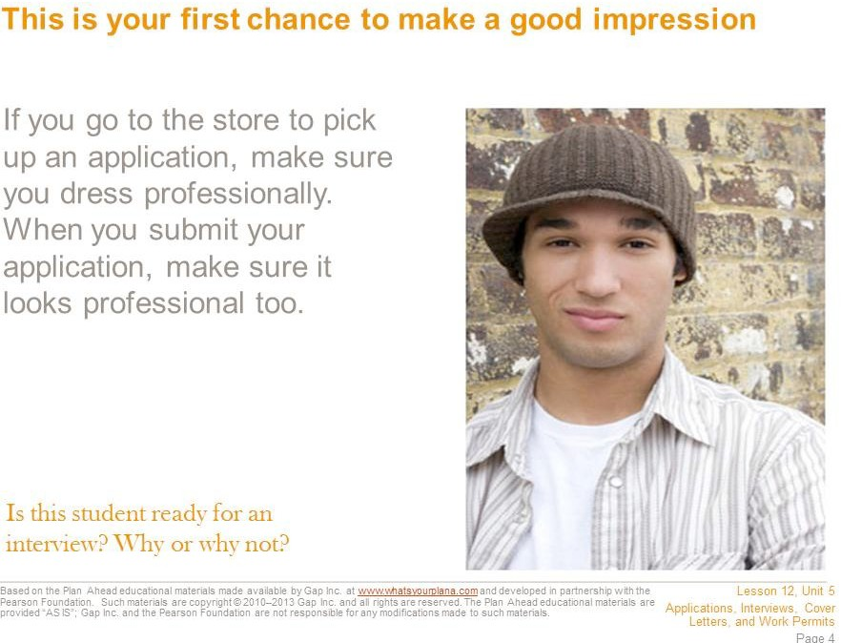

First impressions are very powerful. Even if you’re just submitting an application, you want to look professional. If you are going into a store to pick up an application, dress nicely. That doesn’t mean you need to wear a suit or fancy clothes, but you should wear clothes that will not offend people. For example, this is not the time to wear a t-shirt with profanity on it or a mini-skirt.

You also want your application to look professional. If you are filling out an application by hand, make sure to use blue or black ink. Bright colors and glitter pens are fun to take notes with at school, but they do not look professional on an application. Don’t draw on your application either—no smiley faces next to your signature or hearts dotting the i’s. Neatness is essential: do not turn in a wrinkled application or one that has crossed-out words, and use your easiest-to-read handwriting. Take your time filling it out.

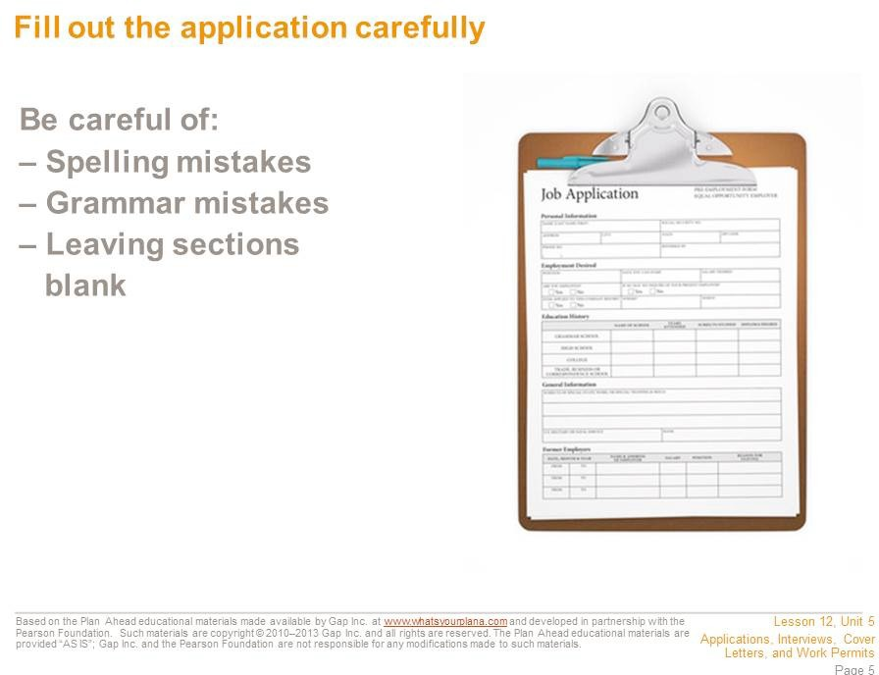

Do your best to avoid making spelling and grammar mistakes. If managers or store owners see a lot of mistakes on your application, they might think you will make mistakes when you’re working.

Don’t leave any sections blank; the manager might think that you didn’t finish the application. Of course there may be sections that you can’t fill out. If this is your first job, you won’t have any “previous employment” to list, and if the application asks about degrees, you don’t have one yet. However, instead of leaving the section blank, you should put “N/A,” which means “not applicable.” That way the manager will understand that you did read the whole application, but just don’t have anything to include in that section. Don’t worry about putting N/A down on a section if you need to; the manager can see that you are just starting out.

If possible, have someone read over your application for you before you turn it in, and make sure you read over the whole thing yourself at least twice. Read it carefully—you don’t want to lose out on a good job because of some careless mistakes.

Many job applications can be filled out online. Before you hit the Send button, however, have someone check your application for mistakes that you didn’t catch. Print a copy of the application to keep for yourself. It will make filling out future applications faster, because you’ve already collected all the information you need.

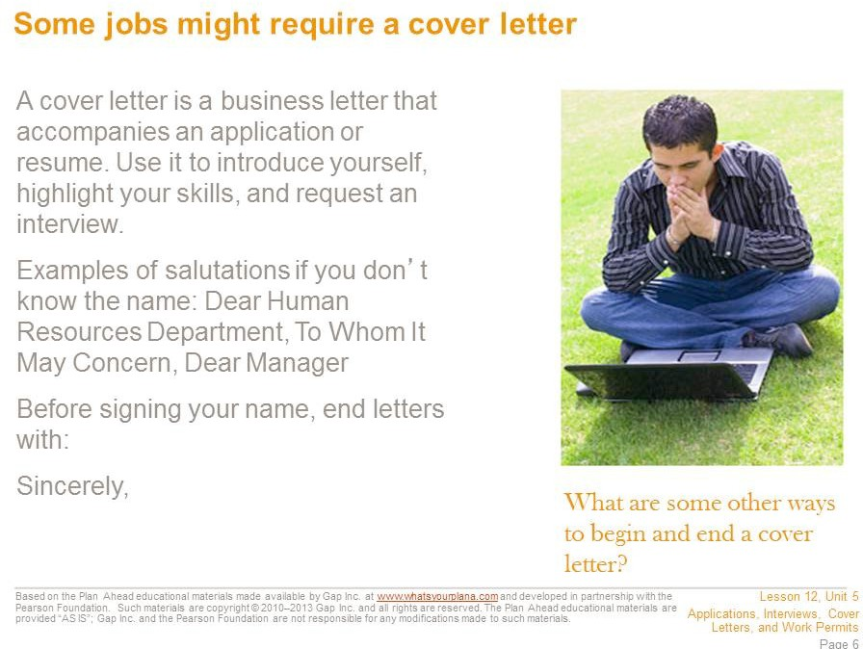

Some employers like to receive a cover letter to have another chance to learn about the potential employee. A cover letter gives you a chance to write about things that might not be on your application. It generally has three parts: an introduction, a summary of your key qualifications, and a request for future action.

In the first section, introduce yourself and explain why you are applying. For example, “I am interested in the position of part-time retail associate that I saw advertised on Jobsforteens.com.”

In the second section, point out why you are a good candidate. For example, “Your ad says that you want someone who is knowledgeable about sports and sports equipment. I have played baseball, lacrosse, and football, and last year I served as the equipment manager for the junior varsity football team at my school.” You also need to make it clear why you want to work at this company. Good reasons? You like its products, you want to have a career in that industry, or you know people who work there and you’ve heard it’s a good job. Bad reasons? It’s the only company hiring, or you think the company will pay you well.

In the third section, you request future action. This generally means that you are asking for an interview. You may want to say something like, “I hope we can discuss this position in the near future,” or “Thank you for considering my application. I look forward to hearing from you soon.”

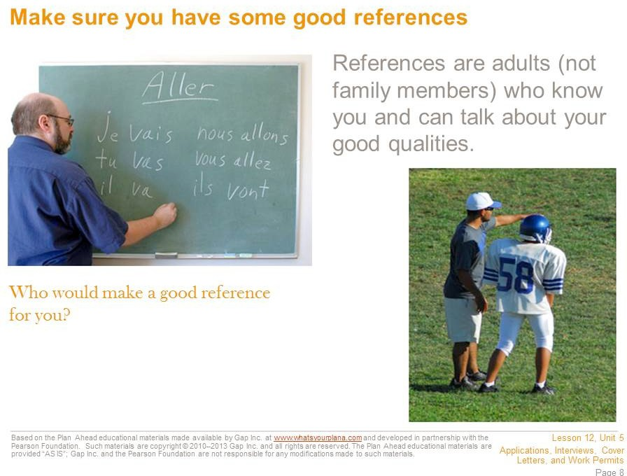

Most companies ask for references. These are people who can talk about what you are like and give potential employers more information about you. Not all employers will ask for references, but it’s good to be prepared.

Your references need to be adults and they can’t be family members. So who can you ask? If you’ve had a job, you can ask your previous employers. If you babysit for your neighbor, she can tell a potential employer if you’re reliable and trustworthy. But maybe you’ve never had a paying job. Don’t worry—for people your age, school has basically been your job. Your teachers can talk about whether or not you show up on time, are reliable, get homework done, etc. Choose one or two teachers you have a good relationship with.

You can also ask adults who work with you on school activities: coaches, band or drama directors, or club moderators. Just like teachers, these people know if you show up on time, do what is asked of you, and are reliable and trustworthy. That’s also true for scout leaders or coaches of local sports teams. If you are involved with a church, a temple, a mosque, or a religious organization, you may also be able to ask people there to vouch for you. And if you do volunteer work, your volunteer supervisor could be a good reference.

You should ask if it’s okay to use someone as a reference before you put that person’s name and information on an application, not after. Make sure you have all of the right information for contacting your reference, too.

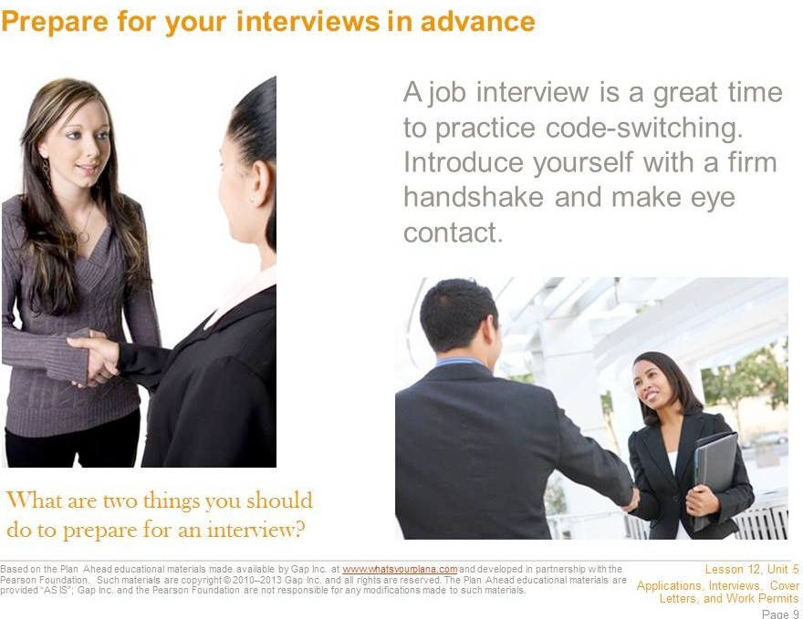

Know how to get to the interview and how long it will take to get there. Leave plenty of time. It’s better to be too early for an interview than to be late. Only a true emergency should cause you to miss an interview. You don’t want to have to say, “Well, my friend was going to give me a ride, but then he had to do something….” Have a back-up plan. Also keep in mind that you may be asked to come back more than once. The employer may want to see if you are reliable and can follow instructions.

If you are going to get a job in an office, wear your most professional-looking clothes. On the other hand, if you are going to work in a restaurant or a store, you probably don’t need to dress up quite as much. Your clothes need to be clean, with no wrinkles, not too baggy, short, or low cut, and nothing with sayings or pictures that might offend people. A nice shirt or blouse and nice pants (not jeans) would be a reasonable outfit. Don’t wear lots of make-up or perfume; some people are allergic to perfume. This is

also not the time to have a really unusual hair style.

Bring a couple of pens in case there are other forms you need to fill out. Bring a note pad so you can jot down information. If you have submitted a resume or cover letter, bring copies. Also, be prepared to shake hands with the interviewer and to introduce yourself by your first and last name. To shake hands, extend your right hand (not just your fingertips), fully connect with the other person’s hand, and shake firmly yet gently. An appropriate hand shake only takes a second.

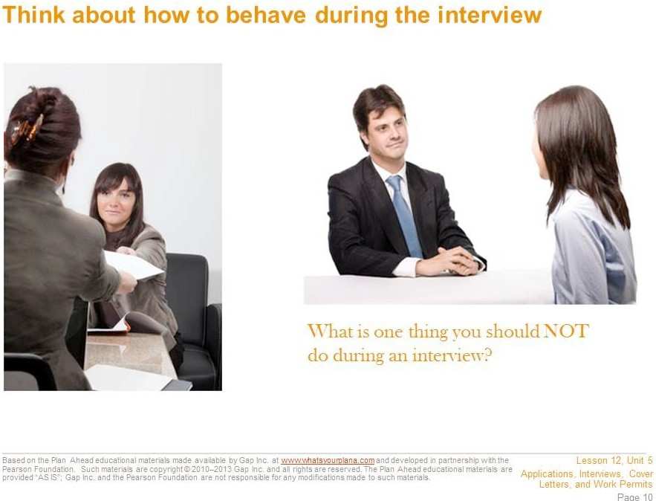

Before you go, think about how you might answer interview questions. Common questions are designed to get to know you, like: “Tell me about yourself,” “What’s your greatest strength? Your greatest weakness?” “Why do you want to work here?”

Practice saying your answers out loud with someone who can give you good feedback. If nobody is around, practice in the mirror.

If you sit down for the interview, sit up straight. Don’t chew gum, bring snacks or drinks with you, or yawn. You might be nervous, but try not to fidget. Listen carefully to the questions, without interrupting. Make sure you give good answers, but stay on topic and keep it brief. For example, if the interviewer asks if you are reliable, you can say that you get good grades or never missed a practice when you were on the volleyball team. Those are all good points. But you shouldn’t say that you get good grades even though you have this one teacher who’s mean or that not only do you show up to practice, but your team made it to state this year…those are not details the interviewer needs to know.

You can prepare some questions of your own; be sure to only ask ones that didn’t get answered already in the course of your conversation. Otherwise it will seem as if you don’t listen well. Remember to turn off your cell phone before the interview.

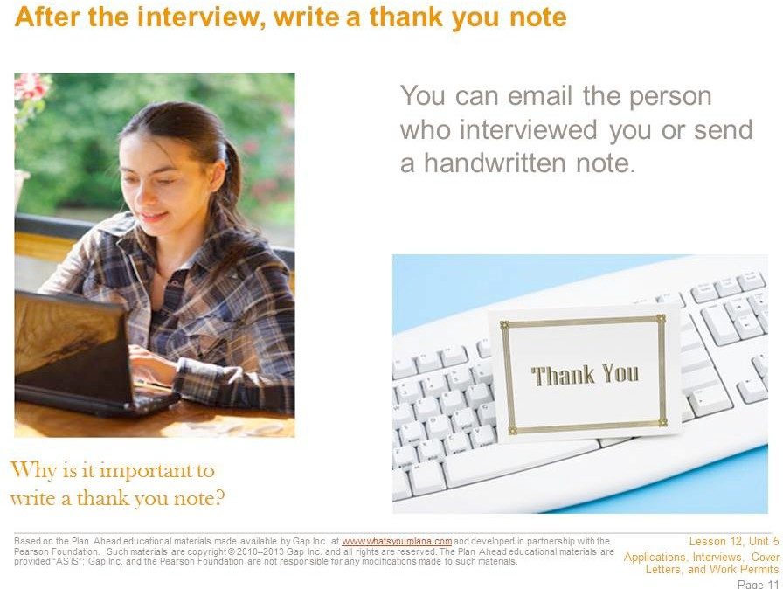

At the end of the interview look the interviewer in the eye, smile, and shake hands again if the interviewer extends his or her hand. Thank the interviewer for taking the time to meet with you. Then, after you get home, write a thank you note or email. If you have been communicating with the interviewer via email, you can send your thank you note that way. Otherwise, write a handwritten note and mail it or personally deliver it.

A thank you note is appropriate, because this person took time out of his or her day to talk to you. Even if the person doesn’t hire you for the job, he or she is helping you learn more about how to do an interview and giving you valuable experience. Sending a thank you note is a great way to impress the interviewer— and to remind the interviewer of what a good candidate you are for the job.

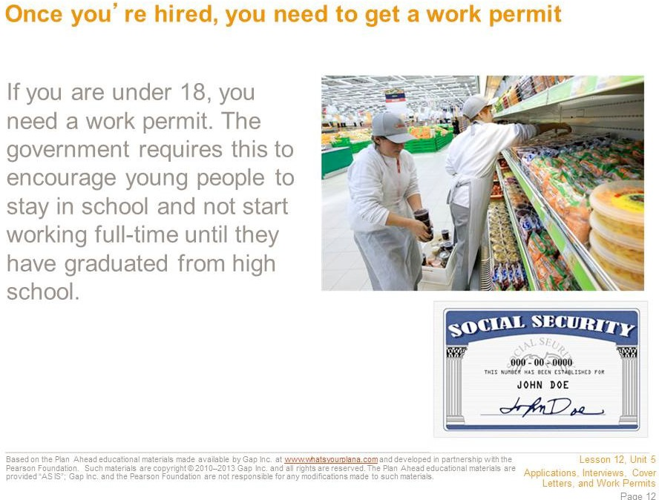

Once an employer agrees to hire you, you can apply for a work permit. You need one because state and federal laws are in place to protect young workers (until the age of 18) from overwork and unsafe conditions, and to ensure that they receive an education.

Your teacher can help you figure out how to obtain a work permit locally.

To obtain a permit, you need to provide the following: a completed application, a social security card, proof of your age (for example, a birth certificate), and proof of school attendance from your school office.

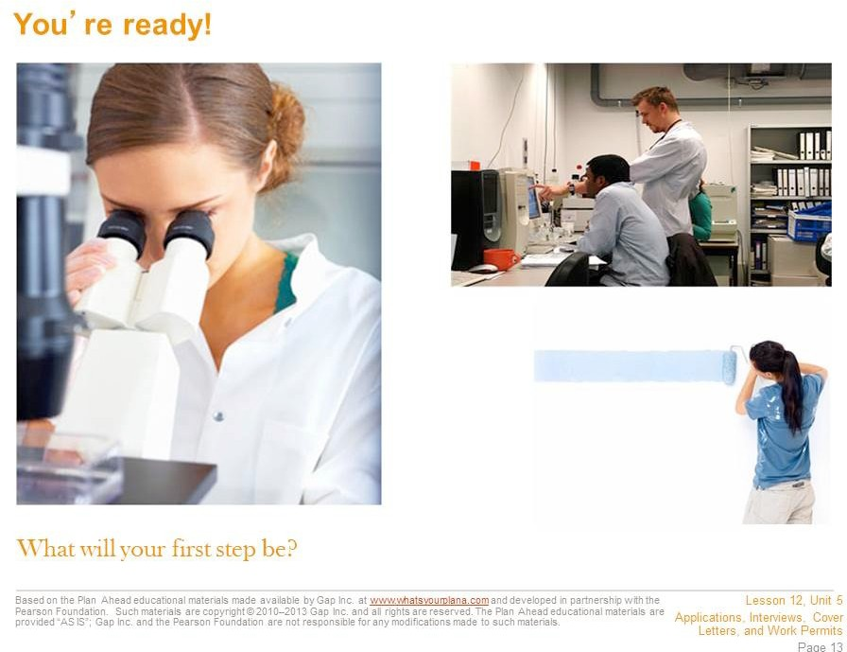

You now have the information you need to apply for a job, internship, or college admission.

If you’ve taken all these steps and you don’t get the job, it’s disappointing—but don’t be discouraged. Everyone has to go through this process more than once, and usually many times, before landing a job. Stay focused, patient, and persistent, and eventually your efforts will yield results.

Worksheet: Job Ad Terminology

Student Name: Date:

Directions: As you read over the job ads, write down any terms you don’t recognize. Then work together with your teacher and classmates to define the terms in your own words. An example is provided.

Term Definition

Example: Equal Opportunity It means that the employer will hire anybody who’s right for the job Employer (EOE) without discriminating because of gender, race, or anything else. I

think it’s a legal thing—it’s in a lot of ads.

Based on the Plan Ahead educational materials made available by Gap Inc. at [www.whatsyourplana.com](http://www.whatsyourplana.com/) and developed in partnership with the Pearson Foundation. Such materials are copyright © 2010–2013 Gap Inc. and all rights are reserved. The Plan Ahead educational materials are provided “AS IS”; Gap Inc. and the Pearson Foundation are not responsible for any modifications made to such materials.

#### Introduction to Job Applications Activity

|  |
| --- |
| **Purpose** |
| This activity helps students make connections between a want ad and the information provided in a job application. |

|  |
| --- |
| **Suggested Grade Level:** |
| 10 |

|  |
| --- |
| **Materials and Handouts** |
| Pet Supply Store Job Ad Example Student Application |

|  |
| --- |
| **Approximate Time Needed:** |
| 50 minutes |

**Student-Facing Instructions**

This activity will introduce you to job applications by reviewing the attached job ad and application and identifying the key sections of the application. You will look at a student example and determine what aspects are specific to this job and what you would need to look up or research if you were to apply to this job.

**Teacher Notes**

Divide the class into groups of four or five and distribute the Pet Supply Store Job Ad handout. Ask students to identify specific elements of the ad, for example, what are the requirements for this job? How can someone apply? When was this job posted?

Once students are familiar with the ad, explain that they are going to take a look at what one high school student submitted when she applied for this job. Distribute copies of Example Student Job Application (separate Word file). Explain that this is a copy of the application for this job, filled out by a local high school student. Ask students to review the application in their groups. As they look it over, they should discuss the following questions, which may be posted on the board or a sheet of chart paper:

What are the sections of the application?

Are there any parts of the application that you think are unique or specific to this job? Explain.

If you were going to fill out this application, what information would you need to look up or research?

Give students a few minutes to review the application. Then discuss the questions as a class. The sections of the application are clearly labeled (Applicant Information, Education, etc.). The “Knowledge and Skills” section is specific to this job because it asks for detailed information about the applicant’s pet knowledge. Many applications have a knowledge and skills section, but they wouldn’t necessarily ask about pets or pet knowledge. Student answers to the last question will vary, but it’s likely that students might need to look up their social security number, get permission to list people as references, or find addresses of schools or businesses.

**Assessment**

Complete the activity.

**Instructions**

This activity will introduce you to job applications by reviewing the attached job ad and application and identifying the key sections of the application. You will look at a student example and determine what aspects are specific to this job and what you would need to look up or research if you were to apply to this job.

**Example: Pet Supply Store Job Ad**

SF bay area craigslist > san francisco > jobs > retail/wholesale jobs

**Neighborhood Pet Store (mission district)**

Date: 2012-05-04, 12:49PM PDT

Reply to: [job-nrffv-5551234567@craigslist.org](mailto:job-nrffv-5551234567@craigslist.org) [**Errors when replying to ads?**]

We are a friendly and busy pet supply store looking for someone that loves animals and is good with people, too. You must be able to lift 50 pounds on a regular basis. Job includes stocking, managing the register, helping customers and receiving deliveries. No experience necessary, good work ethic a must! Looking for approx. 20 hours/week.

Evening and weekend availability a must! The candidate must:

Be reliable and honest.

Retail/sales experience preferred, but willing to train the right person. Be mature. Stable. No drama.

Be a self-starter with good time management skills. Be chatty and friendly and happy.

Have knowledge of pet foods and needs (have worked in pet store or owned lots of animals).

Be confident and professional.

Be organized and able to multi-task daily ordering, sales, inventory, and research. Be comfortable with a family-owned business.

Submit application (available on our website), as well as a cover letter and resume, in person between 12 pm and 3 pm every day or via email. No calls. Main Street Pet Supply is an Equal Opportunity Employer.

Thanks!

* Compensation: 10-12 DOE
* This is a part-time job.
* Principals only. Recruiters, please don't contact this job poster.
* Please, no phone calls about this job!
* Please do not contact job poster about other services, products or commercial interests

**MAIN STREET PET SUPPLY**

Employment Application

NOTICE TO APPLICANT: We are an Equal Opportunity Employer and do not discriminate on the basis of race, color, religion, sex, sexual orientation, national origin, citizenship, age, physical or mental disability, or any other characteristics. You are not required to furnish any information that is prohibited by federal, state, or local law. **Offers of employment may be contingent upon applicant passing a drug test.**

INSTRUCTIONS: We appreciate your interest in working for Main Street Pet Supply and are interested in your qualifications. A clear understanding of your background and work history will aid us in evaluating your qualifications and in considering your application. Please answer all questions fully and accurately. Completed applications can be dropped off at the store between 12pm and 3 pm every day, or email the completed application to [jobs@mainstreetpetsupply.com.](mailto:jobs@mainstreetpetsupply.com)

|  |  |  |  |  |  |  |
| --- | --- | --- | --- | --- | --- | --- |
| **APPLICANT INFORMATION** | | | | | | |
| Last Name *Ishibashi* | | | First *Hannah* | | M.I. | Date *05/07/2012* |
| Street Address *1300 19th Avenue* | | | | | Apartment/Unit # | |
| City *San Francisco* | | | State *CA* | | ZIP *94122* | |
| Phone *(415) 555-1234* | | | E-mail Address [*hannahishibashi@gmail.com*](mailto:hannahishibashi@gmail.com) | | | |
| Date Available *immediately* | | Social Security No. *555-66-7891* | | Desired Salary  $9.92 an hour | | |
| Position Applied for *Sales associate* | | | | | | |
| Are you a citizen of the United States? | YES ☑ NO **☐** If no, are you authorized to work in the U.S.? YES ☑ NO **☐** | | | | | |
| Have you ever worked for this company? | YES **☐** NO ☑ If so, when? | | | | | |
| Have you ever been convicted of a felony? | YES **☐** NO ☑ If yes, explain | | | | | |
| Are there hours or days you are unwilling or unable to work?*  *Please note: we are generally unable to consider candidates who are unavailable on evenings or weekends. | *I can work any hours once school*  YES ☑ NO **☐** If yes, explain *gets out in June. Before that, I*  *would need to work evenings or*  *weekends.* | | | | | |

|  |  |  |  |
| --- | --- | --- | --- |
| **EDUCATION** | | | |
| High School *Thurgood Marshall H.S.* | | Address *45 Conklin St, San Francisco, CA 94124* | |
| From *08/10* To *present* | Did you graduate? YES **☐** NO ☑ | | Degree *Expected diploma in 2014* |
| College *n/a* | | Address | |
| From To | Did you graduate? YES **☐** NO **☐** | | Degree |
| Other *n/a* | | Address | |
| From To | Did you graduate? YES **☐** NO **☐** | | Degree |

|  |  |  |  |
| --- | --- | --- | --- |
| **REFERENCES** | | | |
| Please list three professional references. | | | |
| Full Name | *Mr. Prashant Desai* | Relations | hip *history teacher* |
| Company | *Thurgood Marshall H.S.* | Phone | ( *415 ) 222-3456* |
| Address’ | *123 Home Street, San Francisco, CA, 12345* | |  |

|  |  |  |  |
| --- | --- | --- | --- |
| Full Name | *Ms. Artemis Bliss* | Relations | hip *Babysitting client* |
| Company | *n/a* | Phone | ( *415 ) 333-1234* |
| Address | *1303 19th Avenue, San Francisco, CA 94122* | |  |
| Full Name | *Mrs. Kyoko Nishimura* | Relationship *Volunteer supervisor* | |
| Company | *Kimochi, Inc.* | Phone | ( *415 ) 444-5678* |
| Address N/A | | | |



|  |  |  |  |  |  |
| --- | --- | --- | --- | --- | --- |
| **PREVIOUS EMPLOYMENT** | | | | | |
| Company *n/a* | | | | Phone *( 415 ) 333-1234* | |
| Address *1303 19th Ave SF CA 94122* | | | | Supervisor  *Artemis Bliss* | |
| Job Title *Babysitter* | | Starting Salary $ *10/hour* | | | Ending Salary $ *10/hour* |
| Responsibil *Supervise three children at once ages 5, 7, and 9*  ities | | | | | |
| From To  *2010 present* | Reason for Leaving | | *Haven’t left. I babysit regularly* | | |
| May we contact your previous supervisor for a reference? | | | YES ☑ NO **☐** | | |
| Company | | | | Phone ( ) | |
| Address | | | | Supervisor | |
| Job Title | | Starting Salary $ | | | Ending Salary $ |
| Responsibil ities | | | | | |
| From To | Reason for Leaving | | | | |
| May we contact your previous supervisor for a reference? | | | YES **☐** NO **☐** | | |
| Company | | | | Phone ( ) | |
| Address | | | | Supervisor | |
| Job Title | | Starting Salary $ | | | Ending Salary $ |
| Responsibil ities | | | | | |
| From To | Reason for Leaving | | | | |
| May we contact your previous supervisor for a reference? | | | YES **☐** NO **☐** | | |



|  |  |  |  |  |  |  |  |
| --- | --- | --- | --- | --- | --- | --- | --- |
| **KNOWLEDGE AND SKILLS** | | | | | | | |
| DOGS | A little ☑ | Some | **☐** | A | lot **☐** | Please explain: *My neighbor has a dog and I’ve taken care of it a few times.* | |
| CATS | A little **☐** | Some | **☐** | A | lot ☑ | Please explain: *I’ve had cats for 10 years and I do almost everything to take care of them.* | |
| FISH | A little **☐** | Some | ☑ | A | lot **☐** | Please explain: *I had a goldfish for three years until it died.* | |
| BIRDS | A little **☐** | Some **☐** | | A | lot **☐** | Please | explain: |
| SMALL MAMMALS | A little **☐** | Some | ☑ | A | lot **☐** | Please explain: *I help my little sister take care of*  *her hamster; she’s six so she needs a lot of supervision with it.* | |
| REPTILES | A little **☐** | Some **☐** | | A | lot **☐** | Please | explain: |
| OTHER | A little **☐** | Some **☐** | | A | lot **☐** | Please | explain: |
| USING WINDOWS | A little **☐** | Some **☐** | | A | lot ☑ | Please explain: *My computer at home uses Windows and I’ve used Windows at school.* | |
| USING WORD | A little **☐** | Some **☐** | | A | lot ☑ | Please explain:  *I write all my school papers in Word.* | |
| USING EXCEL | A little ☑ | Some **☐** | | A | lot **☐** | Please explain:  *I’ve used it a few times for school.* | |
| USING OUTLOOK | A little **☐** | Some **☐** | | A | lot **☐** | Please | explain: |
| OTHER  COMPUTER SKILLS | A little **☐** | Some | ☑ | A | lot **☐** | Please explain:  *I’m also comfortable using Macs.* | |
| Please list any activities, memberships, awards, licenses, or accomplishments you feel may be relevant to this position:  *Perfect Attendance Award (9th Grade) Most Improved, Algebra (9th Grade)* | | | | | | | |
| **DISCLAIMER AND SIGNATURE** | | | | | | | |
| I certify that my answers are true and complete to the best of my knowledge.  If this application leads to employment, I understand that false or misleading information in my application or interview may result in my release. | | | | | | | |
| Signature *Hannah Ishibashi* Date *May 7, 2012* | | | | | | | |

#### Comparing Cover Letters and Resumes

|  |
| --- |
| **Purpose** |
| This activity introduces students to the purpose of a cover letter and how it differs from a resume and a job application. |

|  |
| --- |
| **Suggested Grade Level:** |
| 10 |

|  |
| --- |
| **Materials and Handouts** |
| Pet Supply Store Job Ad Example Student Cover Letter Example Student Resume  Example Student Job Application  Reading- What is a Cover Letter? |

|  |
| --- |
| **Approximate Time Needed:** |
| 40 minutes |

**Student-Facing Instructions**

What is a cover letter? What is its purpose? What is the difference between a cover letter and a resume?

During this lesson you will review the Pet Supply Store Job Ad as an example job that a young person might apply for. Then you will review an Example Student Cover Letter and compare it with an Example Student Job Application and an Example Student Resume.

**Teacher Notes**

Divide the class into groups of four or five and distribute the What is a Cover Letter? handout. After reading the handout, ask students to share their understanding of a cover letter. What is the purpose of a cover letter? Why might an employer as for one.

Next, distribute the Pet Supply Store Job Ad, Example Student Cover Letter, Example Student Job Application, and Example Student Resume. After groups have had some time to review all three related documents, ask students to discuss answers to any of the following questions. Once students have had a few minutes to review the documents and discuss the questions in groups, open it up for a class discussion:

* What are the main differences between a job application, a resume, and a cover letter? (Remember, all

three are often required for when applying for a job)

* How does the cover letter align with the job ad?
* What does Hannah put in her cover letter to show the employer she is a good fit for this job?
* Based on looking at these three documents, what can you say in a cover letter that you can’t say in a resume or job application?

The cover letter provides the information in paragraph format, which also gives a potential employer the chance to see how Hannah expresses herself. The application presents the information as a list, organized in the way the employer wants to see it—so if the employer wants to compare Hannah’s application to another application, it’s set up the same way.

The job ad specifies someone who is reliable and hardworking, good with people and animals. Hannah’s cover letter (and resume) includes details that help her demonstrate those qualities. The cover letter offers an opportunity to tell the employer a little bit about why Hannah wants this particular job. In this case, Hannah can explain that she is a customer of the store and what she thinks is good about the store.

**Assessment**

Complete the activity.

**Instructions**

What is a cover letter? What is its purpose? What is the difference between a cover letter and a resume?

During this lesson you will review the Pet Supply Store Job Ad as an example job that a young person might apply for. Then you will review an Example Student Cover Letter and compare it with an Example Student Job Application and an Example Student Resume.

Adapted from Plan Ahead educational materials made available by Gap Inc. at [www.whatsyourplana.com](http://www.whatsyourplana.com/) and developed in partnership with the Pearson Foundation. Such materials are copyright © 2010–2013 Gap Inc. and all rights are reserved. The Plan Ahead educational materials are provided “AS IS”; Gap Inc. and the Pearson Foundation are not responsible for any modifications made to such materials. Lesson created in conjunction with 12th Grade Career Workshop: Writing a Winning Cover Letter.

Copyright © 2011 MDRC. All Rights Reserved.

**Example: Pet Supply Store Job Ad**

SF bay area craigslist > san francisco > jobs > retail/wholesale jobs

**Neighborhood Pet Store (mission district)**

Date: 2012-05-04, 12:49PM PDT

Reply to: [job-nrffv-5551234567@craigslist.org](mailto:job-nrffv-5551234567@craigslist.org) [**Errors when replying to ads?**]

We are a friendly and busy pet supply store looking for someone that loves animals and is good with people, too. You must be able to lift 50 pounds on a regular basis. Job includes stocking, managing the register, helping customers and receiving deliveries. No experience necessary, good work ethic a must! Looking for approx. 20 hours/week.

Evening and weekend availability a must! The candidate must:

Be reliable and honest.

Retail/sales experience preferred, but willing to train the right person. Be mature. Stable. No drama.

Be a self-starter with good time management skills. Be chatty and friendly and happy.

Have knowledge of pet foods and needs (have worked in pet store or owned lots of animals).

Be confident and professional.

Be organized and able to multi-task daily ordering, sales, inventory, and research. Be comfortable with a family-owned business.

Submit application (available on our website), as well as a cover letter and resume, in person between 12 pm and 3 pm every day or via email. No calls. Main Street Pet Supply is an Equal Opportunity Employer.

Thanks!

* Compensation: 10-12 DOE
* This is a part-time job.
* Principals only. Recruiters, please don't contact this job poster.
* Please, no phone calls about this job!
* Please do not contact job poster about other services, products or commercial interests

Example: Cover Letter

1300 19th Avenue

San Francisco, CA 94122 (415) 555-1234

[hannahishibashi@gmail.com](mailto:hannahishibashi@gmail.com)

May 7, 2012

Mr. Jon Ling, Manager Main Street Pet Supply 1500 Clement Street

San Francisco, CA 94118 Dear Mr. Ling:

In response to your Craigslist posting on May 4, 2012, I would like to be considered for the position of Sales Associate at Main Street Pet Supply.

I am 16 years old and a junior at Thurgood Marshall High School. My teachers think of me as a dependable and hardworking person. I consider myself to be efficient, motivated, and punctual, and I always strive to do my best, whether it’s in school, work, extracurricular activities, or my personal life. I also love animals and currently have two cats and a hamster. For more information about my experience and background, please see my attached resume.

I would like to meet with you to discuss my abilities and how they could benefit Main Street Pet Supply. My family and I have always bought our pet food and other supplies at your store. You have a great selection and the staff is always helpful. I would enjoy being part of your team.

Thank you for your time and consideration.

Sincerely,

*Hannah Ishibashi*

Hannah Ishibashi

HANNAH ISHIBASHI

1300 19th Avenue San Francisco, CA 94122

(415) 555-1234

[hannahishibashi@gmail.com](mailto:hannahishibashi@gmail.com)

Education 10th Grade

Thurgood Marshall High School, San Francisco GPA: 3.5

Awards

Perfect Attendance Award (9th Grade) Most Improved, Algebra (9th Grade)

Work Experience

Babysitter, Private Employers, San Francisco (2010–2012)

 Took care of children ages 5–10, including preparing meals and getting ready for bedtime.

Volunteer, Kimochi, Inc., San Francisco (2011)

 Helped deliver meals to seniors and sell burgers at the Annual Cherry Blossom Festival.

Extracurricular Activities Band (2011–2012)

Spanish Club (2010–2012)

Theater (2010–2011)

Skills

Languages: basic Japanese and Spanish Computer: can use both PCs and Macs Reliable, hardworking, and a good team player

Experienced pet owner: cats (10 years), hamster (1 year), goldfish (3 years)

References

Mr. Prashant Desai, History Teacher (415) 222-3456 Ms. Artemis Bliss, babysitting client (415) 333-1234

Mrs. Kyoko Nishimura, volunteer supervisor (415) 444-5678

**MAIN STREET PET SUPPLY**

Employment Application

NOTICE TO APPLICANT: We are an Equal Opportunity Employer and do not discriminate on the basis of race, color, religion, sex, sexual orientation, national origin, citizenship, age, physical or mental disability, or any other characteristics. You are not required to furnish any information that is prohibited by federal, state, or local law. **Offers of employment may be contingent upon applicant passing a drug test.**

INSTRUCTIONS: We appreciate your interest in working for Main Street Pet Supply and are interested in your qualifications. A clear understanding of your background and work history will aid us in evaluating your qualifications and in considering your application. Please answer all questions fully and accurately. Completed applications can be dropped off at the store between 12pm and 3 pm every day, or email the completed application to [jobs@mainstreetpetsupply.com.](mailto:jobs@mainstreetpetsupply.com)

|  |  |  |  |  |  |  |
| --- | --- | --- | --- | --- | --- | --- |
| **APPLICANT INFORMATION** | | | | | | |
| Last Name *Ishibashi* | | | First *Hannah* | | M.I. | Date *05/07/2012* |
| Street Address *1300 19th Avenue* | | | | | Apartment/Unit # | |
| City *San Francisco* | | | State *CA* | | ZIP *94122* | |
| Phone *(415) 555-1234* | | | E-mail Address [*hannahishibashi@gmail.com*](mailto:hannahishibashi@gmail.com) | | | |
| Date Available *immediately* | | Social Security No. *555-66-7891* | | Desired Salary  $9.92 an hour | | |
| Position Applied for *Sales associate* | | | | | | |
| Are you a citizen of the United States? | YES ☑ NO **☐** If no, are you authorized to work in the U.S.? YES ☑ NO **☐** | | | | | |
| Have you ever worked for this company? | YES **☐** NO ☑ If so, when? | | | | | |
| Have you ever been convicted of a felony? | YES **☐** NO ☑ If yes, explain | | | | | |
| Are there hours or days you are unwilling or unable to work?*  *Please note: we are generally unable to consider candidates who are unavailable on evenings or weekends. | *I can work any hours once school*  YES ☑ NO **☐** If yes, explain *gets out in June. Before that, I*  *would need to work evenings or*  *weekends.* | | | | | |

|  |  |  |  |
| --- | --- | --- | --- |
| **EDUCATION** | | | |
| High School *Thurgood Marshall H.S.* | | Address *45 Conklin St, San Francisco, CA 94124* | |
| From *08/10* To *present* | Did you graduate? YES **☐** NO ☑ | | Degree *Expected diploma in 2014* |
| College *n/a* | | Address | |
| From To | Did you graduate? YES **☐** NO **☐** | | Degree |
| Other *n/a* | | Address | |
| From To | Did you graduate? YES **☐** NO **☐** | | Degree |

|  |  |  |  |
| --- | --- | --- | --- |
| **REFERENCES** | | | |
| Please list three professional references. | | | |
| Full Name | *Mr. Prashant Desai* | Relations | hip *history teacher* |
| Company | *Thurgood Marshall H.S.* | Phone | ( *415 ) 222-3456* |
| Address’ | *123 Home Street, San Francisco, CA, 12345* | |  |

|  |  |  |  |
| --- | --- | --- | --- |
| Full Name | *Ms. Artemis Bliss* | Relations | hip *Babysitting client* |
| Company | *n/a* | Phone | ( *415 ) 333-1234* |
| Address | *1303 19th Avenue, San Francisco, CA 94122* | |  |
| Full Name | *Mrs. Kyoko Nishimura* | Relationship *Volunteer supervisor* | |
| Company | *Kimochi, Inc.* | Phone | ( *415 ) 444-5678* |
| Address N/A | | | |



|  |  |  |  |  |  |
| --- | --- | --- | --- | --- | --- |
| **PREVIOUS EMPLOYMENT** | | | | | |
| Company *n/a* | | | | Phone *( 415 ) 333-1234* | |
| Address *1303 19th Ave SF CA 94122* | | | | Supervisor  *Artemis Bliss* | |
| Job Title *Babysitter* | | Starting Salary $ *10/hour* | | | Ending Salary $ *10/hour* |
| Responsibil *Supervise three children at once ages 5, 7, and 9*  ities | | | | | |
| From To  *2010 present* | Reason for Leaving | | *Haven’t left. I babysit regularly* | | |
| May we contact your previous supervisor for a reference? | | | YES ☑ NO **☐** | | |
| Company | | | | Phone ( ) | |
| Address | | | | Supervisor | |
| Job Title | | Starting Salary $ | | | Ending Salary $ |
| Responsibil ities | | | | | |
| From To | Reason for Leaving | | | | |
| May we contact your previous supervisor for a reference? | | | YES **☐** NO **☐** | | |
| Company | | | | Phone ( ) | |
| Address | | | | Supervisor | |
| Job Title | | Starting Salary $ | | | Ending Salary $ |
| Responsibil ities | | | | | |
| From To | Reason for Leaving | | | | |
| May we contact your previous supervisor for a reference? | | | YES **☐** NO **☐** | | |



|  |  |  |  |  |  |  |  |
| --- | --- | --- | --- | --- | --- | --- | --- |
| **KNOWLEDGE AND SKILLS** | | | | | | | |
| DOGS | A little ☑ | Some | **☐** | A | lot **☐** | Please explain: *My neighbor has a dog and I’ve taken care of it a few times.* | |
| CATS | A little **☐** | Some | **☐** | A | lot ☑ | Please explain: *I’ve had cats for 10 years and I do almost everything to take care of them.* | |
| FISH | A little **☐** | Some | ☑ | A | lot **☐** | Please explain: *I had a goldfish for three years until it died.* | |
| BIRDS | A little **☐** | Some **☐** | | A | lot **☐** | Please | explain: |
| SMALL MAMMALS | A little **☐** | Some | ☑ | A | lot **☐** | Please explain: *I help my little sister take care of*  *her hamster; she’s six so she needs a lot of supervision with it.* | |
| REPTILES | A little **☐** | Some **☐** | | A | lot **☐** | Please | explain: |
| OTHER | A little **☐** | Some **☐** | | A | lot **☐** | Please | explain: |
| USING WINDOWS | A little **☐** | Some **☐** | | A | lot ☑ | Please explain: *My computer at home uses Windows and I’ve used Windows at school.* | |
| USING WORD | A little **☐** | Some **☐** | | A | lot ☑ | Please explain:  *I write all my school papers in Word.* | |
| USING EXCEL | A little ☑ | Some **☐** | | A | lot **☐** | Please explain:  *I’ve used it a few times for school.* | |
| USING OUTLOOK | A little **☐** | Some **☐** | | A | lot **☐** | Please | explain: |
| OTHER  COMPUTER SKILLS | A little **☐** | Some | ☑ | A | lot **☐** | Please explain:  *I’m also comfortable using Macs.* | |
| Please list any activities, memberships, awards, licenses, or accomplishments you feel may be relevant to this position:  *Perfect Attendance Award (9th Grade) Most Improved, Algebra (9th Grade)* | | | | | | | |
| **DISCLAIMER AND SIGNATURE** | | | | | | | |
| I certify that my answers are true and complete to the best of my knowledge.  If this application leads to employment, I understand that false or misleading information in my application or interview may result in my release. | | | | | | | |
| Signature *Hannah Ishibashi* Date *May 7, 2012* | | | | | | | |

**Reading: What is a Cover Letter?**



Some employers like to receive a cover letter to have another chance to learn about the potential employee. A cover letter gives you a chance to write about things that might not be on your application. It generally has three parts: an introduction, a summary of your key qualifications, and a request for future action.

In the first section, introduce yourself and explain why you are applying. For example, “I am interested in the position of part-time retail associate that I saw advertised on Jobsforteens.com.”

In the second section, point out why you are a good candidate. For example, “Your ad says that you want someone who is knowledgeable about sports and sports equipment. I have played baseball, lacrosse, and football, and last year I served as the equipment manager for the junior varsity football team at my school.” You also need to make it clear why you want to work at this company. Good reasons? You like its products, you want to have a career in that industry, or you know people who work there and you’ve heard it’s a good job. Bad reasons? It’s the only company hiring, or you think the company will pay you well.

In the third section, you request future action. This generally means that you are asking for an interview. You may want to say something like, “I hope we can discuss this position in the near future,” or “Thank you for considering my application. I look forward to hearing from you soon.”

#### Evaluate a Cover Letter

|  |
| --- |
| **Purpose** |
| This activity introduces students to the characteristics of highly effective cover letters. |

|  |
| --- |
| **Suggested Grade Level:** |
| 10 |

|  |
| --- |
| **Materials and Handouts** |
| Cover Letter Sample 1 Cover Letter Sample 2  Tips for Writing a Winning Cover Letter Outline a Winning Cover Letter  Cover Letter Rubric |

|  |
| --- |
| **Approximate Time Needed:** |
| 50 minutes |

**Student-Facing Instructions**

What makes one cover letter stand out against another? In this lesson, you will work with a partner to evaluate two sample cover letters.

Step 1:

After reviewing “Tips of a Writing a Winning Cover Letter” and “Outline a Winning Cover Letter” discuss with your partner the characteristics to keep in mind when writing a cover letter to an employer. Make a list together to share in class discussion.

Step 2:

Next, review the attached rubric and become familiar with the characteristics of a cover letter that will help you stand out to potential employers. Read over the “Proficient” and “Advanced” columns for each of the following areas:

* Format
* Content

With your partner discuss the following questions:

What are some of the major differences between a cover letter that is emerging/developing and one that is proficient/advanced?

What is the difference between the section related to “format” and the section related to “content”?

Step 3:

Use the rubric and evaluate the two cover letter samples. With your partner, determine how you would score

each of the samples. Be prepared to defend your scores with specific pieces of evidence from each of the letters.

**Teacher Notes**

Tell students that there is a plethora of information available on the internet about how to write cover letters. Most experts agree that the most effective cover letters have 2 – 4 paragraphs and are rarely more than one page.

Conduct a round robin read aloud of the 10 Tips for Writing a Winning Cover Letter.

Give students time to read the Outline for a Winning Cover Letter or ask for volunteers to read each paragraph aloud.

In pairs ask students to assess the Example of a Not-so-Good Cover Letter and the Example of a Winning Cover Letter in light of the 10 Tips. Have students rate the letters on a scale of 1-5 with 1 being the worst (not using the tip at all) and 5 being the best. There is a Cover Letter Rating Rubric for them to use.

Discuss with the class: Which letter would be more likely to lead to an interview and why?

In the last 20 minutes, have students write a draft cover letter for a job opening that you give them from the Job Postings from Craigslist handout. Remind students to use extracurricular activities, internship and/or vol- unteer experiences (if any) and the Career Academy Skills for Success as prompts for the letter. Also make sure that they have the 10 Tips in front of them as they begin writing.

**Assessment**

Assessment of Cover Letter Samples on the rubric.

**Instructions**

What makes one cover letter stand out against another? In this lesson, you will work with a partner to evaluate two sample cover letters.

Step 1:

After reviewing “Tips of a Writing a Winning Cover Letter” and “Outline a Winning Cover Letter” discuss with your partner the characteristics to keep in mind when writing a cover letter to an employer. Make a list together to share in class discussion.

Step 2:

Next, review the attached rubric and become familiar with the characteristics of a cover letter that will help you stand out to potential employers. Read over the “Proficient” and “Advanced” columns for each of the following areas:

* Format
* Content

With your partner discuss the following questions:

What are some of the major differences between a cover letter that is emerging/developing and one that is proficient/advanced?

What is the difference between the section related to “format” and the section related to “content”?

Step 3:

Use the rubric and evaluate the two cover letter samples. With your partner, determine how you would score each of the samples. Be prepared to defend your scores with specific pieces of evidence from each of the letters.



10 Tips for Writing a Winning Cover Letter

* 1. **Be professional by addressing your letter to a named individual** if you have his/her name; sometimes job ads do not give you any person’s name. In fact, some ads are ‘blind’, which means you do not know the name of the company. If you have a name, use it! Addressing the letter to a generic Sir or Madame or Gentlemen will make it sound like a form letter you’ve sent to lots of people.
  2. **Include all your contact information**, either on your letter head or in your closing.
  3. **Focus your letter on the specific job requirements**; this is the reason you need a *different* cover letter for *every* job.

1. **Make your letter factual** -­‐-­‐ no half-­‐truths (like you created a marketing video and a web banner when, in fact, you only attended one meeting about the video and you worked with others to create the web banner)
2. **Avoid wasting words** by stating the obvious, such as “My name is…” (they can read your name at the end of the page) or “Enclosed please find…” (they can see that your resume or application is enclosed or attached).
3. **Make SURE there are NO typos**. Read and reread. Have a friend/teacher read. Revise.
4. **Always be positive about yourself** and your past work experience. Make your letter help the reader answer this question: “Why should I hire this person?” Tell what you can do for the company, not what the company can do for you. Make yourself shine.
5. **Highlight internship**(s) if you have had one.
6. **Demonstrate your eagerness to learn** from others.
7. **If your cover letter is to be e-­‐mailed, follow the employer’s instructions**, but attachments are most often Microsoft Word or Adobe PDF.

Outline for a Winning Cover Letter



There are many ways to write a cover letter, but this outline is the best way to start. REMEMBER, there is NO one “right” cover letter; you need to write a unique one addressing each different job for which you apply. Yes, that’s work. Yes, it’s worth it.

**PARAGRAPH 1: You have about 20 seconds to spark the interest of the reader.** Let them know what job you are applying for and how you learned about it (company website, friend, Craigslist, newspaper). Make it personal (but not too personal) so that the employer wants to continue reading your letter and wants to read your resume.

**PARAGRAPH 2: Explain why the employer should want to hire YOU.**

Describe your skills that match the job description, both technical (Photoshop, InDesign, pastry chef) and transferrable (team worker, creative thinker, careful listener). Say something significant about yourself (received a community service award for your internship project; created innovative packaging for a local product) that will make you stand out from the other applicants. Expand on one or two items in your resume that are particularly relevant to this job.

**PARAGRAPH 3: Show that you know something about the company.** Research the company to show how you know what they do and how you will contribute to the success of the company.

**PARAGRAPH 4: End with confidence and a thank you.**

Indicate that you hope the employer will want to meet with you soon to learn more about your skills. Be sure that all your contact information is in the letter. Thank the employer for considering your application. End with “Yours truly” or “Sincerely Yours” and sign your name exactly as it appears on your resume/application.

**Cover letter Sample 1**

Personal Department ABC Websters Hyland Street

San Francisco, CA Dear Sir,

My name is Albert James and I want to apply for a web designer job in your company. I would be really good at designing web sites because I have a lot of experience.

I am interested in the job because I know that it will help me further my career. My attached resume shows that I have designed web sites recently and people said they were good. I think I have all the requirements for the job and I hope that you will feel the same way. My resume says it all.

I am available for an interview at any time and I will call you next week to set the day and time.

Yours truly,

Albert James

**Cover Letter Sample 2**

Mr. A. Hunter Director of IT Services ABC Websters

2121 Hyland Street

San Francisco, CA 95405 Dear Mr. Hunter,

This letter is in response to your May 16, 2010 advertisement on the Internet for the

position of Web Designer, job reference #WB12. I am an energetic and creative individual who is familiar with the challenges of designing web sites for an innovative company like ABC Websters.

My interest in your job is based on my successful and exciting experiences designing web sites and other related tasks for both profit and non-profit organizations. During my recent summer internship, not only did I create a new website for a start-up company, but I also redesigned and improved an existing website for a large company that has been in business for over 20 years. In my part-time job during my senior year, I created all the content for an internal on-line communication system for Kaiser Hospital staff. In those positions I demonstrated my ability to work well both independently and as part of a team; I enjoy both.

Because ABC Websters is a new company with the goal of helping non-profit organizations to establish an on-line presence, I am confident that my creative thinking and planning skills, as well as my experience with non-profits, will add to the growth of your company.

I would appreciate the opportunity to discuss with you how my skills and background can contribute to ABC Websters. I am available for an interview and look forward to hearing from you soon. Thank you very much for your consideration.

Yours truly, Alberto James

1212 NW 13th Street

San Francisco, CA 95444 (123) 123-1234

[aj@ajprof.com](mailto:aj@ajprof.com)

**Cover Letter Rubric**

352

|  |  |  |  |  |
| --- | --- | --- | --- | --- |
| **SCORING DOMAIN** | **1 EMERGING** | **2 DEVELOPING** | **3 PROFICIENT** | **4 ADVANCED** |
| **FORMAT** | * Font is too big, or otherwise difficult to read * Letter is clearly too long or too short to be effective * Multiple spelling errors and/or grammar mistakes * Not clearly formatted as a letter * Missing contact information * Letter begins without addressing anyone * Letter ends awkwardly/informally | * The font and spacing of the resume are not appealing * Letter is longer than one page, or too short to provide any detail * Multiple spelling errors and/ or grammar mistakes * Clearly formatted as letter but missing professional formalities * Contact information exists, but is difficult to locate easily * Letter begins without addressing anyone * Letter ends awkwardly/informally | * Font and spacing is appropriate * The letter is no longer than one page, and provides detail about job applicant * There may be 1-2 minor grammar or spelling errors * Formal letter format followed – specific person, his/her title, company info, and date located in upper left hand corner * Accurate contact information provided in letter head or at the end of letter * Specific person addressed at the beginning of letter (if known) * Ends letter formally | * Font and spacing is appropriate * The letter is no longer than one page, and efficiently provides rich detail about job applicant * There are no grammar or spelling errors * Formal letter format followed – specific person, his/her title, company info, and date located in upper left hand corner * Accurate contact information provided in letter head or at the end of letter * Specific person addressed at the beginning of letter (if known) * Job applicant thanks the employer, and ends letter formally |
| **CONTENT** | * Clearly contains dishonest or inaccurate information * Difficult to determine the purpose of the letter * Information is mainly off-topic or irrelevant for the available job * Information too general OR letter includes information that would discourage an employer | * Raises questions about truth and accuracy of information * Clearly a cover letter, but may be hard to determine important information about the job being applied to * Refers to the company or job, but does not demonstrate deep understanding of either * Descriptions are general, not specific OR letter includes information that may discourage an employer | * Information is truthful and accurate * Briefly describes the purpose of the cover letter, including the job being applied to * Accurately demonstrates understanding of the company and available job * Accomplishments and strengths shared are relevant to this job application | * Information is truthful and accurate * Spark employer interest by briefly and enthusiastically describing purpose of letter, including the job being applied to * Accurately demonstrates prior research of the company AND understanding of the available job * Celebrate personal accomplishments and strengths relevant to this job application |

*Created by* ***ConnectEd: The California Center for College and Career,*** *using materials created by MDRC for the ECCO Curriculum*

Teacher Resource

**Unit Culminating Task:**

#### Write a Cover Letter

|  |
| --- |
| **Purpose** |
| The purpose of this task is for students to practice the professional skill of writing a cover letter to share with an employer when applying for a job. Student may use the cover letter for an actual job they are applying for or practice the skill of writing a cover letter for a fictitious job application. |

|  |
| --- |
| **Suggested Grade Level:** |
| 10, 11, 12 |

|  |
| --- |
| **Materials and Handouts** |
| Cover Letter Rubric  E-Commerce Marketing Intern Job Posting Tips for Writing a Winning Cover Letter Outline a Winning Cover Letter  Reading What is a Cover Letter? |

|  |
| --- |
| **Approximate Time Needed:** |
| 50-90 minutes |

**Student-Facing Instructions**

Your task is to write a cover letter that you could use when applying for a job. This cover letter should reflect an understanding of the job you want to apply for, and should briefly demonstrate why you should be considered as a worthy candidate for this job. Cover letters allow you to provide specific examples and details about you that an employer might not realize simply by reviewing your resume and job application.

Before you complete this task, you should be aware of the purpose of cover letters and the characteristics of highly effective cover letters. If you have notes or handouts from any of the lessons below, these will help you complete the task:

“Comparing Cover Letters and Resumes” “Evaluating Cover Letters”

**Step 1:**

If you have not already done so, review the attached rubric and become familiar with the characteristics of a cover letter that will help you stand out to potential employers. This is the rubric that will be used to evaluate the cover letter you write for this task. Read over the “Proficient” and “Advanced” columns for each of the following areas:

* Format
* Content

With your partner discuss the following questions:

What are some of the major differences between a cover letter that is emerging/developing and one that is proficient/advanced?

What is the difference between the section related to “format” and the section related to “content”?

**Step 2:**

For this task you have a choice to write a cover letter for an actual job or internship you want to apply for, or to practice the skills of writing a cover letter for a job posting from 2011. Choose one of the options below to complete your task:

**Option 1:** Practice writing a cover letter to Museum Tour Catalog and Online Store

* Review the attached job posting - Look for key details in the posting that will help you determine draft a cover letter specific to the job available.

**Option 2:** Write a cover letter to an actual job or internship you want to apply for

* Download or take a screenshot of the job/internship posting. Or, copy a link to an online job posting and embed it in your cover letter. You will need to submit this with your cover letter to assess the appropriateness of your letter for this particular job.

**Step 3:**

After you have decided which option you will chose above, it is time to write a draft of your cover letter following the expectations below:

* Using a word processing program on a computer type your cover letter. If helpful, ask your teacher for a template that you can fill in, so that you don’t have to spend too much time with formatting for your first draft.
* When you have finished typing your cover letter, review it for errors (including spell and grammar checks), and compare it to the rubric. Do you feel that you’ve done your best job of aligning it to the rubric criteria? If so, you’re ready to submit your cover letter!

**Teacher Notes**

Unit Culminating Task Prerequisites: The following lessons will help students understand the purpose and characteristics of highly effective cover letters: “Comparing Cover Letters and Resumes;” and “Evaluating Cover Letters.” Other lessons will help students learn about the job application process: “Job Advertisement Terminology;” and “Introduction to Job Applications Activity.”

Remind students to use extracurricular activities, internship and/or volunteer experiences (if any) and the Career Academy Skills for Success as prompts for the letter. Most of the files attached for this task come from preceding lessons, but may be helpful for students to have in front of them as they begin writing.

**Assessment**

Student cover letter assessed against aligned rubric:

Student Learning Outcomes assessed in this task:

* Organize and format a professional cover letter that demonstrates an understanding of a specific job and employability

Optional Student Learning Outcomes assessed in the resume :

* Demonstrates command of standard English conventions
* Skillfully uses written language to convey ideas and understanding

**Instructions**

Your task is to write a cover letter that you could use when applying for a job. This cover letter should reflect an understanding of the job you want to apply for, and should briefly demonstrate why you should be considered as a worthy candidate for this job. Cover letters allow you to provide specific examples and details about you that an employer might not realize simply by reviewing your resume and job application.

Before you complete this task, you should be aware of the purpose of cover letters and the characteristics of highly effective cover letters. If you have notes or handouts from any of the lessons below, these will help you complete the task:

“Comparing Cover Letters and Resumes” “Evaluating Cover Letters”

**Step 1:**

If you have not already done so, review the attached rubric and become familiar with the characteristics of a cover letter that will help you stand out to potential employers. This is the rubric that will be used to evaluate the cover letter you write for this task. Read over the “Proficient” and “Advanced” columns for each of the following areas:

* Format
* Content

With your partner discuss the following questions:

What are some of the major differences between a cover letter that is emerging/developing and one that is proficient/advanced?

What is the difference between the section related to “format” and the section related to “content”?

**Step 2:**

For this task you have a choice to write a cover letter for an actual job or internship you want to apply for, or to practice the skills of writing a cover letter for a job posting from 2011. Choose one of the options below to complete your task:

**Option 1:** Practice writing a cover letter to Museum Tour Catalog and Online Store

* Review the attached job posting - Look for key details in the posting that will help you determine draft a cover letter specific to the job available.

**Option 2:** Write a cover letter to an actual job or internship you want to apply for

* Download or take a screenshot of the job/internship posting. Or, copy a link to an online job posting and embed it in your cover letter. You will need to submit this with your cover letter to assess the appropriateness of your letter for this particular job.

**Step 3:**

After you have decided which option you will chose above, it is time to write a draft of your cover letter following the expectations below:

* Using a word processing program on a computer type your cover letter. If helpful, ask your teacher for a template that you can fill in, so that you don’t have to spend too much time with formatting for your first

draft.

* When you have finished typing your cover letter, review it for errors (including spell and grammar checks), and compare it to the rubric. Do you feel that you’ve done your best job of aligning it to the rubric criteria? If so, you’re ready to submit your cover letter!

**Cover Letter Rubric**

356

|  |  |  |  |  |
| --- | --- | --- | --- | --- |
| **SCORING DOMAIN** | **1 EMERGING** | **2 DEVELOPING** | **3 PROFICIENT** | **4 ADVANCED** |
| **FORMAT** | * Font is too big, or otherwise difficult to read * Letter is clearly too long or too short to be effective * Multiple spelling errors and/or grammar mistakes * Not clearly formatted as a letter * Missing contact information * Letter begins without addressing anyone * Letter ends awkwardly/informally | * The font and spacing of the resume are not appealing * Letter is longer than one page, or too short to provide any detail * Multiple spelling errors and/ or grammar mistakes * Clearly formatted as letter but missing professional formalities * Contact information exists, but is difficult to locate easily * Letter begins without addressing anyone * Letter ends awkwardly/informally | * Font and spacing is appropriate * The letter is no longer than one page, and provides detail about job applicant * There may be 1-2 minor grammar or spelling errors * Formal letter format followed – specific person, his/her title, company info, and date located in upper left hand corner * Accurate contact information provided in letter head or at the end of letter * Specific person addressed at the beginning of letter (if known) * Ends letter formally | * Font and spacing is appropriate * The letter is no longer than one page, and efficiently provides rich detail about job applicant * There are no grammar or spelling errors * Formal letter format followed – specific person, his/her title, company info, and date located in upper left hand corner * Accurate contact information provided in letter head or at the end of letter * Specific person addressed at the beginning of letter (if known) * Job applicant thanks the employer, and ends letter formally |
| **CONTENT** | * Clearly contains dishonest or inaccurate information * Difficult to determine the purpose of the letter * Information is mainly off-topic or irrelevant for the available job * Information too general OR letter includes information that would discourage an employer | * Raises questions about truth and accuracy of information * Clearly a cover letter, but may be hard to determine important information about the job being applied to * Refers to the company or job, but does not demonstrate deep understanding of either * Descriptions are general, not specific OR letter includes information that may discourage an employer | * Information is truthful and accurate * Briefly describes the purpose of the cover letter, including the job being applied to * Accurately demonstrates understanding of the company and available job * Accomplishments and strengths shared are relevant to this job application | * Information is truthful and accurate * Spark employer interest by briefly and enthusiastically describing purpose of letter, including the job being applied to * Accurately demonstrates prior research of the company AND understanding of the available job * Celebrate personal accomplishments and strengths relevant to this job application |

*Created by* ***ConnectEd: The California Center for College and Career,*** *using materials created by MDRC for the ECCO Curriculum*

**E-Commerce Marketing Intern**

Date: 2011-01-05, 2:04PM PST

Reply to: [jenniferc@museumtour.com](mailto:jenniferc@museumtour.com) [Errors when replying to ads?]

Museum Tour Catalog & Online Store is looking for a qualified intern to assist us with our online marketing campaign. We are an educational toy catalog and online store for children and the entire family. Museum Tour was founded by Marilynne Eichinger, former president of the Oregon Museum of Science and Industry. Our goal is to encourage education as a fun, lifelong endeavor and to extend the learning experience from the museum into the home. Our selection of toys is based on children’s learning styles, following the philosophy of two great educators, Jean Piaget and Howard Gardner.

Responsibilities Include:

Coupon Advertising - Post coupons in online coupon directories such as Retail Me Not and Tjoos. Find new coupon directories and set up accounts.

Comparison Shopping Engines - Set up new accounts with comparison shopping engines such as Amazon and Nextag. Post products. Assist in the monitoring and analyzing of these accounts.

SEO - Build reciprocal links in order to help improve search engine rankings.

Misc - You may also be called on to assist in other marketing related duties as they arise.

Qualifications/Skills:

Able to conduct in-depth online research Detail oriented and organized

Desire and willingness to learn online marketing Strategic thinker with new ideas

Ability to work quickly and independently Junior or above

This internship will serve as an excellence learning experience in ecommerce marketing. It is also a great opportunity to add a successful online marketing campaign to your resume and with a job well done, a top notch reference.

10-15 hours a week for 3 months College credit available

Flexible hours

Please send to Jennifer Costello, Web Marketing Manager, [jenniferc@museumtour.com:](mailto:jenniferc@museumtour.com)

1. Resume
2. Cover letter stating why you are an excellent match for the internship at Museum Tour. (Hint: Be sure to read up and become familiar with our company.) Please highlight any marketing experience you may have in your cover letter.
3. References will be requested if you are asked to come in for an interview.

You can visit our website at [www.museumtour.com](http://www.museumtour.com/) to learn more. Thank you for your interest!



10 Tips for Writing a Winning Cover Letter

1. **Be professional by addressing your letter to a named individual** if you have his/her name; sometimes job ads do not give you any person’s name. In fact, some ads are ‘blind’, which means you do not know the name of the company. If you have a name, use it! Addressing the letter to a generic Sir or Madame or Gentlemen will make it sound like a form letter you’ve sent to lots of people.
2. **Include all your contact information**, either on your letter head or in your closing.
3. **Focus your letter on the specific job requirements**; this is the reason you need a *different* cover letter for *every* job.
4. **Make your letter factual** -­‐-­‐ no half-­‐truths (like you created a marketing video and a web banner when, in fact, you only attended one meeting about the video and you worked with others to create the web banner)
5. **Avoid wasting words** by stating the obvious, such as “My name is…” (they can read your name at the end of the page) or “Enclosed please find…” (they can see that your resume or application is enclosed or attached).
6. **Make SURE there are NO typos**. Read and reread. Have a friend/teacher read. Revise.
7. **Always be positive about yourself** and your past work experience. Make your letter help the reader answer this question: “Why should I hire this person?” Tell what you can do for the company, not what the company can do for you. Make yourself shine.
8. **Highlight internship**(s) if you have had one.
9. **Demonstrate your eagerness to learn** from others.
10. **If your cover letter is to be e-­‐mailed, follow the employer’s instructions**, but attachments are most often Microsoft Word or Adobe PDF.

Outline for a Winning Cover Letter



There are many ways to write a cover letter, but this outline is the best way to start. REMEMBER, there is NO one “right” cover letter; you need to write a unique one addressing each different job for which you apply. Yes, that’s work. Yes, it’s worth it.

**PARAGRAPH 1: You have about 20 seconds to spark the interest of the reader.** Let them know what job you are applying for and how you learned about it (company website, friend, Craigslist, newspaper). Make it personal (but not too personal) so that the employer wants to continue reading your letter and wants to read your resume.

**PARAGRAPH 2: Explain why the employer should want to hire YOU.**

Describe your skills that match the job description, both technical (Photoshop, InDesign, pastry chef) and transferrable (team worker, creative thinker, careful listener). Say something significant about yourself (received a community service award for your internship project; created innovative packaging for a local product) that will make you stand out from the other applicants. Expand on one or two items in your resume that are particularly relevant to this job.

**PARAGRAPH 3: Show that you know something about the company.** Research the company to show how you know what they do and how you will contribute to the success of the company.

**PARAGRAPH 4: End with confidence and a thank you.**

Indicate that you hope the employer will want to meet with you soon to learn more about your skills. Be sure that all your contact information is in the letter. Thank the employer for considering your application. End with “Yours truly” or “Sincerely Yours” and sign your name exactly as it appears on your resume/application.

**Reading: What is a Cover Letter?**



Some employers like to receive a cover letter to have another chance to learn about the potential employee. A cover letter gives you a chance to write about things that might not be on your application. It generally has three parts: an introduction, a summary of your key qualifications, and a request for future action.

In the first section, introduce yourself and explain why you are applying. For example, “I am interested in the position of part-time retail associate that I saw advertised on Jobsforteens.com.”

In the second section, point out why you are a good candidate. For example, “Your ad says that you want someone who is knowledgeable about sports and sports equipment. I have played baseball, lacrosse, and football, and last year I served as the equipment manager for the junior varsity football team at my school.” You also need to make it clear why you want to work at this company. Good reasons? You like its products, you want to have a career in that industry, or you know people who work there and you’ve heard it’s a good job. Bad reasons? It’s the only company hiring, or you think the company will pay you well.

In the third section, you request future action. This generally means that you are asking for an interview. You may want to say something like, “I hope we can discuss this position in the near future,” or “Thank you for considering my application. I look forward to hearing from you soon.”

# Theme: Internships

## Preparing for the Internship

#### Internship Application

|  |
| --- |
| **Purpose** |
| This activity introduces students to internships and how they differ from jobs and allows them to begin the internship process. |

|  |
| --- |
| **Suggested Grade Level:** |
| 11 |

|  |
| --- |
| **Materials and Handouts** |
| Internship Application Internship Flyer FAQ |

|  |
| --- |
| **Approximate Time Needed:** |
| 40 minutes |

**Student-Facing Instructions**

For the class discussion:

Take a look at the handout, “Internship Flyer”. Turn to the Frequently Asked Questions on the last page. Read the question(s) assigned and be prepared to:

* Read the question
* Explain the answer in your own words
* Tell why the question is important

Remember to show the flyer to your parents/guardian.

Look at the Application Form and follow along. Everyone must complete the application and return it, even if you are not able to do an internship.

**Teacher Notes**

Give students a copy of the ECCO Internship Student Flyer. Tell them that this information will help them— and their parents/guardians understand what an internship is all about. After you review the first page of the flyer, turn to the Frequently Asked Questions on the back. These are critical to understanding the ECCO internship.

Divide the class into small groups and assign each group to read one, two or three of the nine questions Then give each group time to make a short presentation to the class:

* Read their question(s)
* Explain the answer in their own words
* State why the question is important

Tell the students to take their flyer home to their parent/guardian.

Distribute the Application Form and review it with the students. Tell them when it is due back to you.

Tell students that you want everyone to complete the form. If some students are not able or not interested in doing an internship this summer, they will explain this information on the form. **Everyone needs to return the form with their parent/guardian’s signature.**

Answer students’ questions and let them know you are available to address individual issues or concerns after class, after school, or whenever it’s convenient.

**Assessment**

Completion of application form.

**Instructions**

For the class discussion:

Take a look at the handout, “Internship Flyer”. Turn to the Frequently Asked Questions on the last page. Read the question(s) assigned and be prepared to:

* + Read the question
  + Explain the answer in your own words
  + Tell why the question is important

Remember to show the flyer to your parents/guardian.

Look at the Application Form and follow along. Everyone must complete the application and return it, even if you are not able to do an internship.

**Student Internships**



**What is an internship?**

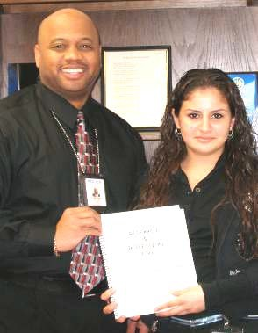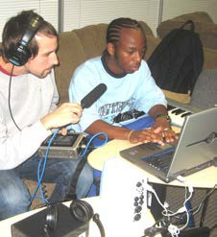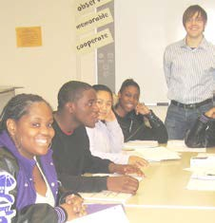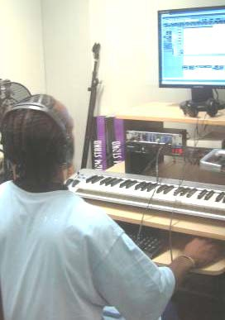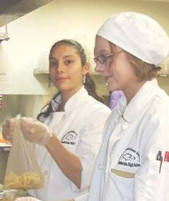

A Career Academies Senior Internship is an experience during the summer after the junior year or during the senior year when you spend 6-12 weeks working with and learning from an adult in a local business related to the academy’s theme.

**What’s in it for YOU?**

* + - It’s a great way to get an inside view of a company in your career theme area.
    - An internship will help you decide if this is a career area you want to pursue in college.
    - An internship really can help you find your career “passion”.
    - Many employers expect to see internships listed on a resume; a resume with internship experience will be impressive.
    - Internships often lead to job offers.
    - You can ask for letters of recommendation for your portfolio.
    - You will acquire skills and experiences to put in your college admission essay.
    - You will earn credit(s) for successful completion of an internship.

**What does it take to be an intern?**

* + - You will need to submit an *Internship Application Form* to your teacher, signed by your parent/guardian
    - You will take your resume and business card to an *interview* at your internship site
    - You will attend a weekly *Internship Seminar* class where you will receive *research assignments* to complete at your internship site
    - You will complete a *Learning Project* during your internship— something that is of value to your employer and a meaningful learning experience for you.
    - You will share information about the Learning Project in a *final presentation and in a written report*

**Frequently Asked Questions**

**Question:** Can I do an internship and still get a summer job?

***Answer:*** *Yes. But it is your responsibility to make sure that your hours do not conflict.*

**Question:** Can I work on weekends or evenings to get my required hours in?

***Answer:*** *Yes, if these hours are agreeable to your supervisor.*

**Question:** I already have a job; can it be my internship?

***Answer:*** *Maybe yes and maybe no. Most likely the reason you have a job is to earn money. Also your summer or part-time job is likely an entry level position. The purpose of an internship is to learn about careers and career paths, as well as gain experience in the industry. If you want to see if your job could qualify as an internship, speak with your Internship Coordinator.*

**Question:** Is the Weekly Seminar required?

***Answer:*** *Yes. The Seminar is a required part of the Senior Internship Program. It addresses topics that are critical for success in the workplace and it will help you have a successful internship. You’ll learn what other interns are experiencing and you’ll have the opportunity to problem-solve together. You will have assignments to complete in a Research and Reflection Log.*

**Question:** Will an internship be all cool work and no grunt work?

***Answer:*** *In all honestly, no. All jobs have menial and routine tasks, and doing your share shows that you’re a team player and willing to cooperate. However, if you find that a majority of your internship time is spent on the menial tasks where you’re not learning new things, speak with your supervisor and your Internship Coordinator.*

**Question:** What if I start an internship and don’t like it?

***Answer:*** *That generally doesn’t happen, but if you are having any problems you should immediately talk with the Internship Coordinator or your Seminar Teacher. They will meet with you and then with your supervisor, if necessary.*

**Question:** Will this internship help me get into college?

***Answer:*** *Yes, definitely. You can enrich your application essay with internship experiences and you can add a letter of recommendation from your Internship Supervisor to your application. Many colleges place a high value on high school internships because they show you are motivated and take initiative.*

**Question:** Will I be offered a job at the end of my internship?

***Answer:*** *Some internships turn into a job and some don’t. Even if you don’t qualify for a job right at the end of your internship, if you’ve done an excellent job, you will certainly be at the front of the line for jobs at this company, as well as at others.*

**Question:** Why can’t I wait until college to do an internship?

*Answer: A successful high school internship will increase your chances of getting into the college of your choice and will increase your chances of getting a good college internship.*

**SENIOR INTERNSHIP APPLICATION FORM**

|  |  |
| --- | --- |
| **NAME** | **ID #** |
|  |  |
| **ADDRESS** |  |
|  |  |
| **EMAIL** | **PHONE** |
| Student email:  Parent/guardian Name: Parent/guardian email: | Student Cell:  Home: |
| **PART I: Career Information** | |
| Careers that interest me:  •  •  • | |
| **PART II: Prior Work Experience** | |
| Organization(s): Job Duties: | Volunteer experience(s): |
| **PART III: Statement of Interest** | |
| How do you think an internship will help you apply to and succeed in college? | |

|  |
| --- |
| How do you think an internship will help you make good career choices?  Pick one of the Career Academy Skills for Success. How will your strengths in that skill make you a successful intern? |
| **PART IV: Transportation** |
| What method of transportation will you use to get to an internship?:   * I have my own car * My family will drive me * I will need to use public transportation * Other: |
| **PART V: Opting Out of the Internship** |
| If you choose not to take an internship, please check your reason(s):   * Paid job hours will not allow time for internship (Give name of employer and work hours): * Family travel plans (Give dates when you will be away.) * After school commitments (if during school year). List here: * Other: |
| **PART VI: Signatures** |
| Student Signature: Date:  Parent/Guardian Signature: Date: |

#### Making a Good First Impression

|  |
| --- |
| **Purpose** |
| In this activity, students will learn strategies to “get off on the right foot” on their internships. |

|  |
| --- |
| **Suggested Grade Level:** |
| 11 |

|  |
| --- |
| **Materials and Handouts** |
| First Day on an Internship Just a Feeling |

|  |
| --- |
| **Approximate Time Needed:** |
| Varies |

**Student-Facing Instructions**

PART 1: FIRST IMPRESSIONS

Consider the following list of “firsts”:

* first day at a new school
* first day of practice with a new team
* first time you meet your girl/boyfriend’s family
* first day on a new job
* first job interview

Select and event and take 3 minutes to jot down what you felt before and after this event and whether you tried to make a good first impression. Share with a partner and take a minute to share your thoughts.

PART 2: ELEMENTS OF A GOOD FIRST IMPRESSION

Starting an internship or a new job is nerve-wracking even for the most experienced and successful people. Read the First Day on an Internship handout. In pairs, identify what makes you nervous about starting your new internship, and what things you might do to prepare for making a solid first impression. Refer to the Just a Feeling chart as you think about your feelings on the internship.

PART 3: PRACTICE MAKING A FIRST IMPRESSION

You have arrived on the first day of their internship. Take turns saying hello, introducing yourselves, and shaking hands. You may also add something personal, such as: “Hello, my name is . I am so excited to be here! Thank you for hosting me!”

Take turns being the interviewer. The interviewer will select a question from the cup and read it aloud to the other partners in the group. The Interviewees will take turns answering the question. Try and be as creative as possible in answering the questions.

What were the elements of a strong professional first impression that you observed?

**Teacher Notes**

Part 2:

When discussing first day on the internship stories,be ready with a story of your own. Make sure to include at least three practical things you did to prepare for making a good impression: e.g. dress professional, arrive early. Give students about five minutes to work in pairs or triads to identify what makes them nervous about starting their new internship, and what things they might do to prepare for making a solid first impression.

Ask each group to report out their ideas for helping to make a solid first impression. As each group reports out, ask one or two students to record on large flip chart paper or on the board. Read the ideas back to stu- dents. Highlight the ability to engage in dialogue with adults, shake hands, ask question and answer ques- tions, and present with confidence.

Part 3:

Tell students they are going to get a chance to practice making a first impression in small groups of three. Divide the students into groups and hand each group a coffee cup (any mug will do). The coffee cup should be filled with folded slips of paper that have questions that might be asked the first day of an internship. Follow- ing introductions have students pass around the coffee cup. One student will remove a slip of paper and read a question to the other two. Then each of the other two students will take turns answering the question. Tell students to try and be as creative as possible in answering their questions. As students are working on this exercise, the teacher is circulating and taking notes. If you notice a student that engages with a high skill of confidence, presence, and creative/ in--depth answers, ask that group if they are willing to demonstrate for the whole group.

**Assessment**

Completion of Just a Feeling handout.

**Instructions**

PART 1: FIRST IMPRESSIONS

Consider the following list of “firsts”:

* first day at a new school
* first day of practice with a new team
* first time you meet your girl/boyfriend’s family
* first day on a new job
* first job interview

Select and event and take 3 minutes to jot down what you felt before and after this event and whether you tried to make a good first impression. Share with a partner and take a minute to share your thoughts.

PART 2: ELEMENTS OF A GOOD FIRST IMPRESSION

Starting an internship or a new job is nerve-wracking even for the most experienced and successful people. Read the First Day on an Internship handout. In pairs, identify what makes you nervous about starting your new internship, and what things you might do to prepare for making a solid first impression. Refer to the Just a Feeling chart as you think about your feelings on the internship.

PART 3: PRACTICE MAKING A FIRST IMPRESSION

You have arrived on the first day of their internship. Take turns saying hello, introducing yourselves, and shaking hands. You may also add something personal, such as: “Hello, my name is . I am so excited to be here! Thank you for hosting me!”

Take turns being the interviewer. The interviewer will select a question from the cup and read it aloud to the other partners in the group. The Interviewees will take turns answering the question. Try and be as creative as possible in answering the questions.

What were the elements of a strong professional first impression that you observed?



Imagine this is your first day on your internship at James John Café, a local family-­‐owned restaurant that has been in the neighborhood for over 20 years. You feel that you did a good job in your internship interview and you researched this restaurant and others in the neighborhood quite well, but you don’t know exactly what you’ll be doing on a daily basis. Therefore, you are nervous, but you really want to “get off on the right foot” because you think you want to apply here for an after-­‐school job next year.

You arrived right on time and found Suzanne, your supervisor, whom you’d met during your interview a few weeks ago. After greeting you, Suzanne gave you a tour of the whole restaurant, including the restrooms and the outside dumpster! While at the dumpster, she explained the local recycling policies and while near the restrooms she explained the health regulations that apply to all employees (and that includes you while on your internship). You KNOW you’ll never remember all the information she gaveyou about recycling and health/safety codes, like how to separate the different colorbottles and what can and what can’t go into the dumpster, what to do if/when the health inspector comes to visit, etc. And it was a bit unnerving to hear her mention a nearby restaurant that got a huge fine from the health inspector!!

After this quick tour, Suzanne introduced you to the other people who work there, including her co-­‐owner/chef and the four wait staff currently on duty. You listenedand observed carefully as Suzanne walked you around the dining room telling you that she wants you to get a taste of all aspects of running a restaurant. She very quickly tickedoff all these things:

* Ordering supplies from many purveyors *(what does purveyor mean?!)*
* Customer service *(being nice even to those people who come in, order one cup of coffee and stay working on their computer for 3 hours!)*
* Planning creative menus *(you want to be a cut above other restaurants in the area)*
* Writing the daily menu with no typos *(there’s one customer who always findsthe typos!)*
* Cooking and getting meals to the tables in a timely manner
* Compliance with health and safety regulations
* Advertising and publicizing special events
* Hiring and training employees
* Seeking ways to contribute to the community
* And of course the bottom line is managing the budget so everyone gets paid and

the restaurant makes a profit!

So now you are officially overwhelmed with all this information. Nonetheless, Suzanne continues by reviewing some of your daily work responsibilities AND yourindividual learning project. Some of your daily tasks are:

* + Shadow one waitress for a couple of days and then have her observe and give you feedback as you start to wait on customers.
  + Make sure there is always coffee ready and the espresso machine is clean.
  + Continuously revise the menu on the blackboard to reflect any daily specials that are sold out.
  + Greet and seat customers.

You feel confident about most of that and Suzanne told you during the interview that as you become more familiar with the restaurant, you will be given moreresponsibility.

Then Suzanne explains what she would like for you to do as a special learning project. You know from your interview that it’s something about nutrition, but you’re not sure what. Suzanne explains that the restaurant is getting pressure from customers to duplicate what some chain restaurants are doing: offer a nutritional analysis of selected menu items. She knows that it’s important to do, but she just hasn’t had the time to do it. She learned from your interview that you have good research and computer skills, so she would like you to start by researching how some national chain restaurants are displaying the information for their customers. The next step will be to actually dothe nutritional analysis of this restaurant’s regular menu items. Suzanne said a teacher inthe community college culinary arts program frequents the restaurant and she’ll want youto meet with that person to learn about how to do the analysis. Next week, after you have a feel for the flow of the daily tasks, you will sit down with Suzanne to make a time line for your project.

Depending on how quickly the nutritional analysis project goes, she may even want you to try to make their menu more graphically creative!

After the tour, the introductions, the explanation of daily tasks and the learningproject, Suzanne asks if you have any questions. But by the time you figure out what question to ask first, because you have so many, Suzanne says “Well, welcome aboard. You really impressed me during our interview and we are lucky to have you here as ourintern.

Excuse me; I have to make a phone call now.”

And she’s gone. And you’re standing there, just about an hour into the first day ofyour internship. What do you do next? In the back of your mind, of course, is your desire to make a professional first impression and there’s also that after-­‐school job you’rehoping for.

### Just a Feeling

Put a **√** mark next to any of these positive and negative emotions which you might have experienced during your first day on that hypothetical internship. Circle the words which describe how you feel about starting your actualinternship.

|  |  |  |  |
| --- | --- | --- | --- |
| □ capable | □ eager | □ bitter | □ exhausted |
| □ frustrated | □ helpless | □ enthusiastic | □ pressured |
| □ panicked | □ confident | □ foolish | □ friendly |
| □ satisfied | □ unqualified | □ pleased | □ bored |
| □ anxious | □ lonely | □ annoyed | □ bad |
| □ stressed | □ patient | □ scared | □ nervous |
| □ calm | □ cheerful | □ mature | □ jumpy |
| □ desperate | □ unhappy | □ happy | □ quiet |
| □ tense | □ angry | □ miserable | □ horrible |
| □ left out | □ determined | □ doubtful | □ curious |
| □ challenged | □ worried | □ confused | □ overwhelmed |
| □ abandoned | □ flustered | □ great |  |
| □ excited | □ competitive | □ brave |  |

#### Information Overboard

|  |
| --- |
| **Purpose** |
| In this activity, students will become familiar with the challenges of beginning a new internship. |

|  |
| --- |
| **Suggested Grade Level:** |
| 11 |

|  |
| --- |
| **Materials and Handouts** |
| Information Overload |

|  |
| --- |
| **Approximate Time Needed:** |
| Varies |

**Student-Facing Instructions**

Appropriate Responses to Information Overload

Have you ever felt frustrated because you were given more information than they could possibly remember? This is called “information overload” and it can happen on the first day or first week of a new job, starting at a new school, or beginning a new class.

Mastering all the new information in the first day or even the first week is an unrealistic expectation. Look at the handout, Information Overload and fill in the chart.

**Question #1:**

A. What behaviors or feelings can result if an intern receives too much information too fast? B: What are appropriate responses to receiving too much information?

**Question #2:**

A. What behaviors or feelings can result if a new intern does not receive enough information to do the job properly?

B: What are appropriate responses to receiving too little information?

Take turns being the interviewer. The interviewer will select a question from the cup and read it aloud to the other partners in the group. The Interviewees will take turns answering the question. Try and be as creative as possible in answering the questions.

What were the elements of a strong professional first impression that you observed?

**Teacher Notes**

Provide students with a personal example of when you felt overwhelmed by receiving too much information. Discuss what feelings came up for you, and how you responded. Facilitate a class discussion based on the Information Overload handout. Offer the following suggestions if they are not mentioned:

Too Much Information:

Behaviors/Feelings: Intern might stop listening or start interrupting inappropriately

Appropriate Responses: Intern could take notes; ask the supervisor to slow down; or ask for clarification

Too Little Information:

Behaviors/Feelings: Intern might feel confused, helpless, or fearful

Appropriate Responses: Intern could explain how they are feeling and why; ask a supervisor for additional information; or ask a co-worker for more information.

Pose this final question for a group brainstorm:

What can you do during the first week of your internship to remember and organize the “glut” of information you’ll get?

Examples include:

* keep notes
* restate information when it is given
* memorize names by creative associations (Rachel has red hair, Devon has dimples)
* observe which co--workers seem most welcoming and willing to answer questions

**Assessment**

Completion of Information Overload handout.

**Instructions**

Appropriate Responses to Information Overload

Have you ever felt frustrated because you were given more information than they could possibly remember? This is called “information overload” and it can happen on the first day or first week of a new job, starting at a new school, or beginning a new class.

Mastering all the new information in the first day or even the first week is an unrealistic expectation. Look at the handout, Information Overload and fill in the chart.

**Question #1:**

A. What behaviors or feelings can result if an intern receives too much information too fast? B: What are appropriate responses to receiving too much information?

**Question #2:**

A. What behaviors or feelings can result if a new intern does not receive enough information to do the job properly?

B: What are appropriate responses to receiving too little information?

Take turns being the interviewer. The interviewer will select a question from the cup and read it aloud to the other partners in the group. The Interviewees will take turns answering the question. Try and be as creative as possible in answering the questions.

What were the elements of a strong professional first impression that you observed?

**Information OVERLOAD**

Fill in the chart below

1. What behaviors or feelings can result if a new employee receives too much information too fast? What are appropriate responses to receiving toomuch information?
2. What behaviors or feelings can result if a new employee does not receive enough information to do the job properly? What are appropriateresponses to receiving too little information?

|  |  |  |
| --- | --- | --- |
|  | Behaviors or Feelings | Appropriate Responses |
| 1. Too much information |  |  |
| 2. Too little information |  |  |

#### First Week on the Internship Scenarios

|  |
| --- |
| **Purpose** |
| In this activity, students will understand the importance of making a good first impression. |

|  |
| --- |
| **Suggested Grade Level:** |
| 11 |

|  |
| --- |
| **Materials and Handouts** |
| First Week on the Internship Scenarios Just a Feeling |

|  |
| --- |
| **Approximate Time Needed:** |
| Varies |

**Student-Facing Instructions**

Look at the handout, First Week on the Internship… Scenarios. There are two scenarios provided. Complete the in-class activity the scenario selected by your teacher and answer the questions, and then do the same individually for the other scenario. As you answer the questions, feel free to refer to the Just a Feeling handout.

**Teacher Notes**

From handout, First Week on the Internship… Scenarios, select one of the scenarios for your students to read and then individually answer questions #1 and #2. Remind them to refer to the Just a Feeling handout.

Now ask the class: If you were the supervisor, how would you respond if this is what your intern did? Would the intern’s response make a good first impression? If, so why? If not, why not? Call on two or three students who have not participated actively up to this point in the seminar. (Tell students they should expect you to call on them throughout the class—you will not just be calling--on students who raise their hands!) Popsicle sticks with students’ names in a jar is helpful in making sure all students are called on equitably. Removing the stick and placing in a different jar after a student is called on.

**Assessment**

Completion of First Week on the Internship Scenarios handout.

**Instructions**

Look at the handout, First Week on the Internship… Scenarios. There are two scenarios provided. Complete the in-class activity the scenario selected by your teacher and answer the questions, and then do the same individually for the other scenario. As you answer the questions, feel free to refer to the Just a Feeling handout.

**First Week on the Internship…Scenarios**

Scenario #1

You've just finished the first week of your internship at a law firm , but you feel that you are not getting enough direction to do your job as well as you know you could. You've been asked to make some detailed editing changes to a newsletter. But here's the kicker...you are familiar with your Apple operating system and software, but this office uses PCs. You were already given an introduction to their technology in your orientation, but it was very general and it didn't really address these specific editing needs. Everyone just assumes that you can easily finish the editing job by the end of next week, but you're not so sure.

1. What are some of your feelings?
2. What appropriate action should you take?

**First Week on the Internship…Scenarios** page 2

Scenario #2

You are excited to land an internship in the pediatric department of a hospital because you're thinking of a career in the medical field. You feel you have strong skills in working with people, particularly youngsters. You've been there just a couple of days now, and all you've been allowed to do is file x-ray charts and sit in for the receptionist while he takes his lunch break. You haven't yet spoken to a patient or a doctor and no one has mentioned expanding your duties. This internship was going to be perfect, but now it looks as if you are not going to meet any of your personal goals.

1. What are some of your feelings?
2. What appropriate action should you take?

### Just a Feeling

Put a **√** mark next to any of these positive and negative emotions which you might have experienced during your first day on that hypothetical internship. Circle the words which describe how you feel about starting your actualinternship.

|  |  |  |  |
| --- | --- | --- | --- |
| □ capable | □ eager | □ bitter | □ exhausted |
| □ frustrated | □ helpless | □ enthusiastic | □ pressured |
| □ panicked | □ confident | □ foolish | □ friendly |
| □ satisfied | □ unqualified | □ pleased | □ bored |
| □ anxious | □ lonely | □ annoyed | □ bad |
| □ stressed | □ patient | □ scared | □ nervous |
| □ calm | □ cheerful | □ mature | □ jumpy |
| □ desperate | □ unhappy | □ happy | □ quiet |
| □ tense | □ angry | □ miserable | □ horrible |
| □ left out | □ determined | □ doubtful | □ curious |
| □ challenged | □ worried | □ confused | □ overwhelmed |
| □ abandoned | □ flustered | □ great |  |
| □ excited | □ competitive | □ brave |  |

#### First Impressions: Use It or Lose It

|  |
| --- |
| **Purpose** |
| In this activity, students will discuss ways in which to respond to information overload. |

|  |
| --- |
| **Suggested Grade Level:** |
| 11 |

|  |
| --- |
| **Materials and Handouts** |
| First Impressions: Use It or Lose It |

|  |
| --- |
| **Approximate Time Needed:** |
| Varies |

**Student-Facing Instructions**

Use It or Lose It is both a summary and an assessment. Complete the worksheet and think about the following questions:

1. “You never get a second chance to make a first impression”. What does this mean to you?
2. What will you do on your internship this week if you start to feel overwhelmed by too little or too much information?

**Teacher Notes**

This lesson should come after Making a Good First Impression, Information Overload, and First Week on the Internship Scenarios.

**Assessment**

Completion of First Impressions: Use It or Lose It handout.

**Instructions**

Use It or Lose It is both a summary and an assessment. Complete the worksheet and think about the following questions:

1. “You never get a second chance to make a first impression”. What does this mean to you?
2. What will you do on your internship this week if you start to feel overwhelmed by too little or too much information?

**Use It or Lose It**

Use the information from today’s seminar to answer thesequestions.

* 1. “You never get a second chance to make a first impression”. What doesthis mean to you?
  2. What will you do this week if you start to feel overwhelmed by too little ortoo much information?

#### First Week on the Internship: Research Assignment

|  |
| --- |
| **Purpose** |
| This activity gives students an opportunity to learn and practice the skills that will enable them to manage their first week on the job successfully. |

|  |
| --- |
| **Suggested Grade Level:** |
| 11 |

|  |
| --- |
| **Materials and Handouts** |
| First Week Research Assignment |

|  |
| --- |
| **Approximate Time Needed:** |
| 30 minutes |

**Student-Facing Instructions**

1. Talk with your supervisor about what it means to be a professional in their place of business. Ask how being a professional can lead to promotion and career advancement.
2. You have already done research about your internship company before your interview. Now think about delving deeper by finding at least one piece of new information, such as how your supervisor fits into the organizational structure of the company. Note below what you will share with the class next week.
3. Fill out the First Week on the Internship Self--assessment.

**Assessment**

Completion of the worksheet.

**Instructions**

1. Talk with your supervisor about what it means to be a professional in their place of business. Ask how being a professional can lead to promotion and career advancement.
2. You have already done research about your internship company before your interview. Now think about delving deeper by finding at least one piece of new information, such as how your supervisor fits into the organizational structure of the company. Note below what you will share with the class next week.
3. Fill out the First Week on the Internship Self--assessment.

**Research Assignment**

Talk with your supervisor about what it means to be a professional in their place of business. Ask how being a professional can lead to promotion and career advancement.

Notes:

You have already done research about your internship company before your interview. Now think about delving deeper by finding at least one piece of new information, such as how your supervisor fits into the organizational structure of the company. Note below what you will share with the class next week.

Fill out the *First Week on the Job Self---assessment* on the next page.

**Self-Assessment**

|  |  |  |  |
| --- | --- | --- | --- |
| **Workplace Skill** | **Not Good**  **1** | **Okay**  **2** | **Great!**  **3** |
| I arrived on time |  |  |  |
| I dressed appropriately |  |  |  |
| I entered with a smile |  |  |  |
| I introduced myself when appropriate |  |  |  |
| I made eye contact |  |  |  |
| I asked good questions |  |  |  |
| I was polite and friendly |  |  |  |
| I showed active interest |  |  |  |
| I was enthusiastic |  |  |  |
| I listened well |  |  |  |
| I observed carefully |  |  |  |
|  |  |  |  |
|  |  |  |  |

#### First Week on the Internship: Reflection

|  |
| --- |
| **Purpose** |
| This activity gives students an opportunity to reflect on their internship experiences and the key takeaways  from related lessons, such as what skills, techniques, and  concepts can be applied to college and future work. |

|  |
| --- |
| **Suggested Grade Level:** |
| 11 |

|  |
| --- |
| **Materials and Handouts** |
| First Week Reflection |

|  |
| --- |
| **Approximate Time Needed:** |
| Varies |

**Student-Facing Instructions**

The Reflection is separated out into five parts:

1. Word of the week
2. Quote of the week
3. Learning in the future
4. Working in the future
5. What if?

Read the prompts in each section and respond, thinking about your own learning, beliefs, values, and experiences. If you need more room for your answers or you have additional thoughts you’d like to put down on paper, an extra page is available for “Free Writing”.

**Assessment**

Completion of the worksheet.

**Instructions**

The Reflection is separated out into five parts:

1. Word of the week
2. Quote of the week
3. Learning in the future
4. Working in the future
5. What if?

Read the prompts in each section and respond, thinking about your own learning, beliefs, values, and experiences. If you need more room for your answers or you have additional thoughts you’d like to put down on paper, an extra page is available for “Free Writing”.

**Word of the week:** “professional”

**Reflection**

* + Why is being “professional” important for your first week as an intern?
  + Use the word “professional” in a sentence to describe a co-­‐worker or supervisor or yourself.

**Quote of the week:** *“You never get a second chance to make a firstimpression.”*

Common saying

Take a few minutes to think about the quote and then re-­‐write it in your ownwords.

**Learning in the future:**

* What did you learn this week about “first days” that might help you in college?

**Working in the future:**

* What did you learn this week about “first days” that might help you in a future job?

**What If?**

* + What if you won the lottery and your co-­‐workers asked you not to quit because they want your help on a project?

**Free writing: anything in the world you want to write about…**

## During the Internship: Time Management

#### It’s All About Time Activity

|  |
| --- |
| **Purpose** |
| In this activity, students will identify issues around time at their workplace. |

|  |
| --- |
| **Suggested Grade Level:** |
| 11 |

|  |
| --- |
| **Materials and Handouts** |
| Task List: It’s All About Time Activity |

|  |
| --- |
| **Approximate Time Needed:** |
| Varies |

**Student-Facing Instructions**

You will be assigned one of four tasks. In your groups, you have 10 minutes to complete your task. After the task, answer the following questions:

1. How did you prioritize what would be completed first?
2. How did you break down the tasks?
3. What were some of the ways this was challenging?
4. Did you find that some tasks needed to be completed prior to others?

**Teacher Notes**

Perceptions of Time

Do a quick exercise to see how we each perceive time differently. Tell students that they will be asked to be absolutely silent with their eyes closed, or staring at the floor, for 60 seconds. You will time them to the second. At the end of the 60 seconds, ask the students to share their responses to the following questions: Did the 60 seconds feel like a long time or did the time just fly by? How difficult or easy was it to be silent for 60 seconds?

Managing Time

Place students into small groups of 3--4. Distribute a bag with materials inside and a sheet of paper with four tasks. Tell students the task must be completed in 10 minutes. (List of materials and tasks included) After 10 minutes ask each group to present their completed tasks. Ask the groups how they prioritized what would be completed first. How did they break down the tasks? What were some of the ways this was

challenging? Did they find that some tasks needed to be completed prior to others? Time Challenges

Remind interns that organization is a learned skill and can help them achieve goals and reduce stress. The key is to prioritize all the things you need to do. Help students understand this vocabulary word.

Ask interns to turn to a partner and together list some of the time challenges they face on their internships. Ask for one example to be sure students understand the task.

Have them call out some of the challenges and post them on the board. Examples could include: getting to work on time (especially if they rely on someone else to drive), taking lunch and breaks at appropriate times, not understanding the priorities on a certain project, totaling receipts at the end of the day, wanting to text a friend, meeting a production deadline, cooking food so it arrives at the same time as another dish, editing music to fit with video.

When you have a significant list, read them over together and note how pervasive time considerations are in the workplace. Without attending to time requirements, a workplace or your life can be chaotic.

Recognize the time challenges that we all face. Point out that almost everyone must cope with conflicting demands on time and sometimes these conflicts make us feel stressed and frustrated, which can lead to drugs, alcohol or just quitting. Let them know that the next seminar is.

**Assessment**

Completion of Information Overload handout.

**Instructions**

You will be assigned one of four tasks. In your groups, you have 10 minutes to complete your task. After the task, answer the following questions:

1. How did you prioritize what would be completed first?
2. How did you break down the tasks?
3. What were some of the ways this was challenging?
4. Did you find that some tasks needed to be completed prior to others?

Please complete the following tasks. These all MUST be completed in the next 10 minutes time. You do not have to complete these tasks in order.

 Make a 4 X 4 inch cube

 Cut three strips of paper

 Number two of the strips of paper 1 & 2

 Glue one of the blank strips to the 4 X 4 inch cube

 Make a human – looking figure out of pipe cleaners

 Place a red sticker on one side of the cube, a blue sticker on another side, and a yellow sticker on another side

 Place the human-looking figure so that it sits on top of the cube

 Write all the names of your group on a piece of paper and the time it took to complete each task

#### Time Saver Tips

|  |
| --- |
| **Purpose** |
| In this activity, students will explore a variety of time management techniques. |

|  |
| --- |
| **Suggested Grade Level:** |
| 11 |

|  |
| --- |
| **Materials and Handouts** |
| Time Saver Tips |

|  |
| --- |
| **Approximate Time Needed:** |
| Varies |

**Student-Facing Instructions**

Here are some commonly accepted tips to manage time more effectively. There is actually a whole industry dedicated to time management and the handout, Time Saver Tips, is based on that industry’s research.

After reading the handout, pick two tips you could apply to your internships. Complete the handout by including how the tips, as well as the suggestions they generated, might help you improve your performance. Be specific!

**Teacher Notes**

In the same small groups as above, ask students to brainstorm ideas for saving time. Have them share out the ideas with the whole group. Do a round--robin read aloud of the handout, Time Saver Tips and have them pick the two tips they’d like to focus on.

Ask for volunteers to share one of the tips they chose and tell how it could improve their internship experi- ence and make them a more successful, professional intern.

Use the word of the week, prioritize, to help process this activity.

**Assessment**

Completion of Time Saver Tips handout.

**Instructions**

Here are some commonly accepted tips to manage time more effectively. There is actually a whole industry dedicated to time management and the handout, Time Saver Tips, is based on that industry’s research.

After reading the handout, pick two tips you could apply to your internships. Complete the handout by including how the tips, as well as the suggestions they generated, might help you improve your performance. Be specific!

|  |
| --- |
| **Time Saver Tips** page 1   1. **Be realistic** • Don’t try to do so much that you never get it all done. 2. **Plan ahead** • Think before you act, look before you leap. If you’re driving toan appointment during rush hour, leave enough time to get caught in traffic so you’re not late, and angry and frustrated as well. 3. **Make a schedule and stick to it** • Carry an appointment book or calendar so you don’t forget commitments—or program info into your phone or PDA. 4. **Keep a daily “to do” list** • Record everything you need to get done todayand this week, and cross items out as you complete each one. 5. **Set priorities** • Do what’s most important first and rearrange your schedule if necessary. If a doctor appointment and a job interview are scheduled forthe same time, what do you do? 6. **Consolidate your actions** • If you need to take some reports from one office to the next, *and* ask your supervisor a question, *and* get coffee, try to do all these on the same trip. 7. **Learn to say “no”** • What if your supervisor asked you at the last minute to do some extra work on a day that you already had a test at school? What if afriend asked you to go to a job interview with him during your internship hours? 8. **Concentrate** • Don’t let your friends, cell phone or iPod distract you fromyour job. 9. **If you don’t know, ask someone** • Asking questions is a respected skill for any job. There are no dumb questions! Asking a question can be more efficient and less frustrating than doing something wrong the first time and then having tofix it. 10. **Don’t blame yourself** • Learn from the past and know your time management skills will continue to improve. |

|  |
| --- |
| **Time Saver Tips** page 2  Select two of the time saver tips that would be most useful to you at your internship. Explain how each chosen tip would improve your performance and make you a successful, professional intern.   * Tip: * Tip: |

#### Time Management: Use It or Lose It

|  |
| --- |
| **Purpose** |
| In this activity, students will assess their personal use of time and identify a strategy to manage their time effectively. |

|  |
| --- |
| **Suggested Grade Level:** |
| 11 |

|  |
| --- |
| **Materials and Handouts** |
| Time Management: Use It or Lose It |

|  |
| --- |
| **Approximate Time Needed:** |
| Varies |

**Student-Facing Instructions**

Use It or Lose It is both a summary and an assessment. Complete the worksheet and think about the following questions:

1. Things in my life that get in the way of good time management are...
2. One time management technique I would like to try is...

**Teacher Notes**

This lesson should come after Time Saver Tips.

**Assessment**

Completion of Time Management- Use it or Lose it handout.

**Instructions**

Use It or Lose It is both a summary and an assessment. Complete the worksheet and think about the following questions:

1. Things in my life that get in the way of good time management are...
2. One time management technique I would like to try is...

|  |
| --- |
| **Use It or Lose It**  Think back on today's seminar on time management and use the information to answer these questions.  Things n y ife hat et n he ay f ood ime anagement  ment techni ue I would like tot is:  _ |



#### A Matter of Time: Research Assignment

|  |
| --- |
| **Purpose** |
| This activity introduces students to successful time management practices that can increase efficiency, self- esteem and job satisfaction. |

|  |
| --- |
| **Suggested Grade Level:** |
| 11 |

|  |
| --- |
| **Materials and Handouts** |
| Matter of Time Research Assignment |

|  |
| --- |
| **Approximate Time Needed:** |
| 30 minutes |

**Student-Facing Instructions**

Using the Time Management Poll they will research how co--workers prioritize their time and what their favorite time management tips are.

Schedule time to talk with two people at your internship about how they manage their time. Use the following Time Management Poll to gather information. After your interviews, summarize the information on page 2 of the poll.

**Assessment**

Completion of the worksheet.

**Instructions**

Using the Time Management Poll they will research how co--workers prioritize their time and what their favorite time management tips are.

Schedule time to talk with two people at your internship about how they manage their time. Use the following Time Management Poll to gather information. After your interviews, summarize the information on page 2 of the poll.

##### A Matter of Time Research Assignment

Schedule time to talk with two people at your internship about how they manage their time. Use the following Time Management Poll to gather information. After your interviews, summarize the information on page 2 of the poll.

For class next week, assume that you are a Time Management Consultant who has been hired by the group. It is your job to present two tips about how the interns could manage their personal and work time better. Keep in mind that you are a hired consultant, so make these suggestions creative and motivating!

The Internship Project Plan needs to be completed during Week 1 or 2, (if not before); you should bring it with you to the seminar next week.

**Time Management Poll**

How do your co-­‐workers manage time? See what nuggets of advice you can learn from their work styles and experience. Arrange for a convenient time to talk to at least two of your co-­‐workers. Explain that you are taking a poll on time management at work.

Read the questions and fill out the chartbelow.

|  |  |  |
| --- | --- | --- |
|  | **Q: When you are pressed for time,**  **how do you prioritize what to do and what to leave until later?** | **Q: What are the best time management tips you can give me?** |
| **Name/Position of Co-­‐worker #1:** |  |  |
| **Name/Position of Co-­‐worker #2:** |  |  |

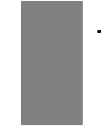

#### A Matter of Time: Reflection

|  |
| --- |
| **Purpose** |
| This activity gives students an opportunity to reflect on their internship experiences and the key takeaways  from related lessons, such as what skills, techniques, and  concepts can be applied to college and future work. |

|  |
| --- |
| **Suggested Grade Level:** |
| 11 |

|  |
| --- |
| **Materials and Handouts** |
| A Matter of Time Reflection |

|  |
| --- |
| **Approximate Time Needed:** |
| Varies |

**Student-Facing Instructions**

The Reflection is separated out into five parts:

1. Word of the week
2. Quote of the week
3. Learning in the future
4. Working in the future
5. What if?

Read the prompts in each section and respond, thinking about your own learning, beliefs, values, and experiences. If you need more room for your answers or you have additional thoughts you’d like to put down on paper, an extra page is available for “Free Writing”.

**Assessment**

Completion of the worksheet.

**Instructions**

The Reflection is separated out into five parts:

1. Word of the week
2. Quote of the week
3. Learning in the future
4. Working in the future
5. What if?

Read the prompts in each section and respond, thinking about your own learning, beliefs, values, and experiences. If you need more room for your answers or you have additional thoughts you’d like to put down on paper, an extra page is available for “Free Writing”.



**Word of the week:** “prioritize”

* + What evidence can you cite that people “prioritize” well at your internship site?
  + Use the word “prioritize” in a sentence to describe a co-­‐worker or supervisor or yourself.

**Quote of the week:** *“The bad news is that time flies and the good news is thatyou are the pilot.”* Michael Altshuler

Take a few minutes to think about the quote and then re-­‐write it in your ownwords.

**Learning in the future:**

* + What did you learn this week about time management that might help you in college?

**Working in the future:**

* + What did you learn this week about time management that might help you in a future job?

**What If?**

* + What if you realized that you are consistently about ten minutes late to work, but nobody seems to notice?

**Free writing: anything in the world you want to write about…**

## During the Internship: Stress Management

#### What Stress Looks and Feels Like

|  |
| --- |
| **Purpose** |
| In this activity, students will define stress and identify how personal stress can have a negative influence at work. |

|  |
| --- |
| **Suggested Grade Level:** |
| 11 |

|  |
| --- |
| **Materials and Handouts** |
| Stress Responses |

|  |
| --- |
| **Approximate Time Needed:** |
| Varies |

**Student-Facing Instructions**

Option 1:

Create a drawing of what it feels like to be stressed out. This can be a drawing of a person or of a place or thing, or an abstract of colors and lines with words surrounding it.

Option 2:

Create a collage using magazines to show what it feels like to be stressed out.

Look at the Stress Responses sheet and identify 1 primary and 1 secondary way you respond to stress. Find your peers that have similar stress responses and brainstorm and what strategies you use to manage your stress.

**Teacher Notes**

Distribute colored pencils or markers and drawing paper. Ask students to create a drawing of what it feels like to be stressed out. You may want to list some of the words and phrases on the board for guidance. Allow about 5--10 minutes for the drawing and then ask for volunteers to share. Record on flip chart or board their descriptive words for stress. Post their creative work.

As an alternative, you may choose to provide magazines and have students create a collage that represents stress in their lives.

Pass out the “stress responses” sheet. Have students read through the responses and identify one primary and one secondary way that they respond to stress. Post each of the stress responses around the room, and

ask students to move to the area most aligned to their response. In the stress response groups, have students brainstorm how they manage stress. What strategies do they use to manage their stress? Ask groups to share out their strategies.

**Assessment**

Illustration/collage of how you respond to stress

**Instructions**

Option 1:

Create a drawing of what it feels like to be stressed out. This can be a drawing of a person or of a place or thing, or an abstract of colors and lines with words surrounding it.

Option 2:

Create a collage using magazines to show what it feels like to be stressed out.

Look at the Stress Responses sheet and identify 1 primary and 1 secondary way you respond to stress. Find your peers that have similar stress responses and brainstorm and what strategies you use to manage your stress.

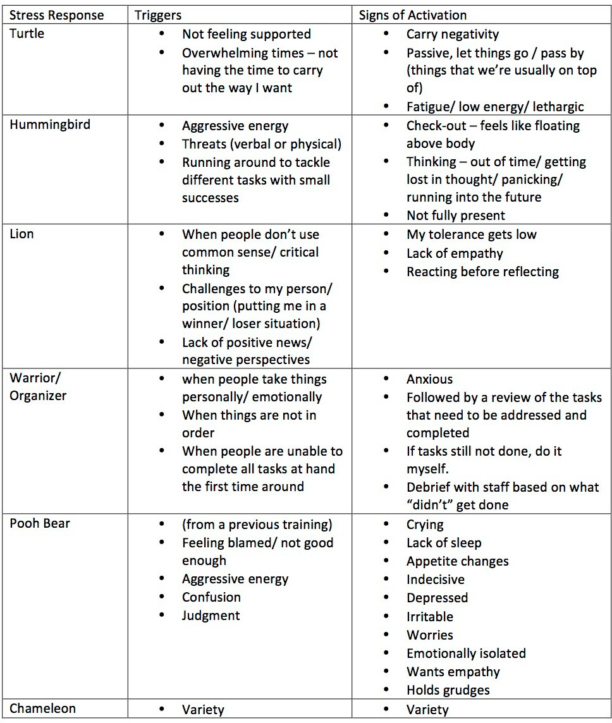

#### What Stress Does to Your Body

|  |
| --- |
| **Purpose** |
| In this activity, students will understand how the body responds to stress. |

|  |
| --- |
| **Suggested Grade Level:** |
| 11 |

|  |
| --- |
| **Materials and Handouts** |
| What Stress Does to Your Body |

|  |
| --- |
| **Approximate Time Needed:** |
| Varies |

**Student-Facing Instructions**

In groups:

* Read the What Stress Does to Your Body handout together
* Underline key phrases or ideas
* Identify ways that personal stress can influence your success as an intern

**Teacher Notes**

Talk about Stress:

Short--term stress can be useful. A rush of adrenaline can help us take a test, meet a work deadline or run to catch the bus. The background to this is that early humans lived in small groups and their bodies developed the ability to fight or flee when a predator attacked. That was natural and quick. But modern life has brought us different kinds of long--term stresses that our bodies are not equipped to handle. If your body’s defense mechanisms are constantly activated, you may become vulnerable to major health problems. It is important to watch for signs of stress and find ways to manage it for success and happiness in your personal and profes- sional lives.

SIGNS OF STRESS TO WATCH FOR

* Feeling depressed, edgy, guilty, tired
* Having headaches, stomach aches, trouble sleeping
* Laughing or crying for no reason
* Feeling tired, even when you have slept well

Adapted from the 11th Grade Internship Seminars. Copyright © 2011 MDRC. All Rights Reserved.

* Seeing only the down side of a situation
* Feeling like things that you used to enjoy aren’t fun or are a burden
* Having feelings of anxiety or excessive worry Group Discussion:

Form groups of four and direct students to the handout What Stress Does to Your Body.

**Assessment**

What Stress Does to Your Body with key phrases underlined.

**Instructions**

In groups:

* + Read the What Stress Does to Your Body handout together
  + Underline key phrases or ideas
  + Identify ways that personal stress can influence your success as an intern

Adapted from the 11th Grade Internship Seminars. Copyright © 2011 MDRC. All Rights Reserved.

**What STRESS Does to Your Body**

Your group task is to read about what happens to your body as a result ofstress and underline or highlight the most important points to remember.

|  |
| --- |
| The stress response, often referred to as the "fight or flight" reaction, is your body's automatic switch into "high gear." There are physical threats and emotional threats. In a physical threat, you need the energy, speed, concentration and agility either to protect yourself or to run as fast aspossible. In an emotional threat, you need ways to understand andcope.  With either physical or emotional stress your brain sets off an alarm system in your body that releases a surge of hormones — mostly adrenaline andcortisol. Both adrenaline and cortisol can cause damage, such as increased heartrate, elevated blood pressure and increased blood sugar.  Your body's defenses against physical dangers are different from what’s needed to deal with the emotional stresses you feel at work, in school, or taking careof an ill parent or sibling. What's good for your body in the short-­‐term (physical) crisis can be very harmful over long periods (emotional).  Long-­‐term stress can disrupt almost all your body's processes, increasing yourrisk of obesity, insomnia, digestive problems, heart disease, depression, memory impairment, physical illnesses and othercomplications.  **Digestive system**  It's common to have a stomach ache or other digestive problems when you're stressed. This happens because stress hormones slow the release of stomachacid and stimulate the colon. Chronic hormone-­‐induced changes can increase your appetite and put you at risk of weight gain. In some people, stress causes an ulcer when gastric acids create an imbalance in thestomach. |

**What Stress Does to Your Body** page 2

|  |
| --- |
| **Immune system**  Your immune system is a complex balancing act to keep you healthy. Long term stress compromises your immune system and makes you susceptible toinfection or autoimmune diseases, in which your immune system attacks your body's own healthy cells. Some people experience hair loss, fatigue, or arthritisattacks.  **Nervous system**  Stress hormones contribute to persistent and severe depression, as well as feelings of anxiety or helplessness. Such stress-­‐induced depression can result in poor sleep and loss of appetite.  **Cardiovascular system**  Chronic activation of stress hormones can raise your heart rate and increaseyour blood pressure and cholesterol levels. These are risk factors for both heart disease and stroke.  **Respiratory system and skin**  Stress worsens many skin conditions — such as psoriasis, eczema, hives andacne  — and can trigger asthma attacks.  **Individual reactions to stress**  People react to stress differently. Some people are naturally laid back about almost everything, while others react strongly at the slightest hint of stress — but most of us fall somewhere between those extremes.  Genetic variations may partly explain the differences. Life experiences may increase your sensitivity to stress as well. Strong stress reactions sometimescan be traced to early environmental factors. People who were exposed toextremely stressful events as children, such as neglect or abuse, tend to beparticularly vulnerable to stress as adults.  *Adapted from: Mayo Clinic web site.* |

#### Managing Stress

|  |
| --- |
| **Purpose** |
| In this activity, students will learn how to use techniques to manage stress. |

|  |
| --- |
| **Suggested Grade Level:** |
| 11 |

|  |
| --- |
| **Materials and Handouts** |
| Managing Stress: How to Achieve Balance |

|  |
| --- |
| **Approximate Time Needed:** |
| Varies |

**Student-Facing Instructions**

Read the handout Managing Stress: How to Achieve Balance and identify one strategy from your own list, or the one provided, that you think would reduce stress for you either at school or at the internship.

Prompt:

How can you avoid letting personal stress have a negative impact on your internship?

**Teacher Notes**

Tell interns you don’t want them to get stressed by thinking about stress! There are lots of proven ways to deal and cope with stress.

Point interns to the posted word of the day, balance: to bring into harmony or perspective.

Explain that achieving balance in different aspects of their lives will help alleviate the effects of stress. And fortunately there are many proven ways to relieve stress and achieve balance, some as simple as hanging out with friends or getting some exercise.

The reading of Managing Stress: How to Achieve Balance can be done in a round-robin.

Ask this question and have students write down their responses: How can you avoid letting personal stress have a negative impact on your internship?

Brainstorm with students some techniques to physically relax. Chart a list. Place into pairs and ask each pair to choose one of the techniques: e.g. deep breathing, drawing a picture, writing/ journaling, exercising. Have

them take 5-10 minutes to do their chosen technique. Ask students to discuss how they feel now. More relaxed? More alert? Or more stressed about stress?

**Assessment**

Complete written response to prompt.

**Instructions**

Read the handout Managing Stress: How to Achieve Balance and identify one strategy from your own list, or the one provided, that you think would reduce stress for you either at school or at the internship.

Prompt:

How can you avoid letting personal stress have a negative impact on your internship?

**Managing Stress: How to Achieve Balance**

Listed here are some of the many proven methods for managing stress on the job, at home and at school.

|  |
| --- |
| **EXERCISE AND PRACTICE RELAXATION TECHNIQUES** |
| If you are angry at a coworker or upset about an upcoming presentation, exercise can regulate balance between your body and your mind. Instead of sending an angry email, you could go for a walk or do some stretching exercises. |
| **BE ASSERTIVE** |
| Deal with problems head on by stating your feelings in polite, firm, and not overly aggressive or passive ways. For example, instead of saying “I hate you” you could say:  “I feel angry when you yell at me.” Being able to express yourself clearly and appropriately reduces your stress. |
| **REHEARSE FOR SITUATIONS THAT CAUSE YOU STRESS** |
| If you are nervous about making calls to unhappy customers at work, you could write down and practice exactly what you want to say. If you are worried about a presentation, practice for a friend or family member. |
| **BE ORGANIZED AND PRACTICAL** |
| To avoid feeling frazzled, it’s always a good idea to keep a calendar to manage your time well. Don’t over-­‐schedule yourself! When faced with a long list of tasks, always prioritize by doing the most important ones first. Do you know how to say “no” politely? |
| **EAT REGULARLY AND EAT WELL** |
| When you are feeling stressed or low, eat a healthy snack or a small meal and watchyour mood improve. Eat breakfast even when you don’t feel like it. Eating regular meals that include protein can prevent low blood sugar. |
| **AVOID EXCESS CAFFEINE** |
| Caffeine can increase feelings of anxiety and nervousness. Remember that most coffee and soft drinks are full of caffeine. |
| **DON'T USE ILLEGAL DRUGS, ALCOHOL ORTOBACCO** |
| They may make you feel better temporarily, but in the long run they damage and stress out your body. |

|  |  |
| --- | --- |
| **TURN NEGATIVE THINKING INTO POSITIVE THINKING** | |
| My life will never get better" can be transformed into "I may feel hopeless now, but my life will get better if I work at it and get help." This is often difficult, so be sure to ask for help when you need it. | |
| **FEEL PROUD ABOUT DOING A COMPETENT JOB** | |
| Don’t demand perfection from yourself or others. Keep an “I DID IT!” list. A good way to manage stress is to feel in control and be proud of your accomplishments. Before you goto sleep, list three things that you are proud of from the day. | |
| **TAKE A BREAK FROM STRESSFUL SITUATIONS** | |
| Listen to music, play basketball, talk to a friend, draw/write, take a walk, spend time with a pet. | |
| **BUILD A NETWORK OF FRIENDS** | |
| Find people you can trust and who will support you. Stay away from people who are demanding or negative or who make you crazy. | |
| **CHOOSE NOT TO WATCH OR LISTEN TO VIOLENT MEDIA** | |
| Just watching an actor scream or yell can bring up your blood pressure. Human stress hormones don’t know the difference between real and fictitious danger. Images of violent people or victims on a TV show or in the news can stick in your mind and disrupt your sleep. | |
| **UNPLUG AND HAVE FUN!** | |
| You don’t need to be available to everyone all the time. Turn off your cell phone, pager, iPod and computer. Relax. Fresh air and laughter are great stress busters | |
| **GET HELP WHEN YOU NEED IT** | |
| If these tips don’t relieve your stress or unhappiness, talk to a trusted teacher, the school counselor, or your family doctor. Panic attacks, depression and other stress-­‐related problems can be avoided, so don’t give up. *Adapted from: Focus Adolescent Services:* [*www.focusas.com/Stress.html*](http://www.focusas.com/Stress.html) | |
| **Which of these techniques is most important for you to concentrate on during yourinternship?** | |
|  |  |

#### Managing Stress: Use It or Lose It

|  |
| --- |
| **Purpose** |
| In this activity, students will identify stress in their work life and a technique they will try in relieving that stress. |

|  |
| --- |
| **Suggested Grade Level:** |
| 11 |

|  |
| --- |
| **Materials and Handouts** |
| Managing Stress: Use It or Lose It |

|  |
| --- |
| **Approximate Time Needed:** |
| Varies |

**Student-Facing Instructions**

Use It or Lose It is both a summary and an assessment. Complete the worksheet and think about the following questions:

1. One personal, school or work situation that causes me stress is...
2. One stress management technique that I could try for this problem is...

**Teacher Notes**

This lesson should come after What Stress Looks and Feels Like, What Stress Does to Your Body, Managing Stress

**Assessment**

Completion of Managing Stress- Use it or Lose it handout.

**Instructions**

Use It or Lose It is both a summary and an assessment. Complete the worksheet and think about the following questions:

1. One personal, school or work situation that causes me stress is...
2. One stress management technique that I could try for this problem is...

**Use It or Lose It**

Think back on today’s seminar about managing stress and use the information to answer these questions.

* 1. One personal, school or work situation that causes me stress is:
  2. One stress management technique that I could try for this problem is:

#### Managing Stress: Research Assignment

|  |
| --- |
| **Purpose** |
| This activity introduces students to techniques for managing stress. |

|  |
| --- |
| **Suggested Grade Level:** |
| 11 |

|  |
| --- |
| **Materials and Handouts** |
| Managing Stress Research Assignment |

|  |
| --- |
| **Approximate Time Needed:** |
| 30 minutes |

**Student-Facing Instructions**

How does your internship worksite manage stress? Look, listen and record what you find.

1. During the week, ask at least two co--workers these two questions:
   * What do you do when facing stress at work?
   * How do you prevent personal stress from having a negative influence on your work?
2. Which stress management techniques that you have learned in class and/or from your co--workers will be most useful for you during your internship? Which will be most useful when you are in college?

**Assessment**

Completion of the worksheet.

**Instructions**

How does your internship worksite manage stress? Look, listen and record what you find.

1. During the week, ask at least two co--workers these two questions:
   * What do you do when facing stress at work?
   * How do you prevent personal stress from having a negative influence on your work?
2. Which stress management techniques that you have learned in class and/or from your co--workers will be most useful for you during your internship? Which will be most useful when you are in college?

Managing Stress Research Assignment

During the week, ask at least two co---workers these two questions:

* What do you do when facing stress at work?
* How do you prevent personal stress from having a negative influence on your work?

Which stress management techniques that you have learned in class

and/or from your co---workers would be the most useful for you during your internship? Which will be most useful when you are in college?

#### Managing Stress: Reflection

|  |
| --- |
| **Purpose** |
| This activity gives students an opportunity to reflect on their internship experiences and the key takeaways  from related lessons, such as what skills, techniques, and  concepts can be applied to college and future work. |

|  |
| --- |
| **Suggested Grade Level:** |
| 11 |

|  |
| --- |
| **Materials and Handouts** |
| Managing Stress Reflection |

|  |
| --- |
| **Approximate Time Needed:** |
| Varies |

**Student-Facing Instructions**

The Reflection is separated out into five parts:

1. Word of the week
2. Quote of the week
3. Learning in the future
4. Working in the future
5. What if?

Read the prompts in each section and respond, thinking about your own learning, beliefs, values, and experiences. If you need more room for your answers or you have additional thoughts you’d like to put down on paper, an extra page is available for “Free Writing”.

**Assessment**

Completion of reflection handout.

**Instructions**

The Reflection is separated out into five parts:

1. Word of the week
2. Quote of the week
3. Learning in the future
4. Working in the future
5. What if?

Read the prompts in each section and respond, thinking about your own learning, beliefs, values, and experiences. If you need more room for your answers or you have additional thoughts you’d like to put down on paper, an extra page is available for “Free Writing”.

|  |
| --- |
|  |

**Word of the week:** “balance”

* + Why do people need to be able to “balance” things in order to be successful at a job or internship?
  + Use the word “balance” in a sentence to describe a co-­‐worker or supervisor or yourself.

**Quote of the week:** *“The ultimate measure of a man is not where he stands in moments of comfort and convenience, but where he stands at times of challenge and controversy.”* Martin Luther King, Jr.

Take a few minutes to think about the quote and then re-­‐write it in your own words.

**Learning in the future:**

* + What did you learn this week about stress management that might help you in college?

**Working in the future:**

* + What did you learn this week about stress management that might help you in a future job?

**What If?**

* + What if every company had a mandatory 15-­‐minute break every daywhen everyone takes a walk or meditates?

Free writing: anything in the world you want to write about...

## During the Internship: Workplace Diversity

#### Miseducation and Education Cycle

|  |
| --- |
| **Purpose** |
| In this activity, students will explore common definitions and how they can lead to mis-education and discrimination. |

|  |
| --- |
| **Suggested Grade Level:** |
| 11 |

|  |
| --- |
| **Materials and Handouts** |
| Miseducation Cycle Sample Collage Stereotype Prejudice isms and Discrimination Miseducation Cycle |

|  |
| --- |
| **Approximate Time Needed:** |
| Varies |

**Student-Facing Instructions**

Many people define things using different words and terms.

* Prejudice
* Stereotypes
* Discrimination
* “ism” Race, Class, Gender, Sexuality

Look at the Mis-education cycle handout. In each area of the miseducation cycle, you will demonstrate visually your understanding of the cycle and how it can lead to discrimination and/or inappropriate workplace. In your group, use cutouts from magazines and ads or draw images to illustrate your understanding of each of the four areas: misinformation; stereotypes; prejudice; and racism/sexism/ heterosexism/classism.

**Teacher Notes**

Miseducation College Teacher Prep

1. Explain to students that often there is a cycle of ignorance that accompanies prejudice and racism. This cycle begins with misinformation that we often get from many different sources.
2. Brainstorm with students the major places they receive information:
   * News/ Media
   * Movies/ Music
   * School
   * Parents
   * Social Media
3. Explain that often the information we receive is twisted and inaccurate. This “Misinformation” creates the premise for the Mis – Education Cycle
4. Misinformation leads to the formation of Stereotypes – Vast generalizations about whole groups of peo- ple. Stereotypes are often (though not always) negative.
5. Stereotypes lead to people making judgments about others prior to knowing them (prejudice)
6. Once these belief systems are in place they can lead to the development of systems and institutions that reinforce unequal and oppressive laws and structures that affect entire groups of people. This leads the developments of: Racism, Sexism, Heterosexism, and Classism. These imply institutional power.
7. Once these institutions are in place, they begin to replicate the misinformation that sustains and feeds them

After talking through the Cycle with students. Ask them to sort through the magazines, and/or Google imag- es to cut and paste in each category. Use the sample provided. These images should support the themes of each section, Ask students to share their collage and talk through each section in pairs or small groups upon completion.

**Assessment**

Group illustration of mis-education cycle.

**Instructions**

Many people define things using different words and terms.

* Prejudice
* Stereotypes
* Discrimination
* “ism” Race, Class, Gender, Sexuality

Look at the Mis-education cycle handout. In each area of the miseducation cycle, you will demonstrate visually your understanding of the cycle and how it can lead to discrimination and/or inappropriate workplace. In your group, use cutouts from magazines and ads or draw images to illustrate your understanding of each of the four areas: misinformation; stereotypes; prejudice; and racism/sexism/ heterosexism/classism.

Intern Resource

**Stereotype,Prejudice, “Isms”andDiscrimination: What’s theDifference?**

Categories give order to life, and we constantly group people into categories based on social and other characteristics. But this kind of thinking is the foundation of stereotypes, prejudice and, ultimately, discrimination. So what’s the difference?

**Stereotype** is an exaggerated belief, image or distorted truth about a person or group that allows for little or no individual differences. Stereotypes can bepositive or negative.

Examples of stereotypes

* Boys don’t like to play with dolls.
* All Mexicans like hot food.
* People with red hair get angry easily.
* Asians are all good at math.

**Prejudice** is an opinion, prejudgment or attitude about a group or itsindividual members. Prejudices can be caused by ignorance or fear of people or groupswe aren’t familiar with.

Examples of prejudice

* I can’t associate with people who don’t share my faith.
* People who ride motorcycles are violent and aggressive.
* Someone who looks like a Muslim should be questioned at airport security.

**Discrimination** is behavior or actions that treat people unequally because oftheir individual characteristics or group memberships. Discriminatory behavior,ranging from subtle slights to hate crimes, often begins with negative stereotypes and prejudices.

Examples of discrimination

* I would not hire a person who has an accent.
* People with dreadlocks are not allowed in this theater.
* Latinos are not allowed to be partners at this law firm.

**“Isms” Racism, Sexism, Classism, & Heterosexism** are systems of oppression that have structures that privilege some group or groups at the expense of another group or groups of people.

**Examples of “isms”**

* Women getting paid less money for the same work as men
* People of color getting arrested and jailed at higher rates than white people, stopped and arrested for the same activities
* Marriage being illegal unless you are heterosexual

Intern Resource

**Mis-Education & Education Cycles**

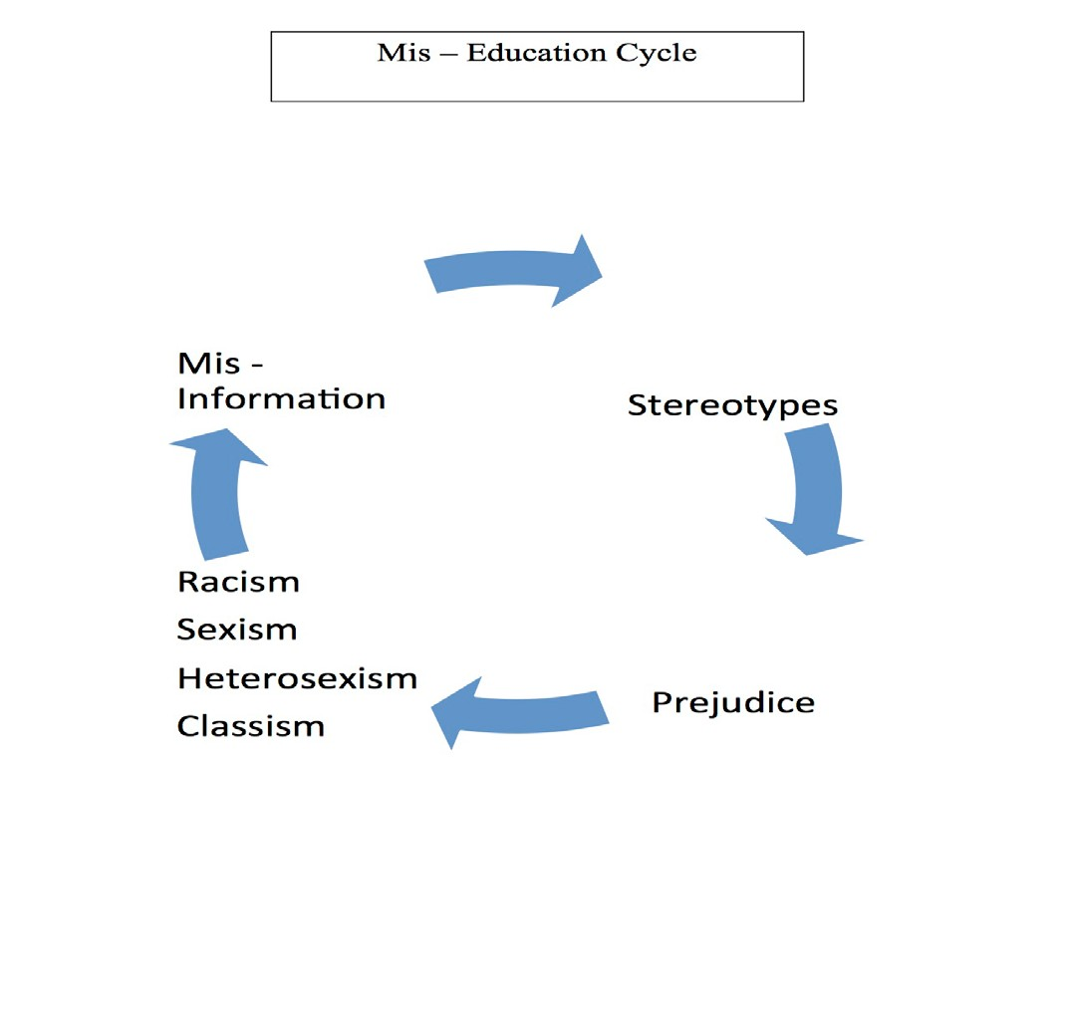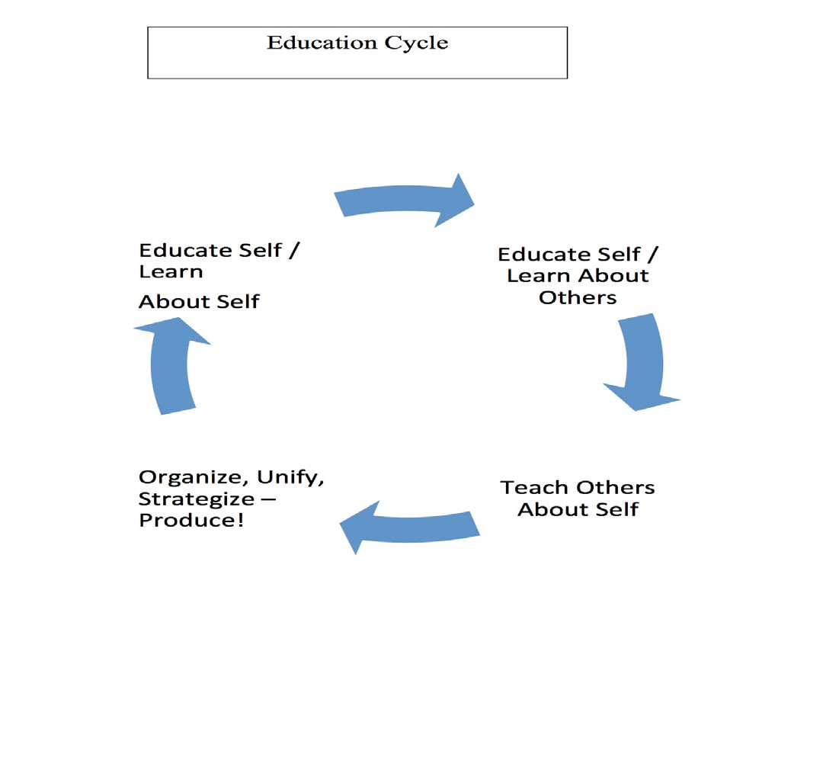

**Miseducation Cycle Sample Collage**

**ISM**



**Prejudice**

**Misinformation**

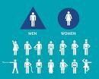

**Stereotypes**

#### Take a Stand on Diversity Activity

|  |
| --- |
| **Purpose** |
| In this activity, students will grasp the “big picture” of the world’s diversity. |

|  |
| --- |
| **Suggested Grade Level:** |
| 11 |

**Materials and Handouts**

|  |
| --- |
| **Approximate Time Needed:** |
| Varies |

**Student-Facing Instructions**

It’s time to take a public stand about your opinions concerning diversity. In this activity you will hear statements read aloud and decide if you “Agree,” “Disagree” or are “Unsure”. As a group, you will defend your responses in under a minute. After the activity, consider the following questions:

1. Was it difficult to take a stand that expressed your true feelings?
2. If you stood alone, how did that feel?
3. Were you surprised by a stand you took?
4. If you changed your stand, what was the reason?

**Teacher Notes**

**Preparation:** You will need three signs posted around the room: “Agree,” “Disagree,” and “Unsure.”

**The Activity:** Ask interns to stand up so they are ready to move around the room in response to the state- ments you will read. The statements are meant to make students aware of their opinions and assumptions about various aspects of diversity. Read each one slowly, and ask interns to move to the spot under one of the three signs they feel best describes their reaction to the statement (i.e. if interns agree with the state- ment, they stand under “Agree,” and so on).

After the statement has been read and all have moved to their chosen areas, turn to the largest group. Read the statement again and ask each intern, or volunteers, to say one sentence in response to the statement.

Students are only allowed to respond to the statement; they are not allowed to respond to anything other people say. Be strict about the one sentence rule, or the exercise can turn into a lengthy debate. If an intern doesn’t wish to respond, he or she can say “pass” or “it’s been said.”

Adapted from the 11th Grade Internship Seminars. Copyright © 2011 MDRC. All Rights Reserved.

If interns change their minds about their stance on an issue in the midst of the exercise, they can move to another area (for instance, move from “Agree” to “Unsure”).

Then move to the next to largest group and ask the students to respond, then the smallest group. Beginning with the largest group insures that the smallest group has the final say and its members will not be over- whelmed by the opinions of the largest group. If there is a response with no one standing there, you should state some of the arguments that someone might make. Explain that you are playing the “devil’s advocate” so that the interns can be aware of what some people think.

On the next page are some suggested statements, but you can make up your own, choosing issues that will be relevant for your students. To make the exercise interesting and interactive, choose controversial issues

Suggested statements to elicit opinions on diversity:

* If you hear someone tell a racist joke, it is important to tell that person that you disapprove.
* There are some jobs men do better than women and some jobs women do better than men.
* Businesses and schools should go out of their way to recruit people of different cultures.
* It is acceptable to judge people by their appearance.
* A diverse work force can make things more difficult for supervisors (or employees).
* Our country is a better place to live because of our multicultural population.
* Strict immigration laws are important to keep America safe.
* The world would be a better place if we were all the same.
* Every business should encourage workers to get to know each other and celebrate each other’s culture.

**Assessment**

Responses to post-activity questions.

**Instructions**

It’s time to take a public stand about your opinions concerning diversity. In this activity you will hear statements read aloud and decide if you “Agree,” “Disagree” or are “Unsure”. As a group, you will defend your responses in under a minute. After the activity, consider the following questions:

1. Was it difficult to take a stand that expressed your true feelings?
2. If you stood alone, how did that feel?
3. Were you surprised by a stand you took?
4. If you changed your stand, what was the reason?

#### Practice Your Workplace Diversity Skills

|  |
| --- |
| **Purpose** |
| In this activity, students will practice workplace diversity skills. |

|  |
| --- |
| **Suggested Grade Level:** |
| 11 |

|  |
| --- |
| **Materials and Handouts** |
| Practice Your Workplace Diversity Skills |

|  |
| --- |
| **Approximate Time Needed:** |
| Varies |

**Student-Facing Instructions**

No matter what your personal leanings or public stance is, you will be expected to work well with people from different cultures and backgrounds. In the Practice Your Workplace Diversity Skills handout, are four scenarios.

In each of the scenarios, discuss what you think the source of the cultural misunderstanding might be and then write down how you would handle the situation with your co-workers.

**Teacher Notes**

Divide class into pairs or triads. Give students 15-20 minutes to analyze the four scenarios in the Practice Your Workplace Diversity Skills handout. If time is short, you may give one scenario per group/pair. Ask them to discuss the scenario(s) and come up with a collective answer. Share responses together as a class.

As each scenario is discussed, have students locate the subject’s home country (Guatemala, India, Nigeria, or Taiwan) on a globe or the world map in their handouts. This should help reinforce the students’ appreciation of the distance, region and variety of national origins of their potential co--workers in a diverse workforce.

After all the scenarios are discussed, pose this question: Now that you‘ve discussed respecting diversity in the workplace, how do you think respecting diversity will be important in college?

**Assessment**

Complete Practice Your Workplace Diversity Skills worksheet.

**Instructions**

No matter what your personal leanings or public stance is, you will be expected to work well with people from different cultures and backgrounds. In the Practice Your Workplace Diversity Skills handout, are four scenarios.

In each of the scenarios, discuss what you think the source of the cultural misunderstanding might be and then write down how you would handle the situation with your co-workers.

**Practice Your Workplace Diversity Skills**

**How would you handle the following situations with yourco-­‐workers?**

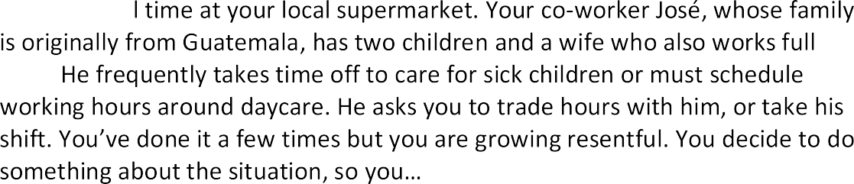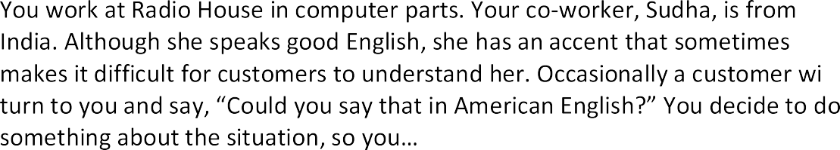

**Practice Your Workplace Diversity Skills** page 2

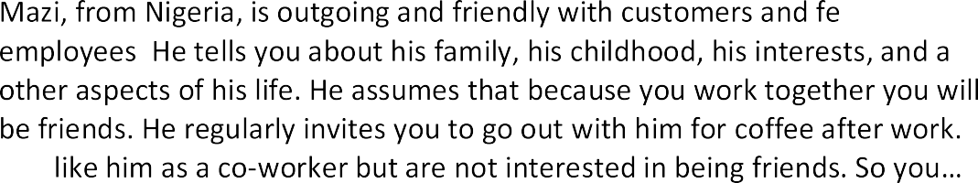



A co-­‐worker is trying to connect with you because they want to get to know you better. However, they make numerous statements to you in what they think is “your accent”, they make some offensive assumptions about the things you like to do that are rooted in stereotypes, and sometimes you feel like they are treating you in an extremely condescending way, so you

#### Diversity: Use It or Lose It

|  |
| --- |
| **Purpose** |
| In this activity, students will apply what they have learned about diversity in the workplace to their internships. |

|  |
| --- |
| **Suggested Grade Level:** |
| 11 |

|  |
| --- |
| **Materials and Handouts** |
| Diversity: Use It or Lose It |

|  |
| --- |
| **Approximate Time Needed:** |
| Varies |

**Student-Facing Instructions**

Use It or Lose It is both a summary and an assessment. Complete the worksheet and think about the following questions:

1. What are the biggest barriers to creating a successful, diverse workforce?
2. What can you as an individual do to respect diversity at your internship? What can you do to get support at the workplace if you find yourself uncomfortable because of how someone is responding to your culture or your youth?

**Teacher Notes**

This lesson should come after Mis-Education and Education Cycle and Practice Your Workplace Diversity Skills.

**Assessment**

Completion of Diversity- Use It or Lose it handout.

**Instructions**

Use It or Lose It is both a summary and an assessment. Complete the worksheet and think about the following questions:

1. What are the biggest barriers to creating a successful, diverse workforce?
2. What can you as an individual do to respect diversity at your internship? What can you do to get support at the workplace if you find yourself uncomfortable because of how someone is responding to your culture or your youth?

**Use It or Lose It**

Think back on today's seminar on diversity and use the information to answer these questions.

* 1. What are the biggest barriers to creating a successful, diverse work force?
  2. What can you as an individual do to respect diversity at your internship?

#### Diversity in the World of Work: Research Assignment

|  |
| --- |
| **Purpose** |
| This activity introduces students to multilingual skills and cultural knowledge and the practice of workplace diversity skills. |

|  |
| --- |
| **Suggested Grade Level:** |
| 11 |

|  |
| --- |
| **Materials and Handouts** |
| Diversity in the World of Work Research Assignment |

|  |
| --- |
| **Approximate Time Needed:** |
| 30 minutes |

**Student-Facing Instructions**

Pick one of the three listed research assignments:

1. Describe an incident of a cultural conflict that you either observed or experienced at your internship, or one that someone told you about.
2. Interview a co--worker of a different ethnic background (or different from you in another significant way)
3. Visit a store where you regularly shop (e.g. clothing, music) and take a look around at the workforce. Do you see people of different ages? Different ethnic backgrounds? Different skin color? Different sexes? Employees with disabilities?

Write up your observations addressing the following questions:

* Why do you think this store does or does not have a diverse workforce?
* What effect might this diversity or lack of diversity have on customers?
* Do you observe any unusual ways that customers are treated?
* If you owned the business, what would you do differently in terms of diversity?

**Assessment**

Completion of the worksheet.

**Instructions**

Pick one of the three listed research assignments:

1. Describe an incident of a cultural conflict that you either observed or experienced at your internship, or one that someone told you about.
2. Interview a co--worker of a different ethnic background (or different from you in another significant way)
3. Visit a store where you regularly shop (e.g. clothing, music) and take a look around at the workforce. Do you see people of different ages? Different ethnic backgrounds? Different skin color? Different sexes? Employees with disabilities?

Write up your observations addressing the following questions:

* Why do you think this store does or does not have a diverse workforce?
* What effect might this diversity or lack of diversity have on customers?
* Do you observe any unusual ways that customers are treated?
* If you owned the business, what would you do differently in terms of diversity?

Diversity in the World of Work Research Assignment

Pick ***one*** of the three following research assignments and be prepared to report back to the class next week:

Describe an incident of a cultural conflict that you either observed or experienced at your internship, or one that someone told you about. Be sure to note details such as the nature of the conflict, who was present, who said what, when it happened, how it was resolved.

Interview a co---worker of a different ethnic background (or different from you in another significant way). Discuss with the co---worker the challenges and benefits of working in a culturally diverse workplace. After the interview, record your thoughts in your R&R Log.

Visit a store where you regularly shop (e.g. clothing, music) and take a look around at the workforce. Do you see people of different ages?

Different ethnic backgrounds? Different skin color? Different sexes? Employees with disabilities?

Write up your observations addressing the following questions: Why do you think this store does or does not have a diverse workforce?

What effect might this diversity or lack of diversity have on customers? If you owned the business, what would you do differently in terms of diversity?

Research Assignment Notes Page

#### Diversity in the World of Work: Reflection

|  |
| --- |
| **Purpose** |
| This activity gives students an opportunity to reflect on their internship experiences and the key takeaways  from related lessons, such as what skills, techniques, and  concepts can be applied to college and future work. |

|  |
| --- |
| **Suggested Grade Level:** |
| 11 |

|  |
| --- |
| **Materials and Handouts** |
| Diversity in the World of Work Reflection |

|  |
| --- |
| **Approximate Time Needed:** |
| Varies |

**Student-Facing Instructions**

The Reflection is separated out into five parts:

1. Word of the week
2. Quote of the week
3. Learning in the future
4. Working in the future
5. What if?

Read the prompts in each section and respond, thinking about your own learning, beliefs, values, and experiences. If you need more room for your answers or you have additional thoughts you’d like to put down on paper, an extra page is available for “Free Writing”.

**Assessment**

Completion of reflection handout.

**Instructions**

The Reflection is separated out into five parts:

1. Word of the week
2. Quote of the week
3. Learning in the future
4. Working in the future
5. What if?

Read the prompts in each section and respond, thinking about your own learning, beliefs, values, and experiences. If you need more room for your answers or you have additional thoughts you’d like to put down on paper, an extra page is available for “Free Writing”.



**Word of the week:** “respect”

* + Why is it important to have respect for those you work with?
  + Use the word “respect” in a sentence to describe a co-­‐worker or supervisor or yourself.

**Quote of the week:** *“It is time for parents to teach young people early on that in diversity there is beauty and there is strength.”* Maya Angelou

Take a few minutes to think about the quote and then re-­‐write it in your ownwords.

**Learning in the future:**

* + - What did you learn this week about diversity and respect that might help you in college?

**Working in the future:**

* + - What did you learn this week about diversity and respect that might help you in a future job?

**What If?**

* + - What if there was a class required to graduate from high school called “Respect and Tolerance” and you were in charge of the curriculum?

Free writing: anything in the world you want to write about...

## During the Internship: Customer Service

#### Rants and Raves Activity

|  |
| --- |
| **Purpose** |
| In this activity, students will understand what makes good customer service. |

|  |
| --- |
| **Suggested Grade Level:** |
| 11 |

|  |
| --- |
| **Materials and Handouts** |
| Rants and Raves Stories |

|  |
| --- |
| **Approximate Time Needed:** |
| Varies |

**Student-Facing Instructions**

What makes a good and not-so-good customer service experience? Look at the handout Rants and Raves: Customer Service Stories and discuss your reactions to one of them.

Share a personal rant and rave. Think about a time in your life when you have been a customer (e.g., in a restaurant, with the cell phone internet provider, at a store where you shop). What kind of experiences have you had? What made your experiences positive or negative?

Answer the following questions:

1. Where is empathy evident in your examples of good customer service?
2. How does empathy help customers, even if they don’t go away satisfied?

**Teacher Notes**

As students describe their experiences, you may want to offer one example from the list below or a personal story to model the type of responses you expect from the interns.

Examples of positive experiences:

* The cell phone salesperson knew a lot about different kinds of phones and helped you get a great, but not expensive, phone.
* The waitress at the restaurant realized service was slow so she gave you a complimentary dessert.
* You returned a shirt that was the wrong size and the salesperson called around to other stores in the region to find the right size.

Examples of negative experiences:

* The salesperson was talking on his cell phone at the same time he was waiting on you.
* The receptionist at the doctor’s office didn’t even look at you while checking you in.
* You tried to return a pair of pants that ripped right after you bought them, but the salesperson would say nothing but “we don’t take returns at this store.

Refer to definition of empathy, located in ECCCO Resources when discussing personal experiences. Conclude by reading one of the other rants or raves from the worksheet.

**Assessment**

Empathy responses.

**Instructions**

What makes a good and not-so-good customer service experience? Look at the handout Rants and Raves: Customer Service Stories and discuss your reactions to one of them.

Share a personal rant and rave. Think about a time in your life when you have been a customer (e.g., in a restaurant, with the cell phone internet provider, at a store where you shop). What kind of experiences have you had? What made your experiences positive or negative?

Answer the following questions:

1. Where is empathy evident in your examples of good customer service?
2. How does empathy help customers, even if they don’t go away satisfied?



Teacher Resource

Rants and Raves: Customer Service Stories page 1

***These are all based on true stories told by customers. Nothing is made up!***

**RANT #1 Poor service…no purchase**

I took my three teenage daughters into the cool new clothing store at the mall to shop for school clothes. The new store is bright, well laid out, and the variety of clothing is wonderful and so are the prices. But the customer service is shameful**.** No one acknowledged us at any time when we were in the store for about one hour. No smiles, no offer of help. As a matter of fact, the young staff just walked by us as though we were invisible. The young girl that cashed us out was downright miserable, as if we were imposing upon her. The store was not busy, and therefore no excuses can be made that they were too busy to do their job. All we expected was a simple greeting like “Can I help you?” or “Did you find what you were looking for?” If this store is going to employ young personnel, then train them right! Good customer service will keep us coming back; if not, there are many other clothing stores to choose from that are very willing to take my money.

**RANT #2 Who’s the idiot at the home store?**

I wanted to renovate my kitchen. I decided I would purchase the cabinets from the home store. After ordering the cabinets, doors, shelves and trim, I received a call to say that it had arrived and I went to pick it up. There were quite a lot of boxes, which I expected. The cashier called a sales rep to help load the boxes into the van (well, we had to push the carts out the door and the sales rep just walked beside us). When we arrived at my car, he lit up a cigarette and went to talk to other employees having a smoke not ten feet from my car. He stood there along with the other employees and watched me load my vehicle. When I got to the last box he finally asked if I needed any help! When I got home I opened the cartons to inspect the doors and trim. There were many defects, scratches, gouging, warped doors and color mismatches. I packed up the defective doors and returned to the home store. The returns desk paged the kitchen manager. He came over, looked at the boxes on the cart and without even looking at a single item said "What do you expect? You purchased a crap kitchen, it is substandard in quality. What can I do?

You are gonna have to put up with it." After I told him what I thought, he said in a loud voice for all to hear "Not my fault if you're an idiot.” Well, to all of you out there thinking of purchasing a kitchen from the home store, you heard it straight from the manager’s mouth: "It's crap and substandard" and you are an idiot if you buy it.



Rants and Raves: Customer Service Stories

**RANT #3 Harry Potter and the elusive pants**

page 2

I went into the store to pick up my Harry Potter book. I then decided to look for some school clothes for my two sons. We found four pairs of pants to try on. We proceeded to the men’s fitting rooms and rang the bell for service. We waited for a while and rang again; during this time four different employees walked past us but none came in to help. So we decided to go over to the ladies’ fitting rooms where there were a few employees standing around and talking. We then had to ring the bell for service there. We waited for a couple of seconds for an employee to come over and unlock the door but when she saw that it was two boys who wanted to try clothes on she refused to let them into the fitting room because of their gender. My sons are 10 and 7 years old...it was not like they were teenagers or grown men! I told her that we had been waiting at the men's fitting room ringing the bell over there. She still would not let them in nor did she offer to take us over the men’s area to let them in there. Well let's just say that I lost it and put everything back and lodged a complaint, but that got me nowhere. I will not do any more of my shopping at a store that thinks that little boys are peeping toms. They lost a big supporter of their store and do not even care. I can only say that it is their loss, because I will never shop there again.

**RANT**

**#3**

**Harry Potter and the elusive pants**

**RAVE #1 More shoppers for this store**

The other day I popped into a local watch shop because I had lost the small piece that clips my watchband together. When I explained the problem, the proprietor said that he thought he might have one lying around. He found it, attached it to my watchband and charged me nothing! Where do you think I’ll go when I need a new watchband or even a new watch? And how many people do you think I’ve told this story to?

**RAVE #2 Free flour!**

I have to follow a special diet and needed some gluten-free flour. I visited a new local store and searched for the flour on the shelves without luck. I gave up and waited at the checkout. Then I saw a manager standing behind the registers and called him over. I asked if he had any of the flour in stock and if not when he would be getting some more. He personally went out to the storeroom to check for me, but sadly came back empty-handed. I paid for my shopping and headed back to the car. Moments later I heard running feet and turned around to see the manager across the parking lot. In his hand he held a packet of flour. He had searched again and found what I needed. He handed me the flour and said "Take it with my compliments." As the flour costs 10 times the price of normal wheat flour that was a generous offer and I was delighted. That store won a regular customer that day!

Rants and Raves: Customer Service Stories page 3

**RAVE #3 Key to good service – taking the blame**

One morning I needed an extra set of keys to my apartment, so on the way to work, I went to the locksmith around the corner. Thirteen years living in an apartment in New York City has taught me never to trust a locksmith. Half the time their copies don’t work. So I went home to test the new keys, and, lo and behold, one didn’t work. I took it back to the locksmith. He made it again. I went back home and tested the new copy. It *still* didn’t work. Now I was fuming. Squiggly lines were coming up out of my head. I was a half-hour late to work and had to go to the locksmith a *third* time. I was tempted just to give up on him. But I decided to give this loser one more chance. I stomped into the store, ready to unleash my fury. “It *still* doesn’t work?” he asked. “Let me see.” He looked at it. I was sputtering, trying to figure out how best to express my rage at being forced to spend the morning going back and forth. “Ah. It’s my fault,” he said. And suddenly, I wasn’t mad at all. Mysteriously, the words “it’s my fault” completely defused me. That was all it took. He made the key a third time. I wasn’t mad any more. The key worked. And, here I was on this planet for forty years, and I couldn’t believe how much the three words “it’s my fault” had completely changed my emotions in a matter of seconds.

#### 10 Rules for Good Customer Service

|  |
| --- |
| **Purpose** |
| In this activity, students will understand the role of empathy in customer service. |

|  |
| --- |
| **Suggested Grade Level:** |
| 11 |

|  |
| --- |
| **Materials and Handouts** |
| 10 Rules for Good Customer Service |

|  |
| --- |
| **Approximate Time Needed:** |
| Varies |

**Student-Facing Instructions**

Look at the handout, 10 Rules for Good Customer Service. In pairs:

* Take turns reading the 10 rules.
* On the worksheet, write down who your internship customers are and describe them to your partner. Remember, co-workers can be considered customers!
* Pick which of the 10 rules are most important at your internship site, and explain why to your partner.

**Teacher Notes**

Tell the class that now they are going to think about who the customers are at their internship sites and how they can learn the skills to serve these customers effectively and with empathy.

Divide the class into pairs and have them turn to the handout, 10 Rules for Good Customer Service, and complete the task.

**Assessment**

Complete 10 Rules for Good Customer Service worksheet.

**Instructions**

Look at the handout, 10 Rules for Good Customer Service. In pairs:

* Take turns reading the 10 rules.
* On the worksheet, write down who your internship customers are and describe them to your partner. Remember, co-workers can be considered customers!
* Pick which of the 10 rules are most important at your internship site, and explain why to your partner.

**10 Rules for Good Customer Service**

* 1. **Understand the customer’s needs**

Engage customers in a friendly, open manner. Spend as much timeas possible with each one to figure out what he or she wants or needs.

* 1. **Practice empathy**

Put yourself in the customer’s place. Imagine what the customer is thinking or feeling by paying attention to body language and tone ofvoice.

* 1. **Make eye contact**

Look directly at people and use expressive gestures such as smiling and nodding to let customers know you are interested, attentive and eager to help them.

* 1. **Listen to your customers**

Use active listening techniques and open-­‐ended questions to let your customers know you hear them. Make comments or suggestions that reflect an understanding of a customer’s needs anddesires.

* 1. **Think on your feet**

Use communication skills to think and respond quickly when interacting with customers. Saying the right thing at the right time is important**:** “I’m sorry you’re not happy, but let’s see what we can do to make it right” or “I won’t be able to solve that problem, but let me get my supervisor.”

* 1. **Don’t make promises you can’t keep**

Reliability is one of the keys to good customer service. If you say, “I’ll call you back tomorrow,” make sure you do call. The same rule applies to client appointments, deadlines, and relations with co-­‐workers.

**10 Rules for Good Customer Service** page 2

* 1. **Go the extra mile**

Customers and clients (and bosses) notice when employees make anextra effort. If someone walks into your store and asks you to help find anitem, don’t just say, “It’s in aisle 3.” Lead the customer to the item and wait to see if he or she has questions about it. Ask if you can be of furtherhelp.

* 1. **Deal with complaints**

View difficult or complaining customers as a challenge rather than a threat. A four-­‐stage process for dealing with complaining customers is to:

* + 1. listen, (2) clarify, (3) summarize and (4) take action. Recognize when you cannot help the customer and need to ask a supervisor.
  1. **Smile as often as you can**

A smile a day keeps the complaints away. Just like yawns, smiles are contagious.

* 1. **Use your sense of humor**

Humor and laughter can diminish anger and defuse a tense situation. People who laugh together rarely sue each other.

**Question**: Who are the customers at your internshipworkplace?

**Question:** Which of the above rules are most important at your internship?

Based in part on About.com: “8 Rules for Good Customer Service”

Teacher Resource

#### Be an Active Listener Activity

|  |
| --- |
| **Purpose** |
| In this activity, students will learn and practice active listening skills in workplace scenarios. |

|  |
| --- |
| **Suggested Grade Level:** |
| 11 |

|  |
| --- |
| **Materials and Handouts** |
| Be an Active Listener |

|  |
| --- |
| **Approximate Time Needed:** |
| Varies |

**Student-Facing Instructions**

Refer to the Be an Active Listener handout during this activity.

**Teacher Notes**

This lesson should follow 10 Rules for Good Customer Service.

Tell students you want them to practice active listening (Rule #4 of the *10 Rules for Good Customer Service*). Give them the following background:

Active listening is a structured form of listening and responding that focuses the attention on the speaker. It is not simply understanding what the other person is saying, but letting the person know you heard what he or she said by asking questions, showing genuine interest, being empathic and being fully engaged.

Active listening has several benefits

It forces people to listen attentively to others. It lessens the chance of misunderstandings.

It encourages the speaker to open up and talk freely.

Present the information on the handout, Be an Active Listener. If you have time, you can divide the class into three groups, with each group taking one section of the handout to read and explain to the class.

Student Resource

**Instructions**

Refer to the Be an Active Listener handout during this activity.

**Be an Active Listener**

|  |
| --- |
| **Active Listening Steps** |
| * Look at the person and stop other things you are doing. * Listen not merely to the words, but to body language, as well. * Restate in your own words what the person said. * Ask clarifying questions. * Be aware of your own feelings and strong opinions. |
| **Verbal Signals of Active Listening** |
| * Show you’re listening by saying “Yes, I understand” or “I hear you” or“That’s true.” * Be honest and say “I don’t know much about this particular product, butlet’s see if I can help.” * Validate the customer by saying “You’re absolutely right!” or “You’ve got a good point.” * Offer support by saying “You have a right to complain.” * Show you understand by paraphrasing such as “If I understand whatyou’re saying…” or “Let me summarize the problem.” |
| **Nonverbal Signals of Active Listening** |
| * Good eye contact * Pleasant facial expressions such as smiles and affirmative head nods * Eliminate distractions: no cell phones or chats with fellow workerswhile attending to customers * Silence: let the customer talk without interruption * Space: maintain a comfortable space between you and the customer, nottoo close, not too far |

Adapted from <http://712educators.about.com/cs/activelistening/a/activelistening_2.htm>

#### Customer Service Role-Plays

|  |
| --- |
| **Purpose** |
| In this activity, students will identify how customer service skills can be applied at their internship site. |

|  |
| --- |
| **Suggested Grade Level:** |
| 11 |

|  |
| --- |
| **Materials and Handouts** |
| Customer Service Role Plays |

|  |
| --- |
| **Approximate Time Needed:** |
| Varies |

**Student-Facing Instructions**

You will work in groups of three to stage a role--play of a hypothetical customer service situation. One student will be the customer, one will be the employee, and the third will be an observer. The observer will have the responsibility to fill out a form and offer feedback to the employee.

Your teacher will assign you one of the scenarios below and after you have decided who will play which role, take five minutes to prepare. If you are playing the “customer”, try assuming a personality different from your own. Portraying an imaginary character adds more creativity and the freedom to have fun. If you are playing an “employee,” do your best to handle the situation as if it were real. If the customer asks to “speak to the manager,” say that the manager is not available.

Remember that the employee should practice active listening skills and the observer should think about empathy as he/she gives feedback during the debriefing of the role play.

Observers: As an observer of the Customer Service role--plays, your job is to identify what works well and what doesn’t. Focus on empathy and listening skills. As you observe, fill out the Observer Checklist in the handout.

**Teacher Notes**

This lesson should come after Be an Active Listener Activity.

Divide students into groups of three to stage a role--play of customer service. Assign each group one of the 5 scenarios listed on their handout and tell them to decide who will be the customer, who will be the

Adapted from the 11th Grade Internship Seminars. Copyright © 2011 MDRC. All Rights Reserved.

employee, and who will be the observer. The observer will have the responsibility to fill out a form and offer feedback to the employee.

After they have decided who will play which role, give students five minutes to prepare. Encourage the students playing the “customers” to assume a personality different from their own. Portraying an imaginary character adds more creativity and will give the interns freedom to have fun.

When briefing the “employees,” encourage them to do their best to handle the situation as if it were real. Tell them if the customer asks to “speak to the manager,” they can say that the manager is not available. Remind the employees to practice active listening skills.

While customers and employees prepare, you will meet with the observers to review the Observer Checklist for Customer Service Scenarios. Suggest that the observers think about empathy as they give feedback during the debriefing of the role play. Have them answer the question: Why is it important for both the employee and the customer to have empathy?

If there is not enough time for every group to present their role--play to the class, ask for two or three groups to volunteer. You may want to assign the same role--play to several groups and then have just one of them present to the class with the others contributing to the debriefing discussion.

**Assessment**

Complete Customer Service Role-Plays handout.

**Instructions**

You will work in groups of three to stage a role--play of a hypothetical customer service situation. One student will be the customer, one will be the employee, and the third will be an observer. The observer will have the responsibility to fill out a form and offer feedback to the employee.

Your teacher will assign you one of the scenarios below and after you have decided who will play which role, take five minutes to prepare. If you are playing the “customer”, try assuming a personality different from your own. Portraying an imaginary character adds more creativity and the freedom to have fun. If you are playing an “employee,” do your best to handle the situation as if it were real. If the customer asks to “speak to the manager,” say that the manager is not available.

Remember that the employee should practice active listening skills and the observer should think about empathy as he/she gives feedback during the debriefing of the role play.

Observers: As an observer of the Customer Service role--plays, your job is to identify what works well and what doesn’t. Focus on empathy and listening skills. As you observe, fill out the Observer Checklist in the handout.

Adapted from the 11th Grade Internship Seminars. Copyright © 2011 MDRC. All Rights Reserved.

**Customer Service Role-Plays**

You will work in groups of three to stage a role--play of a hypothetical customer service situation. One student will be the customer, one will be the employee, and the third will be an observer. The observer will have the responsibility to fill out a form and offer feedback to the employee.

Your teacher will assign you one of the scenarios below and after you have decided who will play which role, take five minutes to prepare. If you are playing the “customer”, try assuming a

personality different from your own. Portraying an imaginary character adds more creativity and the freedom to have fun. If you are playing an “employee,” do your best to handle the situation as if it were real. If the customer asks to “speak to the manager,” say that the manager is not available.

Remember that the employee should practice active listening skills and the observer should thin about empathy as he/she gives feedback during the debriefing of the role play.

**SCENARIO#1**

**Employee**: You work at local radio station KDOG. Your job is to take calls from listeners about what they like and don’t like and suggestions for programming. KDOG needs to maintain a good image to stay on the air.

**Customer:** You (and your dog) are strict vegetarians. You have heard an ad on radio station KDOG about tasty dog food (“MMMMM, with so much meat!”) that is offensive to you. You are calling to say you are not going to listen to the station any more if they don’t take the advertisement off the air.

**SCENARIO#2**

**Employee:** You work at City Auditorium. Your job is to serve customers who walk up to the ticket window, take ticket orders over the phone, and answer questions about

concert schedules. Tonight’s concert is Dillary Huff and the Heartbreakers. Tickets start at $60.

**Customer**: You have two tickets to tonight’s concert at City Auditorium for Dillary Huff and the Heartbreakers. But your date has suddenly come down with the flu and can’t attend. Although the tickets say “nonrefundable,” you have spent a lot of money and you want to exchange the tickets for a concert in another town next week. You call the ticket office to try to exchange the tickets.

**SCENARIO#3**

**Employee:** You work as a hostess in a very nice hotel restaurant. Your job is to greet customers, ask if they have a reservation, take their coats, seat them, offer menus and tell them that their wait person will be right there.

**Customer:** This restaurant is one of your favorites so you’re bringing your grandparents for a special treat. When you made the reservation, you requested a table by the window, but you were just seated at an inside table with no view. Additionally there is a very loud large group seated near you. You tell your wait person that you want to speak with the hostess about moving to another table, but the wait person says the hostess is busy and the restaurant is full, anyway.

**SCENARIO#4**

**Employee**: You work in a neighborhood pharmacy, WeCare, answering customers’ calls and ringing up sales. Even though you know that the pharmacy’s motto is “We take care of you, no matter what.” you have been given strict instructions by the pharmacist not to give medical advice or recommend particular medications.

**Customer**: You have a terrible sore throat and high fever but you don’t want to go to the doctor. You walk into the nearest WeCare Pharmacy and ask what might be wrong with you, and which over--the--counter medications you might take to alleviate the symptoms. As you walk in, you notice that the pharmacy’s motto is “We take care of you, no matter what.”

**SCENARIO#5**

**Employee**: You work in the financial department of the Leagle Beagle law firm. It’s your job to get meeting and phone records from each attorney and bill the customers monthly. The attorneys charge anywhere from $250 to $600 per hour for anything they do related to a case.

**Customer**: You got the bill from your attorney and you simply can’t believe it!! The bill is for $750 and all you had this month was one half hour phone call. You know that your attorney charges $300 per hour, so you call the Leagle Beagle financial department to complain.

|  |  |  |
| --- | --- | --- |
| **Observer Checklist**  **for Customer Service**  **Scenarios**  As an observer of the Customer Service role--plays,your job is to identify what works well and what doesn’t. Focus on **empathy** and **listening skills**.  **Background information for the observer**  Active listening is a structured form of listening and responding that focuses the attention on the speaker. It is not simply understanding what the other person is saying, but letting the person know you heard what he or she said by asking questions, showing genuine interest, being empathic and being fully engaged.  **Active listening has several benefits**   1. It forces people to listen attentively to others. 2. It lessens the chance of misunderstandings. 3. It encourages the speaker to open up and talk freely.   **As you observe your role--play scenario, evaluate whether the employee** | | |
| **Techniques** | **Employee did it** | **Employee didn’t do it** |
| **Made good eye contact** |  |  |
| **Restated what the oth- er person said** |  |  |
| **Asked questions for clarification** |  |  |
| **Looked sincere and positive** |  |  |
| **Focused only on the other person** |  |  |
| **Showed pleasant fa- cial expressions** |  |  |

#### Customer Service: Use It or Lose It

|  |
| --- |
| **Purpose** |
| In this activity, students will reflect on the role of empathy and their personal expectations from customer service representatives. |

|  |
| --- |
| **Suggested Grade Level:** |
| 11 |

|  |
| --- |
| **Materials and Handouts** |
| Customer Service: Use It or Lose It |

|  |
| --- |
| **Approximate Time Needed:** |
| Varies |

**Student-Facing Instructions**

Use It or Lose It is both a summary and an assessment. Complete the worksheet and think about the following questions:

1. Why is empathy so important for customer service?
2. What do you expect from an employee if you are a dissatisfied customer?

**Teacher Notes**

This lesson should come after Rants and Raves Activity, 10 Rules for Good Customer Service and Customer Service Role-Plays.

**Assessment**

Completion of Customer Service- Use It or Lose It handout.

**Instructions**

Use It or Lose It is both a summary and an assessment. Complete the worksheet and think about the following questions:

1. Why is empathy so important for customer service?
2. What do you expect from an employee if you are a dissatisfied customer?

**Use It or Lose It**

Think back on today's seminar about customer service and use the information to answer these questions.

Why is empathy so important for customer service?

What do you expect from an employee if you are dissatisfied customer?

#### Customer Service: Research Assignment

|  |
| --- |
| **Purpose** |
| This activity introduces students to the characteristics of good customer service and explore how they use empathy and good listening skills in their interactions. |

|  |
| --- |
| **Suggested Grade Level:** |
| 11 |

|  |
| --- |
| **Materials and Handouts** |
| Customer Service Research Assignment |

|  |
| --- |
| **Approximate Time Needed:** |
| 30 minutes |

**Student-Facing Instructions**

* 1. Describe two examples of how you used empathy and good listening skills in interactions with your customers/clients or co--workers in your workplace during the past week.
  2. Did you alter your behavior with customers/clients as a result of this week’s lesson? If so, how? And what was the response?

**Assessment**

Completion of the worksheet.

**Instructions**

1. Describe two examples of how you used empathy and good listening skills in interactions with your customers/clients or co--workers in your workplace during the past week.
2. Did you alter your behavior with customers/clients as a result of this week’s lesson? If so, how? And what was the response?

**Customer Service Research Assignment**

Describe two examples of how you used empathy and good listening skills in interactions with your customers/clients or co--workers in your work- place during the past week.

Did you alter your behavior with customers/clients as a result of this week’s lesson? If so, how? And what was the response?

#### Customer Service: Reflection

|  |
| --- |
| **Purpose** |
| This activity gives students an opportunity to reflect on their internship experiences and the key takeaways  from related lessons, such as what skills, techniques, and  concepts can be applied to college and future work. |

|  |
| --- |
| **Suggested Grade Level:** |
| 11 |

|  |
| --- |
| **Materials and Handouts** |
| Customer Service Reflection |

|  |
| --- |
| **Approximate Time Needed:** |
| Varies |

**Student-Facing Instructions**

The Reflection is separated out into five parts:

1. Word of the week
2. Quote of the week
3. Learning in the future
4. Working in the future
5. What if?

Read the prompts in each section and respond, thinking about your own learning, beliefs, values, and experiences. If you need more room for your answers or you have additional thoughts you’d like to put down on paper, an extra page is available for “Free Writing”.

**Assessment**

Completion of reflection handout.

**Instructions**

The Reflection is separated out into five parts:

1. Word of the week
2. Quote of the week
3. Learning in the future
4. Working in the future
5. What if?

Read the prompts in each section and respond, thinking about your own learning, beliefs, values, and experiences. If you need more room for your answers or you have additional thoughts you’d like to put down on paper, an extra page is available for “Free Writing”.



**Word of the week:** “empathy”

* + Why is it important to have “empathy” in order to be successful at a customer service job or internship?
  + Use the word “empathy” in a sentence to describe a co-­‐worker or supervisor or yourself.

**Quote of the week:** *“One kind word can warm three wintermonths.”*

Japanese proverb Take a few minutes to think about the quote and then re-­‐write it in your own words.

**Learning in the future:**

* + - What did you learn this week about empathy and customer service that might help you in college?

**Working in the future:**

* + - What did you learn this week about empathy and customer service that might help you in a future job?

**What If?**

* + - What if, before any corporate decision was made, the decision-­‐maker put him/herself in the shoes of all employees at all levels?

**Free writing: anything in the world you want to write about…**

## During the Internship:

Job Satisfaction

#### We CAN Get Satisfaction

|  |
| --- |
| **Purpose** |
| In this activity, students will learn what they find satisfying about their internship. |

|  |
| --- |
| **Suggested Grade Level:** |
| 11 |

|  |
| --- |
| **Materials and Handouts** |
| We CAN Get Satisfaction |

|  |
| --- |
| **Approximate Time Needed:** |
| Varies |

**Student-Facing Instructions**

What do you find satisfying about your internship job so far? Why? In the future, what would make a job satisfying to you? Why?

In pairs, complete the handout, We CAN Get Satisfaction.

**Teacher Notes**

For the second question (Why?), clarify that you’re not talking about what kind of work they want to do, but about what aspects of a job they think would make them happy – e.g. flexible hours, high pay, good co- workers, helping other people, close to home).

When students get in pairs to fill out the worksheet, allow about ten minutes to make a combined list. Bring interns back together, and on the board write “Job Satisfaction” with two headings: “Internship” and “Future Jobs.” Go around the room and ask each pair to provide an answer to what they find satisfying about their internship jobs, and why. Go around again to record what interns think will satisfy them in their jobs of the future. Tell them not to repeat what someone else has already said.

**Assessment**

Complete We CAN Get Satisfaction.

**Instructions**

What do you find satisfying about your internship job so far? Why? In the future, what would make a job satisfying to you? Why?

In pairs, complete the handout, We CAN Get Satisfaction.

Intern Handout

**We CAN Get Satisfaction**



List four things you find satisfying about your internship job; and briefly state why. (An example might be “I LIKE: the great co-workers — BECAUSE: I’m making new friends.”)

**I LIKE: BECAUSE:**

1.

2.

3.

4.

List four things you would look for in a future job to give you satisfaction, and briefly state why.

**I WOULD LIKE: BECAUSE:**

1.

2.

3.

4.

#### What Do You Expect from a Job?

|  |
| --- |
| **Purpose** |
| In this activity, students will understand what most people look for in a job. |

|  |
| --- |
| **Suggested Grade Level:** |
| 11 |

|  |
| --- |
| **Materials and Handouts** |
| Top 10 Job Expectations  Survey Reveals Most Satisfying Jobs (Teacher Resource) |

|  |
| --- |
| **Approximate Time Needed:** |
| Varies |

**Student-Facing Instructions**

Job satisfaction depends to a great degree on what one expects from a job. Expectations vary as people tend to approach work from one of two perspectives: as a job or as a career. So, what’s the difference?

As a job, it’s “show me the money!” The work itself may hold little interest; it’s the income that matters. If a job with better pay comes along, you would not hesitate to move on.

As a career, you’re most likely motivated by personal goals, status, and long-term stability. You want to get the education or training to climb the professional ladder as far as possible.

Whether you choose work for money or to advance a career, every job has characteristics in common: you have working hours, you are responsible for accomplishing work tasks, and you get paid. However, jobs vary tremendously in working conditions and in many other ways.

Turn to the handout Top Ten Job Expectations. What are your job expectations? Consider the following questions:

Would you take a job with good pay but bad hours? How about a job with good pay but low job security?

**Teacher Notes**

Jobs versus Career

Emphasize that no one of these options is necessarily better than another. The high prestige and high paying jobs are not always the most satisfying. For instance:

Stress, overwork, and a high-pressure workplace put doctors and lawyers near the bottom of the job satisfaction scale.

Many people choose to stay at low-paying jobs with less status because they love the company or their co- workers, find fulfillment from the work, or prefer the lack of stress.

Refer to the Teacher Resource Survey Reveals Most Satisfying Jobs and give a few more examples that would resonate with your students.

Turn to Top Ten Job Expectations and do a round-robin, asking each intern to read one expectation aloud. Point out the additional information on page 2 about Employee Benefits. Quickly explain the terms used. This may not be important to young people for their first job, but it will become increasingly important in their work lives. Ask if they have any other job expectations to add. Take time for a short discussion, giving examples, or asking provocative questions such as the ones listed in the instructions.

**Assessment**

Personal job expectations.

**Instructions**

Job satisfaction depends to a great degree on what one expects from a job. Expectations vary as people tend to approach work from one of two perspectives: as a job or as a career. So, what’s the difference?

As a job, it’s “show me the money!” The work itself may hold little interest; it’s the income that matters. If a job with better pay comes along, you would not hesitate to move on.

As a career, you’re most likely motivated by personal goals, status, and long-term stability. You want to get the education or training to climb the professional ladder as far as possible.

Whether you choose work for money or to advance a career, every job has characteristics in common: you have working hours, you are responsible for accomplishing work tasks, and you get paid. However, jobs vary tremendously in working conditions and in many other ways.

Turn to the handout Top Ten Job Expectations. What are your job expectations? Consider the following questions:

Would you take a job with good pay but bad hours? How about a job with good pay but low job security?

Intern Handout **Top Ten Job Expectations**

|  |
| --- |
| **What do people look for in a job?** |
| **1. TYPE OF WORK**  Having the kind of work that makes the best use of your special capabilities and that gives you a feeling of accomplishment |
| **2. SECURITY**  Having a job that provides steady employment |
| **3. COMPANY**  Working for a company that has a good reputation, and that you can be proud of working for |
| **4. ADVANCEMENT**  Being able to progress in one's job or career and/or having the chance to move ahead in the company |
| **5. CO-WORKERS & CUSTOMERS/CLIENTS**  Having co-workers who are competent and congenial, and customers or clients you enjoy interacting with |
| **6. COMPENSATION**  Being paid enough to meet your needs, and being paid fairly in comparison to others |
| **7. SUPERVISION**  Having an immediate supervisor or boss who is respectful, considerate and fair |
| **8. HOURS**  Having work hours that allow you enough time with family and time to pursue other interests |
| **9. EMPLOYEE BENEFITS**  Receiving employee benefits that meet your needs and compare well with those of others, e.g. health insurance, vacation days, sick time, a pension plan. (See  next page for more details.) |
| **10. WORKING CONDITIONS**  Having physical working conditions that are safe, not injurious to health, not  stressful and even comfortable |

**Top Ten Job Expectations** page 2

|  |
| --- |
| **More information about employee benefits** |
| When applying for, accepting, or negotiating the terms of a job, it is important to learn about **employee benefits** (sometimes called “fringe benefits”). These are features, in addition to salary, that contribute to the overall value of a position. |
| * Some of the typical benefits offered as part of employee compensation in the United States include:   + health insurance o vacation time   + dental insurance o holiday pay   + disability insurance o sick days   + life insurance o personal days   + retirement savings plan or pension o family leave   + educational assistance o on-site day care   + discounts on merchandise or service |
| * Depending on the type of business or industry, and whether a job is a profession or a trade, union or non-union, the variety of employee benefits may differ greatly. |
| * As you look ahead to career choices beyond your internship, you may want to consider which of these benefits add not only to the financial advantages of a job, but also to the security and comfort of your family and your future. |



**Job Satisfaction Keeps Falling**

Americans are growing increasingly unhappy with their jobs, with the newest entrants to the workforce more disillusioned and disengaged than ever before.

Twenty years ago, six out of ten said they were satisfied with their jobs. Today, research found that fewer than four out of ten workers under the age of 25 are satisfied with their jobs, the lowest level of job satisfaction overall and the lowest level ever recorded in the two decades the survey has been carried out.

And this decline in satisfaction is not just focused at the younger end of the workforce. Those aged 45-54 expressed the second lowest level of satisfaction, with less than 45% content with their current job.

At the other end of the scale, nearly half of those aged 55-64 and 65 and over said they were satisfied with their employment situation.

One clue as to the reasons for this widespread discontent is the fact that job satisfaction tends to rise as hours worked per week increases, but begins to recede at a life-sapping 60 or more hours.

Location plays a part, too, with satisfaction levels ranging from a miserable 41% in the Mid-Atlantic states (NY, NJ and PA) to a height of 56% in the Mountain states (MT, ID, WY, NV, UT, CO, AZ, NM).

Bonus plans and promotion policies were also identified as big sources of unhappiness, with less than a quarter (23%) of those surveyed saying they were satisfied with their company's policies.

Performance review processes, workload, work/life balance, communication channels and potential for future growth came in for similarly heavy criticism, with only around a third of respondents satisfied with these aspects of their working lives.

"Although a certain amount of dissatisfaction with one's job is to be expected, the breadth of dissatisfaction is somewhat unsettling, since it carries over from what attracts employees to a job to what keeps them motivated and productive on the job," said Lynn Franco, Director of The Conference Board Consumer Research Center. "Perhaps, this is why two out of every ten employees do not see themselves in their current job a year from now."

Source: [www.management-issues.com,](http://www.management-issues.com/) February 26, 2007, author: Brian Amble

**Survey Reveals Most Satisfying Jobs**

Firefighters, the clergy and others with professional jobs that involve helping or serving people are more satisfied with their work and overall are happier than those in other professions, according to results from a national survey.

“The most satisfying jobs are mostly professions, especially those involving caring for, teaching and protecting others, and creative pursuits,” said Tom Smith, director of the General Social Survey (GSS) at the National Opinion Research Center at the University of Chicago.

The 2006 General Social Survey is based on interviews with randomly selected people who collectively represent a cross-section of Americans. In the current study, interviewers asked more than 27,000 people questions about job satisfaction and general happiness. Individuals' level of contentment affects their overall sense of happiness, Smith said.

“Work occupies a large part of each worker’s day, is one’s main source of social standing, helps to define who a person is and affects one’s health both physically and mentally,” Smith states in a published report on the study. “Because of work’s central role in many people’s lives, satisfaction with one’s job is an important component in overall well-being.”

**Job satisfaction**

Across all occupations, on average 47% of those surveyed said they were satisfied with their jobs and 33% reported being very happy.

Here are the top ten most gratifying jobs and the percentage of subjects who said they were very satisfied with the job:

1. Clergy 87%
2. Firefighters 80%
3. Physical therapists 78%
4. Authors. 74%
5. Special education teachers 70%
6. Teachers 69%
7. Education administrators 68%
8. Painters and sculptors. 67%
9. Psychologists. 67%
10. Security and financial services salespersons 65%

A few common jobs in which about 50% of participants reported high satisfaction included: police and detectives, registered nurses, accountants, and editors and

reporters. The perceived prestige surrounding an occupation also had an effect on job satisfaction and general happiness. Not all jobs linked with prestige topped these charts, however, including doctors and lawyers. Smith attributes this to the high degree of responsibility and stress associated with such jobs.

“The least satisfying dozen jobs are mostly low-skill, manual and service occupations, especially involving customer service and food/beverage preparation and serving,” Smith said.

Here are the ten *least* gratifying jobs, where few participants reported being very satisfied:

1. Laborers, except construction 21%
2. Apparel salespersons. 24%
3. Handpackers and packagers 24%
4. Food preparers. 24%
5. Roofers. 25%
6. Cashiers. 25%
7. Furniture and home-furnishing salespersons 25%
8. Bartenders. 26%
9. Freight, stock and material handlers. 26%
10. Waiters and servers. 27%

**Happiness scores**

Three occupations – clergy, firefighters and special education teachers – topped both the job satisfaction and overall happiness lists. Roofers made it on the bottom of both charts, with just 14% of roofers surveyed reporting they were very happy.

People who scored high on the happiness scale had the following jobs:

* Clergy • Architects
* Firefighters • Mechanics and repairers
* Transportation ticket and reservation agents • Special Education Teachers
* Housekeepers and butlers • Actors and Directors
* Hardware/building supplies salespersons • Science technicians

Jobs that plummeted to the bottom of the happiness chart along with the roofers included garage and service station attendants and molding and casting machine operators.

Smith said the results could be useful for job-seekers as “psychological reward” is another factor, in addition to salary and employment security, that can be considered when choosing a profession.

Source: [www.livescience.com,](http://www.livescience.com/) April 17, 2007, author: Jeanna Bryner

#### Interview Yourself

|  |
| --- |
| **Purpose** |
| In this activity, students will better understand their own values, interests and abilities. |

|  |
| --- |
| **Suggested Grade Level:** |
| 11 |

|  |
| --- |
| **Materials and Handouts** |
| Interview Yourself |

|  |
| --- |
| **Approximate Time Needed:** |
| Varies |

**Student-Facing Instructions**

Knowing your unique qualities is not always easy, but the clearer the picture you have of your own abilities, interests and values, the more likely you are to choose a satisfying career and lifestyle. Complete the worksheet by asking yourself:

1. What do you most love to do in your life? What jobs pay people to do this?
2. What are you best subjects in school and what careers connect to these subjects?
3. What are your best skills outside of school? What jobs pay people to use these skills?
4. What makes you feel like a unique person? What careers value these qualities?
5. If a workplace genie gave you the choice of any job at your internship site, which one would you choose and why?
6. If you could say “abracadabra” and any job in the world, what would it be?
7. If you won the lottery, would you choose to work? Why or why not?

**Teacher Notes**

Let students know that one way to make sure that your job gives you satisfaction is to know more about yourself. The clearer the picture you have of your abilities, interests and values, the more likely you are to choose work that makes you happy and suits your lifestyle. Some people take formal career interest inventories and consult with career counselors, but today we’ll do some informal and personal thinking.

Give students about 10-15 minutes to work on the handout Interview Yourself.

End with a short discussion, asking:

* + What did you learn about yourself?
  + Why is this kind of brainstorming useful?

**Assessment**

Complete Interview Yourself worksheet.

**Instructions**

Knowing your unique qualities is not always easy, but the clearer the picture you have of your own abilities, interests and values, the more likely you are to choose a satisfying career and lifestyle. Complete the worksheet by asking yourself:

1. What do you most love to do in your life? What jobs pay people to do this?
2. What are you best subjects in school and what careers connect to these subjects?
3. What are your best skills outside of school? What jobs pay people to use these skills?
4. What makes you feel like a unique person? What careers value these qualities?
5. If a workplace genie gave you the choice of any job at your internship site, which one would you choose and why?
6. If you could say “abracadabra” and any job in the world, what would it be?
7. If you won the lottery, would you choose to work? Why or why not?

|  |
| --- |
| **Interview Yourself**  Knowing your unique qualities is not always easy, but the clearer the picture you have of your own abilities, interests and values, the more likely you are to choose a satisfying career and lifestyle. Ask yourself:   1. What do you most love to do in your life? What jobs pay people to do this? 2. What are your best subjects in school and what careers connect to these subjects? 3. What are you best skills outside of school? What jobs pay people to use these skills? |









Intern Handout

|  |
| --- |
| **Interview Yourself** Page 2   1. What makes you feel like a unique person? What careers value these qualities?   _   1. If a workplace genie gave you the choice of any job at your internship site, which one would you choose and why? 2. If you could say “abracadabra” and have any job in the world, what would it be? 3. If you won the lottery, would you choose to work? Why or why not?   _ |

#### Dictionary for Success

|  |
| --- |
| **Purpose** |
| In this activity, students will learn tips for success on the job. |

|  |
| --- |
| **Suggested Grade Level:** |
| 11 |

|  |
| --- |
| **Materials and Handouts** |
| Dictionary for Success  Teacher Guide: Dictionary for Success |

|  |
| --- |
| **Approximate Time Needed:** |
| Varies |

**Student-Facing Instructions**

This activity will apply Tips for Success into an alphabet for job success that you can refer to.

**Teacher Notes**

1. Ask interns to stand and form a circle, leaving space in the center.
2. Pass around a hat or basket containing the Tips for Success cut into strips (to be done prior to the activity). Each intern takes one. Keep passing the hat and have students take a second slip until they are all gone.
3. Give the interns a few minutes to read and note the first letter of each bold underlined word on their slips

of paper.

1. Tell interns you are going to call out each letter of the alphabet, starting with A, and then in random order. If they have a bold underlined word beginning with that letter, they should step inside the circle. Give an example: “If I call out C and you have a slip that reads, ‘Cooperate with your supervisor and co- workers,’ with ‘cooperate’ underlined and in bold, step forward.”
2. Ask each intern inside the circle to read aloud the tip on his or her slip for the class. Have students read loudly—with expression!
3. The key to this activity is to move it along quickly. Treat it like an auction. For example, say: “A! I’ve got a letter A! Who has a tip containing a word that starts with A? Come on! I need one more A!”

**Instructions**

This activity will apply Tips for Success into an alphabet for job success that you can refer to.



**Dictionary for Success**

|  |  |  |  |
| --- | --- | --- | --- |
| A | **Ask** questions when you need more information Be **assertive**, not aggressive or passive  Be open to **advice** and suggestions from others | N | **Negotiate** conflicts  Create a support **network** with competent and ambitious people |
| B | **Brainstorm** with yourself and others to get new ideas | O | Be **organized**  **Observe** what people at higher levels around you are doing |
| C | **Cooperate** with your supervisor and co-workers Accept **criticism** with an open mind | P | Take **pride** in your work Use your time **productively**  Work on **problem solving** |
| D | Be **dependable** and reliable  **Document** your success and quietly toot your own horn | Q | Ask good **questions** |
| E | Have high, but realistic, **expectations** of yourself | R | Know your job and carry out your  **responsibilities**  Take **risks** |
| F | Give and receive **feedback** with respect | S | **Speak** clearly  Maintain your **self-esteem**  Work on **solving** problems |
| G | Set **goals** and prioritize | T | Be on **time**  **Toot** your own horn appropriately |
| H | Never underestimate the power of **honesty** | U | Use **technology** responsibly |
| I | Take **initiative**  Make yourself **irreplaceable**  Show **interest** in doing the job better Show that you can always **improve** | V | **Volunteer** to help your supervisor and co-workers |
| J | Listen without **judgment** | W | Keep a **weekly** to-do list |
| K | **Know** when you need to ask questions | X | Go the **eXtra** mile |
| L | **Listen** carefully  **Learn** new skills  **Learn** from your mistakes | Y | **Yes** is better than no when someone asks you for assistance |
| M | Cultivate a **mentor** to coach and guide you | Z | **Zero** in on the main issue before jumping to a conclusion |

Teacher Resource

**Dictionary for Success: Instructions**

* 1. Ask interns to stand and form a circle, leaving space in the center.
  2. Pass around a hat or basket containing the **Tips for Success** cut into strips. Each intern takes one. Keep passing the hat and have students take a second slip until they are all gone.
  3. Give the interns a few minutes to read and note the first letter of each **bold underlined** word on their slips of paper.
  4. Tell interns you are going to call out each letter of the alphabet, starting with A, and then in random order. If they have a **bold underlined** word beginning with that letter, they should step inside the circle. Give an example: “If I call out **C** and you have a slip that reads, ‘**Cooperate** with your supervisor and co- workers,’ with ‘cooperate’ underlined and in bold, step forward.”
  5. Ask each intern inside the circle to read aloud the tip on his or her slip for the class. Have students read loudly—with expression!
  6. The key to this activity is to move it along quickly. Treat it like an auction. For example, say: “A! I’ve got a letter A! Who has a tip containing a word that starts with A? Come on! I need one more A!”

**Sequence**

0 You call out letter A.

6 Three interns step into the circle. Intern #1 reads: “**Ask** questions when you need more information.” Intern #2 reads: “Be **assertive**, not aggressive or passive”.

@ When all tips with **bold underlined** words starting with A have been read, call out another letter, going through the alphabet in random order.



Teacher Resource

**Dictionary for Success: Tip Strips**

Copy and cut these sentences into strips to pass out for the activity



**A**

**Ask questions** when you need more information

Be **assertive**, not aggressive or passive

Be open to suggestions and **advice** from others



**B**

**Brainstorm** with yourself and others to get new ideas



**C**

**Cooperate** with your supervisor and co-workers

Accept **criticism** with an open mind



**D**

Be **dependable** and reliable

**Document** your success and quietly toot your own horn



**E**

Have high, but realistic, **expectations** of yourself



**F**

Give and receive **feedback** with respect



**G**

Set **goals** and prioritize



**H**

Never underestimate the power of **honesty**



**I**

Take **initiative**

Make yourself **irreplaceable**

Show **interest** in doing the job better

Show that you can always **improve**



**J**

Listen without **judgment**



**K**

**Know** when you need to ask questions



**L**

**Listen** carefully

**Learn** new skills

**Learn** from your mistakes



**M**

Cultivate a **mento**r to coach and guide you



**N**

**Negotiate** conflicts

Create a support **network** with competent and ambitious people



**O**

Be **organized**

**Observe** what people at higher levels around you are doing



**P**

Take **pride** in your work

Use your time **productively**

Work on **problem solving**



**Q**

Ask good **questions**



**R**

Know your job and carry out your **responsibilities**

Take **risks**



**S**

**Speak** clearly

Maintain your **self-esteem**

Collaborate with others to **solve problems**



**T**

Be on **time**

**Toot** your own horn appropriately



**U**

**Use** technology responsibly



**V**

**Volunteer** to help your supervisor and co-workers



**W**

Keep a **weekly to-do list**



**X**

Go the **extra mile**



**Y**

**Yes** is better than no when someone asks you for assistance



**Z**

**Zero in** on the main issue before jumping to a conclusion

#### Sometimes We “Settle” Activity

|  |
| --- |
| **Purpose** |
| In this activity, students will understand strategies to improve job satisfaction. |

|  |
| --- |
| **Suggested Grade Level:** |
| 11 |

|  |
| --- |
| **Materials and Handouts** |
| Ten Strategies to Increase Your Job Satisfaction |

|  |
| --- |
| **Approximate Time Needed:** |
| Varies |

**Student-Facing Instructions**

In this activity you will be participating in a group discussion about ways to maximize your job satisfaction.

If a dream job doesn’t turn out as hoped, you don’t have to immediately admit you made a poor choice or quit. There are some useful strategies to make a job better. Turn to the handout, Ten Strategies to Increase Your Job Satisfaction.

Do any of these strategies NOT apply to internships?

**Teacher Notes**

Tell interns that we all dream about the ideal job in which we’re motivated, inspired, respected and well paid. But in reality, there are times when we have to settle for less.

* You may really like your co-workers, and value the benefits (such as health insurance, vacation days, etc.), but the job is boring.
* Maybe the job is fascinating, but you don’t agree with how your boss treats people.

Ask interns what they think are the main reasons people are not satisfied with their jobs. Record their answers on the board and supplement with the following reasons, if necessary:

* conflict with a co-worker
* conflict with a supervisor
* not being appropriately paid
* lack of opportunities for promotion
* having little or no say in decisions that affect you
* fear of losing your job

**Instructions**

In this activity you will be participating in a group discussion about ways to maximize your job satisfaction.

If a dream job doesn’t turn out as hoped, you don’t have to immediately admit you made a poor choice or quit. There are some useful strategies to make a job better. Turn to the handout, Ten Strategies to Increase Your Job Satisfaction.

Do any of these strategies NOT apply to internships?



Intern Handout

**Ten Strategies to Increase Your Job Satisfaction**



What can you do to maximize your job satisfaction? Based on research and the experience of professional career specialists, here are some recommendations.

* + 1. **Know yourself**

Know what is important to you and what is not. What kinds of work tasks or activities appeal to you? Be clear about what you expect from or require of a job.

* + 1. **Improve your job skills**

You might imagine yourself as an excellent project manager – a confident communicator and a highly organized person. Why not work on these skills in your present job?

* + 1. **Learn about jobs that are most likely to satisfy you**

Take career tests and do job shadows to help you identify occupations that fit your personality and get accurate information about these occupations.

* + 1. **Don’t let job dissatisfactions go unresolved**

Depression, anxiety, worry, tension and interpersonal problems can result from, or be made worse by, job dissatisfaction. So it is important to work out a solution if your job is making you unhappy.

* + 1. **Take initiative**

Be realistic…there are dissatisfactions even in the best jobs. In today's work world, you cannot expect your company to look out for you, so you have to take the initiative yourself.

|  |
| --- |
| **Ten Strategies to Increase Your Job Satisfaction** page 2   1. **Separate the kind of work you are doing from the conditions of your job** If you are dissatisfied with the *kind* of work you are doing, you should consider a career change. If you are dissatisfied with the *conditions* of your job, try to set matters right by negotiating with your supervisor or your co-workers *or* look for the same kind of job in another company. 2. **Look down the road at possible career progress**   Current dissatisfaction might be worth bearing if you see your career progressing. This job could be a stepping stone to a better position.   1. **Examine your values**   How important is your job, or your career, to you? Only when this question is answered can you put your job satisfaction or dissatisfaction in proper perspective.   1. **Stay positive**   Use positive thinking to reframe your thoughts about your job. If you understand what it is about your work that makes you unhappy, you can potentially increase your satisfaction by viewing the situation differently.   1. **Learn from your mistakes**   We all make them. Many times. Failure is one of the greatest learning tools, but many people let failure defeat them. When you make a mistake, learn from it and try again. |



#### Job Satisfaction: Use It or Lose It

|  |
| --- |
| **Purpose** |
| In this activity, students will think about job satisfaction and how it is different depending on the type of work, internship or job. |

|  |
| --- |
| **Suggested Grade Level:** |
| 11 |

|  |
| --- |
| **Materials and Handouts** |
| Job Satisfaction: Use It or Lose It |

|  |
| --- |
| **Approximate Time Needed:** |
| 30 minutes |

**Student-Facing Instructions**

Use It or Lose It is both a summary and an assessment. Complete the worksheet and think about the following questions:

1. If your uncle came over tonight, sat down on the couch and said, “I really don’t think I like my job anymore,” what questions might you ask him?
2. Is satisfaction with an internship different from satisfaction with a permanent job? If so, how?

**Teacher Notes**

This lesson should come after We CAN Get Satisfaction, What Do You Expect from a Job, and Sometimes We “Settle” Activity (optional).

**Assessment**

Completion of Job Satisfaction: Use It or Lose It handout.

**Instructions**

Use It or Lose It is both a summary and an assessment. Complete the worksheet and think about the following questions:

1. If your uncle came over tonight, sat down on the couch and said, “I really don’t think I like my job anymore,” what questions might you ask him?
2. Is satisfaction with an internship different from satisfaction with a permanent job? If so, how?

**Use It or Lose It**



Think back on today’s seminar on job satisfaction and use the information to answer ***one*** of these questions.

* 1. If your uncle came over tonight, sat down on the couch and said, “I really don’t think I like my job anymore,” what questions might you ask him?
  2. Is satisfaction with an internship different from satisfaction with a permanent job? If so, how?

#### Job Satisfaction: Research Assignment

|  |
| --- |
| **Purpose** |
| This activity provides students with an opportunity to explore what is satisfying about their internships, either through personal experience or the experience of a colleague at the internship site. |

|  |
| --- |
| **Suggested Grade Level:** |
| 11 |

|  |
| --- |
| **Materials and Handouts** |
| Job Satisfaction Research Assignment |

|  |
| --- |
| **Approximate Time Needed:** |
| 30 minutes |

**Student-Facing Instructions**

Complete one of the two research assignments: Read the two stories provided on the next page.

1. Then write your own story about your internship job in the same conversational style. Use humor and creativity. Be prepared to read it out loud next week in class.
2. Create a questionnaire about job satisfaction. Be sure to include a question about compensation and benefits. Find a person at your internship site who is doing a job you think you might consider in the future and make an appointment with the person. Tell him or her you would like to schedule 10-15 minutes for an interview about job satisfaction. Be prepared to share what you learn with the class in an interesting way.

**Assessment**

Completion of one of the assignments.

**Instructions**

Complete one of the two research assignments: Read the two stories provided on the next page.

1. Then write your own story about your internship job in the same conversational style. Use humor and creativity. Be prepared to read it out loud next week in class.
2. Create a questionnaire about job satisfaction. Be sure to include a question about compensation and benefits. Find a person at your internship site who is doing a job you think you might consider in the future and make an appointment with the person. Tell him or her you would like to schedule 10-15 minutes for an interview about job satisfaction. Be prepared to share what you learn with the class in an interesting way.

**Job Satisfaction Research Assignment**

Pick ***one*** of the following two research assignments.

Read the two stories provided on the next page. Then write your own story about your internship job in the same conversational style. Use humor and creativity. Be prepared to read it out loud next week in class.

**1**

Using what you learned today, create a questionnaire about job satisfaction. Be sure to include a question about compensation and benefits. Find a person at your internship site who is doing a job you think you might consider in the future and make an appointment with the person. Tell him or her you would like to schedule 10-15 minutes for an interview about job satisfaction. Be prepared to share what you learn with the class in an interesting way.

**2**

**Job Satisfaction Stories**

**“Not so much loving it!”**

I was a crew member at the “Very Best Burger” fast food restaurant for a little over a month and I hated it. There were times where it wasn’t so bad but then there were way many more times when I wished I didn’t work there. First of all it’s a little humiliating just because it's a fast food restaurant when some of my friends are working at really fancy hotel restaurants.

Second of all, some customers can be so picky about orders, and I believe some even try to make my job hard. Like someone will say they want a special burger meal with a coke and then after you give it to them they say they didn't want ice. So you have to make it again and it isn’t good if the manager is watching you. I always feel like it’s my fault even when it isn’t!

Plus the pay is crummy and you get very little recognition for all your work. Then, on the other hand, some people LOVE their jobs at this place so I guess it all just depends, but I’m not really loving’ it.

**"Very Best Burger and Me"**

I grew up saying I would never work at a fast food restaurant, but here I am at Very Best Burger. And this job is paying for my college tuition, so I really can't complain. My bosses are great, because they trust me to do the right thing, even when a customer is sort of demanding.

I started just taking orders at the counter or the drive up window, but now I’m a part-time manager. I also go to community college full time! I've gained so many business management skills that I could use in other kinds of restaurants. I am married and my husband works at a really nice hotel while going to college.

For neither of us having a college degree, I think we are doing great. I am 20 and he is 22 and most people think we are 30.

Now please, can anyone tell me how working at a fast food restaurant is a bad thing???

#### Job Satisfaction: Reflection

|  |
| --- |
| **Purpose** |
| This activity gives students an opportunity to reflect on their internship experiences and the key takeaways  from related lessons, such as what skills, techniques, and  concepts can be applied to college and future work. |

|  |
| --- |
| **Suggested Grade Level:** |
| 11 |

|  |
| --- |
| **Materials and Handouts** |
| Job Satisfaction Reflection |

|  |
| --- |
| **Approximate Time Needed:** |
| Varies |

**Student-Facing Instructions**

The Reflection is separated out into five parts:

1. Word of the week
2. Quote of the week
3. Learning in the future
4. Working in the future
5. What if?

Read the prompts in each section and respond, thinking about your own learning, beliefs, values, and experiences. If you need more room for your answers or you have additional thoughts you’d like to put down on paper, an extra page is available for “Free Writing”.

**Assessment**

Completion of reflection handout.

**Instructions**

The Reflection is separated out into five parts:

1. Word of the week
2. Quote of the week
3. Learning in the future
4. Working in the future
5. What if?

Read the prompts in each section and respond, thinking about your own learning, beliefs, values, and experiences. If you need more room for your answers or you have additional thoughts you’d like to put down on paper, an extra page is available for “Free Writing”.

**Reflection**

**Word of the week:** “initiative”

* + Why is it important to take the “initiative” while working at a job or internship?
  + Use the word “initiative” in a sentence to describe a co-worker or supervisor or yourself.

**Quote of the week:** *“I think the worst thing you can do about a situation is nothing.”*

Ice Cube, singer and actor

Take a few minutes to think about the quote and then re-write it in your own words.

**Learning in the future:**

* What did you learn this week about initiative and job satisfaction that might help you in college?

**Working in the future:**

* What did you learn this week about initiative and job satisfaction that might help you in a future job?

**What If?**

* What if everyone changed their jobs every five years?

**Free writing: anything in the world you want to write about…**

## During the Internship: Leadership Roles

#### Who Has Been a Leader in Your Life

|  |
| --- |
| **Purpose** |
| In this activity, students will be able to identify leaders in their own lives. |

|  |
| --- |
| **Suggested Grade Level:** |
| 11 |

|  |
| --- |
| **Materials and Handouts** |
| The Right Stuff- Ten Leadership Characteristics Who Has Been a Leader in Your Life? |

|  |
| --- |
| **Approximate Time Needed:** |
| Varies |

**Student-Facing Instructions**

Leadership is: the ability to motivate and influence people to achieve goals.

Think about who has had a positive influence on your life. Who has set a good example or been an inspiration for you? Who has provided you with guidance, encouragement, emotional support, or help in making important decisions? Who has been a personal role model or hero?

This person might be a family member, teacher, member of the clergy, counselor, sports coach, job supervisor, other type of mentor or advisor, community or team leader, or even a classmate or friend.

**Teacher Notes**

Leaders can be found just about anywhere in daily life, from the kindergarten playground to the local soccer league. Leaders don’t need to be famous.

Have one student stand and be a “leader of the moment” by reading aloud the displayed definition of leadership. Ask the leader/reader to call out the most critical words in the definition and give a brief explanation of why they’re significant. Assist as needed.

Using the handout, Who Has Been a Leader in Your Life? ask students to write the name of someone who has personally motivated them or who’s had a positive influence on them. It could be a family member, a local community member, a teacher, a friend, a sports figure. Also have them describe some of that person’s characteristics and the ways he/she motivated and influenced them. Record their responses on the board or

newsprint to revisit later in the seminar.

Using the handout, The Right Stuff: Ten Leadership Characteristics, see if students can add to this list based on what they just said about the leader in their own life.

**Assessment**

Completion of Who Has Been a Leader in Your Life handout.

**Instructions**

Leadership is: the ability to motivate and influence people to achieve goals.

Think about who has had a positive influence on your life. Who has set a good example or been an inspiration for you? Who has provided you with guidance, encouragement, emotional support, or help in making important decisions? Who has been a personal role model or hero?

This person might be a family member, teacher, member of the clergy, counselor, sports coach, job supervisor, other type of mentor or advisor, community or team leader, or even a classmate or friend.

Handout



Intern andout

**The Right Stuff:**

**Ten Leadership Characteristics**

|  |
| --- |
| **LEADERSHIP CHARACTERISTICS** |
| 1. **Influences others to reach a common goal** |
| 2. **Is honest and trustworthy** |
| 3. **Listens and makes decisions with input from others** |
| 4. **Knows what people want and/or need** |
| 5. **Is a creative thinker and problem solver** |
| 6. **Can be assertive without being aggressive** |
| 7. **Treats others with respect and dignity** |
| 8. **Has a strong set of personal beliefs *and* respects other’s beliefs** |
| 9. **Admits mistakes and takes responsibility** |
| 10. **Rarely grumpy** |

Intern Handout

**Who Has Been a Leader in Your Life?**

Leadership is: ***the ability to motivate and influence people to achieve goals*.**

Think about who has had a positive influence on your life. Who has set a good example or been an inspiration for you? Who has provided you with guidance, encouragement, emotional support, or help in making important decisions?

Who has been a personal role model or hero?

This person might be a family member, teacher, member of the clergy, counselor, sports coach, job supervisor, other type of mentor or advisor, community or team leader, or even a classmate or friend.

* Name of a leader in your life:
* List some qualities exemplified by this person:
* How has this person influenced or motivated you?

#### Leader of the Pact Activity

|  |
| --- |
| **Purpose** |
| In this activity, students will identify characteristics that are common to many different kinds of leaders. |

|  |
| --- |
| **Suggested Grade Level:** |
| 11 |

|  |
| --- |
| **Materials and Handouts** |
| The Right Stuff- Ten Leadership Characteristics Concepts of Leadership and Leadership Styles (Teacher Resource) |

|  |
| --- |
| **Approximate Time Needed:** |
| Varies |

**Student-Facing Instructions**

After you complete the in-class activity, think critically about the following questions:

* Which characteristics appear on more than one list? Circle them.
* Which leadership skills do you think are hardest to develop?
* Does a gang leader act for the good of the gang members? Does that make the leader ethical?
* The soccer team captain and gang leader both lead young people. How are they different? How are they similar?
* What do you think of rappers who write lyrics that call for violence? How influential is a song?

Group Discussion

Have you ever been tempted to follow someone whom you knew did destructive or illegal activities? What did that person do or say to try to get you to follow?

Many different kinds of leaders use the same key leadership skills to motivate and influence people.

These skills and qualities are often transferable to different situations and roles. (For example, the maturity you gain as a parent might help you be a better employee. An older sibling might use leadership skills that can be applied later as they become a store manager.)

There is no single leadership style.

Leadership often means choosing the right action or quality (strictness, compassion, creative thinking,

problem-solving) to respond to the situation at hand. An effective leader often knows the right thing to say or do at the right time. It takes time and experience to develop this judgment.

Leaders can be constructive or destructive.

They can benefit their communities or harm them.

**Teacher Notes**

Divide the class into groups of 3-5 and give each group one of the index cards you have prepared in advance, along with newsprint and markers. Ask each group to go to a different area of the room and take about ten minutes to do the following three things:

1. On the newsprint, make a list of the characteristics usually demonstrated by the leader on their card.
2. Come up with a typical phrase or phrases your leader would say that indicates his or her role (e.g. “No, you cannot stay out after midnight,” is a typical phrase for a parent).
3. Plan how to portray your leader, without saying who it is, to the rest of the class with a very short “dramatic moment” using the phrase you came up with. The goal is for the rest of the class to guess what type of leader you are portraying. One person will be the leader and the others in the group are the

“followers.” The “followers” might respond to the leader to more fully demonstrate the “dramatic moment.”

Circulate to help students get started. Remind them to use“The Right Stuff…” as a resource. You might also mention other leadership characteristics such as “motivates the group,” “represents the group to outsiders,” “sets a good example,” “tells others what to do,” “makes sure everyone follows the rules,” etc.

Reconvene and give each group about one minute to present its “dramatic moment” so the other groups can guess who their leader is. (If, after one minute, the class doesn’t guess, the presenting group will reveal who it is.) After each leader is revealed, the group tapes its newsprint on the wall and presents its list of characteristics.

Group Discussion

As the discussion winds down, help interns draw some of the following conclusions. (Refer to the Teacher Resources, Concepts of Leadership and Leadership Styles.)

**Assessment**

Responses to post-activity questions.

**Instructions**

After you complete the in-class activity, think critically about the following questions:

* Which characteristics appear on more than one list? Circle them.
* Which leadership skills do you think are hardest to develop?
* Does a gang leader act for the good of the gang members? Does that make the leader ethical?
* The soccer team captain and gang leader both lead young people. How are they different? How are they similar?
* What do you think of rappers who write lyrics that call for violence? How influential is a song?

Group Discussion

Have you ever been tempted to follow someone whom you knew did destructive or illegal activities? What did that person do or say to try to get you to follow?

Many different kinds of leaders use the same key leadership skills to motivate and influence people.

These skills and qualities are often transferable to different situations and roles. (For example, the maturity you gain as a parent might help you be a better employee. An older sibling might use leadership skills that can be applied later as they become a store manager.)

There is no single leadership style.

Leadership often means choosing the right action or quality (strictness, compassion, creative thinking, problem-solving) to respond to the situation at hand. An effective leader often knows the right thing to say or do at the right time. It takes time and experience to develop this judgment.

Leaders can be constructive or destructive.

They can benefit their communities or harm them.

Handout



Intern andout

**The Right Stuff:**

**Ten Leadership Characteristics**

|  |
| --- |
| **LEADERSHIP CHARACTERISTICS** |
| 1. **Influences others to reach a common goal** |
| 2. **Is honest and trustworthy** |
| 3. **Listens and makes decisions with input from others** |
| 4. **Knows what people want and/or need** |
| 5. **Is a creative thinker and problem solver** |
| 6. **Can be assertive without being aggressive** |
| 7. **Treats others with respect and dignity** |
| 8. **Has a strong set of personal beliefs *and* respects other’s beliefs** |
| 9. **Admits mistakes and takes responsibility** |
| 10. **Rarely grumpy** |

Teacher Resource

**Concepts of Leadership**

* 1. **Expanded Definition of Leadership**

***DIVERSITY OF LEADERSHIP STYLES***

There is an almost infinite variety in the ways people lead one another. Sometimes they lead by quietly suggesting a new way to do something; sometimes they speak forcefully and convincingly about the goals of the group; sometimes they say nothing at all but lead others through their own positive example. The best leaders are those who can modify their style depending on the needs of the situation at hand.

***INFORMAL AND FORMAL LEADERSHIP ROLES***

When you think about leadership, consider the variety of contexts and situations where people lead and influence one another. Some leadership roles are formal and public; they involve expectations, responsibilities and privileges that are widely recognized. Examples include: the director of a program, a minister and an elected official.

Other roles are informal and private; some individuals simply take more personal responsibility for influencing others to do things that are valuable. Examples include: a grandparent who takes a strong interest in the welfare of the extended family, someone who convinces an alcoholic friend to get treatment, and an intern who consistently encourages his or her peers to work hard on a grade.

* 1. **Interconnectedness of Leading and Following**

***MOST PEOPLE ARE BOTH LEADERS AND FOLLOWERS***

The person who leads at work, perhaps by supervising coworkers and taking an active role in decision-making, may be quite passive at home with his or her family. Or, someone who is not a strong leader on the job might still be very influential among peers in social situations. It is natural to be a leader in areas where we feel comfortable and knowledgeable, and to be a follower in areas that are new and unfamiliar or particularly difficult.

**Concepts of Leadership** page 2

***GOOD FOLLOWING IS AS IMPORTANT AS GOOD LEADING***

Often these are interconnected. A good follower is a person who listens well, is patient while learning to do new things, follows instructions well, and supports those who have final responsibility for decision-making or accountability for the success of a project. Many of these skills are also important for successful leaders. In fact, following a master well is the best way to acquire skills and knowledge that will later make it possible to lead and teach others.

* 1. **Distinctions Between Types of Leaders**

***CONSTRUCTIVE VS. DESTRUCTIVE***

Some leaders are very effective and influential, except they lead people to do destructive things. Extreme examples include: Adolf Hitler, Mafia bosses, some gang leaders, criminals and drug warlords. Even aside from these cases, we often face persuasive leaders who encourage us to join them in doing something that does not seem quite ethical. Every time we choose to follow someone, we must make a moral decision as to whether that leadership is for essentially destructive or constructive ends, based on our value system.

***EFFECTIVE VS. INEFFECTIVE LEADERS***

Everyone knows wonderful people with whom they agree on many issues but who are not strong leaders. Ineffective leaders are people who tend to be out of touch with those whom they seek to lead, who don’t motivate people to do good work, and/or who don’t follow through on projects. Effective leaders are just the opposite. Among the characteristics of many good leaders are: a positive attitude towards people, a strong set of personal values and principles, a grasp of group dynamics and human motivation, the ability to listen, and the desire to accomplish goals.

Teacher Resource

**Leadership Styles**

As you work with students to help them develop as leaders, be sure that they grasp these basic assumptions.

* + There is no single perfect leadership style.
  + Different situations require different leadership styles.
  + The most effective leaders are those who can vary their style to fit the situation.
  + Two basic leadership styles are “structuring” and “encouraging.”

**Structuring Style**

This style provides direct guidance in an uncertain situation. The leader emphasizes a sincere interest in training and teaching, and does not need to be unpleasant or unfriendly.

**Use when:**

* + People you supervise are resistant or inexperienced
  + Work methods, technology or conditions change
  + Direct, continuous supervision is necessary
  + The task could be botched without close supervision

**A leader using a structuring style takes a major role in:**

* + Deciding what is to be accomplished
  + Deciding when, how, where and with whom
  + Teaching the task
  + Closely monitoring the work

**Encouraging Style**

In the encouraging style, the leader takes a more “stand-back” approach in order to enable those she or he is guiding to do or learn for themselves. This style should not be confused with being wishy-washy.

**Use when:**

* + People in the group are motivated and skilled and need either more experience or self-confidence in order to progress
  + Trying to foster more independence or risk-taking

**A leader using an encouraging style takes a more active role in:**

* + Letting groups plan their own work
  + Recognizing and rewarding achievements
  + Offering mostly advice or feedback, rather than instructions
  + Listening, facilitating and praising

#### Why is This Person Famous?

|  |
| --- |
| **Purpose** |
| In this activity, students will conduct research on famous leaders and identify what makes them famous. |

|  |
| --- |
| **Suggested Grade Level:** |
| 11 |

|  |
| --- |
| **Materials and Handouts** |
| Why is This Person Famous? |

|  |
| --- |
| **Approximate Time Needed:** |
| Varies |

**Student-Facing Instructions**

Research one of the following leaders (or another of your choice):

* The Dalai Lama
* Nelson Mandela
* Eleanor Roosevelt
* Bono
* César Chávez
* Bill Gates
* Maya Angelou
* Jesse Jackson
* Ice Cube
* Fidel Castro
* Adolf Hitler
* Barak Obama

1. Write a profile of your chosen leader that includes at least the following information:
   * Who is this person and why is he/she famous?
   * What leadership qualities does this person have?
   * How does he/she demonstrate that they are ethical… or not?
2. What lessons from this leader can you carry into the world of work?

**Assessment**

Complete Why is This Person Famous? worksheet

**Instructions**

Research one of the following leaders (or another of your choice):

* + The Dalai Lama
  + Nelson Mandela
  + Eleanor Roosevelt
  + Bono
  + César Chávez
  + Bill Gates
  + Maya Angelou
  + Jesse Jackson
  + Ice Cube
  + Fidel Castro
  + Adolf Hitler
  + Barak Obama

1. Write a profile of your chosen leader that includes at least the following information:
   * Who is this person and why is he/she famous?
   * What leadership qualities does this person have?
   * How does he/she demonstrate that they are ethical… or not?
2. What lessons from this leader can you carry into the world of work?

**In-Class Research Assignment**

|  |
| --- |
| **Why Is This Person Famous?**  **Leader:**   1. **Profile**    * Who is this person and why is he/she famous?    * What leadership qualities does this person have?    * How does he/she demonstrate that they are ethical… or not? 2. **What lessons from this leader can you carry into the world of work?** 3. **Other information** |



#### Leadership Roles: Use It or Lose It

|  |
| --- |
| **Purpose** |
| This activity allows students to identify leadership skills and distinguish whether they are developed or innate skills. |

|  |
| --- |
| **Suggested Grade Level:** |
| 11 |

|  |
| --- |
| **Materials and Handouts** |
| Leadership Roles: Use It or Lose It |

|  |
| --- |
| **Approximate Time Needed:** |
| 30 minutes |

**Student-Facing Instructions**

Answer the following questions:

1. In what ways has your understanding of leadership changed as a result of today’s seminar?
2. Is leadership something that can be learned or developed, or is it a skill you are born with?

**Teacher Notes**

Allow five minutes to complete the questions.

**Assessment**

Completion of Leadership Roles: Use It or Lose It handout.

**Instructions**

Answer the following questions:

1. In what ways has your understanding of leadership changed as a result of today’s seminar?
2. Is leadership something that can be learned or developed, or is it a skill you are born with?

Intern Handout

**Use It or Lose It**

Think back on today’s seminar on leadership and use the information to answer these questions.

* 1. In what ways has your understanding of leadership changed as a result of today's seminar?
  2. Is leadership something that can be learned and developed, or is it a skill you are born with?

#### Leadership Roles: Research Assignment

|  |
| --- |
| **Purpose** |
| This activity allows students to identify leaders in their own lives and characteristics common to different kinds of leaders. |

|  |
| --- |
| **Suggested Grade Level:** |
| 11 |

|  |
| --- |
| **Materials and Handouts** |
| Leadership Roles Research Assignment |

|  |
| --- |
| **Approximate Time Needed:** |
| 30 minutes |

**Student-Facing Instructions**

Interview a person in an upper position at your worksite to discover how that person achieved his or her status and learned leadership skills.

Research Questions:

1. Identify the leaders and your internship company. List their name and position and why you consider that person a leader.
2. Pick one of the leaders you identified to interview. Ask for 10-15 minutes of his or her time. If you have not been working with this person, introduce yourself and explain a little about the internship program. Ask some of the following questions or make up your own:
   * What kinds of leadership responsibilities do you have?
   * When you took the job did you have confidence that you the skills to take on the leadership responsibilities?
   * If not, how did you learn these skills?
   * How do your co-workers express respect for your leadership?

* **Be sure to ask this question:** How does a young person know when he or she is ready to take on a leadership role?

**Assessment**

Completion of interview.

**Instructions**

Interview a person in an upper position at your worksite to discover how that person achieved his or her status and learned leadership skills.

Research Questions:

1. Identify the leaders and your internship company. List their name and position and why you consider that person a leader.
2. Pick one of the leaders you identified to interview. Ask for 10-15 minutes of his or her time. If you have not been working with this person, introduce yourself and explain a little about the internship program. Ask some of the following questions or make up your own:
   * What kinds of leadership responsibilities do you have?
   * When you took the job did you have confidence that you the skills to take on the leadership responsibilities?
   * If not, how did you learn these skills?
   * How do your co-workers express respect for your leadership?

* **Be sure to ask this question:** How does a young person know when he or she is ready to take on a leadership role?

-

-

**Lec,diirship RQl,f!S Research Assig nme nt**

Identify the leaders at your internship company. List their name and position and why you consider that person a leader in the space below:

Interview one of the leaders that you identified at your internship. Ask for 10-15 minutes of his or her time. If you have not been working with this person, introduce yourself and explain a little about the Senior Internship Program.

Ask some of the following questions or make up your own.

* What kinds of leadership responsibilities do you have?
* When you took the job, did you have confidence that you had the skills to take on the leadership responsibilities?
* If not, how did you learn these skills?
* How do your co-workers express respect for your leadership?
* ***Be sure* to *ask this question:*** How does a young person know when he or she is ready to take on a leadership role?

Leadersl1jp Interview. **Nc,tes Page**

-t Jf archA. ssign

!11t

• . · ._ · • ,C,, '

• .. . •c-•

#### Leadership Roles: Reflection

|  |
| --- |
| **Purpose** |
| This activity gives students an opportunity to reflect on their internship experiences and the key takeaways  from related lessons, such as what skills, techniques, and  concepts can be applied to college and future work. |

|  |
| --- |
| **Suggested Grade Level:** |
| 11 |

|  |
| --- |
| **Materials and Handouts** |
| Leadership Roles: Reflection |

|  |
| --- |
| **Approximate Time Needed:** |
| Varies |

**Student-Facing Instructions**

The Reflection is separated out into five parts:

1. Word of the week
2. Quote of the week
3. Learning in the future
4. Working in the future
5. What if?

Read the prompts in each section and respond, thinking about your own learning, beliefs, values, and experiences. If you need more room for your answers or you have additional thoughts you’d like to put down on paper, an extra page is available for “Free Writing”.

**Assessment**

Completion of reflection handout.

**Instructions**

The Reflection is separated out into five parts:

1. Word of the week
2. Quote of the week
3. Learning in the future
4. Working in the future
5. What if?

Read the prompts in each section and respond, thinking about your own learning, beliefs, values, and experiences. If you need more room for your answers or you have additional thoughts you’d like to put down on paper, an extra page is available for “Free Writing”.

**Reflection**

**Word of the week:** “ethical”

* + Why is it important for a leader to be “ethical”?
  + Use the word “ethical” in a sentence to describe a co-worker or supervisor or yourself.

**Quote of the week:** *“Leaders have a harder job to do than just choose sides. They must bring sides together.”* Jesse Jackson

Take a few minutes to think about the quote and then re-write it in your own words.

**Learning in the future:**

* What did you learn this week about leadership and being ethical that might help you in college?

**Working in the future:**

* What did you learn this week about leadership and being ethical that might help you in a future job?

**What If?**

* What if leaders were chosen by a lottery?

**Free writing: anything in the world you want to write about…**

## Completing the

Internship

#### Making a Memorable Last Impression Activity

|  |
| --- |
| **Purpose** |
| In this activity, students will reflect on their internship experience and identify ways to conclude it successfully. |

|  |
| --- |
| **Suggested Grade Level:** |
| 11 |

**Materials and Handouts**

|  |
| --- |
| **Approximate Time Needed:** |
| Varies |

**Student-Facing Instructions**

A final challenge is to conclude their internship on a positive note. Review today’s agenda with them. Think back to the word **professional** and the idea of demonstrating professional behavior. Now, how do you make a professional last impression?

Suggest ideas for what you can do to end on a positive note-- so that your supervisor and co-workers remember you as a memorable intern. How can they use this last week to show that you are professional, responsible, and reliable?

Follow your teachers directions for writing down responses to these questions and participating in a discussion.

**Teacher Notes**

Congratulate students on arriving at the last week(s) on their internship.

If they have done reflections during the internship, give them a couple of minutes to review what they wrote as the reflect on the word “professional”. Introduce and define the posted word of the week for this final seminar, reliable. Explain the virtues of being a reliable worker, emphasizing how it will help the interns to leave a good last impression.

Write their ideas on the board or a flip chart. If they need assistance, some ideas suggested by previous interns are: show appreciation, finish projects well, be on time every day the last week, and don’t get “inter- nists” like “senioritis”!

**Instructions**

A final challenge is to conclude their internship on a positive note. Review today’s agenda with them. Think back to the word **professional** and the idea of demonstrating professional behavior. Now, how do you make a professional last impression?

Suggest ideas for what you can do to end on a positive note-- so that your supervisor and co-workers remember you as a memorable intern. How can they use this last week to show that you are professional, responsible, and reliable?

Follow your teachers directions for writing down responses to these questions and participating in a discussion.

#### Update Your Resume

|  |
| --- |
| **Purpose** |
| In this activity, students will revise their resumes to include their internship experience and skills. |

|  |
| --- |
| **Suggested Grade Level:** |
| 11 |

|  |
| --- |
| **Materials and Handouts** |
| Updating Your Resume: Facts and Tips |

|  |
| --- |
| **Approximate Time Needed:** |
| Varies |

**Student-Facing Instructions**

You have a new experience to add to your resume. To keep your resume recent, add the following:

* The internship site and job title (“Intern”) in your list of work experience(s)
* Your internship supervisor’s name and contact information (if you are listing references on your resume)
* New job skills and transferable skills

Refer to the handout Updating Your Resume: Facts and Tips as you make your updates.

**Teacher Notes**

If students do not have computer access during this seminar, they should make their changes in writing in preparation for entering them electronically.

Remind them that an updated resume is an item on the Final Checklist and must be submitted as part of their grade in the course People continue to update their resumes throughout their working lives.

Finally, give students time to make revisions to their resumes. Circulate and work individually with students who need your help. Or, have students revise their resumes at home or use the computer labs after class time.

**Assessment**

Completion of Just a Feeling handout.

**Instructions**

You have a new experience to add to your resume. To keep your resume recent, add the following:

* The internship site and job title (“Intern”) in your list of work experience(s)
* Your internship supervisor’s name and contact information (if you are listing references on your resume)
* New job skills and transferable skills

Refer to the handout Updating Your Resume: Facts and Tips as you make your updates.



Intern Handout

**Updating Your Resume: Facts & Tips**

|  |  |
| --- | --- |
| **Your resume can work *for* you or *against* you. Here are some facts and tips.** | |
| **FACT** | Most of the resumes that immediately get tossed in the “NO” pile are there because of typographical or grammatical errors. |
| **TIP #1** | Ask two people to proofread your resume before you send it anywhere. |
| **FACT** | Even a little white lie can backfire. |
| **TIP #2** | Never exaggerate on your resume. Honesty and accuracy add strength and integrity to your resume. |
| **FACT** | Your resume makes you come alive to a person who may never have met you. |
| **TIP #3** | Focus on memorable success stories, your creativity and accomplishments…how you shined. |
| **FACT** | Providing unnecessary or casual information may work against you. |
| **TIP #4** | Don’t give too much personal information. There is no need to mention age, height, weight, hobbies, or references to health reasons for leaving past jobs or other extraneous facts. |
| **FACT** | Your resume is a professional document, not a quick email or text message. |
| **TIP #5** | Don’t use conversational language, slang, or abbreviations common in email. |
| **FACT** | Paper resumes are *not* dead. |
| **TIP #6** | You should have both electronic and paper copies of your resume. Sometimes you’ll email your resume in advance and sometimes you’ll hand it to a prospective employer at an interview. |

#### Writing a Thank You Letter

|  |
| --- |
| **Purpose** |
| In this activity, students will write a thank you letter to their supervisors and learn the importance of a hand-written note. |

|  |
| --- |
| **Suggested Grade Level:** |
| 11 |

|  |
| --- |
| **Materials and Handouts** |
| Writing a Thank You Letter |

|  |
| --- |
| **Approximate Time Needed:** |
| Varies |

**Student-Facing Instructions**

*“The practice and art of writing letters is dying; for most of us it may already be dead. Email has taken over. Written communication in our daily lives now is made up of snippets of prose stored on our electronic desktops. While this has advantages – speed of response, ability to forward documents, and spontaneity of composing – there are disadvantages, too. Gone, usually, are the long rambling missives about our lives and work; gone is the thoughtful response, re--read many times. Gone, too is a physical entity that we looked forward to when we approached our mailbox, a physical object that – for some of us – has importance beyond the duration of our lives.”*

--Jim Carmin, The Oregonian

Part of concluding an internship is writing a thank you letter to your supervisor. Review the Writing a Thank You Letter handout. Think about what you will write to your supervisor and draft your thank you letter.

Proofread and/or have it peer reviewed and revise your letter. Make copies of the final letters—and turn in a copy to your teacher, either printed or digitally—before you mail or hand-deliver your letter.

**Teacher Notes**

Ask students when was the last time any of them wrote a letter – not an email – and put it in the mail with a stamp on it?

Ask students what the purpose of a thank you letter is (e.g., to show appreciation; to honor another; to pay back in a personal, not monetary, way). Some of them may have written a thank you letter to the Career Exploration Visit hosts. Ask if they’ve ever written or received a thank you letter and how they felt about

writing/receiving it.

Tell them that part of concluding an internship is writing a thank you letter to their supervisor. We know that some supervisors have kept these letters for years because the letter made them feel valued and appreciated. Some special letters are even framed! It’s one way of making a memorable last impression.

Give them a few minutes to think about the thank you letter that they will write to their supervisor and then have them write a first draft. As students finish, have them show you the letters to proof read or have students do peer reviews. Then they can re--write their final letter. If you have cards or letterhead for this purpose, hand them out to students for their final copies. Alternatively, assign the letters to be written at home and arrange a time to review them before the students send the letters.

**Assessment**

Write a Thank You Letter.

**Instructions**

*“The practice and art of writing letters is dying; for most of us it may already be dead. Email has taken over. Written communication in our daily lives now is made up of snippets of prose stored on our electronic desktops. While this has advantages – speed of response, ability to forward documents, and spontaneity of composing – there are disadvantages, too. Gone, usually, are the long rambling missives about our lives and work; gone is the thoughtful response, re--read many times. Gone, too is a physical entity that we looked forward to when we approached our mailbox, a physical object that – for some of us – has importance beyond the duration of our lives.”*

--Jim Carmin, The Oregonian

Part of concluding an internship is writing a thank you letter to your supervisor. Review the Writing a Thank You Letter handout. Think about what you will write to your supervisor and draft your thank you letter.

Proofread and/or have it peer reviewed and revise your letter. Make copies of the final letters—and turn in a copy to your teacher, either printed or digitally—before you mail or hand-deliver your letter.



Intern Handout

**Writing a Thank You Letter**

|  |  |
| --- | --- |
| **TIP #1** | It’s always appropriate to say thank you! If you’re not sure you should thank someone, think positively and just do it! |
| **TIP #2** | Act fast. Do it now. Don’t delay. The sooner the better. |
| **TIP #3** | Proofread your letter. Ask a friend to proof it, too. Four eyes are better than two. |
| **TIP #4** | Be personal, without being too informal. Address the person with his or her full name, even if you are on a first-name basis. Sign the letter with your full name, as well. |
| **TIP #5** | Make it either handwritten or typed on the computer and mailed; do not email this one. |
| **Ideas to include in the thank you letter to your supervisor:**   * What you learned about the world of work from your supervisor * New skills you learned from your internship. Use vocabulary words from the seminar (words of the week) and Skills for Success in describing what you learned * How your internship is helping you to think about and plan your future * Let your supervisor know that you would like to stay in touch | |

#### Requesting Letters of Recommendation Activity

|  |
| --- |
| **Purpose** |
| In this activity, students will learn how to ask for a letter of recommendation. |

|  |
| --- |
| **Suggested Grade Level:** |
| 11 |

|  |
| --- |
| **Materials and Handouts** |
| Tips for Letters of Recommendation |

|  |
| --- |
| **Approximate Time Needed:** |
| Varies |

**Student-Facing Instructions**

You should ask your supervisor for a personal recommendation. Refer to the handout Tips for Letters of Recommendation.

**Teacher Notes**

Explain why it’s important to ask for a general letter of recommendation, rather than waiting months or years from now when they may be applying for an actual job and need a recommendation. (It’s best to ask while you are fresh in your supervisor’s mind, and in case the person moves on and you cannot locate him or her later when a letter is needed.)

* Ask for a volunteer to role-play with you the process of asking for a letter of recommendation. Afterwards, have the class comment and give suggestions for other ways this could have been done.
* Tell students to request the letter before their final internship day.
* You may also want to tell students that YOU will write them a letter of recommendation as well— because you are so proud of their hard work.

**Instructions**

You should ask your supervisor for a personal recommendation. Refer to the handout Tips for Letters of Recommendation.



Intern Handout

**Tips for Letters of Recommendation**

|  |  |
| --- | --- |
| **TIP #1** | Don’t ask “Could you write a letter of recommendation for me?” Instead, ask “Do you feel you know me well enough to write me a good letter of recommendation?” or “Do you feel you could give me a good recommendation letter?” |
| **TIP #2** | Explain that you will put the letter in your portfolio and that it will help you as you apply to college or when applying for a job in the future. |
| **TIP #3** | Offer your supervisor a copy of your updated resume so he or she has the most current information about you. |
| **TIP #4** | Remember that your supervisor has a busy schedule and is doing you a favor. Don’t expect him or her to write the letter the moment you ask. |
| **TIP #5** | When you ask for a *general* letter of reference, give your supervisor a self-addressed, stamped envelope to make it as easy as possible to mail you the letter (if it’s not emailed on their letterhead or handed to you in person). |
| **TIP #6** | In the future, when you ask for a letter of recommendation for a *specific* job you’re applying for, it will be most convenient to give the person who’s writing your letter a stamped envelope addressed to the prospective employer. |

#### Internship Feedback Form

|  |
| --- |
| **Purpose** |
| In this activity, students will fill out the feedback form and understand that this is an important task that helps im- prove internship programs so they better meet the needs of the students. |

|  |
| --- |
| **Suggested Grade Level:** |
| 11 |

|  |
| --- |
| **Materials and Handouts** |
| Internship Feedback Form |

|  |
| --- |
| **Approximate Time Needed:** |
| Varies |

**Student-Facing Instructions**

Turn to the Intern Feedback Form and spend some time providing thoughtful and honest feedback about the internship program. This feedback will help your academy and district to improve the program for the future.

**Teacher Notes**

Many of the student quotes will be helpful in promoting the program to funders and future students. Dismiss the students after they hand-in their feedback form. You may want to copy them for review and analysis.

**Assessment**

Complete feedback form.

**Instructions**

Turn to the Intern Feedback Form and spend some time providing thoughtful and honest feedback about the internship program. This feedback will help your academy and district to improve the program for the future.

Intern Feedback Form

This form asks for your feedback about your internship: where you worked, what tasks and projects you did, what kind of support you received from your supervisor and your internship coordinator, what you think you learned, what you thought of the seminars, and what suggestions you have for improving the internship program. We ask that you

please

The feedback forms may be read by your internship coordinator and by your teachers, but they will not be shared with internship supervisors.



answer the questions as honestly as you can.

Thank you for taking the time to complete this feedback form. Your opinions and experiences matter a lot to us!

Name

Name of Internship Supervisor

Sponsor Organization or Company

1.



Before your internship began, were you already employed by this company or organization?

01 Yes (Please answer question 2.)

00 No (Skip to question 3.)

2.



If you were already employed by this organization, how was your internship different from your previous job with this company or organization?

3.



Please check below to indicate which of the following things was done for you by your Internship Supervisor (or someone else at the organization) before, during, or after your internship?

Check all that apply

a. Interviewed you before the internship began.................................................................... 01

1. Oriented you to the organization, its goals, staff, facilities, workplace rules, etc ............ 02
2. Met with you regularly (usually daily) to discuss your work............................................. 03
3. Helped you complete assignments for the internship seminar (in your Research &

Reflection Log)…………………………………………………………………………………………………………………………………………………….. 04

1. Attended or plans to attend your final presentation or closing

events/ceremony ............................................................................................................ 06

4.



What other support would you have liked from your Internship Supervisor (or someone else at the organization) while you were in the internship?

5.



Regarding your internship, which of these statements are TRUE and which are FALSE?

|  |  |  |
| --- | --- | --- |
|  | True | False |
| a. You had a challenging job and enough work to do. ...........……….. | 01 | 00 |
| b. You had a good relationship with your supervisor........................ | 01 | 00 |
| c. You had a good relationship with your co-workers....................... | 01 | 00 |
| d. You learned a lot ......................................................................... | 01 | 00 |
| e. Overall, you liked your internship .......................................... ……. | 01 | 00 |

6.



Do you think the work you did during your internship benefitted the organization?

01 No, not at all 02 Yes, a little 03 Yes, some 04 Yes, a lot

7.



During your internship, did you have any opportunities to practice skills that you learned in school last year?

01 No, not at all 02 Yes, a little 03 Yes, some 04 Yes, a lot

8.



During your internship, did you learn or practice any skills that you think will help you when you return to school in the fall?

01 No, not at all 02 Yes, a little 03 Yes, some 04 Yes, a lot

9.



Has your internship influenced how you think about your education or career goals?

01 Yes (please answer question 14)

00 No (skip question 14)

10.



In what ways has your internship influenced how you think about your education and career goals?



Check all that apply

a. It has helped me decide to pursue a career in this field..................................................... 01

b. It has made me realize that I am not interested in pursuing a career in this field. ........... 02

c. It has helped me understand the education or training I need to succeed in this field. .... 03

11.



Has the internship helped you improve your skills in any of these areas?

Yes, some

No, not at all

Yes, a little

Yes, a lot

a. Solve problems and make decisions ............................................ 01 02 03 04

b. Think creatively ........................................................................... 01 02 03 04

c. Learn through research ................................................................ 01 02 03 04

d. Ask appropriate questions .......................................................... 01 02 03 04

e. Observe carefully .......................................................................... 01 02 03 04

f. Listen carefully ........................................................................... 01 02 03 04

g. Speak distinctly ............................................................................. 01 02 03 04

h. Write clearly .................................................................................. 01 02 03 04

i. Use visuals appropriately and skillfully .......................................... 01 02 03 04

j. Be precise and accurate................................................................ 01 02 03 04

k. Cooperate with others ................................................................... 01 02 03 04

l. Persist (not give up) when faced with a difficult task or

|  |  |  |  |  |
| --- | --- | --- | --- | --- |
| situation....................................................................................... | 01 | 02 | 03 | 04 |
| m. Give and receive feedback ........................................................... | 01 | 02 | 03 | 04 |
| n. Negotiate challenges and resolve conflicts .................................. | 01 | 02 | 03 | 04 |
| o. Plan and prioritize to reach a goal ................................................ | 01 | 02 | 03 | 04 |
| p. Use new and emerging technology .............................................. | 01 | 02 | 03 | 04 |
| q. Use responsible behavior regarding technology ........................... | 01 | 02 | 03 | 04 |
| r. Manage time effectively ................................................................ | 01 | 02 | 03 | 04 |
| s. Demonstrate appropriate behavior and attire ................................ | 01 | 02 | 03 | 04 |
| t. Recognize and respond to workplace challenges ......................... | 01 | 02 | 03 | 04 |

|  |  |  |  |  |
| --- | --- | --- | --- | --- |
| u. Show initiative and work independently ........................................ | 1 | 2 | 3 | 4 |
| v. Be reliable and dependable......................................................... | 1 | 2 | 3 | 4 |
| w. Understand the career field in which you interned ....................... | 1 | 2 | 3 | 4 |

12.



How many times did your teacher or Internship Coordinator visit you at your internship site during the internship?

1 Never visited

2 1 – 2 times

3 3 – 4 times

4 5 or more times

13.



Would you say that the number of visits from your Internship Coordinator was:

1 too few?

2 too many?

3 just about right?

14.



What other support would you have liked from your teacher or Internship Coordinator to get an internship or complete the one you had?

15.



How would you rate each of these Internship Seminars? You may want to review your binder or Research and Reflection Log to remind you about the seminars.

SEMINAR

Not useful



Somewhat useful

Very useful

Did not attend

Not taught

a. First Week on the Job ......................................... 1 2 3 4 5

b. A Matter of Time.................................................... 1 2 3 4 5

c. Managing Stress ................................................. 1 2 3 4 5

d. Customer Service.................................................. 1 2 3 4 5

e. Job Satisfaction................................................... 1 2 3 4 5

f. Leadership Roles ................................................ 1 2 3 4 5

g. Moving Ahead ..................................................... 1 2 3 4 5

16.



In general, the work in the seminars was:

1. too difficult.
2. about right.
3. too easy.

17.



Your Internship Seminars may have included some guest speakers. you as a way of learning about careers?



Were these guest speakers useful to

* 1. No, not very useful
  2. Yes, somewhat useful
  3. Yes, very useful
  4. Guest speakers were not used at my school

18.



Overall, what did you like most about the internship program?

19.



How do you think the internship program can be improved in the future?

20.



Would you recommend the internship program to a friend?

01 Yes

00 No

21.



Please explain why you would or would not recommend the internship program to a friend.



Thank you for your feedback.

#### Moving Forward: Research Assignment

|  |
| --- |
| **Purpose** |
| This activity provides students with an opportunity to re- flect on their experiences and offers guidance on how to conclude their internship successfully and appropriately. |

|  |
| --- |
| **Suggested Grade Level:** |
| 11 |

|  |
| --- |
| **Materials and Handouts** |
| Moving Forward worksheet |

|  |
| --- |
| **Approximate Time Needed:** |
| 30 minutes |

**Student-Facing Instructions**

At the end of any internship and at the end of most jobs, a successful conclusion includes a final conversation

---- often called an “exit interview” with the supervisor.

During the conversation, they should do the following:

Thank your supervisor for giving you this opportunity and for contributing his/her time to assist you during

the internship.

Ask for general feedback on your performance—in terms of what you learned and accomplished during the

internship.

Ask your supervisor if he/she would be willing to write a letter of recommendation for you that you can put into your portfolio. Explain that you’ll use the letter as part of your college application or when applying for a job in the future.

**Assessment**

Completion of checklist items.

**Instructions**

At the end of any internship and at the end of most jobs, a successful conclusion includes a final conversation

---- often called an “exit interview” with the supervisor.

During the conversation, they should do the following:

Thank your supervisor for giving you this opportunity and for contributing his/her time to assist you during

the internship.

Ask for general feedback on your performance—in terms of what you learned and accomplished during the

internship.

Ask your supervisor if he/she would be willing to write a letter of recommendation for you that you can put into your portfolio. Explain that you’ll use the letter as part of your college application or when applying for a job in the future.

**Moving Forward Research Assignment**

This is your final week on the internship site.

At the end of any internship and at the end of most jobs, a successful conclusion includes a final conversation (often called an “exit interview”) with your supervisor.

You need to take the initiative to schedule this meeting in advance. Don’t wait until the last day! During the conversation, you should do the following:

* Thank your supervisor for giving you this opportunity and for contributing his/her time to assist you during the internship.
* Ask for general feedback on your performance—in terms of what you learned and accomplished during the internship.
* Ask your supervisor if he/she would be willing to write a letter of recommendation for you that you can put into your portfolio. Explain that you’ll use the letter as part of your college application or when applying for a job in the future.
* If your school is having a celebration at the end of the program—invite your supervisor to be your guest!

#### Checklist Task:

**Final Checklist for Concluding Your Internship**

|  |
| --- |
| **Purpose** |
| In this activity, students will assemble their important documents and make sure that final drafts are in their portfolios. |

|  |
| --- |
| **Suggested Grade Level:** |
| 11 |

|  |
| --- |
| **Materials and Handouts** |
| Final Checklist |

|  |
| --- |
| **Approximate Time Needed:** |
| Varies |

**Student-Facing Instructions**

By the end of your internship, you should have the following:

* Updated resume
* Their own business cards
* Letter of recommendation from their supervisor
* Business cards and contact information for their supervisor and co--workers
* Copy of the thank you letter sent to their supervisor
* Work products, e.g. photos, PowerPoint presentations, computer discs, videos, written work, recordings, spreadsheets, etc.

**Teacher Notes**

Remind students that many of these are too valuable to lose and it’s a critical skill to organize all of their important documents so that they can find them when needed. This is why it’s important to keep a digital portfolio. Suggest that they make photocopies of all their important papers, especially if they are going to be going to interviews as many site hosts and employers require hardcopies. Ask for other reasons they might want a friend or relative to keep duplicates of these documents. (hurricane, tornado, fire, mischievous young- er brothers or sisters, dog ate it, etc.).

**Assessment**

Completion of final checklist.

**Instructions**

By the end of your internship, you should have the following:

* Updated resume
* Their own business cards
* Letter of recommendation from their supervisor
* Business cards and contact information for their supervisor and co--workers
* Copy of the thank you letter sent to their supervisor
* Work products, e.g. photos, PowerPoint presentations, computer discs, videos, written work, recordings, spreadsheets, etc.

Intern Handout

**Final Checklist for Concluding Your Internship**

* + Confirm that your final day on the internship site will be
  + Finish your Learning Project and review it with your supervisor.
  + Prepare for your final Presentation and Celebration
    - Confirm that the date/time/location is:
    - Invite family members and internship supervisor to the celebration
    - Make an outline for your presentation
    - Ask your teacher to review your outline
    - Do a “practice run” of your presentation
  + Write a thank you letter to your supervisor.
  + Update your resume to include your internship experience.
  + Ask your supervisor for a letter of recommendation.
  + Gather all your important documents in a folder or Portfolio, including work products (photos, PowerPoint presentations, videos, written works, recordings, spreadsheets, etc.) as well as all the documents on this *Final Checklist.*
  + Have your Portfolio ready for your exit interview (if required).
  + Complete the Senior Intern Feedback Form.
  + Make your final presentation and attend the presentation of other interns.

## Appendix: Internship Project and Presentation Guides

Internship Projects & Presentations

**What is an Internship Project?**

In addition to performing the daily tasks on your internship, you will complete a special project that is of value to the company and also of interest to you. Some examples of recent intern projects are:

! Create an animated video presentation about recyclable grocery bags

! Design materials to help a community theater increase their season ticket holders

! Design a website for a small start---up company

! Conduct a cost analysis of existing menu items

! Prepare information for customers about the nutrition of selected menu items

! Prepare a marketing plan to increase catering business

The bottom line is that you will make a significant contribution to your internship company; as a result, you will have many new skills and experiences to add to your resume.

**What does it take to complete an Internship Project?**

In addition to working on your project at your internship, you have these two requirements:

1. Internship Project Plan
2. Internship Final Presentation

They are described on the following pages.

1. **Internship Project Plan - DRAFT**

Your Name: Internship Company: Supervisor Name/Title: Project Title:

Project start date: Project end date:

* 1. Purpose of the project (Who will benefit? Why is this project important to the company?)
  2. What products do you expect to produce?
  3. List the Career Academy Skills for Success that you hope to learn and/or improve by working on this project.

Create a Storyline for your Presentation

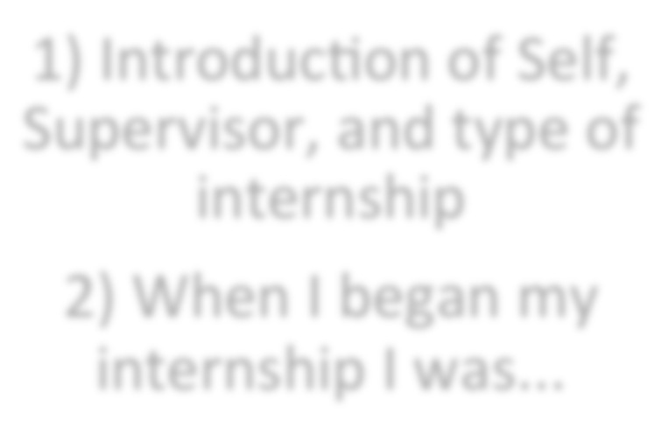

1. Introducqon of Self,

Supervisor, and type of internship

1. When I began my internship I was...



My Project Consisted of ...

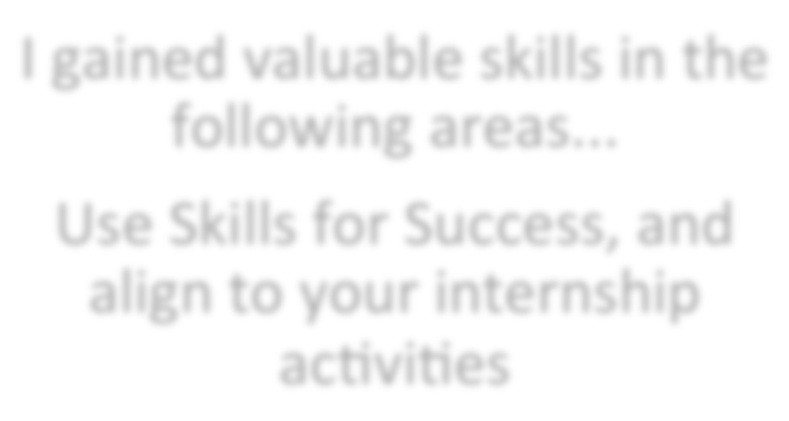

I gained valuable skills in the following areas...

Use Skills for Success, and align to your internship acqviqes

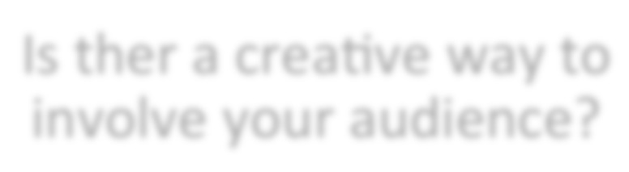

Is ther a creaqve way to involve your audience?

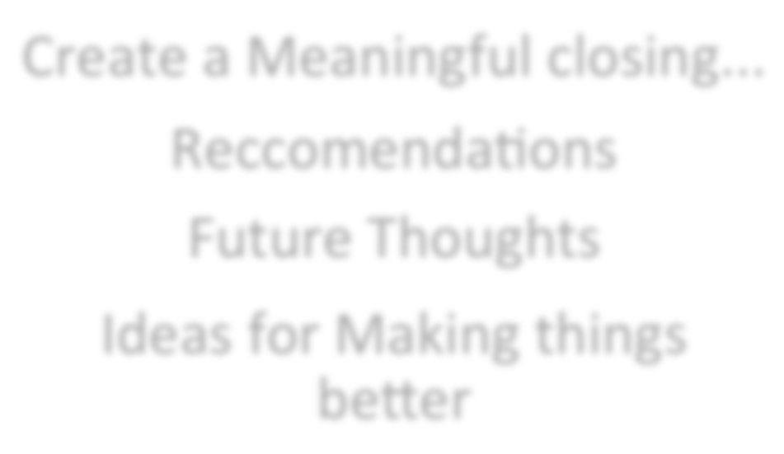

Create a Meaningful closing...

Reccomendaqons Future Thoughts

Ideas for Making things berer

Sample Presentation Outline:

* + 1. Introductions: State your name. Introduce your supervisor, and describe the place of your internship
    2. Introduce the story of your internship. Start with your first day, your predictions of what it might be like. Describe your work there.
    3. Introduce your Learning Project or Product (Display Pictures, Videos, or the product itself (when applicable)
    4. Discuss the Skills for Success you used, practiced, and learned during your internship. These skills should be directly connected to the work you were doing
    5. (Optional) Create an interactive piece where you ask the audience to engage in some thinking, questions, or activity
    6. Create a meaningful closing. This can be any of the following: Recommendations for the future. Key Learning you will take with you into the next phase of your life. A short slide show with photos. Question and Answer session